Task-level phenomenon:
Across the globe, Earth’s climate is changing, and temperatures are increasing. Every year since 1980, annual global temperatures have been above the average temperature of the past 140 years. As demonstrated in the anchoring phenomena below, “global surface temperatures in 2017 were the second warmest since modern record-keeping [of temperature] began in 1880.” Global temperature increases have become an annual phenomenon.

Synopsis of high-quality task:
Students will identify factors that are contributing to global climate change. They will analyze data of human population growth, world carbon dioxide emissions, change in forest area, energy consumption, and global temperature change, and make a claim about the relationship between the data and human impact on the environment. After calculating a carbon footprint, they will use this information to draft a letter to a local official advocating for action. Students will provide possible solutions for curbing climate change including a plan to reduce the impact that specific activities have on the environment.

Anticipated student time spent on task: 2 sessions, 90 minutes each. An additional 45 minutes may be required if using peer editing for the letter writing component.

Type of Task (check one):
____ 1. Investigation/experimentation/design challenge
__X_ 2. Data representation, analysis, and interpretation
____ 3. Explanation

Student task structure(s): Partner/group data analysis and individual

STE Standards and Science and Engineering Practices:

STE Standard:
8.MS-ESS3-5. Examine and interpret data to describe the role that human activities have played in causing the rise in global temperatures over the past century.
Clarification Statements:
- Examples of human activities include fossil fuel combustion, deforestation, and agricultural activity.
- Examples of evidence can include tables, graphs, and maps of global and regional temperatures; atmospheric levels of gases such as carbon dioxide and methane; and the rates of human activities.

Science and Engineering Practice:
- Analyzing and Interpreting Data
Prior Knowledge:
Previous Standards from Strand Map:
4-ESS3-1. Obtain information to describe that energy and fuels humans use are derived from natural resources and that some energy and fuel sources are renewable and some are not.
Clarification Statements:
- Examples of renewable energy resources could include wind energy, water behind dams, tides, and sunlight.
- Non-renewable energy resources are fossil fuels and nuclear materials.

8.MS-ESS2-6. Describe how interactions involving the ocean affect weather and climate on a regional scale, including the influence of the ocean temperature as mediated by energy input from the Sun and energy loss due to evaporation or redistribution via ocean currents.
Clarification Statement:
- A regional scale includes a state or multi-state perspective.
State Assessment Boundary:
- Koppen Climate Classification names are not expected in state assessment.

Other Prior Learning or Related Learning:
MATH 8.F.B.5 Use functions to model relationships between quantities. Describe qualitatively the functional relationship between two quantities by analyzing a graph (e.g., where the function is increasing or decreasing, linear or nonlinear). Sketch a graph that exhibits the qualitative features of a function that has been described verbally.

Cross-disciplinary Connection (Social Studies/ History (Civics)):
HSS.8.T6.10 Explain the major components of local government in Massachusetts, including the roles and functions of mayors, city councils, and school committees in cities; town managers, select boards, representative and open town meetings and school committees, in towns, and courts and sheriff’s departments in counties.

Connections to the real-world:
Climate change is a contemporary topic that is routinely presented in the media. Students frequently hear of or read these stories, but rarely have the chance to review any relevant research. This task is an opportunity for students to deepen their understanding of what is occurring with global climate change. Through the analysis of authentic data, students will better understand human impact on the environment. By seeing the changes that are occurring students will connect climate change and their own carbon footprint. Finally, through writing to their elected officials, students are challenged with entering the debate and advocating for change on the local level.
Mastery Goals:
Learning Objective:
Students will be able to…
- Analyze a collection of climate change data resources in order to understand potential causes of climate change.
- Construct a claim explaining global climate change and suggest solutions for local implementation to combat its continuation.
- Complete a carbon footprint quiz and record their results in order to understand their impact on the Earth.

Performance Objectives:
Students will be able to…
- Analyze a variety of data resources and compose a fact-based claim supported by evidence for a potential cause of global climate change.
- Write a letter to a local elected official to advocate for change on the local level that will contribute to fighting global climate change.

Language Objective:
Students will be able to…
- Speak, using academic and content relevant vocabulary, as they collaboratively analyze a variety of climate-related data resources;
- Record their interpretation of each data resource in writing, as well as write a Claim-Evidence-Reasoning composition using academic and content relevant vocabulary.
- Write a letter to a local official that incorporates academic and content relevant vocabulary.

Teacher Instructions
Instructional Tips/Strategies/Suggestions:

Part 1:
- Introduce the video Climate Change: Global Temperature Anomalies from 1890 - 2017 (resource link #1). This video serves as the tasks anchoring phenomenon. After viewing the video, ask students for descriptions/observations of what is occurring and their reactions. Ask, “What is impacting this change in climate?” and “Do humans have a role in what is occurring?”
  - This is a brainstorming exercise, so write down student answers and questions on board and accept all reasonable answers.
  - Explain to students that the goal of the assignment is to analyze data related to temperature, energy, etc. and that they will be figuring out what they think the underlying cause of global climate change is.
- Distribute the Global Climate Change Data Analysis worksheet to students (one for each student). Students will write down their interpretations on this handout in order to collect evidence for a CER composition.
- Students should complete the data analysis in a group. Consider assigning group members meaningful roles (such as examples included here https://www.humber.ca/centreforteachingandlearning/instructional-strategies/teaching-methods/classroom-strategies-designing-instruction/collaborative-learning/roles-and-responsibilities-for-group-members.html)
- Some classes might need a guide on how to analyze graphs. You can make your own or it might be a good idea to do a sample analysis the day before as a class. Students may need prompting. The following questions are helpful:
  - Does this data resource have a title?
  - Does this resource have a legend or code?
  - How are the x-axis and y-axis labelled?
  - How many lines are on the graph and are they labelled?
  - What is happening to the line or columns as you scan the graph from one side across to the other side?
  - Do you see any peaks, dips, or flat areas in the data? What do these mean?
  - Overall, what are the data points in the graph telling you?
  - Do you see any patterns or trends in the data?
  - Can you make any connections between two or more graphs that were provided?
  - Does the data show any relationship between human impact and climate change?
  - Does everyone agree with X? What data do you have to support X?
- The teacher should circulate around the room to listen to the students and their discussions. All students in each group should be collaborating and contributing. No members of the group should jump ahead. A good way to prompt students back into discussion who have moved ahead is to ask,
“Did everyone agree with the interpretations of X graph?” and encourage them to discuss their evidence with the group to see if they agree, or need to continue to discuss.
- If groups are done (some may work faster than others), then they should move on to the CER writing assessment which is located at the end of Part 1.
- All of Part 1 should take about 90 minutes. This includes beginning to write the CER assessment. Note: The CER assessment can be done in class or assigned for homework. This depends on your class time and the needs of your students.
Part 2:
- Students complete the carbon footprint calculator (there are several available online) and take notes of their results. [Note: If some of the questions ask for the square footage of their home, students could use common real estate sites to get the information they need, or could be given the square footage of the classroom or other spaces they are familiar with to estimate.]
  - A class graph on the white board, a class spreadsheet, or virtual graph comparing students’ results will support students in discussing the results (Note: this was not done during pilot testing).
  - Students should discuss what factors tended to make footprints higher or lower than the average.
- Students use an online tool to estimate the carbon footprint of their community. [Note: Teachers should choose a tool that is best for their community and context in advance, using the following key words in a web search: carbon footprint estimate zip code map. Many of these tools incorporate maps, so that is a good keyword to include. Student-friendly calculators are available by searching “carbon footprint calculator for kids.”]
- When students have completed their carbon footprint estimates for themselves and their communities they should use that information to write their letter to a local official. The Mayor or relevant member of the City Council of your city are good ideas. A letter template is provided below (if needed) that includes some guided questions in the body for students to use to help them get started. It will be important for students to draw upon their data analysis and CER composition to add depth to their letter. [Note: Consider collaborating with your History and Social Science colleagues, as this part of the task connects with MA Grade 8 Civics standards]
- Municipal websites frequently contain information on the community's conservation and environmental policies, as well as initiatives. This would be a useful resource to students as they prepare their letters.
- Depending on students’ writing ability, they may need additional class or homework time to complete their letters. Also, this is a good opportunity for students to engage in peer feedback/ editing with classmates. Consider using a peer feedback protocol, such as sticky note feedback (https://ambitiousscienceteaching.org/sticky-note-student-feedback/), a student-friendly version of the tuning protocol (https://schoolreforminitiative.org/doc/tuning.pdf), or a student friendly version of a consultancy (https://www.schoolreforminitiative.org/download/consultancy-adapted-for-examining-student-work/)
- After students have completed and submitted their letter, a class discussion on what they feel needs to be done/changed to help their community address climate change would be an effective activity to wrap up this task. Close by watching the Climate Change: Global Temperature Anomalies from 1890 - 2017 (resource link #1) video one final time to remind students how their discussion began.

Instructional Materials/Resources/Tools:

Student Directions:
- Using the Global Climate Change Data Analysis, work with your group members to analyze the graphs. Do not go out of order. You should be writing down what you observe about the graphs. Use the guiding questions at the top of your worksheet to help you through the process of what to look for and write down.
- After you finish your graph analysis you will use it to write the CER Assessment for Part 1. You can hand write this or type it.
- When you have finished the CER Assessment you will move on to Part 2. Use the Carbon Footprint Calculator and do your best to answer the questions. Some of the questions you might need to look up online.
- Take notes on the calculation results.
- When done, you will begin to take all the information you learned to write a letter to our local representative about what our community can do to address climate change.
- Please edit your letter by reviewing grammar, spelling, and punctuation.
- Show your letter to at least one classmate and ask for feedback for improvement.
- Complete any necessary revisions based on feedback and submit the letter when it is completed.

[Note: Adapt these instructions, especially #4 if you are using a class representation of the data and #7 if you are using a feedback protocol, to meet your instructional needs.]

Materials List:
- Student “Handout” - Data Analysis Resources worksheet electronically shared with students OR a color copy handout with one graph per page (from the links provided in the “Handout”). [Note: the first link is a video, and should preferably be played on the projector as a whole class]
- WORKSHEET: Global Climate Change Data Analysis (hardcopies or electronically shared)
- WORKSHEET: Data Analysis Writing Assessment (or scaffolded version if needed)
- WORKSHEET: Your Carbon Footprint and Advocacy for Change
- Letter to Local Official Template
- Computer access and a projector to show class graph for discussion (if applicable)

Task Source
Part 1:

- NASA, Climate Change: Global Temperature Anomalies from 1890 - 2017. (video), retrieved June 18, 2019 from https://www.youtube.com/watch?v=Z4bSxb5THm4
  - Public Domain US government video - https://www.nasa.gov/multimedia/guidelines/index.html

- NOAA, National Centers for Environmental Information, Climate At a Glance: Global Time Series (interactive), published June 2019, retrieved on June 18, 2019 from
  - https://www.ncdc.noaa.gov/cag/global/time-series/globe/land_ocean/10/10/1880-2019
  - Public domain US Government website

- Our World in Data, World Population Growth, 1750-2100. Retrieved on June 18, 2019 from https://ourworldindata.org/wp-content/uploads/2013/05/updated-World-Population-Growth-1750-2100.png
  - Creative Common License (CC-BY): https://ourworldindata.org/about/how-to-use-our-world-in-data

- USEIA, Today in Energy: Energy Consumption in the United States 1776-2017, published July 3, 2018, retrieved June 20, 2019 from https://www.eia.gov/todayinenergy/detail.php?id=36612
Public Domain US Government Website, Copyrights and Reuse statement:
  - https://www.eia.gov/about/copyrights_reuse.php

- USEIA, Today in Energy: World Energy Consumption by Energy Source (1990-2040), published September 14, 2017, retrieved June 20, 2019 from https://www.eia.gov/todayinenergy/detail.php?id=32912
  - Public Domain Government Website, Copyrights and Reuse statement: https://www.eia.gov/about/copyrights_reuse.php

- World Carbon Dioxide Emissions 1990-2030:
  - Mak Thorpe, Global Carbon Emission by Type to Y2004: Global Fossil Carbon Emissions (image), last updated on January 9, 2018, retrieved on June 20, 2019 from https://commons.wikimedia.org/wiki/File:Global_Carbon_Emission_by_Type_to_Y2004.png
    - CC BY-SA 3.0: https://creativecommons.org/licenses/by-sa/3.0/deed.en

- Global Forest Resources Assessment 2020
  - Food and Agriculture Organization of the United Nations, Global Annual forest area net change, by decade (1990-2020), published 2020, retrieved July 29, 2020 found at http://www.fao.org/3/CA8753EN/CA8753EN.pdf#page=4
  - Source: FAO, 2020. Global Forest Resources Assessment. FAO. Rome.
  - FAO Open Access Policy: http://www.fao.org/publications/highlights-detail/en/c/1119190/
  - CC BY-NC-SA-IGO 3.0

Part 2:

- USEPA, Carbon Footprint Calculator, last updated July 16, 2016, retrieved June 18, 2019 from https://www3.epa.gov/carbon-footprint-calculator/

The Ambassador would like to recognize Kelly Mansour from Haverhill Public Schools for their contributions to the development of this task.

Accessibility and Supports:
- Data analysis template for students to record interpretation of each data resource;
- Two versions of CER composition template - one open format and the second is scaffolded by section for struggling writers;
- Template of letter to local official.

Student “Handout” - Data Analysis Resources

Step 1: Analyze the five graphs in the links below as well as the video on the Data Analysis Template below. Do you see any patterns or trends in the data? Do you see any peaks or dips in the data? Can you make any connections between the graphs?

- Video: Climate Change: Global Temperature Anomalies from 1890 – 2017
https://www.youtube.com/watch?v=Z4bSxb5THm4

- Climate At a Glance: Global Time Series (interactive)
https://www.ncdc.noaa.gov/cag/global/time-series/globe/land_ocean/10/10/1880-2019

- World Population Growth, 1750-2100
https://ourworldindata.org/wp-content/uploads/2013/05/updated-World-Population-Growth-1750-2100.png

- Today in Energy: Energy Consumption in the United States 1776-2017
https://www.eia.gov/todayinenergy/detail.php?id=36612

- Today in Energy: World Energy Consumption by Energy Source (1990-2040)
https://www.naturalgasintel.com/ext/resources/Daily-GPI/DG3Q2017/continued/2017-09-14-World-Energy-Consumption-By-Source-EIA.png?1505413705

- Global Fossil Fuel Carbon Dioxide Emissions (1880-2004)
https://d32ogoqmya1dw8.cloudfront.net/images/eslabs/carbon/global_fossil_fuel_carbon.jpg

- Annual Change in Forest Area (1990-2020)
http://www.fao.org/3/CA8753EN/CA8753EN.pdf#page=4

Name:____________________________________________________
Global Climate Change Data Analysis

Use the spaces below to record your analysis of each of data resources 1-7.
Here are some questions to prompt your thinking:
- What is each data resource demonstrating over the given time span?
- What is happening to the line or columns from the left side over to the right side of the graph?
- Do you see any peaks, dips, or flat areas in the data? What do these mean?
- Overall, what are the data points in the graph telling you?
- Do you see any patterns or trends in the data?
- Are there multiple lines on the graph? Are these lines somehow related to each other? Are the lines similar in appearance or different? Why do you think that is the case?
1. Video - Global Temperature Anomalies from 1890 - 2017

2. Climate At a Glance: Global Time Series

3. World Population Growth 1750 - 2100

4. Energy Consumption in the U.S. 1776-2017

5. World Energy Consumption by Source 1990-2040

6. Global Fossil Fuel Carbon Dioxide Emissions 1880-2004

7. Annual Change in Forest Area (1990-2020)

Data Analysis CER Writing Assessment:
Write a CER composition in which you provide Evidence and Reasoning to support a Claim about what you think is a potential cause of global climate change. Here are some questions which may prompt your thinking:
- After looking at all of the graphs, is there an overall claim that multiple data resources support?
- Is there a connection across most/ all of the graphs?
- Can you come to a conclusion about the underlying cause of global climate change?
- What other data do you think is useful to help you come to a conclusion about climate change?
- Use specific evidence from resources 1-7 to support your claim.

Claim - Evidence - Reasoning (CER) Composition Template [version 1]

Provide an explanation that answers the scientific question: What is a potential cause of global climate change?

Ensure that claims are supported by evidence, and that the reasoning between the claim and evidence is strong and clear. Finally, identify other sources of data that you would like to see in order to deepen your understanding of this topic.

Claim - Evidence - Reasoning (CER) Composition Template [version 2]

- Make a claim that answers the scientific question: What is a potential cause of global climate change?

- What evidence was used to write your claim? (Reference specific data from resources 1-7 to support your claim.)

- Explain your reasoning and why the evidence supports your claim. Identify the factors in the data resources that may be contributing to global climate change and explain how they connect to your claim.

Your Carbon Footprint and Advocacy for Change

Step 2: Complete the following tasks:
- Calculate your own carbon footprint using the calculator below.
- Perform a webquest to find web resources that will allow you to determine the carbon footprint of your city/ town.

Personal Carbon Footprint Calculator:
https://www3.epa.gov/carbon-footprint-calculator/

Community Carbon Footprint:
Perform a webquest to find online tools that will allow you to estimate the carbon footprint of your community.

Your goal is to provide possible solutions for curbing climate change including a plan to reduce the impact that specific activities have on the environment. After calculating your and your family's carbon footprint, you will use this information to draft a letter to a local official (Mayor, City Manager, City Councilor etc.) that addresses the following:

- The severity of climate change and the relationship to your (and your community’s) carbon footprint. Provide evidence from your data analysis and carbon footprint calculations to communicate the seriousness of this phenomenon.
- Changes that you and your family are committing to make in order to reduce your carbon dioxide emissions.
- Identify environmental policies your community has in place and suggest additional policies/ actions that could contribute to combating this climate change.

Letter to Local Official Template

<insert your first and last name>
<insert your street address>
<insert your City, State abbreviation, and zip code>

The Honorable <insert Mayor’s full name here>
Mayor of the City of <insert name of City here>
<insert the Mayor’s office address>
<insert street address>
<insert City, State abbreviation, and zip code>

<insert date>

Dear Mayor <insert Mayor’s Last Name>:

<insert text of your letter here>
- <Introduce yourself as a student of the Haverhill Public Schools>
- <State the purpose of your letter>
- <Identify the topic that has been studied in science class, AND provide a brief overview of the research that you feel is most relevant to your purpose.>
- <Share reasonable/ actionable suggestions of policies/ actions that the City can take in order to address the concerns that you raise in your letter>

Sincerely,

<insert your name>
<insert your grade>
<insert the full name of your school>

Student work exemplar #1
CER Assessment
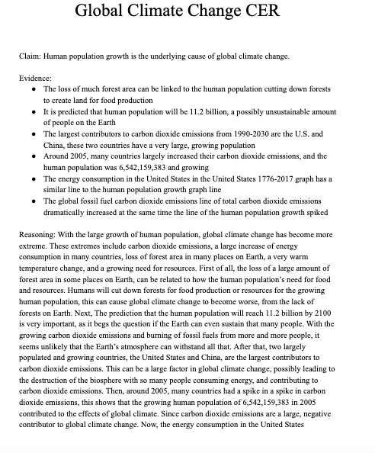

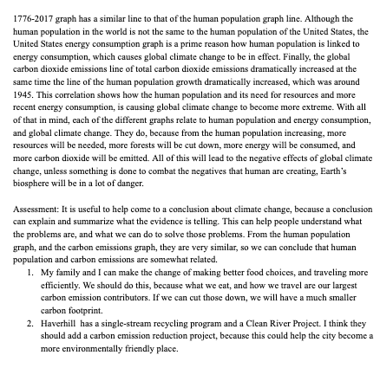

Letter to Local Official
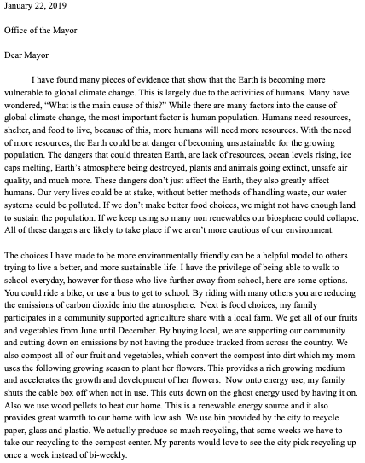

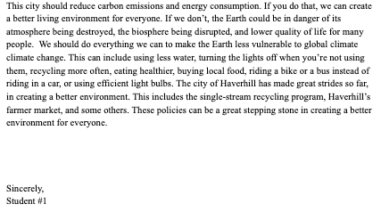

Student work exemplar #2

CER Assessment
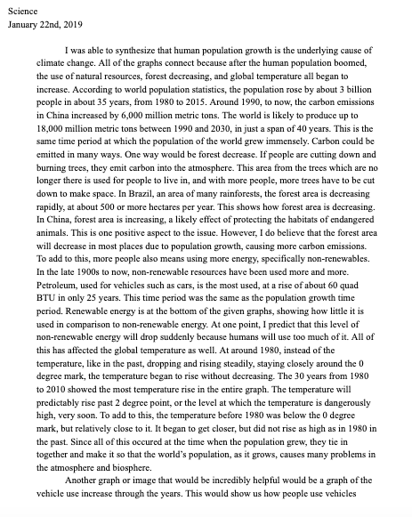
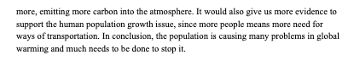

Letter to Local Official
