|  |
| --- |
| **Synopsis of high-quality task:**  This is a multi-part task that addresses linear relationships in 8th grade. Students explore the linear relationships that exist when mixing drinks using drink powder. Students use tables, graphs, and equations.  **Anticipated student time spent on task:** 60 minutes  **Student task structure(s):** partner work and group work |
| [**Math Content Standards and Practices:**](http://www.doe.mass.edu/frameworks/math/2017-06.pdf)  **8.EE.B.5** Graph proportional relationships, interpreting the unit rate as the slope of the graph. Compare two different proportional relationships represented in different ways.  **8.F.A.2** Compare properties of two functions each represented in a different way (algebraically, graphically, numerically in tables, or by verbal descriptions).  **8.F.B.4** Construct a function to model a linear relationship between two quantities. Determine the rate of change and initial value of the function from a description of a relationship or from two (x, y) values, including reading these from a table or from a graph. Interpret the rate of change and initial value of a linear function in terms of the situation it models, and in terms of its graph or a table of values.  **SMP.1** Make sense of problems and persevere in solving them.  **SMP.2** Reason abstractly and quantitatively.  **SMP.4** Model with mathematics.  **SMP.8** Look for and express regularity in repeated reasoning. |
| **Prior Knowledge:**  **7.RP.A.1** Compute unit rates associated with ratios of fractions, including ratios of lengths, areas, and other quantities measured in like or different units.  **7.RP.A.2** Recognize and represent proportional relationships between quantities.  a. Decide whether two quantities are in a proportional relationship, e.g., by testing for equivalent ratios in a table, or graphing on a coordinate plane and observing whether the graph is a straight line through the origin.  b. Identify the constant of proportionality (unit rate) in tables, graphs, equations, diagrams, and verbal descriptions of proportional relationships.  c. Represent proportional relationships by equations. For example, if total cost t is proportional to the number n of items purchased at a constant price p, the relationship between the total cost and the number of items can be expressed as t = pn.  d. Explain what a point (x, y) on the graph of a proportional relationship means in terms of the situation, with special attention to the points (0, 0) and (1, r) where r is the unit rate.  **7.RP.A.3** Use proportional relationships to solve multi-step ratio, rate, and percent problems.  **7.EE.B.4** Use variables to represent quantities in a real-world or mathematical problem, and construct simple equations and inequalities to solve problems by reasoning about the quantities. |
| **Connections to the real-world:**  -Mixing soft drinks  -Entertaining  -Producing food/beverage to a larger scale |
| **Mastery Goals:**  Learning Objective:  Students will be able to demonstrate their reasoning abilities and determine the constant rate of change (slope) and starting value (y-intercept) of a linear equation and how it relates to a real-world task (mixing drinks using drink powder.)  Language Objective:  During the task, students should use applicable vocabulary terms that includes, but not limited to: rate of change, slope, y-intercept, x/y axis, etc. Students should also be able to interchange these terms with the real-world scenario. |
| **Teacher instructions**  **Instructional Tips/Strategies/Suggestions:**  Prior to distributing the task, have students view the two Kool-Aid images and ask them what they know about making Kool-Aid, particularly with mixing powder with water. Provide some emphasis on the fact that for the taste of Kool-Aid to be consistent for any amount made, the water to powder ratio should be consistent.  If the class period is at least 45 minutes, the task may be run in one day. It is expected that students will take between 30 to 45 minutes on this task. If there is less than 40 minutes to run, it is recommended that the task be broken up over two days, completing Part I on day one, and Part II on day two. It is also recommended that the task be broken up over two days in classes that have significant learning challenges, providing extra time for check-ins and reviews.  It is also recommended that all groups check in with the classroom teacher or other professional supervising the task at the end of Part I before moving on to Part II. |
| **Instructional Materials:**  Include:   * Student directions for completing the task   **Images:**  <http://davidgillespie.org/its-time-to-stop-drinking-the-kool-aid-of-public-health-dogma/>  <http://csharpileweb.blogspot.com/2017/03/blank-quadrant-1.html> |
| **Accessibility and Supports:**  Potential sentence starters:  While students are discussing and sharing with their partners, invite them to use the sentence frame:  “For the Kool-Aid to taste the same no matter how much is made, _______________ has to be true/must be equal.”  “The best way to compare the rate is _______________________ because _______________.”  Key academic vocabulary:  -slope  -rate of change (constant)  -y-intercept |
| **Sample Student Work:**  **student work**  **student work with graphical representation of ratio between sugar and powder**  **line graph**  **table showing relationship between the number of servings and the amount of powder**  **linear model of sugar to powder**  **graphical representation of linear model** |

**Student Handout:**

Name ____________________________________ Date ______________ Class _____________________

**Mixing Kool-Aid**

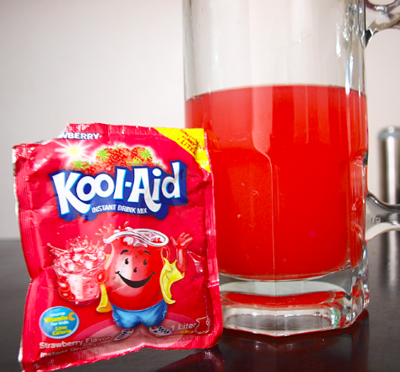 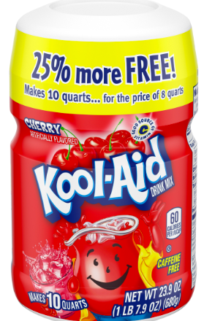

**PART I:**

**Payton and Julia spend much of their time together in the summer, and their favorite summertime drink is Kool-Aid. Payton has memorized that when she makes Kool-Aid for herself and Julia, she uses three tablespoons of drink mix powder to make two 8-oz. servings.**

1. **Determine how much drink mix powder is needed for only one serving.**

**B. Complete the table below.**

|  |  |  |  |  |  |  |
| --- | --- | --- | --- | --- | --- | --- |
| **Servings (s)** | **1** | **2** | **3** | **4** | **5** | **6** |
| **Tablespoons of powder (p)** |  |  |  |  |  |  |

**C. Develop the equation that best represents the number of tablespoons of powder, *p* to the number of servings, *s*. Let the tablespoons of powder be the independent variable. What does the slope of the equation represent?**

**D. Graph the equation below. Pay attention to the labeling of the x-axis and y-axis:**

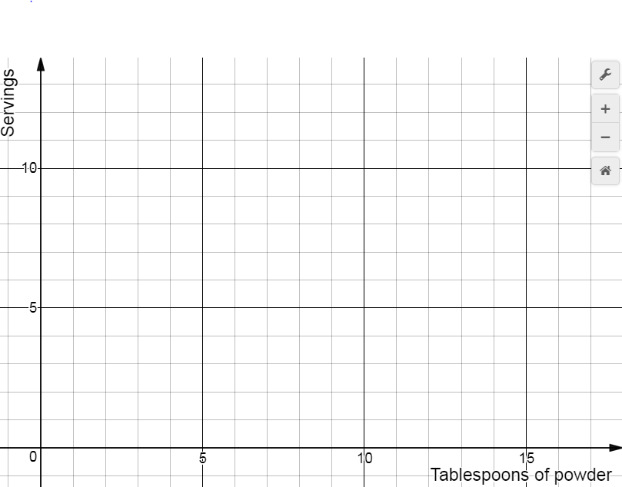



**PART II:**

**Julia’s birthday is next week, and Payton is in charge of making the Kool-Aid for Payton, herself, and her guests. She has one 64-oz. bottle of pre-made Kool-Aid, but will need to make the remaining amount by mixing the powder with water. Payton will make sure that the pre-made bottle is consumed first before making more with the powder and water.**

**E. Will mixing water and Kool-Aid powder be necessary for the first…**

**-6 servings?**

**-8 servings?**

**-10 servings?**

**Remember to explain your reasoning.**

**F. Complete the table below. Remember that mixing powder and water is not necessary for the first 64 ounces!**

|  |  |  |  |  |  |  |
| --- | --- | --- | --- | --- | --- | --- |
| **Servings (s)** | **8** | **9** | **10** | **11** | **12** | **13** |
| **Tablespoons of powder (p)** |  |  |  |  |  |  |

**G. Develop an equation that best represents the number of tablespoons of drink mix powder needed for any number of servings. What does the y-intercept of the equation represent?**

**H. Graph the equation below. Pay attention to the labeling of the x-axis and y-axis.**





**I. Of the two scenarios, which represents a drink powder to serving ratio as a proportional relationship? Give at least two supporting reasons for your choice.**