Synopsis of high-quality task:

This task should be presented as a 3-Act Math Task. Act 1 would be Part A of the task. Students will only be given the map if they need the scaffold. All other students should create a visual based on their findings and wonderings. Act 2 will ask them to find the shortest distance to the next bus stop. Act 3 will then ask to compare the speed of the bus and the speed of Carlos.

Students will be using Pythagorean Theorem to calculate the distance of a hypotenuse. They will then calculate the speed of a bus and of Carlos to see if he will be able to catch the bus. The bus will be traveling along the “legs” of a right triangle (the streets), and he will be running along the “hypotenuse” of the right triangle (through the backyard).

Student products would include triangles, ratio tables, standard algorithms, and calculations using Pythagorean theorem.

Anticipated student time spent on task: 45 mins

Student task structure(s): Individual plan/clarification time leading to collaboration with peers

Math Content Standards and Practices:

8.G.B.7 Apply the Pythagorean Theorem to determine unknown side lengths in right triangles in real-world and mathematical problems in two and three dimensions

SMP3 Construct viable arguments and critique the reasoning of others
SMP4 Model with mathematics
SMP8 Look for and express regularity in repeated reasoning

Prior Knowledge:

7.NS.A.3 Solve real-world and mathematical problems involving the four operations with integers and other rational numbers.
7.RP.A.1 Compute unit rates associated with ratios of fractions, including ratios of lengths, areas and other quantities measured in like or different units.

Connections to the real-world:

Students miss the bus all the time so they will understand and visualize the problem. Some may be able to relate to the problem. The street names used are the streets in the surrounding area of the school giving the students a comfortable learning experience.

Mastery Goals:

Learning Objective:
Students will be able to use the Pythagorean Theorem in real life context.

Language Objective:
Students will be able to explain what a hypotenuse is and why it is different from the legs. This can lead into the next standard of finding the distance between two points on a coordinate grid.
Students will be able to explain to themselves the meaning of a problem and looking for entry points to its solution.
Students will be able to communicate precisely to others.

Teacher instructions

Instructional Tips/Strategies/Suggestions:

This task should be presented as a 3-Act Math Task, do not hand out the worksheet until when students will start their written work.

- Present Part A of the task as Act 1. Read the situation aloud and ask students what they notice and wonder about the situation. List what they notice and wonder on a chart paper. Students responses can be math or non-math related. After a few responses guide the class to ask to the questions of the day. Will Carlos be able to catch up to the bus at the next bus stop? What is the shortest path to the next bus stop?
- Part B and Part C each have an Act 2 and 3 embedded in them.
- For part B, ask students what they would need to know in order to determine what the shortest distance is to the next bus stop. List student ideas on chart paper. Once the list is generated provide the included reference data:
  - The bus has to travel 22 yards down the street to a stop light.
  - The light turned green after 10 seconds
  - The bus turns 90 degrees and travels 120 yards to the next stop
- Continuing part B, given the above information, ask students to estimate the shortest route. What would be an underestimate and what would be an overestimate? Record these estimates on the chart paper as well. Now ask students to calculate the shortest distance to the next bus stop, they can work individually or with partners at teacher discretion.
- Once part B is completed, share out the results with the class and move on to part C. For part C, ask students what they would need to know in order to determine if Carlos can catch up to the bus. List student ideas on chart paper. Once the list is generated provide the included reference data:
  - Carlos can run 100 yards in 20 seconds.
  - The bus travels at 8 yards per second.
- Continuing part C, given the above information, ask students to estimate how close to catching the bus Carlos will be. What would be an underestimate and what would be an overestimate? Record these estimates on the chart paper as well. Now ask students to determine if he will catch the bus or not, they can work individually or with partners at teacher discretion.
- Once part C is complete, share out the results with the whole class.

Scaffolds include:
- Pythagorean Theorem formula
- Detailed map
- Empty ratio tables
- Sentence frames for the answers

Accessibility and Supports:

Potential sentence starters:
The hypotenuse is _____________ because _____________.
I can apply the Pythagorean Theorem because ________________.
I can use the Pythagorean Theorem to find the missing length of a right triangle by ________________.
The length of the hypotenuse compares to the length of a leg by _______________?

Key academic vocabulary: Square root, legs, hypotenuse, Pythagorean Theorem, scale drawing, similarity, right angle

Name:______________________________________________ Date:_____________

Run, Carlos. Run!
Part A:
Carlos misses his alarm in the morning, so he has to rush to get ready. When he finally runs out his front door, the bus is pulling away from the bus stop in front of his house.

Part B:
The bus has to travel 22 yards down the street to a stop light.
The light turned green after 10 seconds
The bus turns 90 degrees and travels 120 yards to the next stop

What is the shortest path that he could take to make it to the next stop? (round your answers to the nearest whole number)

Part C:
Carlos can run 100 yards in 20 seconds.
The bus travels at 8 yards per second.

Will Carlos make it to the bus stop in time? (round your answers to the nearest whole number)

Sample Student Work:
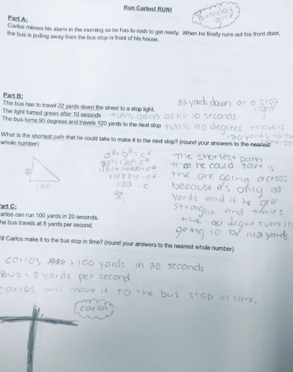

St