Task-level Phenomena:
Students engage in photos, video, and data to assess whether the City of Lawrence can reverse the effects of carbon emissions from cars by planting trees.

Synopsis of high-quality task:
This task is designed as a culminating activity after photosynthesis, cellular respiration, and the carbon cycle. Students analyze the concept of carbon sequestration, the rate at which carbon dioxide is absorbed by plants over an amount of time. Quantitative data from an urban environment is analyzed through inquiry. Students will expand upon acquired knowledge through graphing, data interpretation, and calculations using formulas. The final cumulative artifact requires students to synthesize prior knowledge with their quantitative data in order to compose an evidence-based argument (CER response) to answer the essential question: Can the City of Lawrence reverse the effects of carbon emissions from cars by planting trees?

Anticipated student time spent on task: 4 classes 55 mins each

Type of Task (check one):
_____ 1. Investigation/experimentation/design challenge
__X__ 2. Data representation, analysis, and interpretation
_____ 3. Explanation

Student task structure(s): Small group work

STE Standards:

HS-LS2-5. Use a model that illustrates the roles of photosynthesis, cellular respiration, decomposition, and combustion to explain the cycling of carbon in its various forms among the biosphere, atmosphere, hydrosphere, and geosphere.
Clarification Statement:
- The primary forms of carbon include carbon dioxide, hydrocarbons, waste (dead organic matter), and biomass (organic materials of living organisms). Examples of models could include simulations and mathematical models.
State Assessment Boundary:
- The specific chemical steps of respiration, decomposition, and combustion are not expected in state assessment.

Science and Engineering Practice:
- Analyzing and interpreting data
Prior Knowledge:
Previous Standard from Strand Map:

8.MS-ESS1-1b. Develop and use a model of the Earth-Sun system to explain the cyclical pattern of seasons,

which includes Earth’s tilt and differential intensity of sunlight on different areas of Earth across the year,

Clarification Statement:
- Examples of models can be physical or graphical.

7.MS-LS2-3. Develop a model to describe that matter and energy are transferred among living and
nonliving parts of an ecosystem and that both matter and energy are conserved through these processes.
Clarification Statements:
- Cycling of matter should include the role of photosynthesis, cellular respiration, and decomposition, as well as transfer among producers, consumers (primary, secondary, and tertiary), and decomposers.
- Models may include food webs and food chains.
State Assessment Boundary:
- Cycling of specific atoms (such as carbon or oxygen), or the biochemical steps of photosynthesis, cellular respiration, and decomposition are not expected in state assessment.

HS-LS1-5. Use a model to illustrate how photosynthesis uses light energy to transform water and carbon dioxide into oxygen and chemical energy stored in the bonds of sugars and other carbohydrates.
Clarification Statements:
- Emphasis is on illustrating inputs and outputs of matter and the transfer and transformation of energy in photosynthesis by plants and other photosynthesizing organisms.
- Examples of models could include diagrams, chemical equations, and conceptual models.
State Assessment Boundary:
- Specific biochemical steps of light reactions or the Calvin Cycle, or chemical structures of molecules are not expected in state assessment.

Previous Topics:
- Photosynthesis
- Cellular Respiration
- Carbon Cycle
- Claim, Evidence, Reasoning (CER) Response Writing
- Graphing basics: scale, x- and y-axes, best fit line, outliers

Teacher Background:
Global climate change is accelerating at an alarming rate and scientists are worried that if we don’t make a dramatic change in energy usage it will have devastating impacts on ecosystems and human populations. According to the 2018 Global Carbon Budget, the United States is the greatest contributor to CO₂ emissions per person, per year (preceded by China; the greatest total CO₂ emissions per year). Many cities across the United States are searching for ways to reduce and offset their carbon emissions. As a result, many are turning to tree planting because trees have the ability to collect atmospheric carbon dioxide during photosynthesis and store it as cellulose -- carbon sequestration.

During photosynthesis, the chlorophyll within chloroplasts traps light energy and sugars are produced. Plants use energy from light to combine carbon dioxide and water to make food. Chlorophyll is a green pigment, found inside chloroplasts, that absorbs the sunlight plants use during photosynthesis. Photosynthesis is the process that autotrophs (producers) use to produce their own food. Using this sunlight along with materials from their environment (water and carbon dioxide), they produce the necessary molecule, glucose, which is used for life processes and is also broken down by heterotrophs (consumers) in order to produce cellular energy by the process of cellular respiration. The balanced equation for photosynthesis is as follows:

6CO₂ + 6H₂O
C₆H₁₂O₆ + 6O₂

SUN
What students may not realize is that the sugars that plants produce during photosynthesis aren’t just used in cellular respiration. Much of the glucose molecules produced during this process is used to build the plant itself. Plants need to use glucose molecules to produce polysaccharides such as cellulose. Cellulose makes up the cell walls of plants and is a large component of wood. This is when carbon sequestration, or the storage of atmospheric carbon, takes place in plants. As carbon is sequestered in plants, the tree grows. The older the tree, the more carbon is stored for a long period of time.

Connections to the real-world:

- Today, we face many environmental problems. One of the most relevant to us is the growing concentration of carbon dioxide in the atmosphere caused by humans. Can Lawrence reverse the effects of carbon emissions from cars by planting trees? This lesson poses this question to students and pushes them to think critically about this phenomenon.

- Trees are a natural source for carbon sequestration, which contributes to offsetting atmospheric carbon.

- Municipalities are taking into account that there are other socioeconomic benefits to planting trees such as reducing temperatures in heat islands, absorbing excess water in flood plains, and increasing the socioemotional health of citizens.

- Groundwork Lawrence (GWL) is an organization is a local organization. This provided students with a real-world connection to the work that is taking place right in their neighborhood. They also learned that they could get a free tree planted in their yard and be active in helping to reduce their carbon footprint.

Mastery and Language Goals:

Learning Objectives:
- Create graphs to analyze and interpret carbon sequestration data.
- Calculate the number of trees needed to offset carbon dioxide emissions in order to gather evidence to support their claim.
- Construct an explanation using claim, evidence, and reasoning about the carbon cycle. (Lesson 2).

Performance Objectives:
- Obtain information about carbon sequestration. (Lesson 1)
- Create a graph and analyze data about carbon sequestration. (Lesson 2A).
- Use mathematical concepts to calculate the number of trees needed to offset CO2 emissions from cars per year. (Lesson 2B).
- Use scientific data to construct an argument that determines whether the City of Lawrence can reverse the effects of carbon emissions from cars by planting trees

Language Objectives:
- Engage in group discussions, using text and data in order to provide evidence to support a claim.
- Discuss orally and in writing the number of trees to offset carbon dioxide emissions from cars in the City of Lawrence in order to gather evidence to support their claim.
- Write a claim based on evidence from multiple sources of data and provide scientific reasoning using vocabulary about photosynthesis.

Teacher Instructions:

Lesson 1: Observations and Gathering Information
- Students write down ideas/questions/observations about a picture of a city before and after planting trees. Have students that answer the question: Which picture is more desirable? Why? Record students’ ideas/questions/observations on board.
- Activate students’ prior knowledge. Refer back to “Required Teacher Background” for topics. During this time, students will Think-Write-Pair-Share about questions that surfaced from the initial observations. Other questions to ask students if they are not student generated:
  - If trees don’t consume food, how do they get so tall?
  - Why do we need plants?
  - Why are plants important to an ecosystem?
  - Why are the outputs of photosynthesis important to us?
  - What value do trees provide? Why are they valuable to us?

Students watch video, “Why cities should plant more trees” https://www.youtube.com/watch?v=aKyvGHycngM&t=4s. Post the questions (What are some ways that trees can help cities? Do you think we should plant more trees? Why or why not?) provided in the student sheets to get students thinking about what is to come in the video. Pause the video as needed to discuss questions and to help students answer the questions.

Students independently read about carbon sequestration, annotate the text, and answer aligned questions using the text found in the Lesson 1 Student Sheets. Note: There are two versions of the readings for students at varying levels. Provide additional images and sentence frames to assist students in using the terms in a sentence as well as recording the definition. This method can be used to help students create a personal glossary.
- Provide students with Carbon Cycle Worksheet for them to practice a claims, evidence and reasoning.
- Use the exit ticket as a means to assess students’ new knowledge or misconceptions.

Lesson 2A: Graphing and Data Analysis
- Begin class with the Do Now (See Lesson 2 Student Sheets: How do these infographics relate to
what we talked about yesterday?) Ask students to expand upon what was learned in Lesson 1. Add to a word wall of key vocabulary using the student sheet. Provide images and ask students to write a definition for each term in their own words.
- Students can refer back to their claims, evidence, reasoning worksheet from day before and add to it.
- Graphing Activity Carbon Sequestration of Trees in Urban Cities Across the Country. Students collaborate in teams of 4 and create a graph of carbon sequestration of trees (kg C/hectare/year) in urban cities across the country.
- Graphs have guiding questions to help students access the data and find the meaning. (NOTE: This is nice data to graph because the pattern is both clear and makes sense: more trees/area = more carbon sequestration/area. Students draw a “best fit” line to extrapolate the carbon sequestration at tree densities we don’t have data for (say for 200 trees/hectare). They should notice that the line cannot pass through all the data points, as some cities with a similar number of trees have different amounts of carbon sequestration (Philadelphia and New York, for example). You could allow students to speculate about this, or if you choose to use the Graph 2 (Extension), you can show them the importance of both age and tree species for carbon sequestration rates. Using Graph 2 will also give students more data to use as evidence to support their claim.

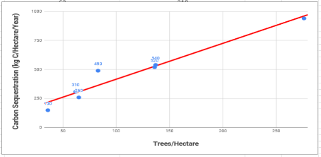
Graph: Answer Key
- Analysis Questions
- Peer Feedback: Students will exchange graphs and answers to the analysis questions

Lesson 2B: Calculations
- Students calculate the amount of trees needed to offset CO₂ emissions per year. Calculations Worksheet using Think-Write-Pair-Share. Note: “Estimated number of cars in Lawrence, MA” was determined by multiplying the average of Americans with cars by the current population of people in Lawrence, MA.
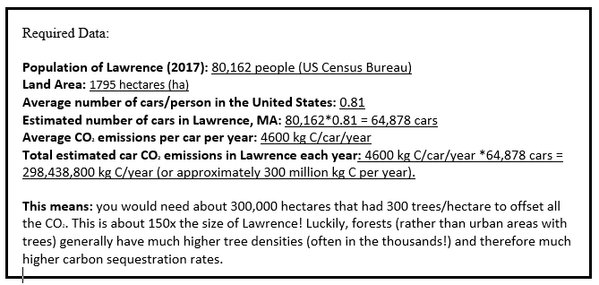
  - Question 1: Teacher will model how to use the research data to calculate the total number of cars in Lawrence. Have students follow along and cold call on random students to give the data to be used in the equation (i.e., population of Lawrence and average cars/person in the US)
  - Questions 2 - 5: It is most efficient to chunk these calculations into 2-minute sections for lower level students and give time for students to calculate each part. Higher level students who are proficient in graphing and calculating using equations can work in pairs/groups to calculate the data.
  - Check for understanding: One student per group will share their answer aloud for the class to hear. Whole class will agree/disagree/build on the answer given. Teacher should discuss/clarify any misconceptions and ensure that students understand and label units with their calculations. (See last page of document for answers to calculations)
  - Optional - Graph 2 (Extension) and Analysis Questions

- Exit Ticket: Does Lawrence have enough trees to offset the total of its’ CO2 car emissions every year? Why or why not? Use exit ticket as a means to assess students’ new knowledge or misconceptions and their ability to apply it to a new scenario.

Lesson 3 and 4: Argument Writing (CER)
- Do Now. Students review the graph, Rates of Urban Carbon Sequestration in Various U.S. Cities and Identify any outliers and justify why they are outliers. (See Do Now Lesson 3 Student Sheets)
- Revisit the graph from Lesson 2 to encourage students to participate in a more in-depth analysis. Project the computer-generated graph while students write observations about the graph using claim, evidence, and reasoning.
- Introduce the Argument (CER) – Prompt:
  - Can Lawrence offset the current carbon emissions from cars by planting 2,400 trees? Why or why not?
  - Propose how Lawrence could increase the amount of carbon sequestered by planting trees? (Hint: consider the various data provided, your formulas, and calculations.)
- Students complete the CER Lab Conclusion Planning Sheet (Graphic Organizer) independently.
- Students exchange their completed CER Graphic Organizer with a partner, turn and talk, and provide warm and cool peer feedback using the CER Lab Conclusion Rubric.
- Teacher shows student exemplary work to the whole class. Students will agree/disagree/build on the peer feedback provided, call attention to areas of strength, and offer additional suggestions for improvement
- Finally, students will write their Argument Response (CER) - Final Draft

Extensions: Consider incorporating a discussion surrounding current advances in negative emissions technologies or carbon capturing.

Instructional Materials/Resources/Tools:
- Lesson 1 Student Sheets
- Lesson 2 Student Sheets
- Graph Paper for Lesson 2 - Graph 2 Extension (Optional)
- Lesson 3 Student Sheets

Task Source:

The Ambassador would like to recognize Haydee Esquivel and Rebecca Veilleux from Lawrence Public Schools for their contributions to the development of this task.

Portions of task sourced from the following:

Images:
Images are from Groundwork Lawrence (GWL); American Planning Association; Sustainable Communities Division (2017). A Health Impact Assessment of the Lawrence Green Streets Program. 0-50. doi: https://apascd.wordpress.com/2017/04/07/green-streets-a-health-impact-assessment-of-the-lawrence-green-streets-program/

Lesson 1:
- Background Information Picture: Global Carbon Project. John Muyskens, The Washington Post. Tennis Lilly, Project Manager, www.GroundworkLawrence.org (GWL)
- GWL Health Impact Assessment (https://drive.google.com/file/d/0B4zDVSnrIBOnNVJyazJfZzViZ2M/view) GWL Report: Planning the Urban Forest: Ecology, Economy, and Community Development
Lawrence State of the Urban Forest 2012, Urban Ecology Institute, By: Kyle Greaves and Brian Szekely City of Lawrence State of the Urban Forest Report (https://drive.google.com/file/d/12gaL_Ry0Z9PQ5BBFNobcOuxLdEWFPt9k/view)
- Video, “Why Cities Should Plant More Trees?” https://www.youtube.com/watch?v=aKyvGHycngM&t=4s

Lesson 2:
- Graph data: Fiona Jevon, Graduate student at Dartmouth College, NH - Department of Biological Sciences; Data Nuggets
- Carbon Sequestration Rates: 6 Common Massachusetts Tree Species; this data set is from the following paper: Nowak, D.J. and Crane, D.E., 2002. Carbon Storage and Sequestration by Urban Trees in the USA. Environmental pollution, 116(3), pp.381-389.
- US Census Bureau: Population of Lawrence (2017): 80,162 people (US Census Bureau); Lawrence land area in hectares (US Census, 2010): 1795 hectares
- Data is derived from US DOE, 1998. Method for calculating carbon sequestration by trees in urban and suburban settings. Voluntary reporting of greenhouse gasses, pp.1-16. Found here:
https://www3.epa.gov/climatechange/Downloads/method-calculating-carbon-sequestration-trees-urban-and-suburban-settings.pdf

Lesson 3:
- Graphic Organizer: www.BiologyCorner.com

Accessibility and Supports:

Additional supports are provided (such as scaffolded readings, sentence frames, and vocabulary organizers) allow the scaffolds necessary to enable all students to succeed. These scaffolds will help EL students access the language necessary to explain their claims with confidence.

Lesson 1: Observations and Gathering Information
LL: 7 Steps Strategy to introduce new vocabulary
Language supports for pre-reading assignment:
- Explicitly teach vocabulary
- Add all terms to a word wall
- Close reading strategies (3 Reads)
- Annotate: Identify cognates

Lesson 2: Graphing, Data Analysis and Calculations
Provide a pre-made graph or one that is partially completed that then can be used for the analysis questions

Lesson 3: Argument Writing (CER)
Provide sentence frames and the CER Graphic Organizer.

Sample Student Work:
Included below
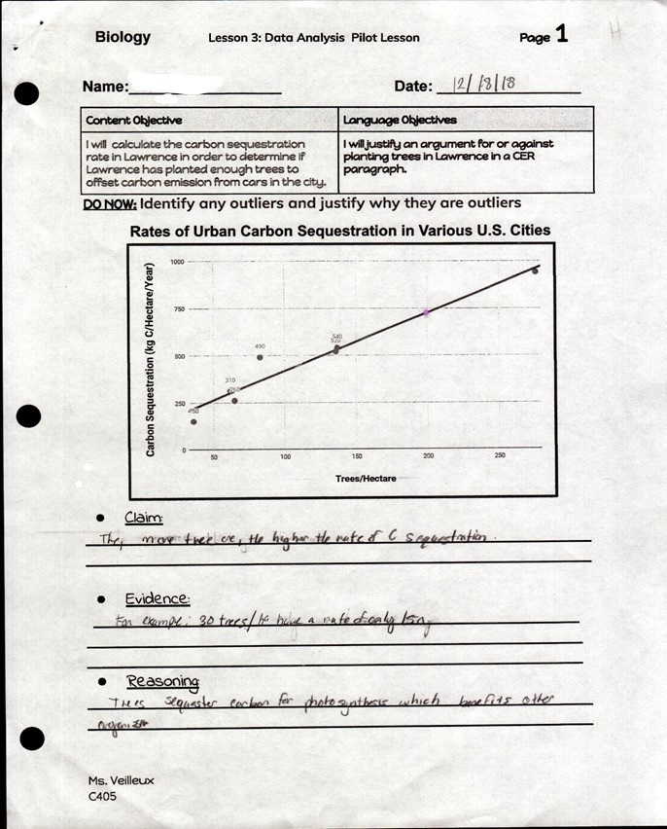

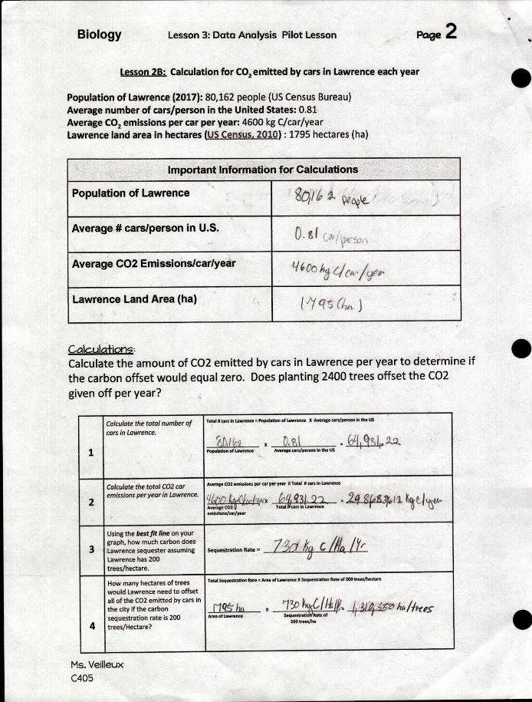
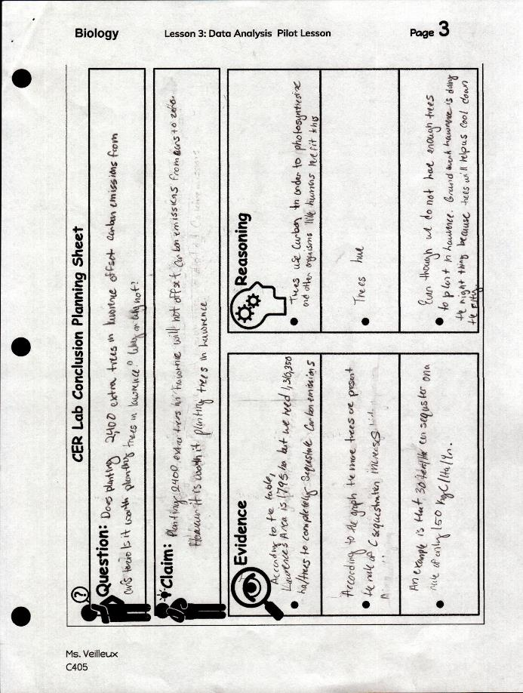

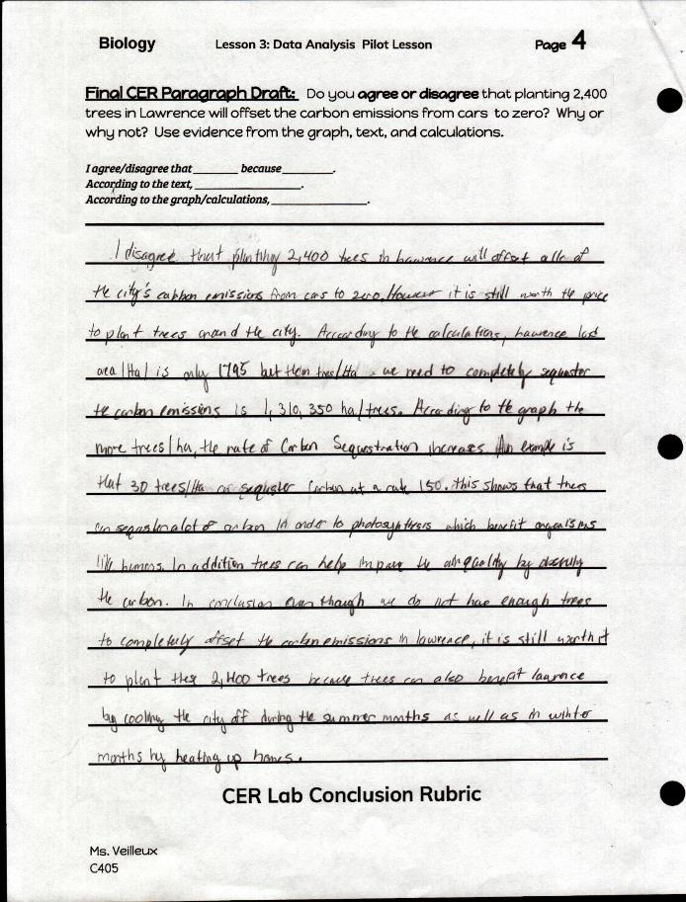
Name: __________________________________ Date: ________________

Lesson 1
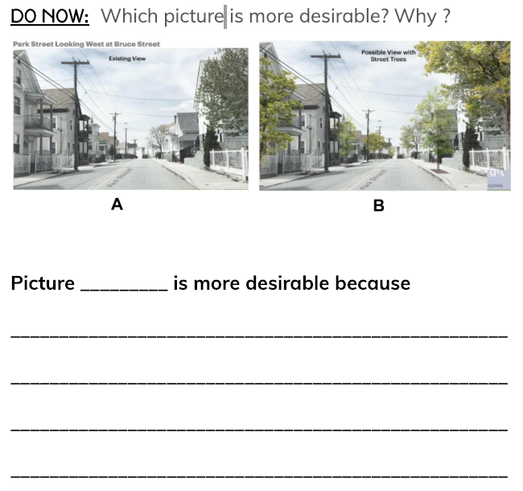
Questions I have…..

Image © Groundwork Lawrence

Lesson 1
Video: Why Cities Should Plant More Trees
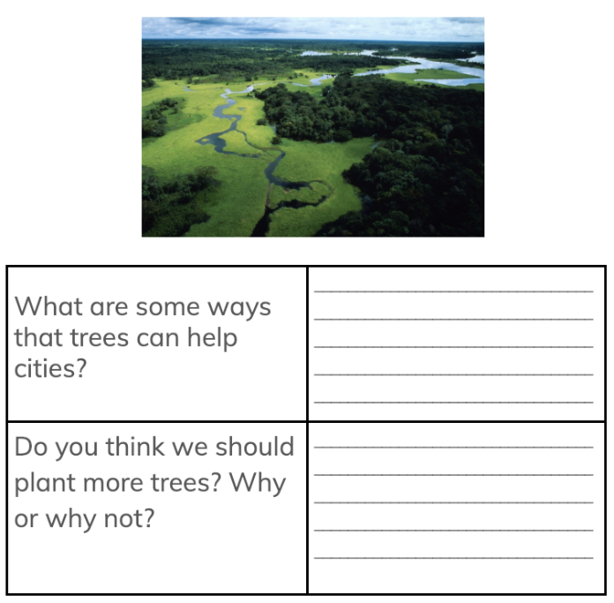

Lesson 1 Reading: Carbon Sequestration that is part of the Lesson 1 student sheets

Essential Question: Can Lawrence reverse the effects of carbon emissions from cars by planting trees?

Global climate change is accelerating at an alarming rate. Scientists are worried that if we do not make a dramatic change in energy usage, climates worldwide will change and have devastating impacts on ecosystems and human populations. According to the Global Carbon Project, the United States is the #2 (preceded by China) contributor to carbon emissions and other greenhouse gases. Many cities across the united states are searching for ways to offset their carbon emissions, many of which are turning to tree planting. Additionally, municipalities are taking into account that there are other socioeconomic benefits to planting trees such as reducing temperatures in heat islands, absorbing excess water in flood plains, and increasing the socioemotional health of citizens.

Carbon sequestration is the rate at which a tree absorbs atmospheric carbon per year. In contrast, carbon storage is the amount of biomass a tree has stored at the present moment.
One city that is pioneering this concept is Lawrence, MA. It is a small city composed of approximately 80,162 people (U.S. Consensus). Groundwork Lawrence is a nonprofit organization whose mission is to bring about the sustained regeneration, improvement and management of the physical environment by developing community-based partnerships which empower people, businesses and organizations to promote environmental, economic, and social well-being. One program they manage is called Green Streets or Calles Verdes.
In 2016, with support from the Massachusetts Executive Office of Energy and Environmental Affairs, GWL has embarked on a journey to plant 2800 trees in Lawrence over the next three years as a part of their Green Streets program. Since 2016, 1080 trees have been planted in targeted locations including the South Common and Arlington neighborhoods. Planting trees in residential neighborhoods reduces energy bills, absorbs flood water, improves water quality, and reduces runoff and erosion.
Green Streets works to increase vital tree cover in Lawrence. By working with new homeowners who have front or side yards within 20’ feet of a public way, they are able to plant trees that benefit the community and ensure that each tree has a steward. Once qualified, Green Streets participants received free assistance with selecting a tree and a suitable setback location, as well as technical assistance and volunteer support for a no-cost tree. Green Streets participants received bilingual technical information from Groundwork’s certified arborist, including tools and tips for sustainable tree maintenance during a tree’s first three years in the ground.
Although Groundwork Lawrence is planting record-breaking tree plantings in the City of Lawrence, will it be enough to offset the total carbon emissions given off in the City? Will planting more trees in Lawrence increase the carbon sequestration? Tennis Lilly is the project manager of the Groundwork Lawrence Green Streets Program. His responsibilities include managing the greenstreets program by engaging in community outreach to educate and generate citizen interest in private tree plantings. The primary goal of this program is to plant 5 trees per acre in 3 planting zones in the city to combat the urban heat island effect. This amounts to an additional 2800 trees throughout the city! Tennis explains that this program is important to the community because:

This is important for the community because it will reduce the amount of energy consumption, improve air quality, and help combat global climate change. There are two ways to look at benefits of urban tree planting: localized benefits and a regional benefit. The primary target is to have community streets that are heavily lined with trees. This will have a tremendous impact on environmental conditions in these areas of the city. We are part of the “Greening the Gateway Cities Program”, which is a statewide grant program that supports tree planting in gateway cities. If all cities across the region participate in this program, we significantly increase the carbon sequestration for the region as well as reduce new greenhouse gas emissions by reducing energy consumption by cooling the city on a neighborhood scale.
Tennis Lilly
Project Manager, Groundwork Lawrence

Although climate change scientists agree that planting trees alone would not solve the global carbon emissions crisis, they do serve an important role in carbon sequestration. Given what you have learned about the process of carbon sequestration and the relationship of CO₂ and photosynthesis, provide evidence that supports or rejects that planting trees is a wise investment for a city, such as Lawrence, MA. Do you agree or disagree that trees can contribute to the removal of carbon dioxide at a local level, such as in your own city? Why or why not. Use evidence from the graph and text.
Questions:
- What is the difference between carbon sequestration and carbon storage?

- According to the reading, what are some of the benefits of tree planting?

- What are cities across the USA doing to offset the amount of carbon emission?

- Explain why carbon sequestration helps to offset carbon emissions?

- Predict what will happen when Groundwork Lawrence plants all 2800 trees.

Lesson 1- Support
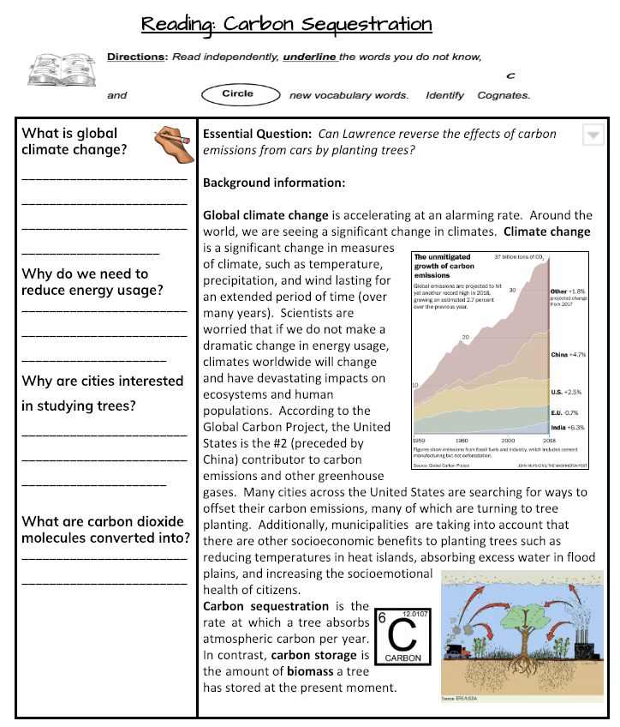

Lesson 1

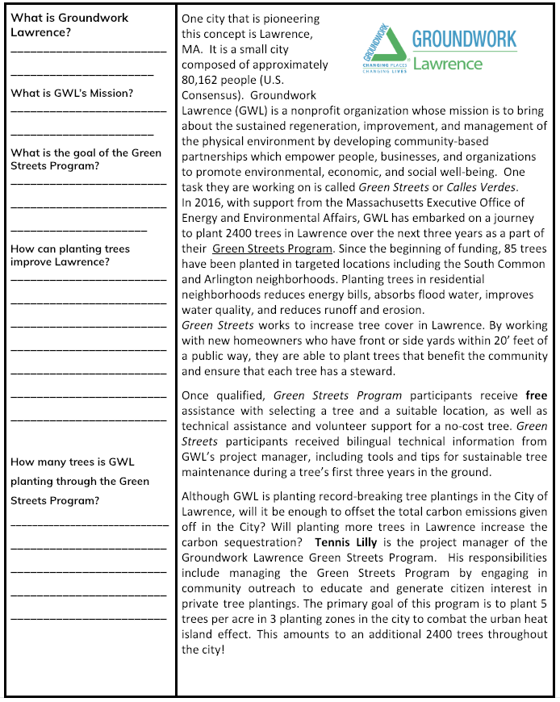

Lesson 1
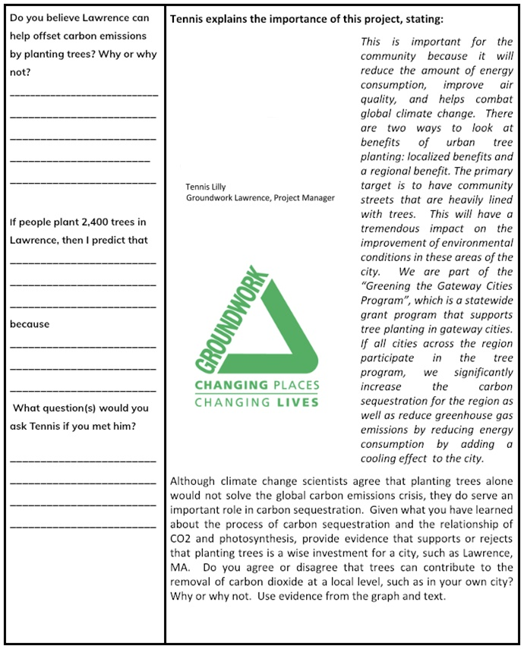

Name: __________________________________ Date: ________________

Lesson 1
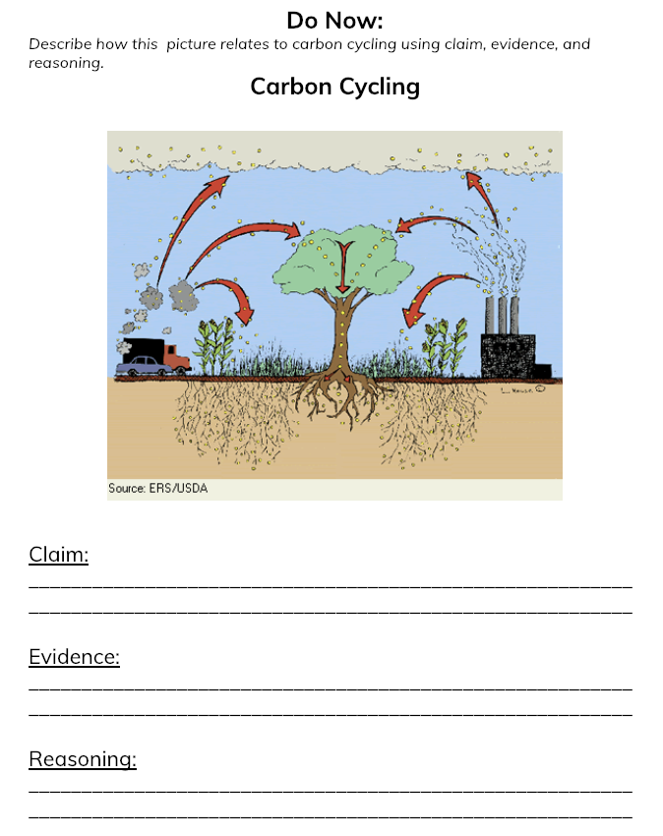

Lesson 1 Support
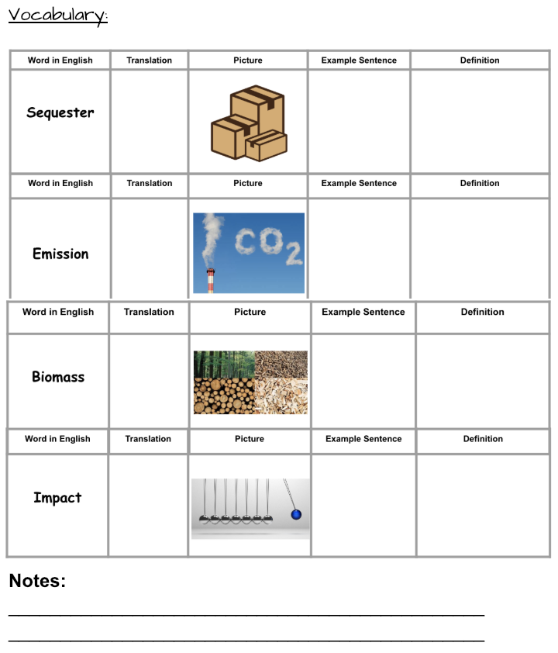

Lesson 1

Name: __________________________________ Date: ________________

Lesson 2- Do Now
How do these infographics relate to what we talked about yesterday?

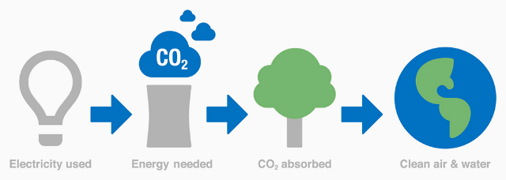
Notes:

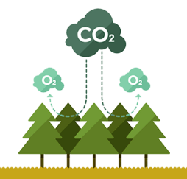

Notes:

Lesson 2
Carbon Sequestration of Trees in Urban Cities Across the Country
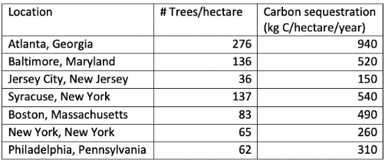
Graph your data results for #Trees/hectare vs. carbon sequestration. Include a title, and label X and Y-axes. Trace a best fit line.

Lesson 2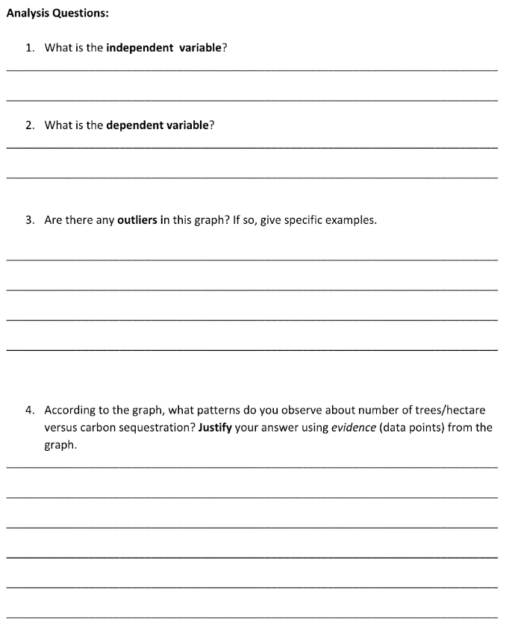

Lesson 2

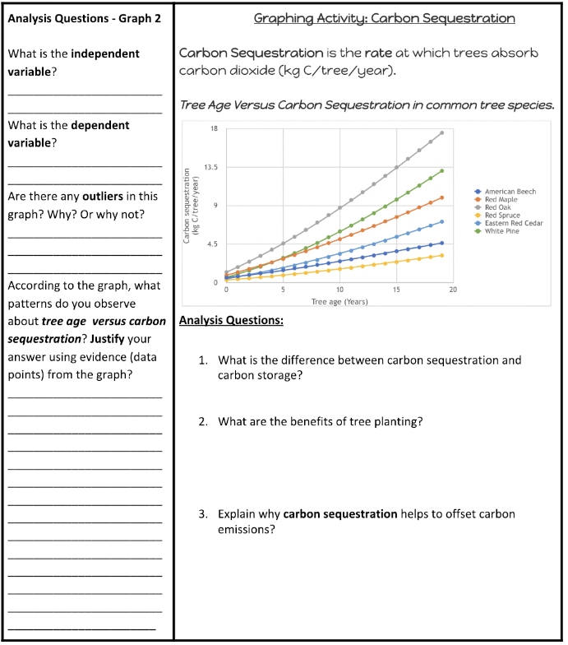

Lesson 2 Support
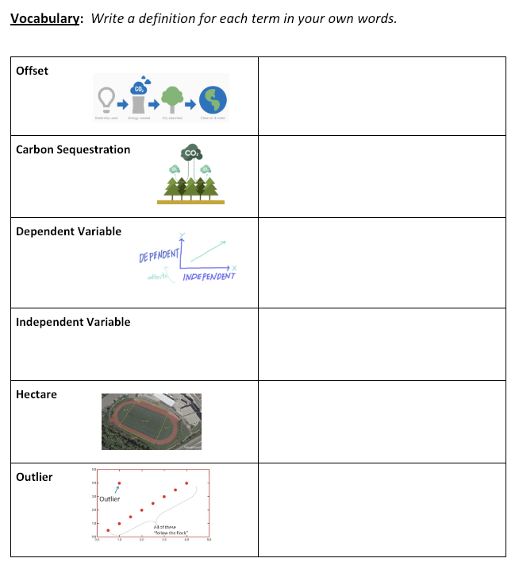

Lesson 2
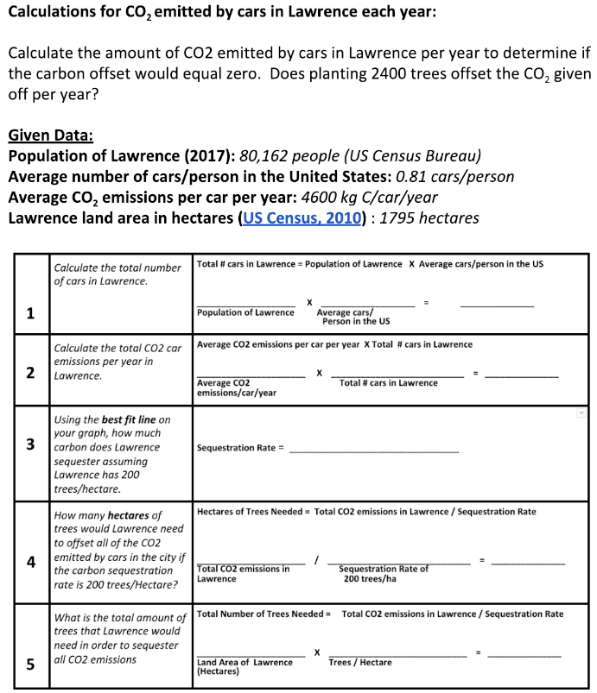

Lesson 2 Support Optional:
Graphic Organizer for Data
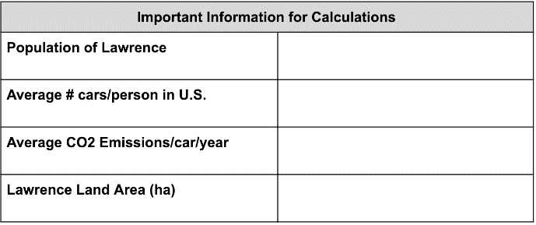

Lesson 2: Note: Graph Paper Needed or Spreadsheet

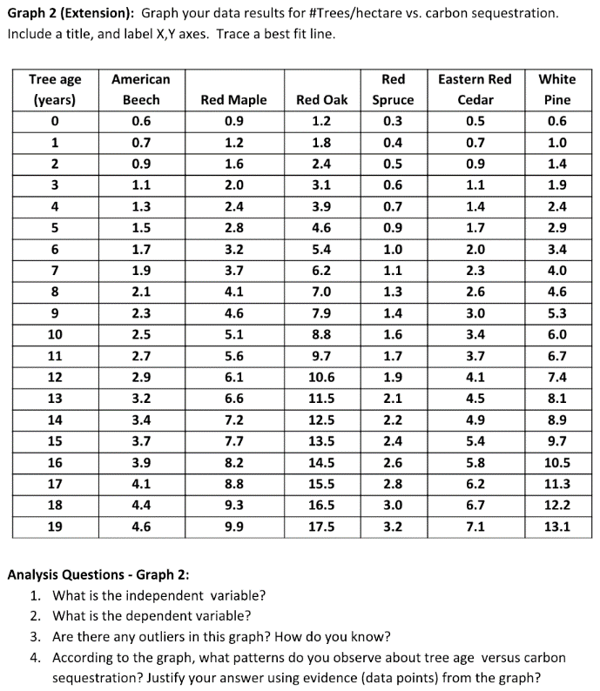

Lesson 2
Name: __________________________________ Date: ________________

Carbon Sequestration Rates: 6 Common Massachusetts Tree Species

Directions: This data set has 6 common tree species in MA which have different carbon sequestration rates (growth rates). Graph your data results for #Trees/hectare vs. carbon sequestration. Include a title, and label X- and Y-axes. Trace a best fit line.

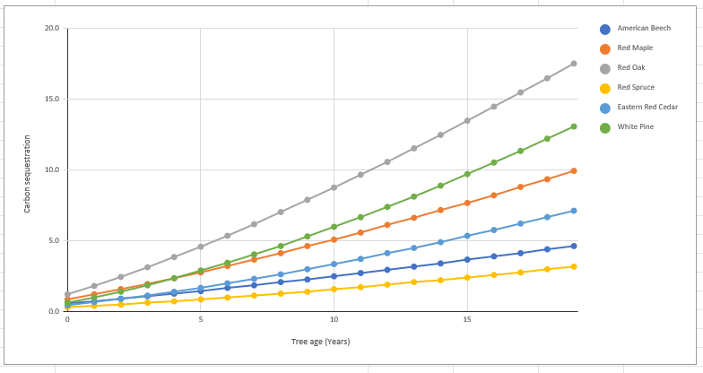

- What is the independent variable?

- What is the dependable variable?

- Are there any outliers in this graph? How do you know? If so, what do they represent?

- According to the graph, what patterns do you observe about tree age versus carbon sequestration? Justify your answer using evidence (data points) from the graph?

Lesson 2
Name: __________________________________ Date: ________________

Lesson 3- Do Now

Name: __________________________________ Date: ________________

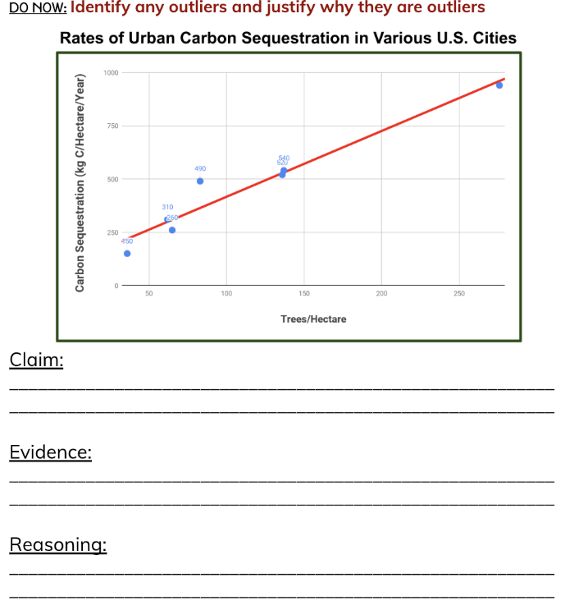

Lesson 3
Name: __________________________________ Date: ________________

Argument Response (CER) - Final Draft

Directions: Compose an evidence-based argument for the following question. Be sure to reference your graphic organizer and data from your calculations.

- Can Lawrence offset the current carbon emissions from cars by planting 2,400 trees? Why or why not?
- Propose how Lawrence could increase the amount of carbon sequestered by planting trees? (Hint: consider the various data provided, your formulas, and calculations.)
_____________________________________________________________________________________________________________________________________________________________________________________________________________________________
________________________________________________________________________________________________________________________________________________________________________________________________________________________________________________________________________________________________________
________________________________________________________________________________________________________________________________________________________________________________________________________________________________________________________________________________________________________
______________________________________________________________________________________________________________________________________________________________________________________________________________________________

Lesson 3
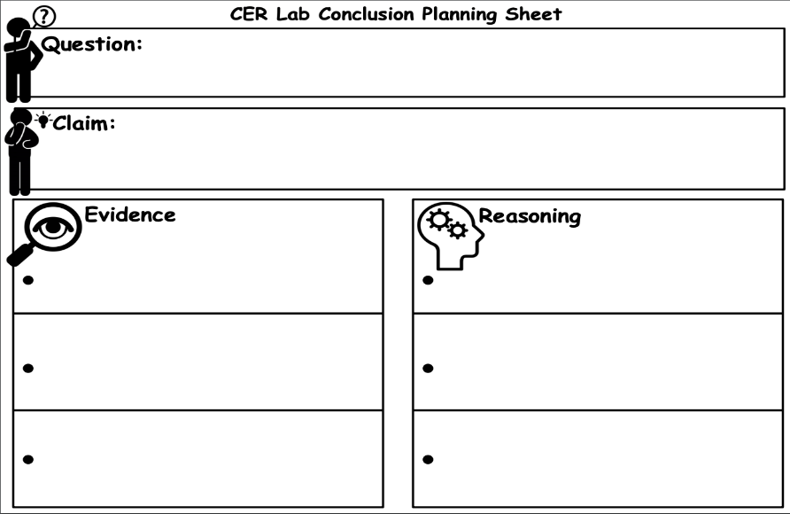
Lesson 3
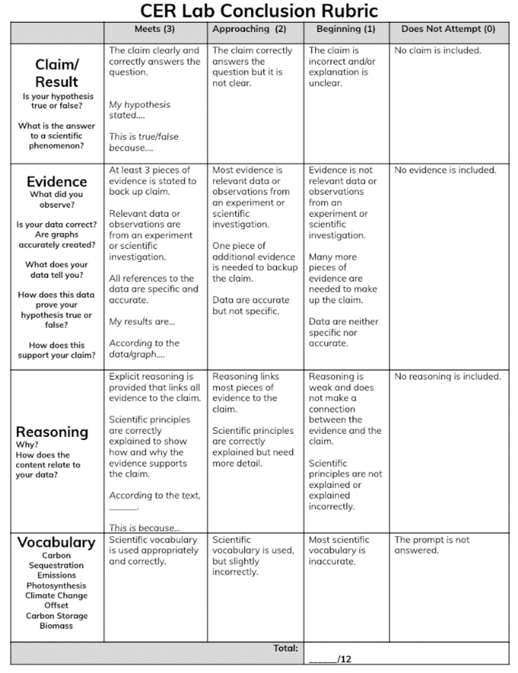

ANSWER KEY for Calculations (Lesson 3)
