Task-level Phenomena: In this lesson, the specific phenomenon is the coat color of Labrador Retrievers as an example of epistasis in this task.

Synopsis of high-quality task:
Students are tasked by a breeder of Labrador Retriever puppies to identify which color Labrador Retriever she should cross with her black lab with genotype BbEe, in order to have the highest percentage outcome of yellow Labrador Retriever puppies with brown noses. Students present their recommendations to the breeder.

This lesson should come after students have a strong understanding of dihybrid crosses and 16 box Punnett Squares. Students will apply their understanding of dihybrid crosses to the interaction of genes and the masking of one gene by another. This task will be limited to the understanding of dominant and recessive alleles.

The goal is to introduce epistasis and how one gene can interact to “turn on” or “turn off” another gene. Following this task, would be a larger lesson of gene regulation and expression, including instruction on polygenic traits, incomplete dominance, and codominance.

Anticipated student time spent on task: Two 50-minute class periods

Type of Task:
___ 1. Investigation/experimentation/design challenge
___ 2. Data representation, analysis, and interpretation
_X_ 3. Explanation

Student task structure(s): Individual and partner work
STE Standards and Science and Engineering Practices:
Standard:
HS-LS3-3. Apply concepts of probability to represent possible genotype and phenotype combinations in offspring caused by different types of Mendelian inheritance patterns.
Clarification Statements:
- Representations can include Punnett squares, diagrams, pedigree charts, and simulations. Inheritance patterns include dominant-recessive, codominance, incomplete dominance, and sex-linked.

Science and Engineering Practice:
- Constructing explanations
Prior Knowledge:
Previous Standard from Strand Map:
8.MS-LS3-3. Communicate through writing and in diagrams that chromosomes contain many distinct genes and that each gene holds the instructions for the production of specific proteins, which in turn affects the traits of an individual.

HS-LS1-1. Construct a model of transcription and translation to explain the roles of DNA and RNA that code for proteins that regulate and carry out essential functions of life.
Clarification Statements:
- Proteins that regulate and carry out essential functions of life include enzymes (which speed up chemical reactions), structural proteins (which provide structure and enable movement), and hormones and receptors (which send and receive signals).
- The model should show the double-stranded structure of DNA, including genes as part of DNA’s transcribed strand, with complementary bases on the non-transcribed strand.

8.MS.LS1-5. Construct an argument based on evidence for how environmental and genetic factors influence the growth of organisms.
Clarification Statements:
- Examples of environmental conditions could include availability of food, light, space, and water.
- Examples of genetic factors could include the genes responsible for size differences in different breeds of dogs, such as Great Danes and Chihuahuas.
- Examples of environmental factors could include drought decreasing plant growth, fertilizer increasing plant growth, and fish growing larger in large ponds than they do in small ponds.
- Examples of both genetic and environmental factors could include different varieties of plants growing at different rates in different conditions.
Connections to the real-world:
- Understanding genetics and inheritance in breeding animals.
- Connection to human traits which interact with one another to suppress or “turn off” a gene causing (i.e. red hair).
Mastery Goals:
Learning Objective(s):
- Evaluate genetic information to predict ideal phenotypic outcomes.
- Describe the effects of epistasis.

Performance Objective:
- Create a report for a potential breeder who has tasked them with determining the ideal genetic make-up of dogs for mating.

Language Objective:
- Describe in writing the effects of epistasis on phenotypic outcomes.

Teacher instructions
Instructional Tips/Strategies/Suggestions:

Day 1:
Observations (15 min)
- Show students pictures of different colored Labrador retrievers. Ask them to independently write down their observations and questions (question 1). Students share their observations and questions in small groups.
- Present the Labrador Retriever (question 2) from the worksheet. Students answer the question and share their reasoning.
- Record observations/questions/predictions on the board.

Gathering Data: (20 min)
- In small groups, students work on the cattle problem (question 3) and share their reasoning. Tip: Be sure to remind students of the 9:3:3:1 ratio of phenotypes.
- On the board, use the following example to explain epistasis. Tip: have students record the definition for epistasis into their notes, as well as copying down the following chart.
Epistasis: when one gene locus masks or modifies the phenotype of a second gene locus
B = Black, b = Chocolate E = Express Color, e - Block Color Expression
Dihybrid Cross - BbEe x BbEe Black - 9; Choco - 3; Yellow - 4

 | BE | Be | bE | be
BE | BBEE - Black | BBEe - Black | BbEE - Black | BbEe - Black
Be | BBEe - Black | BBee - Yellow | BbEe - Black | Bbee - Yellow
bE | BbEE - Black | BbEe - Black | bbEE - Choco | bbEe - Choco
be | BbEe - Black | Bbee - Yellow | bbEe - Choco | bbee - Yellow

- Play the following video after you have explained the Punnett Square above: https://www.youtube.com/watch?v=M5IveTJRYyI
- Ask the class what color noses will the yellow labs in the Punnett Square above have and why?
  - Look for answers such as:
    - BBee - Yellow - black nose
    - Bbee - Yellow - black nose
    - Bbee - Yellow - black nose
    - bbee - Yellow - brown nose
    - They were supposed to have black fur, so they will have a black nose.
    - They were supposed to have chocolate fur, so they will have a brown nose.
    - The fur color is masked by the gene (ee), but not the nose color.

Partner Work: (15 min)
- Refer back to the original pictures and the students’ questions.
- Handout the breeder task to the class. Review the task at the top of the assignment page. Tell students that their final assignment is to write a report for the breeder.
- Ask for clarifying questions and then set partners to work. Tip: Ensure students are trying all possible combinations of crosses to be sure they select the highest percentage outcome.

Day 2:
Partner Work: (35 min)
- Students rejoin their groups from last class and work on finalizing the Breeder Report.
- Students share their reports with the whole class after the 35 minutes of work time.

Share out: (15 min)
- Each group should share their Breeder Report with the class. Reading the “Recommendation” and the “Rationale” to the class. Encourage students to ask questions of each other.
- Students then turn in the Breeder Report. Reports can be assessed using the rubric. Tip: Edit the rubric based on your grading policy and whether this is a formative or summative assignment.
Instructional Materials/Resources/Tools:
- Student worksheet
- Student directions for completing the task
- Scoring Rubric
Task Source:
Miko, I. (2008) Epistasis: Gene interaction and phenotype effects. Nature Education 1(1):197 https://www.nature.com/scitable/topicpage/epistasis-gene-interaction-and-phenotype-effects-460

Massachusetts Comprehensive Assessment System, MCAS Question Search http://www.doe.mass.edu/mcas/search/
- 2018 February Biology, Biology - High School Question 24: Multiple-Choice
- 2018 Spring Release, Biology - High School Question 19: Multiple-Choice

YouTube: https://www.youtube.com/watch?v=M5IveTJRYyI
Epistasis in Inheritance in Labrador Retriever Coat Color - Jahn Walter
Accessibility and Supports:
- Provide a word wall for words such as epistasis and the dihybrid.

Lesson 1:
Student Name: _______________________________ Period: ________

  - Write down observations and questions you have about the pictures of the Labrador Retrievers.
  - Complete the question below (circle your answer):
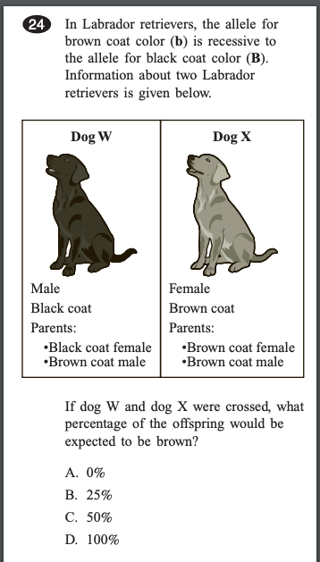
Reasoning: How did you come to your conclusion?

3. Complete the dihybrid cross problem below:
In cattle, the allele for no horns (P) is dominant to the allele for horns (p). The allele for cloven hooves (C) is dominant to the allele for mule feet (c). Cattle that are heterozygous for these traits are crossed (PpCc x PpCc). What is the probability that an offspring will have the same phenotype as the parents?

Answer: ___________________

Note: This worksheet changed after field testing.
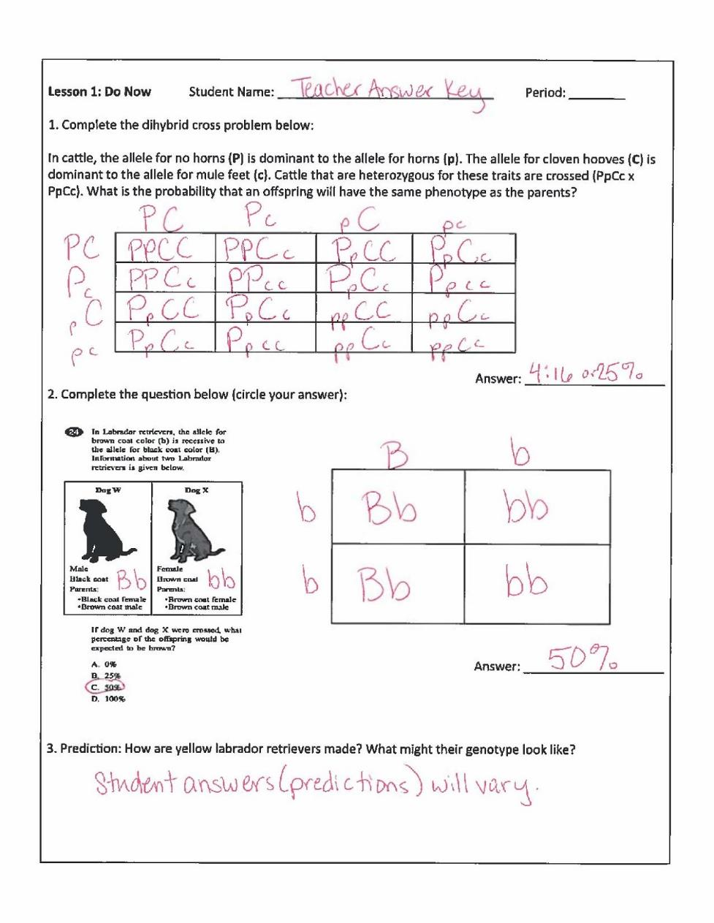

Student Name: _______________________________ Period: ________

Breeder Report

Challenge: You are asked by a breeder of Labrador Retriever puppies to identify which color Labrador Retriever she should cross with her black lab with genotype BbEe, in order to have the highest percentage outcome of yellow Labrador Retriever puppies with brown noses. Your job is to explain to the breeder the genetic implications of a yellow Labrador Retriever, including information on epistasis in a formal report to the breeder.

Assignment: Use the workspace below to test various combinations of genetic crosses in order to identify the highest percentage outcome for yellow dogs with brown noses. Use the back side of this paper to write your Recommendation and Rationale for the breeder. You and your partner will share out your Recommendation and Rationale with the whole class. Be sure to take a look at the rubric on the back.

What is the breeder’s black dog’s genotype? ______________

What genotype is she trying to achieve? _______________

Workspace (attach additional work on separate paper if needed):

Turn over →

Recommendation:
________________________________________________________________________________________________________________________________________________________________________________________________________________________________________________________________________________________________________________________________________________________________________________________________________________________________________________________________________________________________________________________________________________________________________________________________________________________________________________________________________________________________________________________________________________________________________________________________________________________

Rationale (why that particular genotype, why not others?):
________________________________________________________________________________________________________________________________________________________________________________________________________________________________________________________________________________________________________________________________________________________________________________________________________________________________________________________________________________________________________________________________________________________________________________________________________________________________________________________________________________________________________________________________________________________________________________________________________________________________________________________________________________________________________________________________________________________________________________________________________________________________________________________________________________________________________________________________________________________________________________________________________________________________________________________________________________________________________________________________________________________________________________________________________________________________________________________________

Rubric (to be completed by teacher):
 | 4 | 3 | 2 | 1
Content | Skillfully supports information with substantial and relevant evidence | Accurately develops parts of the topic with relevant information from sources | Uses some facts and details but there may not be enough, or some are irrelevant | Uses too few, inappropriate, or irrelevant facts and details
Constructing Explanations | Is unique and cohesive with a very convincing argument | Is well crafted and convincing | Is mostly well crafted and convincing | Not well crafted and several elements do not fit together
Presentation Skills | Speaks clearly, loudly, and formally | Speaks clearly and loud enough for the audience to hear | Speaks clearly most of the time and loud enough to hear | Mumbles or speaks too quickly or slowly

Sample Student Work: