Task Level phenomena:
Students observe pictures of salt trucks in winter, salt road signs, and dead vegetation on the sides of roads and wonder what the connection is between the road salt and dead plants.

Synopsis of high-quality task:
This activity is designed to use the phenomena of the dead vegetation to help students develop a stronger understanding of the process of osmosis, how it affects cell structure and function, and how this then affects living things which are made of cells. It will also help to make connections between human impacts and ecosystem health by connecting our salt use with the death and/or damage to plant life.

Anticipated student time spent on task: two 55 minute periods (the lab set up on the first day needs to run overnight)

Type of Task (check one):
____ 1. Investigation/experimentation/design challenge
X 2. Data representation, analysis, and interpretation
____ 3. Explanation

Student task structure(s): Partner/group work during investigation, individual work for final writing task.

STE Standards and Science and Engineering Practices:
HS-LS1-3. Provide evidence that homeostasis maintains internal body conditions through both body-wide feedback mechanisms and small-scale cellular processes.
Clarification Statements:
- Feedback mechanisms include the promotion of a stimulus through positive feedback (e.g. injured tissues releasing chemicals in blood that activate platelets to facilitate blood clotting), and the inhibition of stimulus through negative feedback (e.g. insulin reducing high blood glucose to normal levels).
- Cellular processes include (a) passive transport and active transport of materials across the cell membrane to maintain specific concentrations of water and other nutrients into the cell and (b) the role of lysosomes in recycling wastes, macromolecules, and cell parts into monomers.

HS-LS2-7. Analyze direct and indirect effects of human activities on biodiversity and ecosystem health, specifically habitat fragmentation, introduction of non-native or invasive species, overharvesting, pollution, and climate change. Evaluate and refine a solution for reducing the impacts of human activities on biodiversity and ecosystem health.*
Clarification Statement:
- Examples of solutions can include captive breeding programs, habitat restoration, pollution mitigation, energy conservation, and ecotourism.

Science and Engineering Practice:
- Planning and carrying out investigations
- Constructing explanations and designing solutions

Prior Knowledge:
Previous Standards from Strand Map:
7.MS-LS2-5. Evaluate competing design solutions for protecting an ecosystem. Discuss benefits and limitations of each design.
Clarification statement:
- Examples of design solutions could include water, land, and species protection and the prevention of soil erosion. Examples of design solution constraints include scientific, economic, and social considerations.

8.MS-ESS3-5. Examine and interpret data to describe the role that human activities have played in causing the rise in global temperatures over the past century.
Clarification Statements:
- Examples of human activities include fossil fuel combustion, deforestation, and agricultural activity.
- Examples of evidence can include tables, graphs, and maps of global and regional temperatures; atmospheric levels of gases such as carbon dioxide and methane; and the rates of human activities.

HS-LS1-2. Develop and use a model to illustrate the key functions of animal body systems, including (a) food digestion, nutrient uptake, and transport through the body, (b) exchange of oxygen and carbon dioxide, (c) removal of wastes, and (d) regulation of body processes.
Clarification statement:
- Emphasis is on the primary function of the following body systems (and structures): digestive (mouth, stomach, small intestine [villi], large intestine, pancreas), respiratory (lungs [alveoli], diaphragm), circulatory (heart, veins, arteries, capillaries), excretory (kidneys, liver, skin), and nervous (neurons, brain, spinal cord).

HS-LS2-6. Analyze data to show ecosystems tend to maintain relatively consistent numbers and types of organisms even when small changes in conditions occur but that extreme fluctuations in conditions may result in a new ecosystem. Construct an argument supported by evidence that ecosystems with greater biodiversity tend to have greater resistance to change and resilience.
Clarification Statement:
- Examples of changes in ecosystem conditions could include modest biological or physical changes, such as moderate hunting or a seasonal flood; and extreme changes, such as volcanic eruption, fires, the decline or loss of a keystone species, climate changes, ocean acidification, or sea level rise.
Connections to the real-world:
Students are typically aware of the chemicals (road salts) used to treat snowy and icy roads in the winter in Massachusetts. They may also be aware of dead vegetation (grass, evergreen trees) often found on roadsides in the spring after the application of these road chemicals.
All Massachusetts communities use salt on their road in the winter to help melt ice and make the roads safe. An outcome of this practice is seen in the spring when the grass, plants, and evergreen needles on the sides of roads appear brown. This would indicate that the plants have been damaged or died. Understanding how salt affects plant life through the process of osmosis can help to explain this effect and how salt use can affect local ecosystems. This will also help to explain why there are areas on roads marked as no or low salt zones, typically sensitive environmental areas.
Mastery Goals:

Learning Objective:
- Understand the effects of human impacts on the environment, specifically on plants, and how this impact can change biodiversity.

Performance Objective:
- Setup an experiment to compare the effect of different salt solutions on cells, and communicate outcomes based on evidence in relation to the lab experiment and larger environmental systems.
- Use data from an investigation to construct analysis on effects of deicing salt on plants.

Language Objective:
- Orally communicate initial observations in order to develop written and/or oral questions about what is occurring.
- Read article about salts and plants to identify key ideas.
- Write an explanation about the outcomes of their experiment in a student-chosen RAFT format.

Teacher instructions
Instructional Tips/Strategies/Suggestions:

Students will be using data from an investigation about how plant cells react to salt water (osmosis) to figure out why vegetation on the side of roads in Massachusetts tends to die in the winter and turn brown during spring.

Day 1
Introduce the phenomenon with the pictures for introduction and questions for student discussion:
- Road Truck spreading salt
- Picture of brown grass on roadside

Have students do a Think-Pair-Share-Listen:
- What do you see?
- What is the reason for this occurrence (brown plants)?
- What questions do you have about the picture?

Make a list of student ideas on the board to facilitate classroom discussion. Use additional pictures as prompts to elicit more responses.

Complete the Building Background activity - Smithsonian Article (https://www.smithsonianmag.com/science-nature/what-happens-to-all-the-salt-we-dump-on-the-roads-180948079/). This is a reading about the use of salt on roads and how it affects the environment. It is designed to help give students some background and foundation for their reporting at the end of the activity.

Ask the following questions after the readings:
- Why are road salts used on roads?
- State one way that plants are affected by road salts.
- State one symptom that plants show when they have salt damage.
- State one other environmental impact of salt use on roads

Introduce the experimental question - How can the effects of salt pollution be tested in the classroom?
Students will then prepare salt solutions to test the effects of salt (as used for deicing roads) on plant tissue.

Begin “Osmosis potato lab” (included below) to help answer the following question - How are potato cubes affected by soaking in salt water? Students will go through procedures A & B on day one. Procedure C will be completed on day two.

Procedure A:
Students will prepare three 100ml solutions and record their amounts in the lab data table.
No salt
Low salt concentration (use between 3-5 grams of salt in 100 ml of water)
High salt concentration (use between 20-30 grams of salt in 100 ml of water)

Procedure B:
Students will cut three small cubes from a potato (no skin). In this lab, a small vegetable corer was used to keep diameter constant. These were then sliced into uniform heights - approx 1 - 1.5 mm³
Obtain the mass of each cube, then place into one of the three solutions made in procedure A. Enter original mass of potato cubes into lab data table.
Leave these overnight

Students will then fill out their prediction (on the lab sheet) about what will happen to the potatoes in different solutions.
- As a helpful scaffold for students you can give them guidance on making a prediction. Write on the board that: (1) the prediction needs to be a guess about what they think will happen in the investigation, and should be based on any prior knowledge or experience and (2) we will compare the prediction to the evidence from the lab and try to figure out what we have observed.

Note: In the lab guidelines there are no set amounts for salt or size of the potato cubes. Use your own judgement for how to have students process through the lab as you may want to give them some general guidelines on these or leave as is.
- For shorter class periods it may be helpful to have cut potatoes ready to use.
- For students who need additional rigor, have them develop the experimental criteria - amount of salt to add and size of potato. The results of the experiment with the honors level can then initiate conversation about experimental design and error as the class compares results and discusses how they set up their procedure. Some topics to focus on in follow up classroom discussions:
  - Size of potato - does size affect amount of diffusion that occurred (surface area vs volume ratios can be explored in this discussion)
  - Uniformity in size of potato - how consistent were potato chunks, and how could this affect the rate of osmosis.
  - Difference in amount of salt added - were final weights significantly different, and how does salt concentration affect rate of osmosis

Note: If you need to modify the salt concentrations, make sure there is a significant difference in salt amounts to help generate viable data. You will need a min of 10 grams difference between low and high salt concentration.

Day 2
Complete the Osmosis Potato Lab - obtain the final mass of the potato cubes and fill in the data tables.

Allow students to analyze their data for patterns/trends and lead a class discussion where students:
- Identify how salt water effected their potatoes
- Discuss how that could impact the health of the plant
- Identify trends the data shows (what happened to potatoes with less salty water vs more salty water

Explain to students that their trends match the pattern of osmosis (if they have not made the connection already). [Note: See “Solutions and their effects on cells notes and questions” below in the resources section. This is designed to help them understand concentrations of solute in solvent.] Review with students the movement of water and particles in different solutions: For instance, if you have a cell in a hypertonic, hypotonic, and isotonic solutions diagram how water will move in these instances. See picture in teacher notes on blood cells as an example diagram to share.

Depending on time, and gauging student understanding, the teacher can have the students perform the following activity to help them visualize the movement of particles: Diffusion, Osmosis, and Active Transport (https://learn.concord.org/resources/120/diffusion-osmosis-and-active-transport)

Students will then work on the communication part of this task - RAFT writing activity. Before beginning the formal written work, students should write an outline of the following:
- Observations of experimental results including quantitative (changes in mass of potatoes in different solutions) and qualitative (how the potatoes in different solutions felt, looked)
- Reasoning for results seen in no salt, low salt, and very salty connected to water movement
- Connection to effect on plant life
- Decision on salt use and why - set this up as CER (Claim, Evidence, Reasoning)

The Osmosis Task RAFT handout has student instructions for their writing including what roles they can choose and what format to present it in. It also contains requirements for content.

A great way to have the students present findings, both in an illustration and with writing, is through an Infographic. This format is accessible to all levels of students and allows them a variety of tools and organizational complexity to work with - can be a simple or very involved format. It is also a relevant and often used medium in which our society is presented with information. Infogram is a free web site for designing infographics that can be useful for this task.
Instructional Materials/Resources/Tools:

Articles for classroom reading:
- The Hidden Dangers of Road Salt (https://www.smithsonianmag.com/science-nature/road-salt-can-disrupt-ecosystems-and-endanger-humans)
- What Happens to All the Road Salt We Dump on Roads? (https://www.smithsonianmag.com/science-nature/what-happens-to-all-the-salt-we-dump-on-the-roads-180948079/)
- Diffusion, Osmosis, and Active Transport (https://learn.concord.org/resources/120/diffusion-osmosis-and-active-transport), Concord Consortium, Creative Commons Attribution 4.0 license (https://creativecommons.org/licenses/by/4.0/)

Following materials are included at end of document.
- Pictures for introduction
- “Solutions and their effects on cells” notes and questions
- Osmosis Task RAFT
- Rubric for osmosis RAFT
- Osmosis potato lab

Task Sources:

The Ambassador would like to recognize Fran Pruyn from Silver Lake Regional High School for her contributions to the development of this task.

Accessibility and Supports:

Supports to help differentiate the activity:
Embedded in the teacher instructions are some methods to differentiate this activity given the makeup of a classroom.
- The article, Hidden Dangers of Road Salt, goes into more detail about the impact of salt on ecosystems and can be used with students as a follow up to the task to probe students about impacts beyond vegetation.
- A variety of activities are employed to help students understand the process of osmosis - guided notes and examples, diagrams of solutions and their effects on red blood cells, an online interactive showing particle movement.
- Lab procedure guidelines can start of as highly structured with given quantities for solutions but can also be more open ended and fully student designed.
- The RAFT activity allows students a variety of formats to present their work based on their own interest and abilities.
Extensions to activity
- To challenge students beyond making the connection of salt use and plant death, have them research alternatives to salt use and explain why they may do less harm to vegetation. This information could also be presented to local officials.
- Students could present findings to town officials or invite town officials in to discuss the pros and cons of how the community is using road salt.

Key Academic Vocabulary:
- Osmosis
- Diffusion
- Mixture
- Solvent
- Solute
- Solution
- Percent solution
- Homeostasis

Sample Student Work: 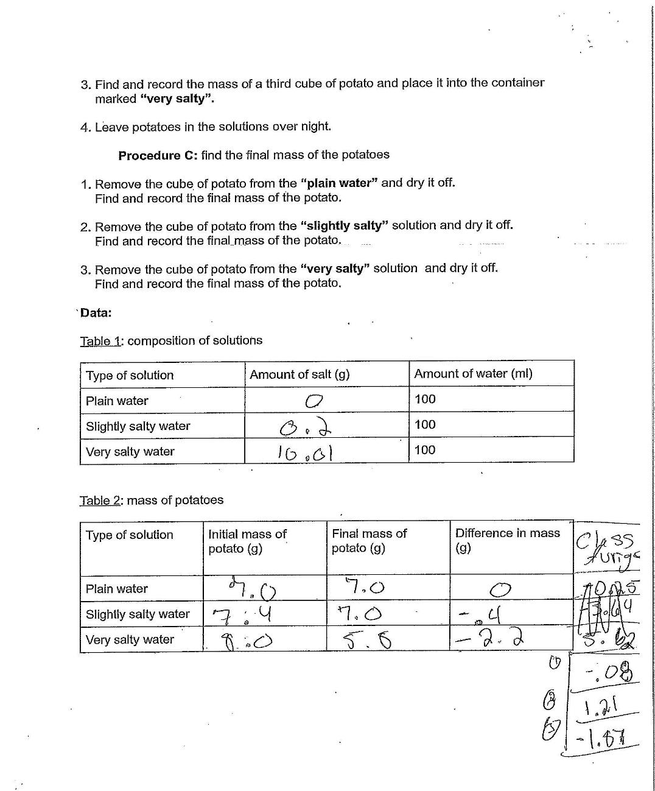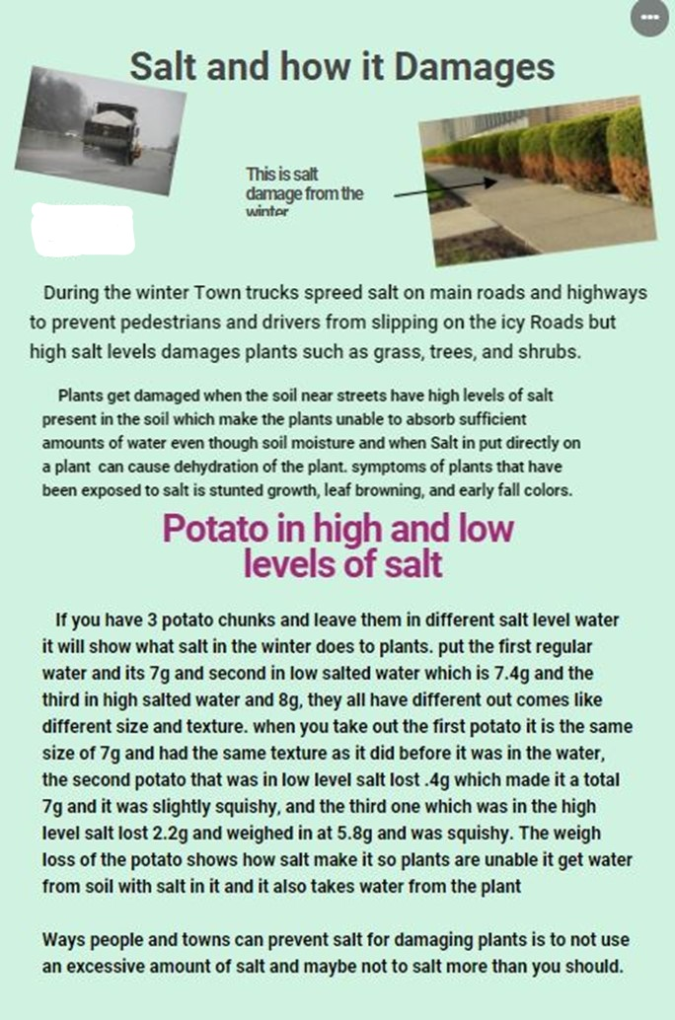

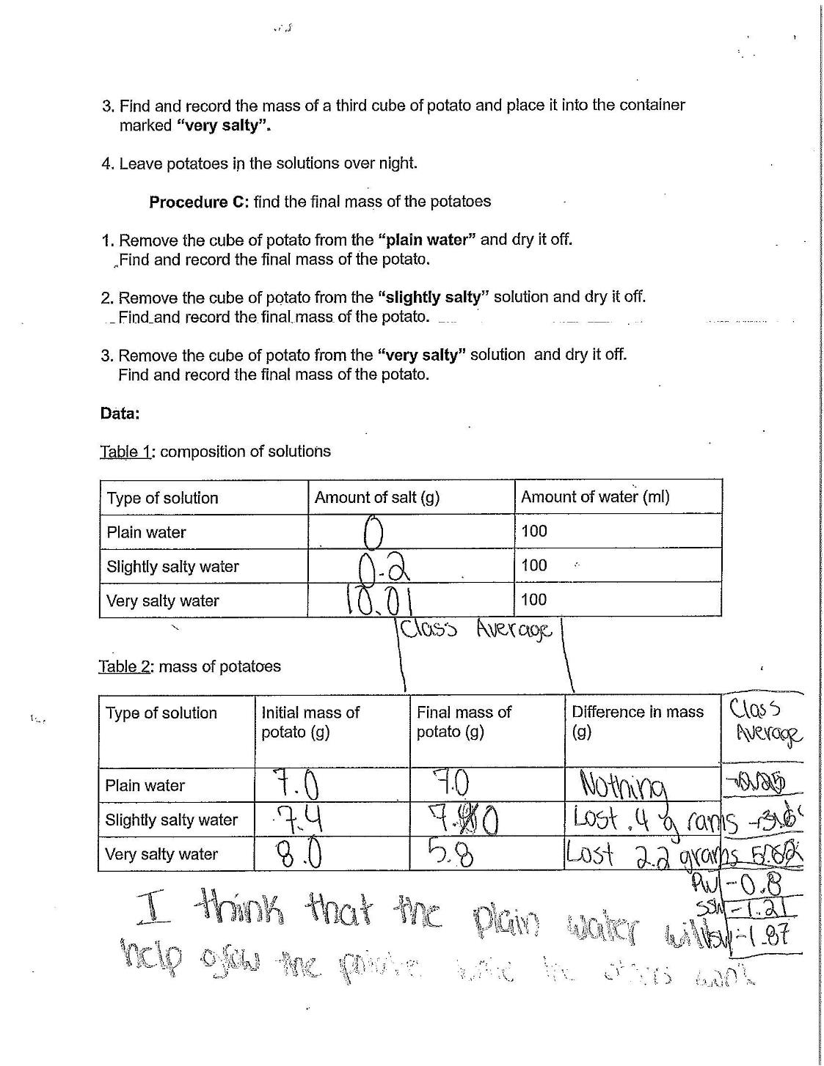
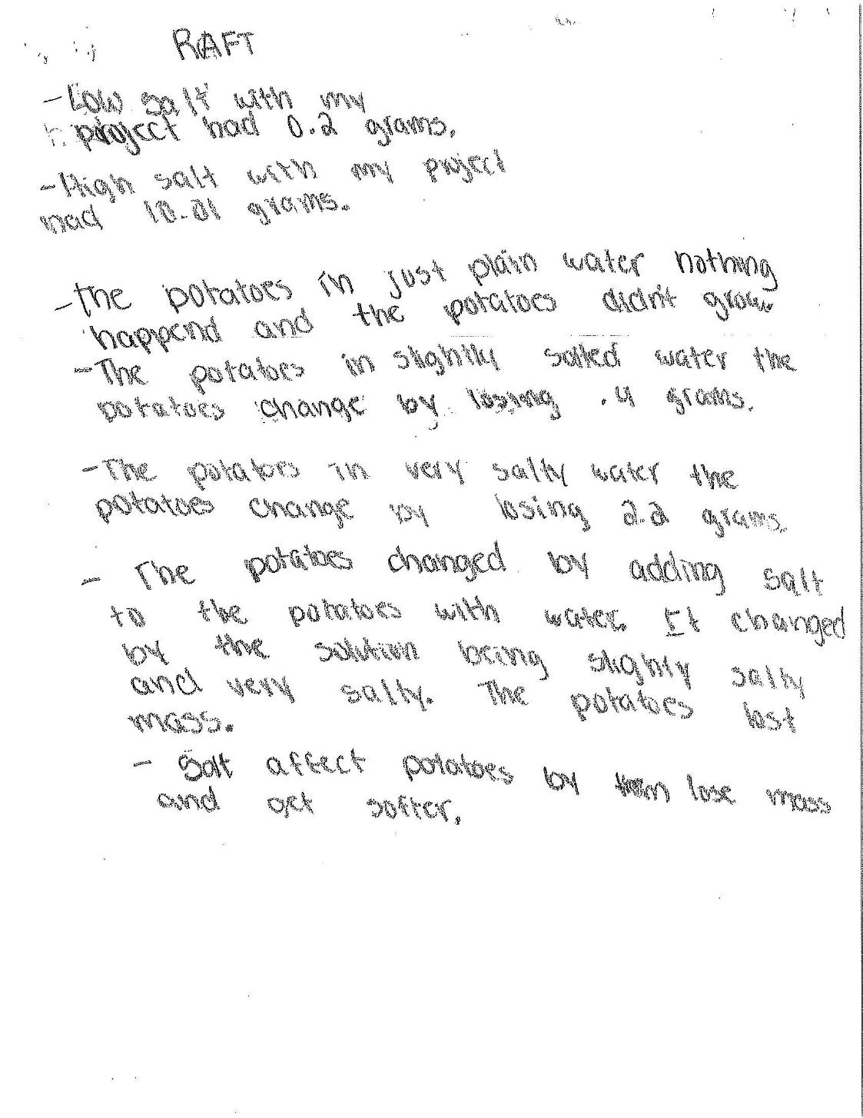
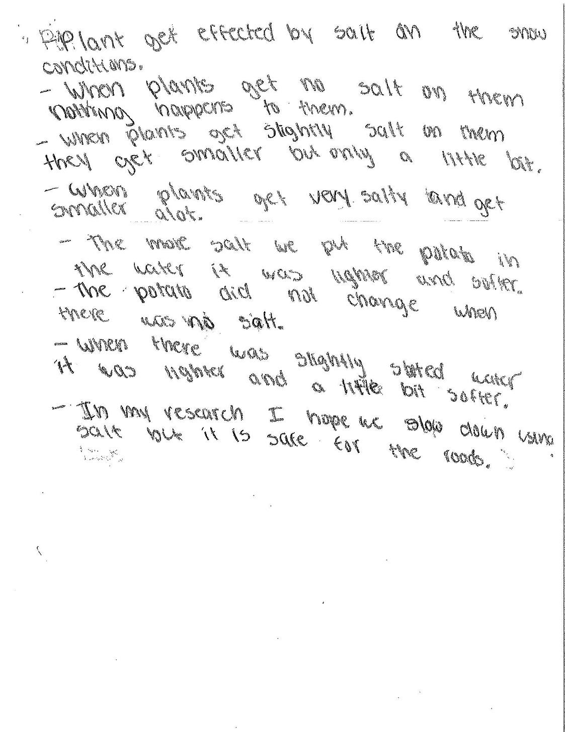

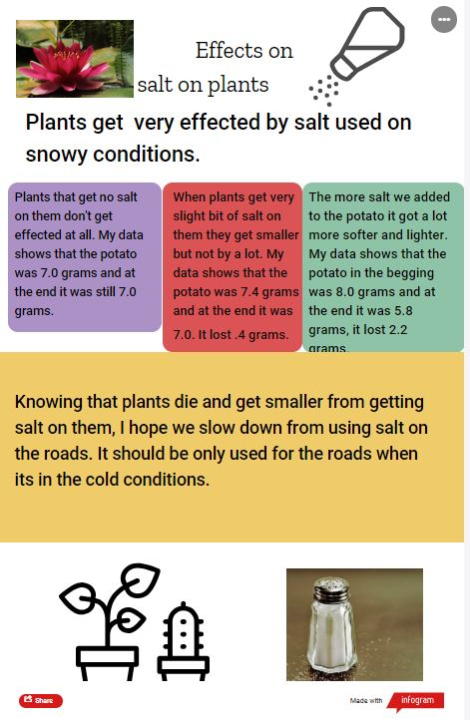

Pictures for introduction

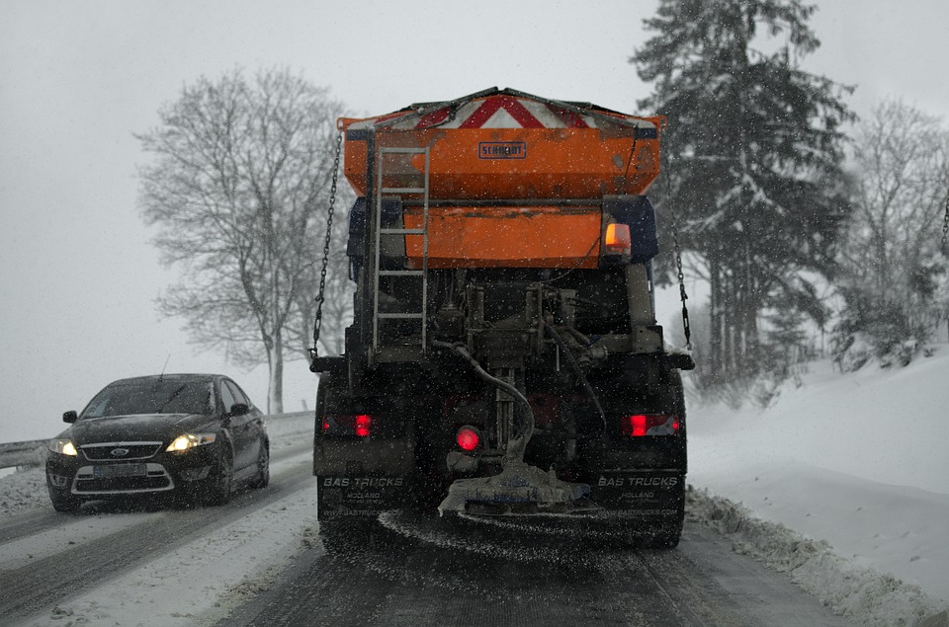

Traffic Image in Blizzard, JerzyGorecki, Pixabay Images, Free for commercial use
No attribution required

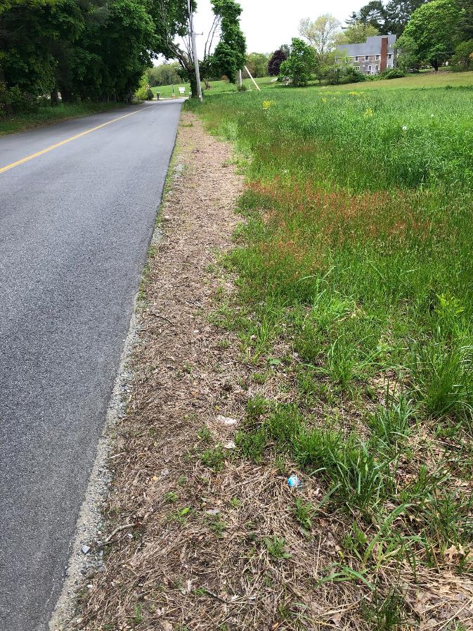

Dead grass on roadside, by Scott Farrell. Permission granted for use by owner, no attribution required.

Structured Performance Task - Potato Lab

Students will prepare salt solutions to test the effects of salt (as used for deicing roads) on plant tissue. Students will prepare data tables to record contents of solutions and results of placing potatoes into these varying salt water solutions.

Question: How are potato cubes affected by soaking in salt water?

Materials:
Potato cubes
Scales
Filter paper/weigh boats
Plastic cups or beakers
3 large graduated cylinders
Salt (NaCl)
Marking pens
Stirring rod
Spoons

Procedure A: Preparation of Solutions

Prepare 3 solutions for soaking potatoes
- The first solution will have no added salt.
  - Add 100 ml of plain water to a container marked “plain water.”

- The second solution should be slightly salty
  - Mass a small amount of salt and record the amount used in the data table
  - Add the salt to 100 ml of plain water in a container marked “slightly salty.”
  - Stir with the stirring rod to dissolve the salt into the water

- The third solution should be very salty
  - Mass a large amount of salt and record the amount used in the data table
  - Add the salt to the 100 ml of water in a container marked “very salty.”
  - Stir with the stirring rod to dissolve the salt into the water.

Procedure B: find the initial mass of potatoes and soak them in salt solutions

- Find and record the mass of a cube of potato and place it into the container marked “plain water.”
- Find and record the mass of a second cube of potato and place it into the container marked “slightly salty.”
- Find and record the mass of a third cube of potato and place it into the container marked “very salty.”
- Leave potatoes in the solutions overnight.

Prediction(s): Make at least one prediction about what will happen to the potatoes in the different solutions

Procedure C: find the final mass of the potatoes

- Remove the cube of potato from the “plain water” and dry it off.
  - Find and record the final mass of the potato

- Remove the cube of potato from the “slightly salty” solution and dry it off
  - Find and record the final mass of the potato

- Remove the cube of potato from the “very salty” solution and dry it off.
  - Find and record the final mass of the potato.

Data Tables

Table 1: composition of solutions
Type of solution | Amount of salt (g) | Amount of water (ml)
Plain Water |  | 100
Slightly salty water |  | 100
Very salty water |  | 100

Table 2: mass of potatoes

Type of solution | Initial mass of potato (g) | Final mass of potato (g) | Difference in mass (g)
Plain Water
Slightly salty water
Very salty water

Comparing Solutions and their Effects on Cells

Vocabulary
Solute | A chemical which is dissolved in a solution; ex: salt, powdered drink mix
Solution | A mixture composed of one substance dissolved in another; ex: salt water, lemonade
Solvent | A chemical which dissolves in another in solution; ex: water

Example of solutions
Solute | + | Solvent | = | Solution
salt | + | water | = | Salt water solution
lemonade powder | + | water | = | Lemonade ready to drink!

The concentration of a solution is based on the percent solute as compared to the percent of solvent/water in the solution. For example, in a low salt solution there is 2% solute/salt and 98% water. In a high salt solution there is 20% solute/salt and 80% solvent/water.

Questions to review:

- Which has a higher percent of solvent/water, a solution with 5% salt or a solution with 10% salt. Explain why.

- Which has more solute, a solution with 5% salt or a solution with 10% salt? Explain why.

- How would you make a salt solution more concentrated?

- If a cell with 2% salt in its cytoplasm (internal solution) is in a solution with 10% salt (external solution), where would there be a higher concentration of water - inside or outside of the cell? Explain why.

- What do you think would happen to the cell described in question 4?

RAFT - Effects of Deicing Salt on Plants
P
Directions:
You will be participating in a R-A-F-T activity to write an analysis of the results of lab on effects of deicing salt on plants. The format will help you understand your role as a writer, the audience you will address, the format you will be writing in and the topic you will be writing about.

R = Role Who you are as a writer?
A = Audience To whom you are writing?
F = Format What form will the writing take?
T = Topic What is the subject?

1. Choose one of the roles from the options below.
2. Everyone will be addressing the same audience.
3. You can choose any format that you like.
4. Everyone will be using the same topic.

RAFT Writing Options

Role | Audience | Format | Topic
Reporter | People at Town Meeting | Letter/Article | Effects of de-icing salts on plants
Environmentalist |  | Poster
Student |  | Slide Presentation

Requirements
Your chosen format must include the following:
- Information on no or low salt vs. high salt
- What happens to plants based on the potato in a no or low salt solutions.
- What happens to plants based on the potato in a high salt solution
- Data from the lab - Include information about the changes the potato underwent in the different solutions.
- Recommendation for salt use based on effects of using deicing salts

Rubric for osmosis RAFT

Task | Points
Lab Day 1:  - Present for activity, full effort shown  - Present for activity, little effort shown  - Not present for activity or no effort shown | 10  5  0
Lab Day 2:  - Present for activity, full effort shown  - Present for activity, little effort shown  - Not present for activity or no effort shown | 10  5  0
Data Table 1 | 12
Data Table 2 | 12
RAFT  - Evidence of knowledge of effects of low salt environment on plants; results of plants in low salt discussed/illustrated and supporting data provided  - Missing discussion/illustrations of results and/or supporting data  - Missing both results and data | 20  10  0
RAFT  - Evidence of knowledge of effects of high salt environment on plants; results of plants in low salt discussed/illustrated and supporting data provided  - Missing discussion/illustrations of results and/or supporting data  - Missing both results and data | 20  10  0
RAFT  - Includes recommendation for salt use based on effects of using deicing salts which is appropriate recommendation based on data  - Recommendation is present but unclear or not appropriate based on data  - No recommendation made | 10  5  0
Presentation  - Organized, clearly resented, appropriate for target audience  - Somewhat lacking in organization or appropriateness for target audience  - Lacking in any organization and no indication of target audience | 6  3  0
Total | /100

