Task Level Phenomenon:
Students watch videos of car crashes with and without seatbelts and other related phenomena, where there is an abrupt stop or start. Please take precaution, as you may have students in your classroom that have experienced accidents or losses from an accident like these.

Synopsis of high-quality task:
This task is part of a three-lesson sequence. This is the second part in the sequence, preceded by Seatbelt Data Analysis, and followed by Seatbelt Prototype Design, which are posted on the STEM Ambassador website. This task is designed to be a follow up activity that expands upon the Seatbelt Data Analysis task, but this Crash Test Investigation task can also be used as a standalone task (see the first bullet point below, as well as the note in the “ENGAGE” section of the lesson plan for guidance).

For this task, students design and carry out an investigation that provides evidence as to why seatbelts are a critical safety component in motor vehicles. Groups present their findings, discussing each step of their design process, the data they choose to collect and why, and relating the results to the science of Newton’s Laws of Motion.

Anticipated student time spent on task: 2-3 sessions (1-2 sessions for investigation; 1 session for creating presentations), 55 minutes each

Type of Task (check one):
_X__ 1. Investigation/experimentation/design challenge
____ 2. Data representation, analysis, and interpretation
____ 3. Explanation

Student task structure(s): group work
STE Standards and Science and Engineering Practices:

Standards:
HS-PS2-1 Analyze data to support the claim that Newton’s second law of motion is a mathematical model describing change in motion (the acceleration) of objects when acted on by a net force.
Clarification Statements:
- Examples of data could include tables or graphs of position or velocity as a function of time for objects subject to a net unbalanced force, such as a falling object, an object rolling down a ramp, and a moving object being pulled by a constant force.
- Forces can include contact forces, including friction, and forces acting at a distance, such as gravity and magnetic forces.
State Assessment Boundary:
- Variable forces are not expected in state assessment.

HS-PS2-10(MA) Use free-body force diagrams, algebraic expressions, and Newton’s laws of motion to predict changes to velocity and acceleration for an object moving in one dimension in various situations.
Clarification Statements:
- Predictions of changes in motion can be made numerically, graphically, and algebraically using basic equations for velocity, constant acceleration, and Newton’s first and second laws.
- Forces can include contact forces, including friction, and forces acting at a distance, such as gravity and magnetic forces.

Science and Engineering Practices:
- Planning and Carrying Out Investigations

Prior Knowledge:
Previous Standards from Strand Map:

7.MS-PS3-1. Construct and interpret data and graphs to describe the relationships among kinetic energy, mass, and speed of an object.
Clarification Statements:
- Examples could include riding a bicycle at different speeds and rolling different sized rocks downhill.
- Consider relationships between kinetic energy vs. mass and kinetic energy vs. speed separate from each other; emphasis is on the difference between the linear and exponential relationships.
State Assessment Boundary:
- Calculation or manipulation of the formula for kinetic energy is not expected in state assessment.

8MS-PS2-2 Provide evidence that the change in an object’s speed depends on the sum of the forces on the
object (the net force) and the mass of the object.
Clarification Statement:
- Emphasis is on balanced (Newton’s first law) and unbalanced forces in a system, qualitative comparisons of forces, mass, and changes in speed (Newton’s second law) in one dimension.
State Assessment Boundaries:
- State assessment will be limited to forces and changes in motion in one dimension in an inertial reference frame and to change in one variable at a time.
- The use of trigonometry is not expected in state assessment.

Considerations for the teacher concerning prior knowledge:
- It cannot be assumed that all students have had experience driving in cars or wearing seatbelts. Especially in the urban environment where travel by subway and buses (which don’t use seatbelts) is common, some students may not be as familiar with seat belt use. Some discussion about seat belts and showing of seatbelts in cars (pictures) may be required.
- Groups are encouraged to use the Claim, Evidence, Reasoning format for their interpretations of data and explanation of results.
- Understanding of qualitative and quantitative data.
- It is helpful if students have some previous knowledge of forces and Newton’s laws.
Connections to the real-world:
- Driver safety and fatalities from car crashes are a reality.
- Seat belts are a real-world device that save lives, yet many students probably have someone they know that refuses to “buckle-up.”
Mastery Goals:

Learning Objective:
- Apply Newton’s 1st Law of Motion to real world phenomenon to demonstrate and explain the importance of seat belts in motor vehicles.

Performance Objective:
- Design and carry out an investigation that provides relevant qualitative and quantitative data on how seat belts increase driver safety during a crash, as well as apply Newton’s Laws of Motion to explain their results.

Language Objective:
- Read and interpret data sets, pictures, and diagrams, and create meaningful visual representations of experimental data, working collaboratively to present relevant findings and conclusions obtained from their investigation.

Teacher instructions/Tips/Strategies/Suggestions:

Introduction:
Note: If you did the Seatbelt Data Analysis task with your students, omit this part of the lesson and use the Phenomenon Extension activity below to launch the lesson.

Phenomenon Videos: Start with a phenomenon based Do Now that will prime students thinking and interest. The instructor can show a car crash with seat belts vs. no seat belts (links included below). Students can write questions they have about the phenomenon videos on poster papers. This provides an opportunity to formatively assess students’ prior knowledge and current misconceptions involve motion and Newton’s Laws. Refer back to these questions throughout the activities.
- Seat belt/no seat belt in the same car - https://www.youtube.com/watch?v=M70yoV2ZizY
- Restrained/unrestrained child in the same car - https://www.youtube.com/watch?v=5RkAIQ6uLxY
- No seat belt/seat belt & airbag - https://www.youtube.com/watch?v=ExLwt-4xnLc

Phenomenon Extension - Show the phenomenon videos linked below. Engage in Think/Pair/Share activity where students can then be asked to describe any similarities and differences, they can think of between the seat belt phenomenon shown and the other phenomena shown. Facilitate a class discussion around students’ observations and questions. Be careful at this early point in the lesson to not give corrections, answers, or information about Newton’s Laws of Motion or forces at this time.
Other phenomena showing Newton’s 1st Law:
- Bike Crash - http://i.imgur.com/3fHBvDd.gif
- Next Level Tablecloth Trick - https://www.youtube.com/watch?v=o94Pm-Cty3M
- Sled Oops - https://static1.squarespace.com/static/56e316c61bbee06d13210ed6/597615d0d482e9419b219cc0/59b546e48fd4d26747fcaa70/1505413031368/sledding+inertia.gif?format=500w

Crash Fatalities/Seat belt usage Graph Analysis (Note: If the instructor has done the Seatbelt Data Analysis task with their class, then this part of the lesson can just be a brief revisit/discussion of the graph and the resulting analysis done previously)
Students should be in groups (recommend no more than 4 students per group). Project the seatbelt data prompt and give out the seatbelt data CER handout.
- Prompt
- Seatbelt Data CER Worksheet

Investigation:
Student groups are to design and carry out an investigation to demonstrate why seat belts are a necessary safety feature for motor vehicles. Emphasize to the groups that the steps they use, the data they choose to collect, and how they organize and present that data is up to them. Designing an investigation can be new to students, and provide scaffolding during this process (e.g., ideas for investigation; crashing into a wall, or creating a ramp out of a board or what could qualify as “quantifiable data”; dent measurements in the clay body, distance the clay body flies off the car, etc.) and a lot of feedback and encouragement about their ideas. Note: The quality of quantifiable data collected, and the experimental design is very dependent upon the level of your students in front of you and their previous experience with designing and carrying out investigations. Teachers can use discretion as to how far to push each group in this regard.

- Crash Investigation Project Design Sheet

The task worksheet should be given to groups as a guide of how to organize their thinking and the required information. However, with more advanced classes that have had more practice with designing investigations, this worksheet/scaffold may not be necessary, and student groups can come up with their own way to organize/collect information about the process used and the results. Alternatively, you may find the opposite true of your classes, in that they may require even more structured graphic organizers to aid in data collection and organization.

The recommended materials are a smaller car or cart with wheels, a piece of cardboard for a ramp, clay to make a model person or object that sits upon the cart, and books or other heavy objects for the cart to crash into, and a paperclip or some magnetic wire for creating a crude seatbelt. If a small car or cart for each group to use is not available an alternative is to make cars out of paper (search paper cars on internet). This will add another level to the task (as well as time involved) but can be a part of the task where students must design their own car to use for the investigation. Note: groups do not necessarily need to create a ramp for the cart to accelerate down. They may choose a different method (pushing the cart, etc.) to put the cart in motion.

Obtain and Evaluate Information:
Groups are to gather information and form an understanding of Newton’s Laws of Motion and their application to their task. Check in frequently with groups to assess the building of an individual’s understanding of Newton’s Laws and their ability to relate it to the assignment. Use of classroom textbooks, as well as some recommended online resources (see links below) can be utilized for this. Once students obtain a basic understanding of forces and Newton’s Laws, and they must then work with their group to apply these understandings to the help explain what occurs with their demonstration and in the real-life situation of a seatbelt in a car crash. Help students keep in mind that this is the goal for their learning- that they must present their findings and explain the science involved.
- Newton’s 1st Law Notes Sheet/Instructions
- Links:
  - https://www.texasgateway.org/resource/newtons-law-inertia
  - https://www.physicsclassroom.com/Physics-Tutorial/Newton-s-Laws
  - https://www.youtube.com/watch?v=PNTLDNxTMdg

Communicate:
Students present their design and data collected related to Newton’s Laws of Motion, in an effort to support the claim “that seatbelts save lives.” The prompt to initiate this is that students are to create a product using Newton’s Laws and Seatbelt Data that will convince people to use seatbelts. Students are given a choice of how they wish to present their findings (poster, slide presentation, video, model, etc.). The rubric should be given to groups and the requirements should be gone over so that students have a complete understanding of what is expected for the presentation. Note: If the teacher incorporated part 1, Seatbelt Data Analysis, groups should be encouraged to also use data from that task as further evidence to support their claim.
- Presentation Evaluation Rubric
- Presentation Notes Handout
Instructional Materials/Resources/Tools:
- Student handouts
  - Prompt
  - Seatbelt Data CER Worksheet
  - Crash Investigation Project Design Sheet
  - Newton’s 1st Law Notes Sheet/Instructions
  - Presentation Evaluation Rubric
- Links for phenomenon videos:
  - https://static1.squarespace.com/static/56e316c61bbee06d13210ed6/597615d0d482e9419b219cc0/59b546e48fd4d26747fcaa70/1505413031368/sledding+inertia.gif?format=500w
  - http://i.imgur.com/3fHBvDd.gif
  - https://www.youtube.com/watch?v=o94Pm-Cty3M

- Links to Newton’s Laws content:
  - https://www.texasgateway.org/resource/newtons-law-inertia
  - https://www.physicsclassroom.com/Physics-Tutorial/Newton-s-Laws
  - https://www.youtube.com/watch?v=PNTLDNxTMdg

- Materials list (per group):
car or cart with wheels, a piece of cardboard for a ramp, clay to make a model person, paperclip or magnetic wire materials that can be used for seatbelt construction

- Scoring rubric

Task Sources:
The Ambassador would like to recognize Stacy-Michelle Reid and Scott Hubeny for their contributions to the development of this task.
Accessibility and Supports:

Students may require support with using the Claims, Evidence, Reasoning format if they have not had practice with it in the past. Use of an anchor chart can help students by giving them a common reference point for this. There are also many detailed CER rubrics on the web; one is included below.

Students should be reminded there is no one “right answer” with such a task and encouraged to explore and try various avenues in pursuit of their goal, knowing it may take a few tries to get a desired outcome.

Some students may need support with deciding what is relevant data to measure and collect, as well as the best way to organize this data for analysis and presenting.

Also, students may need help in understanding that the engineering and design process involves several steps and constant evolution along the way. Remind students that the first way to approach an investigation is not always the optimum way, and constant refinement through assessing results from multiple experiments will be in order.

Word walls and/or glossary for reference can be incorporated to help students remember these key terms.
key academic vocabulary
- Inertia
- Acceleration
- Force
- Unbalanced
- Quantitative
- Qualitative
- Newton’s Laws

Sample Student Work:

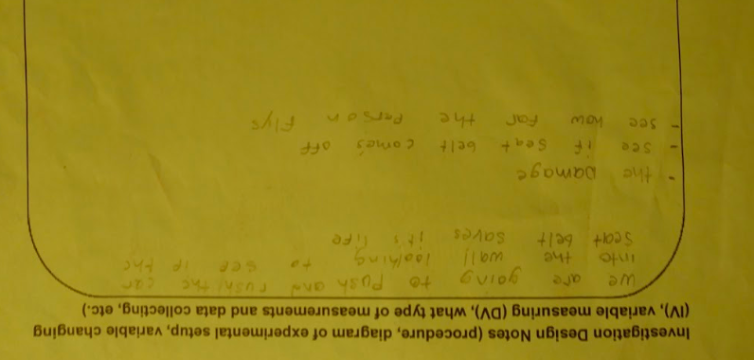

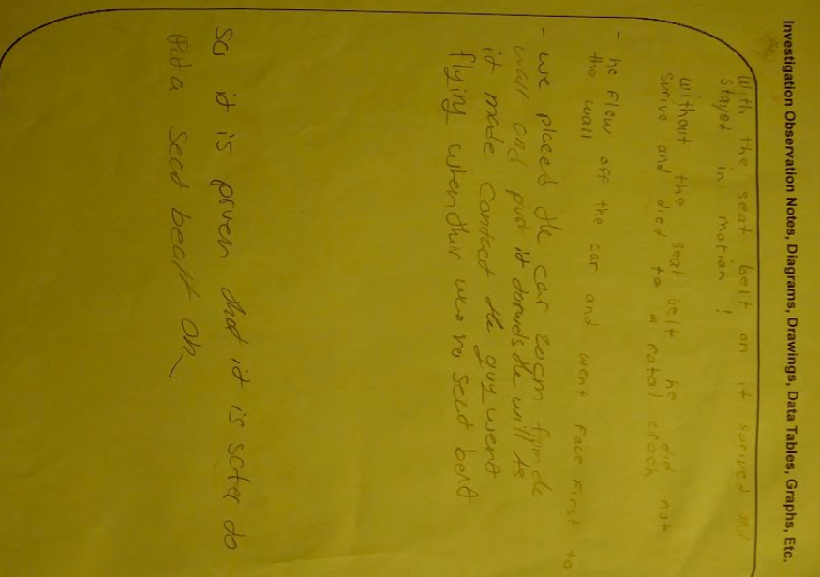
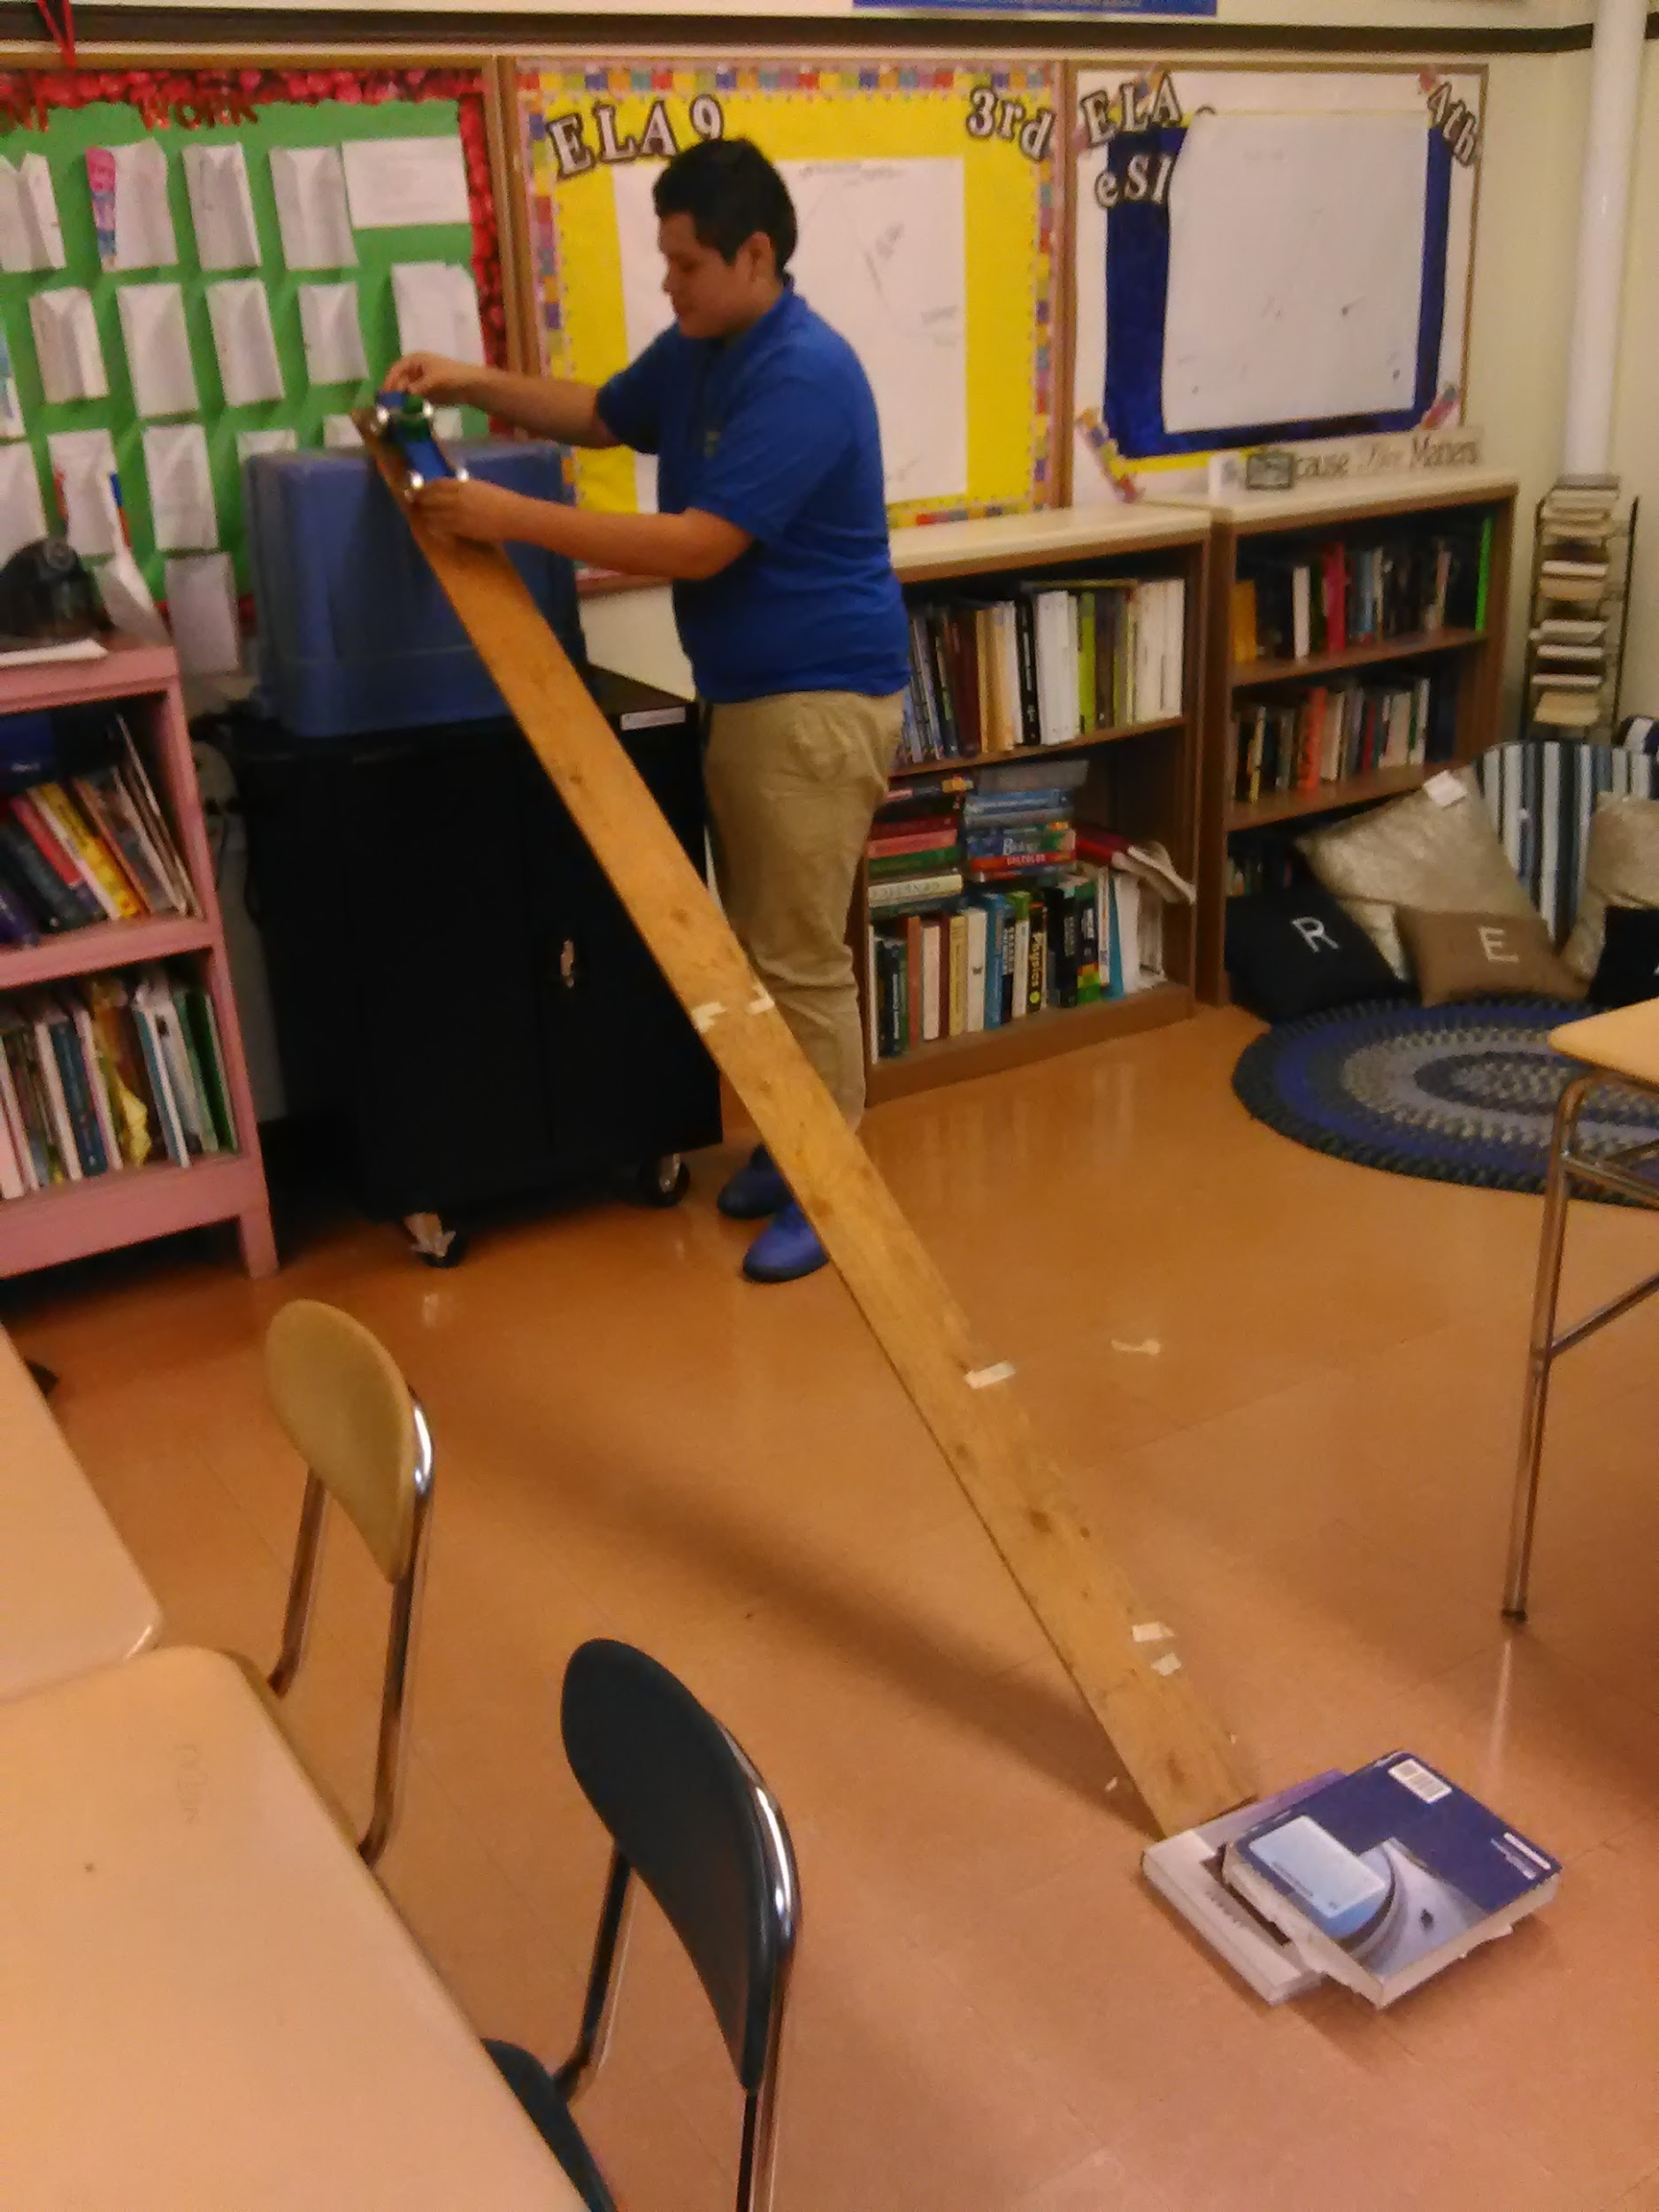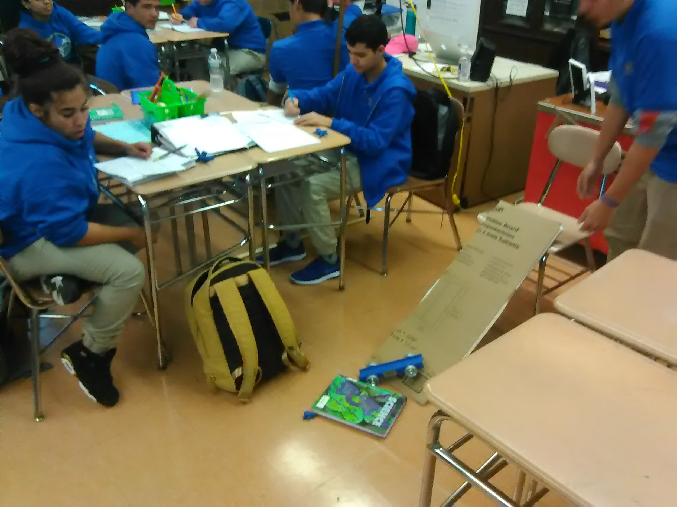

Question: Do seatbelts save lives?

Data:
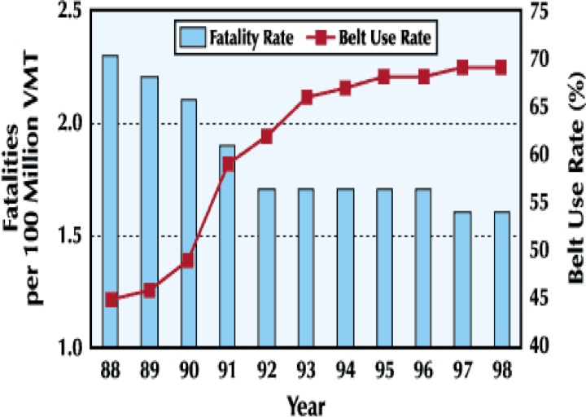

Use the CER format to answer the question!
Claim: One complete sentence that answers the question
Evidence: Specific Data that supports your claim
Reasoning: Explain in detail how the data supports your claim

Seat Belts and Safety C - E - R
Name _______________________________________________________________ Date ______________

The National Association of Motorist Safety (NAMS) strongly believes that seatbelts save lives. They have
sent you some data to support this claim. The data is organized in the graph below:

With your group members, examine the graph, and using relevant information obtained from the graph, evaluate the claim by NAMS that seatbelts save lives. Be sure to provide specific evidence to support your evaluation. You should format your response using the CER (Claims, Evidence, Reasoning) framework and write it on the lined piece of paper. Be prepared to briefly share your group’s evaluation with the class.

Claim: (One sentence that answers the question- Do seat belts save lives?)

Evidence: (specific data from the graph that supports your claim)

Reasoning: (Explain how the data you choose supports your claim)

Crash Investigation Project Design

Group Members Names:_____________________________________________________________

NAMS also requires that your group’s presentation include a demonstration that shows the effectiveness of seatbelt use in preventing driver fatalities. NAMS would like your group to include both qualitative data (observations) as well as quantitative data (measurements) to help prove this claim. Your group must design and create a investigation that demonstrates seat belt effectiveness. Your group will be given a cart, a piece of cardboard for a ramp, clay to make a model person, and a material that can be used for seatbelt construction (paper clip or piece of magnetic wire). The design you use, the data you collect, and how you organize and present that data to the NAMS board is ultimately up to your group. Good luck! You may use the box below for any drawings, notes, data tables, graphs, etc. If you need more room, feel free to use another sheet of paper as well.

Investigation Design Notes (procedure, diagram of experimental setup, variable changing (IV), variable measuring (DV), what type of measurements and data collecting, etc.)

Investigation Observation Notes, Diagrams, Drawings, Data Tables, Graphs, Etc.

Newton’s 1st Law Research/Notes
It is no accident (no pun intended) that NAMS choose your classroom for this task. NAMS is also requiring that the presentations include an explanation of the physics involved. They are particularly interested in how forces and Newton’s Laws of Motion apply to the situation. Your group must gather knowledge about Newton’s Laws of Motion and forces, and detail how they apply in the particular situation of a car crash/seatbelt senario and your group’s demonstration. You may use your textbook, and also consult some of these online resources listed below to gather knowledge about Newton’s Laws.
  - https://www.texasgateway.org/resource/newtons-law-inertia
  - https://www.physicsclassroom.com/Physics-Tutorial/Newton-s-Laws
  - https://www.youtube.com/watch?v=PNTLDNxTMdg

Notes on Newton’s Laws of Motion

Crash Investigation Presentation Notes

It’s now time for the presentations! As part of the NAMS board, you will watch and listen closely to each group’s presentation, using the rubric below to see if they meet the project requirements.

The purpose of your project is to create a product using Newton’s Laws and Seatbelt Data that will convince people to use seatbelts.

This presentation can be:

- A tested prototype with a presentation of the science behind it and the how it will cause people to be more likely to use seatbelts. (Must include some visuals, as well as actual prototype and demonstration)
- A poster (ad campaign, billboard, etc.- be creative!) that uses data from your experiment to convince people to “buckle up”
- A slideshow (google slides) that clearly explains your experiment and the results
- A video or skit that includes science and data and will help change people’s minds about seatbelt use. (to use them more)

Notes:

Rubric:
