Task-level phenomenon:
Students engage in an engineering design challenge around the problem about a business that supplies greeting cards, both custom and mass manufacturing are necessary to meet customers’ needs efficiently and effectively.

Synopsis of high-quality task:
Students expand their understanding of manufacturing to include a comparison of custom and mass manufacturing, while also investigating subsystems of the manufacturing process and how they can adjusted to optimize the system. In pairs and small groups, students fulfill “orders” of greeting cards. Some of these orders require custom manufacturing, while others can be expedited by working in larger groups in a mass manufacturing system. Students use the engineering design process to create and test manufacturing systems, collect data, and refine systems as time allows. Finally, students analyze data (productivity, efficiency, & quality) to reflect on the effectiveness of their systems.

Note: A variety of products can be substituted for greeting cards. Utilizing reusable materials (such as building blocks) decreases consumable costs, while creating something that can be used by students (perhaps for a service project) increases the authenticity of the task.

Anticipated student time spent on task: 3 sessions, 50 minutes each

Type of Task (check one):
__x_ 1. Investigation/experimentation/design challenge
____ 2. Data representation, analysis, and interpretation
____ 3. Explanation

Student task structure(s): Groups of 4-7 students
STE Standards and Science and Engineering Practices:

Standards:
HS-ETS2-3(MA). Compare the costs and benefits of custom versus mass production based on qualities of the desired product, the cost of each unit to produce, and the number of units needed.

Science and Engineering Practice(s):
- Analyzing and interpreting data

Prior Knowledge:
Previous Standard from Strand Map:
HS-ETS2-4(MA). Explain how manufacturing processes transform material properties to meet a
specified purpose or function. Recognize that new materials can be synthesized
through chemical and physical processes that are designed to manipulate material
properties to meet a desired performance condition.
Clarification Statement:
- Examples of material properties can include resistance to force, density, hardness, and elasticity.
Connections to the real-world:
Manufacturing is a critical component of industrialized economies. The creation of goods continues to respond to technological advances. Student understanding of manufacturing processes can improve their ability to make informed decisions as a consumer, appreciation of the economic impact of manufacturing, and lead to interest in careers in manufacturing.
Mastery and Language Goals:

Learning Objective:
- Explain differences between the processes of custom and mass manufacturing, as well as how subsystems affect manufacturing optimization.

Performance Objective:
- Plan, execute, and refine a custom and mass manufacturing task.
- Analyze data collected from these tasks to evaluate the effectiveness of their manufacturing systems.

Language Objective:
- Communicate orally with group members to collaboratively solve a task.
- Explain their analysis of data verbally and in writing.

Teacher Instructions:

Introduction: (15 min)
- Play video of a manufacturing system and ask students to list what they notice (observe) and wonder (have questions) about the video. Suggested videos with many examples of mass manufacturing can be found at How Its’ Made (https://www.sciencechannel.com/tv-shows/how-its-made/).
- Have students discuss their observations with partners and share with class. If questions around custom-made products do not come up, lead the students to ask about the differences. Brainstorm ideas as a class.

Custom vs. Mass Manufacturing (15 min)
- Ask students to research and find their own example of the following (optionally, students can be asked to do this as home-learning before the lesson.)
  - Custom-made product at an online website and record a brief description of the product and the price.
  - Comparable mass-produced product, noting the description and price.
- Have students share the cost of their custom and mass-produced examples on a class chart either virtually or on board/poster. Discuss and record the major comparisons between the custom and mass-produced products. Use the original brainstormed list to compare.
- Optional extension: students calculate an average percent change in price between custom and mass-produced products and discuss the implications of custom and mass-production on price.

Example chart for comparing custom and mass manufacturing:
 | Custom | Mass
Product Cost | Higher | lower
Quality | Higher | Lower (although quality has improved with technological advances)
Efficiency | Lower | Higher
Personalization | Yes | No
Labor cost (per employee) | Higher (more skills needed) | Lower (can learn one assembly line skill)

Custom Manufacturing Simulation: (15-20 min)
- Explain the setting of the simulation: Students are fulfilling orders for custom greeting cards. While the cards have some components that will be the same (e.g., size), other components will be made to order (e.g., color, message, decoration).
- Show students an exemplar card. Have students, in their groups, investigate the exemplar card, and produce one of their own as a model. Allow students to ask clarifying questions about the criteria and constraints of the card construction.
- Working alone, students will make cards according to the order slip that they are given (see card types in the materials below – teachers can make order slips, or have students make as many as possible of each card type). Their goal is to make as many as possible while maintaining accuracy and quality.
- Set a timer for seven minutes while students make cards. Circulate and check finished cards for quality and accuracy. When time is up, unfinished cards do not count toward the total (save these to finish later).
- Ask half of each group to clean up their materials, and the other half to evaluate finished cards for quality and accuracy and count the total of accurate and quality cards produced, and inaccurate or lower quality cards. Given this information, have students calculate their productivity, efficiency, and quality data. If needed, review how to calculate unit rates (efficiency) and how to calculate quality as a percentage of cards made correctly/total cards. Have students share their products.

Mass Manufacturing Simulation: (45-60 min)

- Explain that students will now work in groups of 5-7 to mass manufacture the same exemplar greeting card. Ask what might be different in this process than the previous custom card making process.
- Give groups five minutes to plan their strategy for making cards. Remind students that the goal is to make as many cards as possible while maintaining accuracy and quality. Emphasize that groups will have several attempts and should watch for ways to improve their manufacturing process. Allow students to ask clarifying questions about the criteria and constraints.
- Set a timer for seven minutes as students start making cards. As you circulate, check cards for accuracy and quality.
- At the end of seven minutes, students stop all work and set unused materials aside. Students count the accurate/quality cards and inaccurate/lower quality cards, and calculate and record productivity, efficiency, and quality data.
- Allow groups 5-10 minutes to reflect on their group’s effectiveness, using data as the primary evidence. Students should discuss ways to improve their outcomes by making adjustments to their mass manufacturing process and record their reflections on their previous assembly experience and record their plans for their next trial in their packets.
  - Helpful questions to ask groups that are stuck:
    - How work is being distributed among group members?
    - How could you change the physical layout of the work stations?
    - How could you change the workflow?
  - To show an example of assembly line balancing problems, show the famous I Love Lucy skit where Lucy and Ethel are working on an assembly line can be shown at this point (https://www.youtube.com/watch?v=8NPzLBSBzPI).
- Students now repeat the process of making cards to more times (total three trials). Groups should be using their revised manufacturing plan. The process of recording data, reflecting on effectiveness of the group’s work and revising their manufacturing plan is repeated.
- After three trials, students calculate the average of the trials for each category (productivity, efficiency, and quality).

Analysis (30-40 min)
- After all trials have been completed, students move on to analyzing data and reflecting on how the data might support the main differences between custom and mass manufacturing as discussed previously in the task. Questions in the student materials guide this analysis. Emphasize to students that their analyses should be based on the data that they recorded and their own experiences with the manufacturing process.
- Optionally, students complete a cost analysis using their data to help solidify understanding of the concepts. Students may complete this step individually or in their groups as determined by the teacher. Instructions are found in the student worksheets. This may be used as an extension exercise, or completed as a class for students needing more support.

Instructional Materials/Resources/Tools:
- Student directions
- Scoring rubric

Materials:
- Exemplar products
- Card instructions
- Card Supplies
  - Cardstock
  - Embellishments (paper cutouts, stickers, etc)
- Tools
  - Scissors
  - Glue Sticks
- Videos (see links above)

Instructional Tips/Strategies/Suggestions:

- Cards can be tailored to any specific events/uses. St. Patrick’s Day cards were used in this task for the service club to give to residents of a local nursing home.
- The size of the card, number of tabs, type of embellishments, and several other components of the cards can be changed to meet your needs.
- Cost analysis can be tailored as needed to eliminate labor costs, include delivery/freight charges, and/or marketing costs.
Task Source: The Ambassador would like to recognize Amy Fish for their contributions to the development of this task.
Accessibility and Supports:
Vocabulary:

Tier 2:  Warehouse  Assembly Line  Quality Control  Procurement | Tier 3:  Productivity  Efficiency  Quality

Differentiation:
- Cost Analysis (page 4 of student materials) is an extension. This topic can be further extended by graphing custom/mass data and/or cost analysis data.
- Optional sentence starters and other supports can be found in red in the student materials.
- Provide one of two options for finding examples of custom manufactured products vs. allowing students to find any example.

Create a Card
Custom and Mass Manufacturing

Custom Card Data

Productivity (total cards) | Efficiency (cards/min)* | Quality (cards passed/cards made)*

Mass Card Data

 | Productivity (total cards) | Efficiency (cards/min)* | Quality (cards passed/cards made)*
Trial #1
Trial #2
Trial #3
Average

* Express efficiency as unit rates and quality as percentages.

Before Trial #1:

Give a brief overview of your manufacturing system: Use a diagram and/or text.
List each person and their job.

After Trial #1:

How effective was your group? (What worked well and what could be changed/improved?).
One problem we had was...

Adjust your manufacturing plan and record your changes below:
List group members’ names and jobs:

After Trial #2:

How effective was your group? (What worked well and what could be changed/improved?).
One problem we had was...

Adjust your manufacturing plan and record your changes below:
List group members’ names and jobs:

After Trial #3:

How effective was your group? (What worked well and what could be changed/improved?).
One problem we had was....

Compare your data and experience from custom and mass manufacturing.

What differences do you notice?
Custom and mass manufacturing have this difference:

What similarities do you notice?
Custom and mass manufacturing have this similarity:

Does your data support the differences between custom and mass manufacturing that you discussed previously in class? Explain using specific data.

What was the efficiency of your custom card trial?

What was the efficiency average of your mass card trials?

Which one is higher?

Why is this one higher?

Cost Analysis

Using your group’s data, include cost of materials and labor in your analysis. Assume that materials cost $0.75 per card and labor cost is $12.00 per hour per person. ($12 per hour is the minimum wage in Massachusetts in 2019.)

How much would you need to charge per card to reach the goal of making a 10% profit? Show your calculations.

Custom Manufactured Cards:

Mass Manufactured Cards: (use the average of your trials)

Express any difference between the cost of custom and mass cards in the form of a percent:

Scoring Rubric

Category | 4 | 3 | 2 | 1
Data Collection | All data is recorded and calculated correctly and clearly, using the appropriate formats (unit rate, percentage). | Data is recorded but there are a few clarity issues or mistakes. | Data is recorded but is unclear or contains several mistakes. | Data is incomplete
Assembly Line Analysis | Assembly line design and redesign are clear, thoughtful, and are responsive to data. | Assembly line design and redesign are clear and show some response to data. | Assembly line design and redesign are somewhat clear. | Assembly line design and redesign is minimal, unclear, and/or shows no response to data.
Data Analysis | Data analysis is through and investigative in nature. | Data analysis is complete, but not investigative in nature. | Data analysis is fairly simplistic. | Data interpretation is minimal.
Comparison of Custom & Mass Manufacturing | Comparison is comprehensive, includes all components discussed in class, and is based on data and experiences from the task. | Comparison is comprehensive, includes most components discussed in class and cites most data and experiences from the task. | Comparison is somewhat comprehensive, includes some components discussed in class and cites some data and experiences from the task. | Comparison is incomplete or not based on experiences and data from the task.

Greeting Card Instructions:

- Fold two pieces of 8 x 11.5 inch cardstock in half to make two folded cards that are 8 x 5.75 inches.
- Cut slits in ONE of the cards as indicated below:

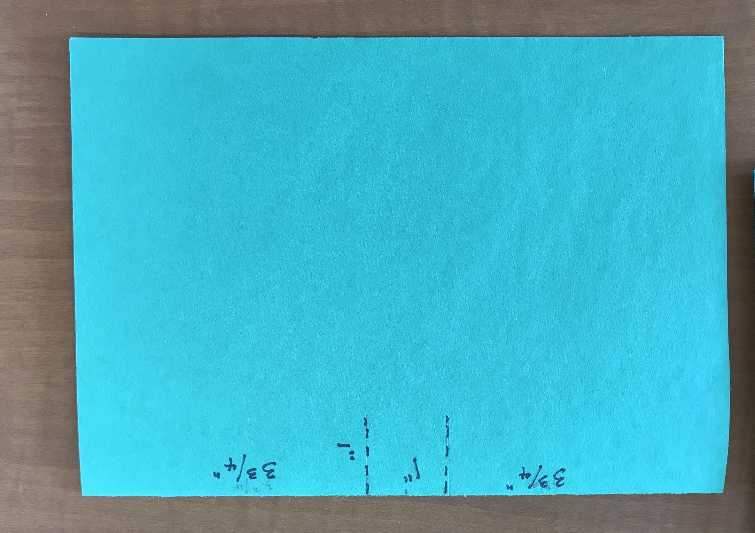

- Fold the tab as indicated below:

- Glue pieces together, avoiding area at spine/tabs.
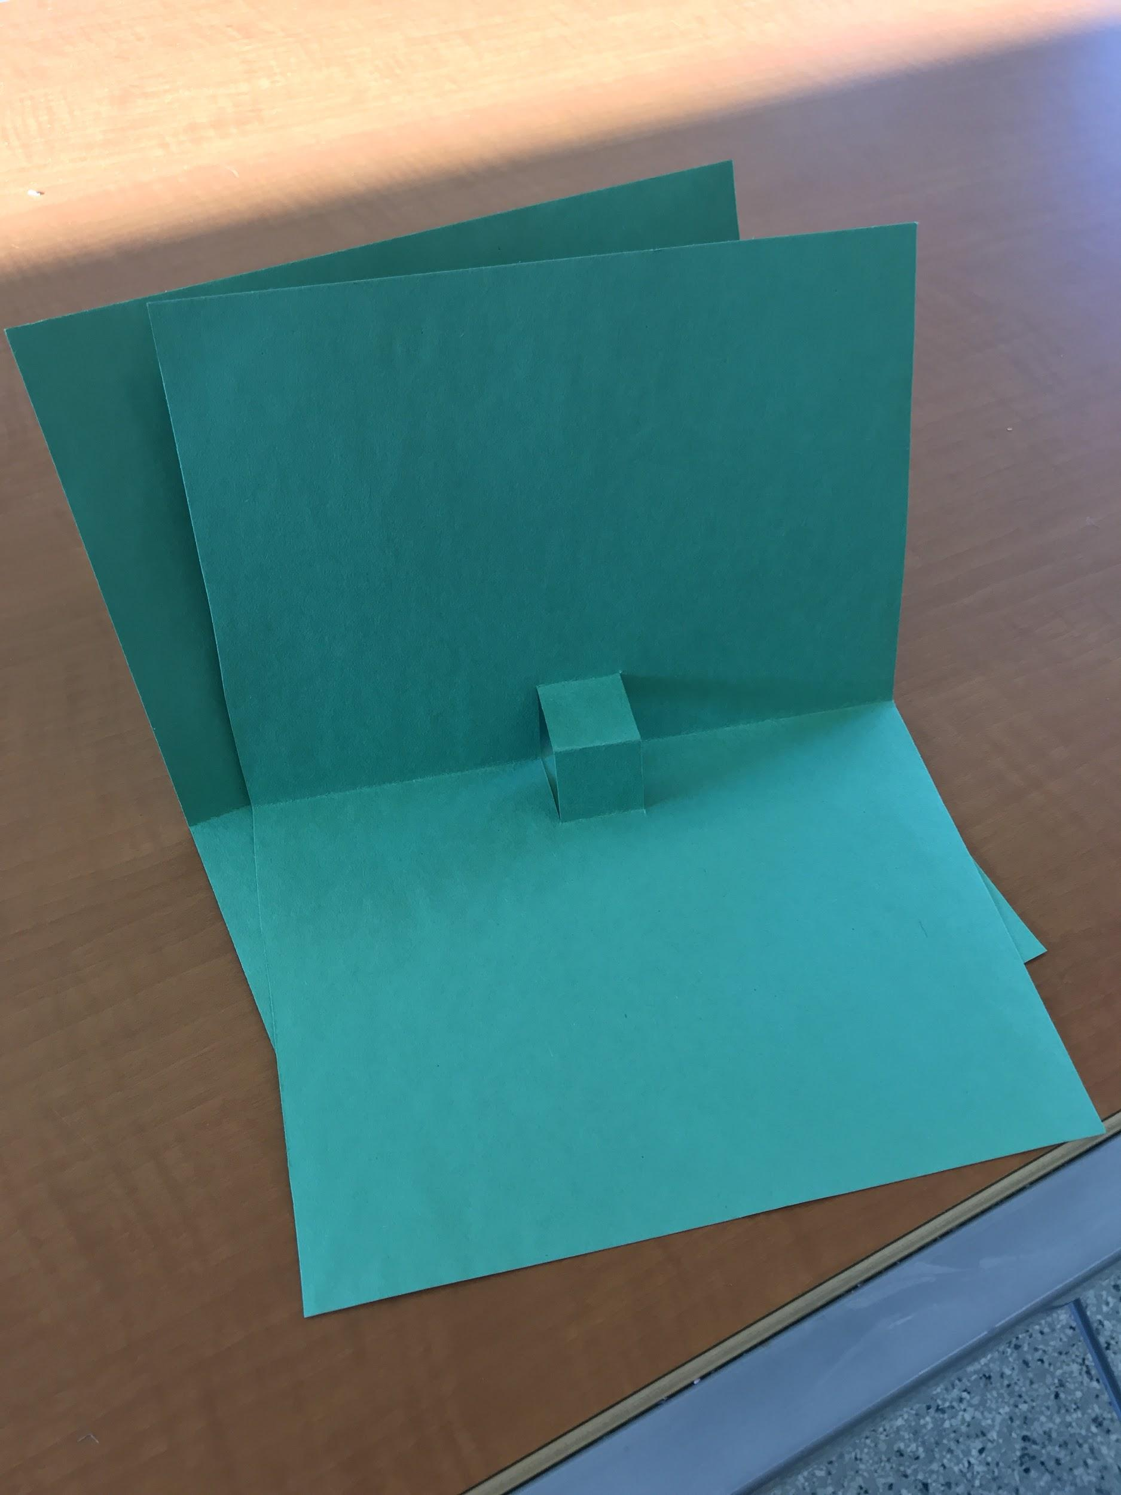

- Glue embellishments to tabs
- Add any other embellishments needed

Front Embellishment Placement

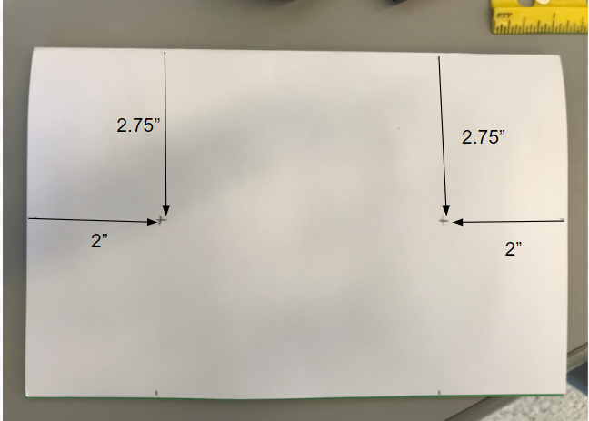

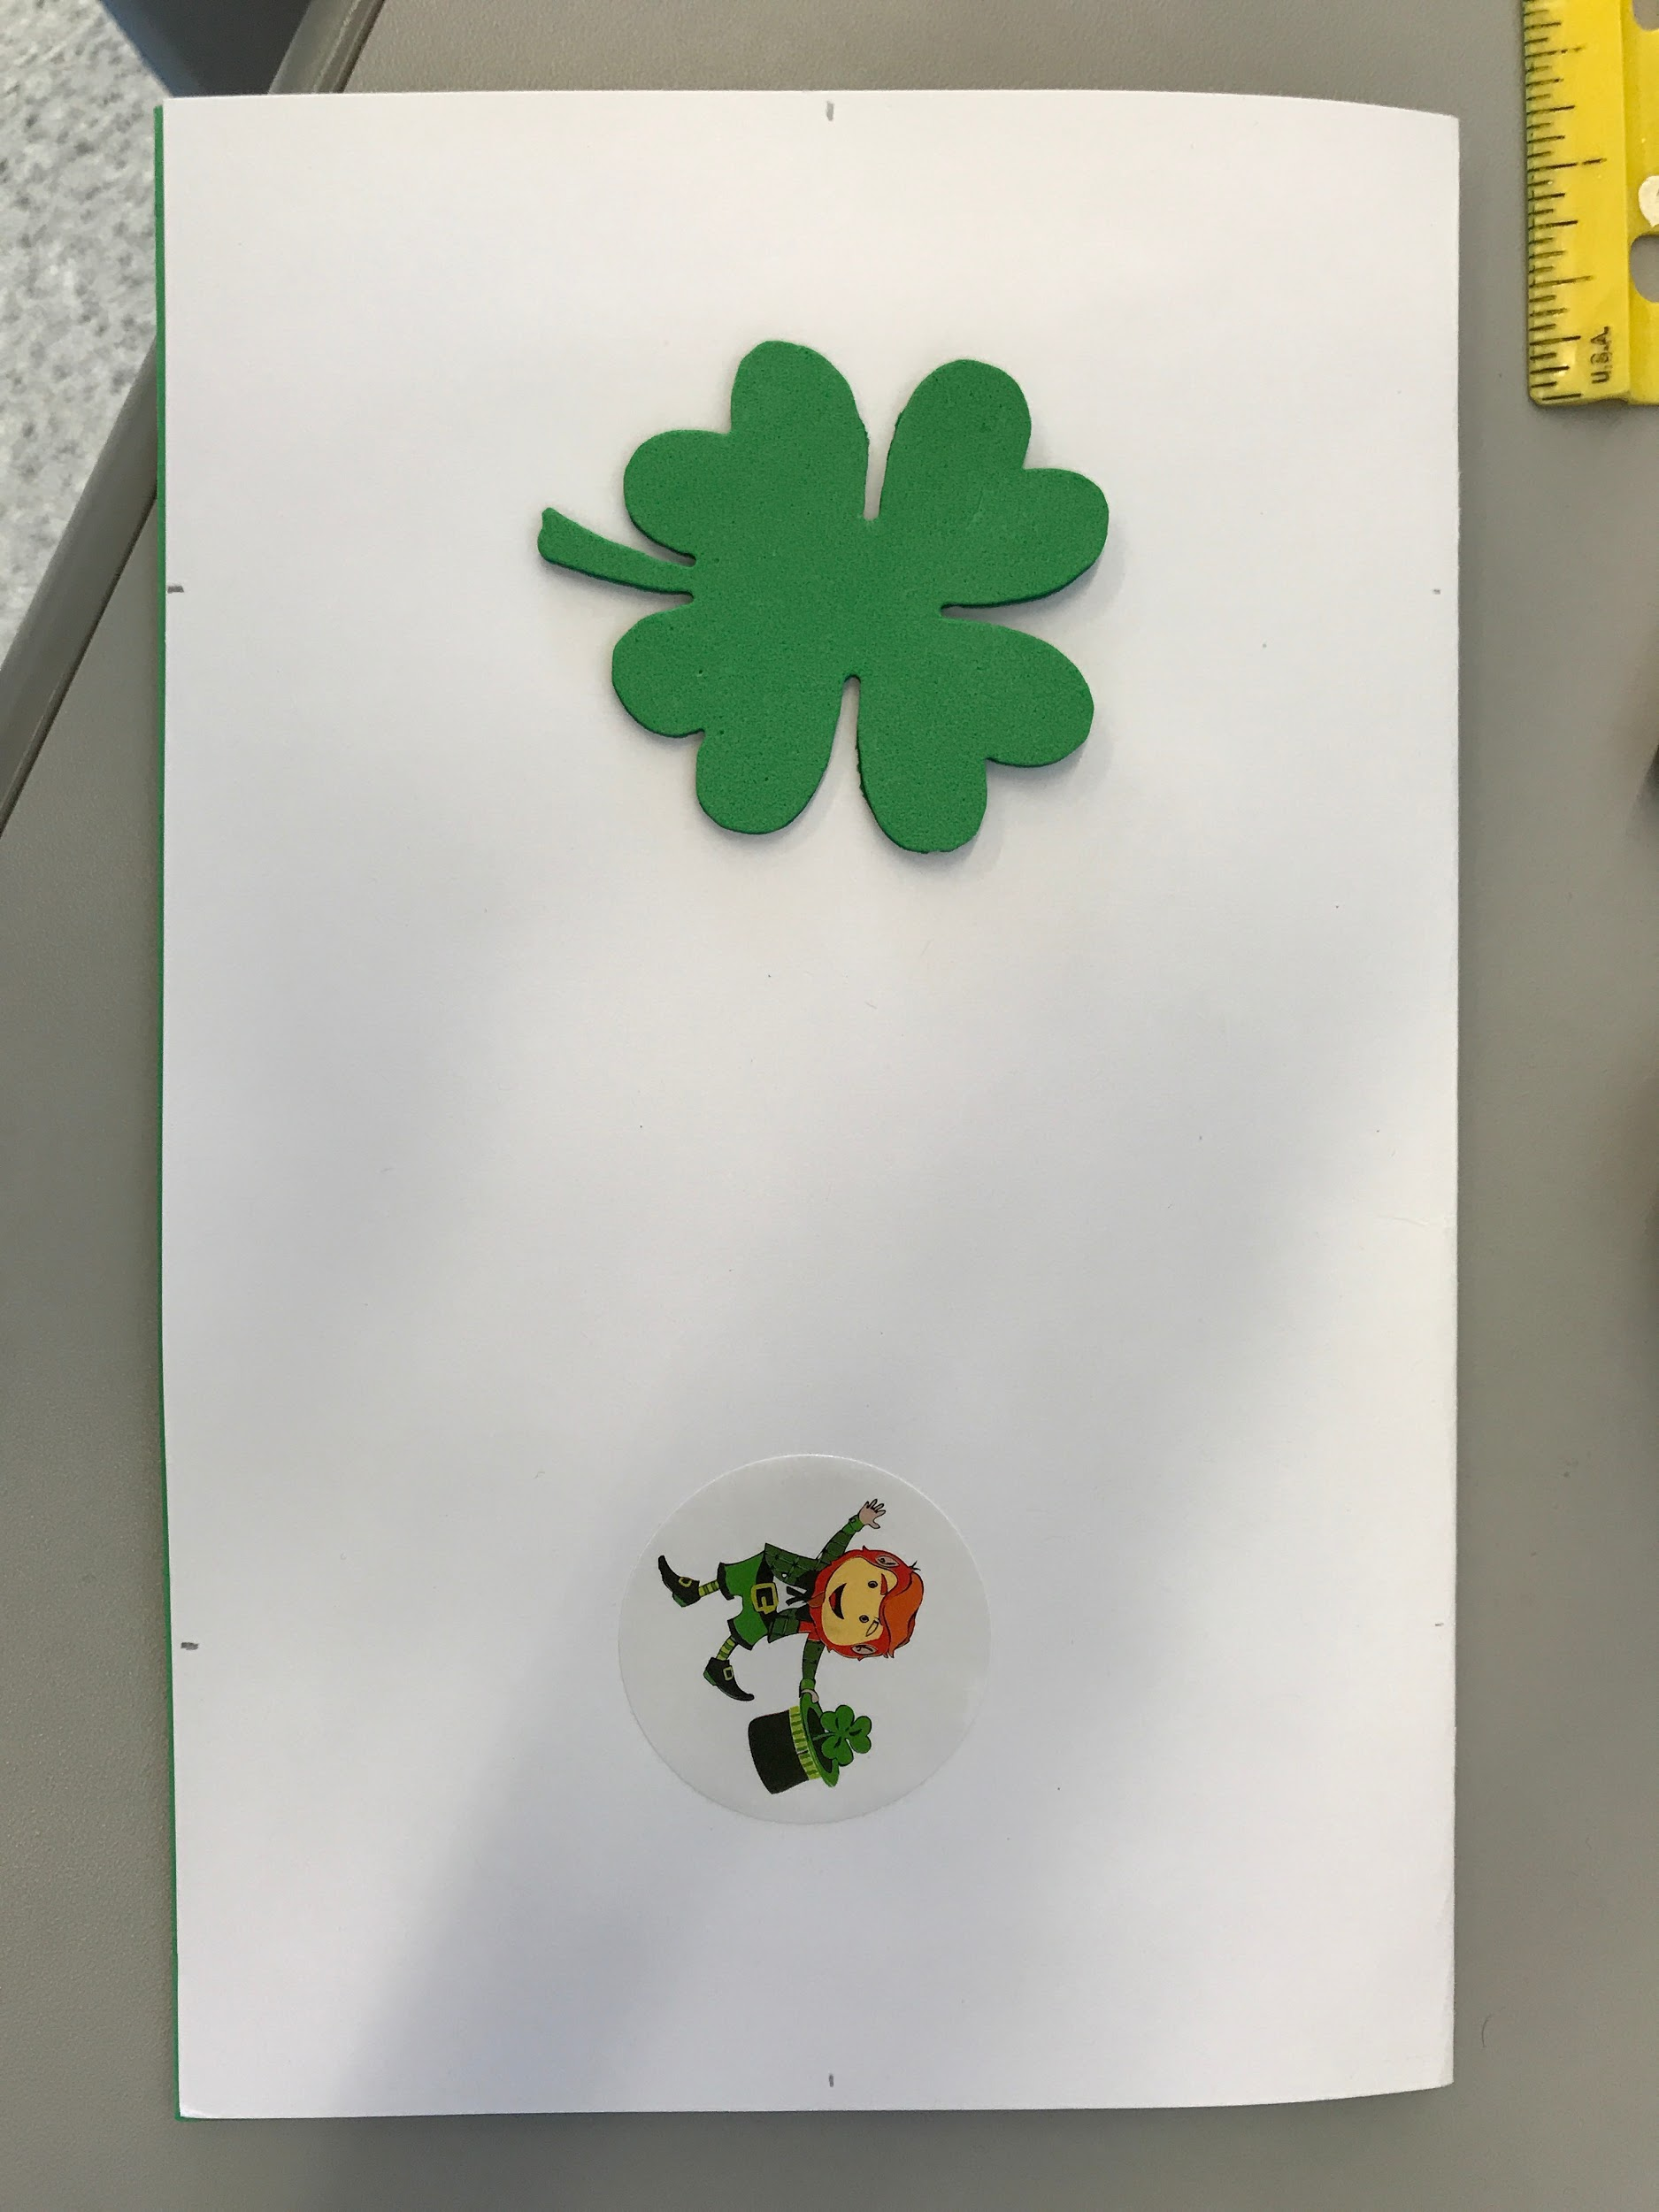

Inside Embellishment Placement

Card Types

Card Type | Outside Card | Inside Card | Front Embellishment | Inside Embellishment | Pop Up
A | White | Light Green | Foam Shamrock &  Rainbow Sticker | Shamrock Sticker | Paper Shamrock
B | Dark Green | Light Green | Foam Shamrock &  Lucky Sticker | Happy St. Patrick’s Day Sticker | Paper Shamrock
C | Medium Green | White | Foam Shamrock &  Leprechaun Sticker | Hat Sticker | Paper Shamrock
D | White | Dark Green | Foam Shamrock &  Face Sticker | Pot of Gold Sticker | Paper Shamrock
E | White | Medium Green | Foam Shamrock &  Hat Sticker | Lucky Sticker | Paper Shamrock

Sample Student Work:

Example #1
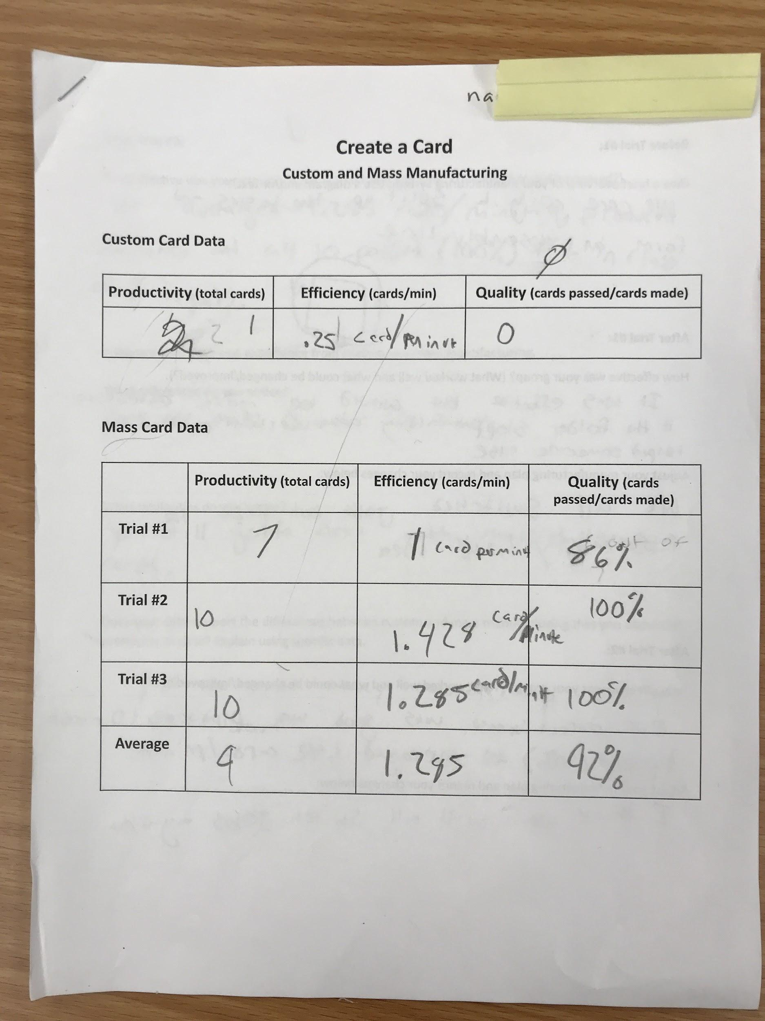

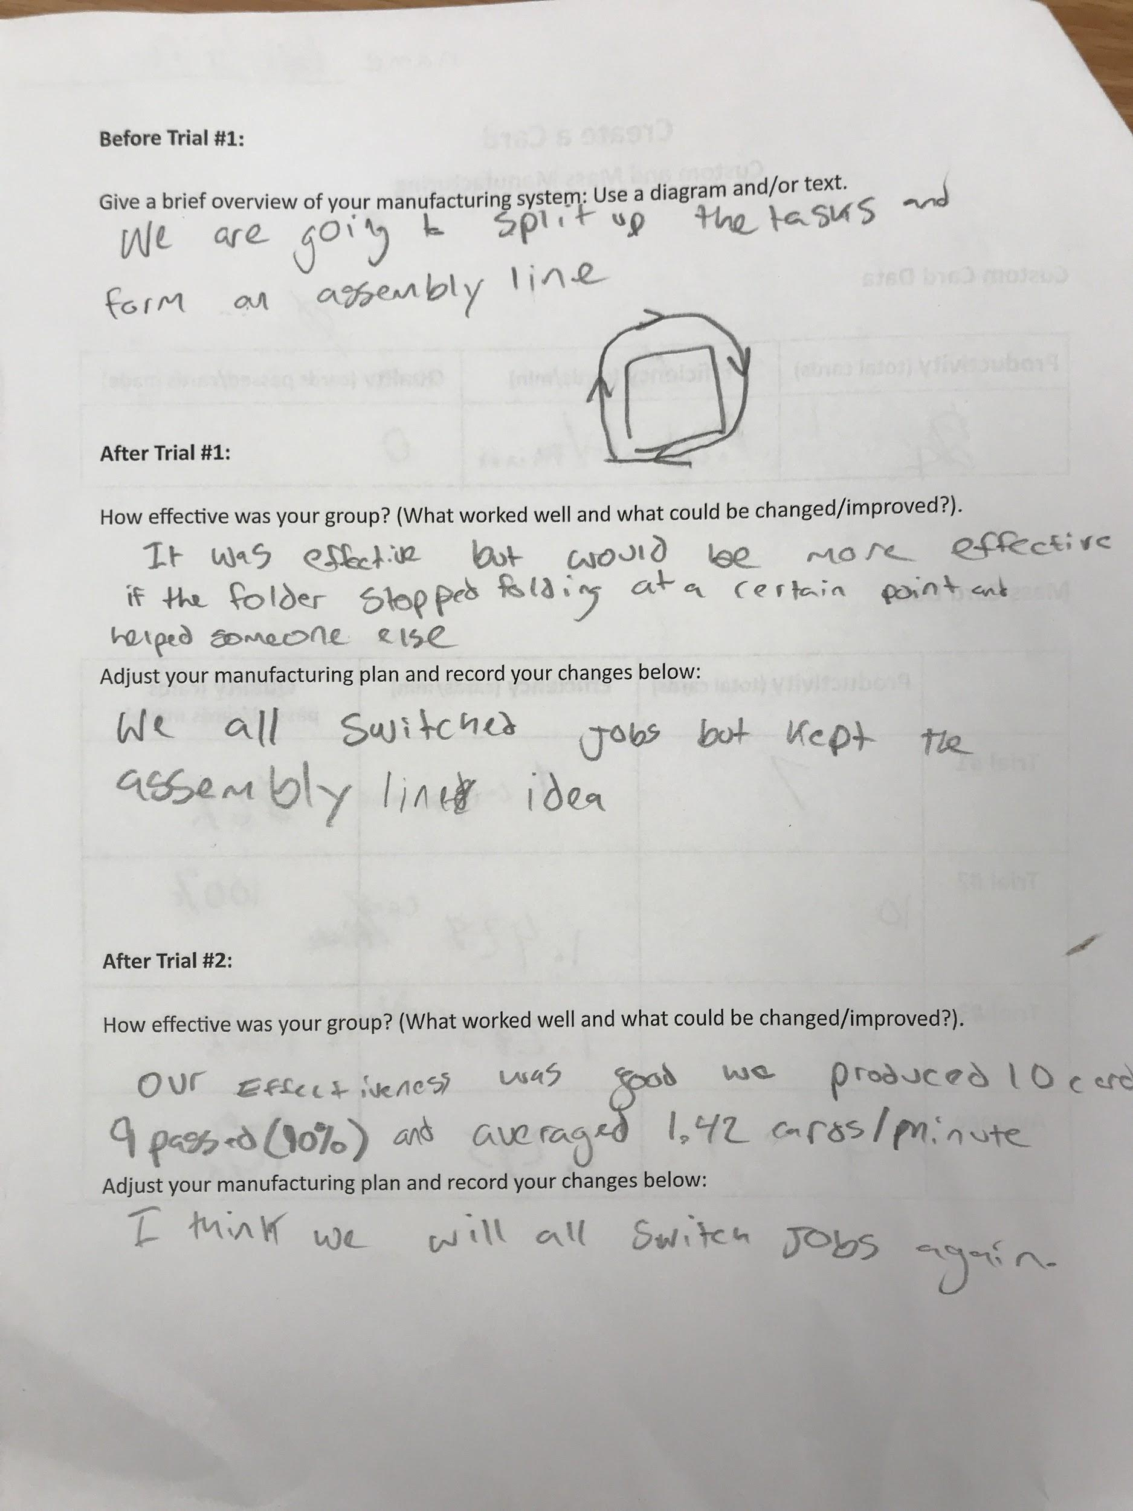

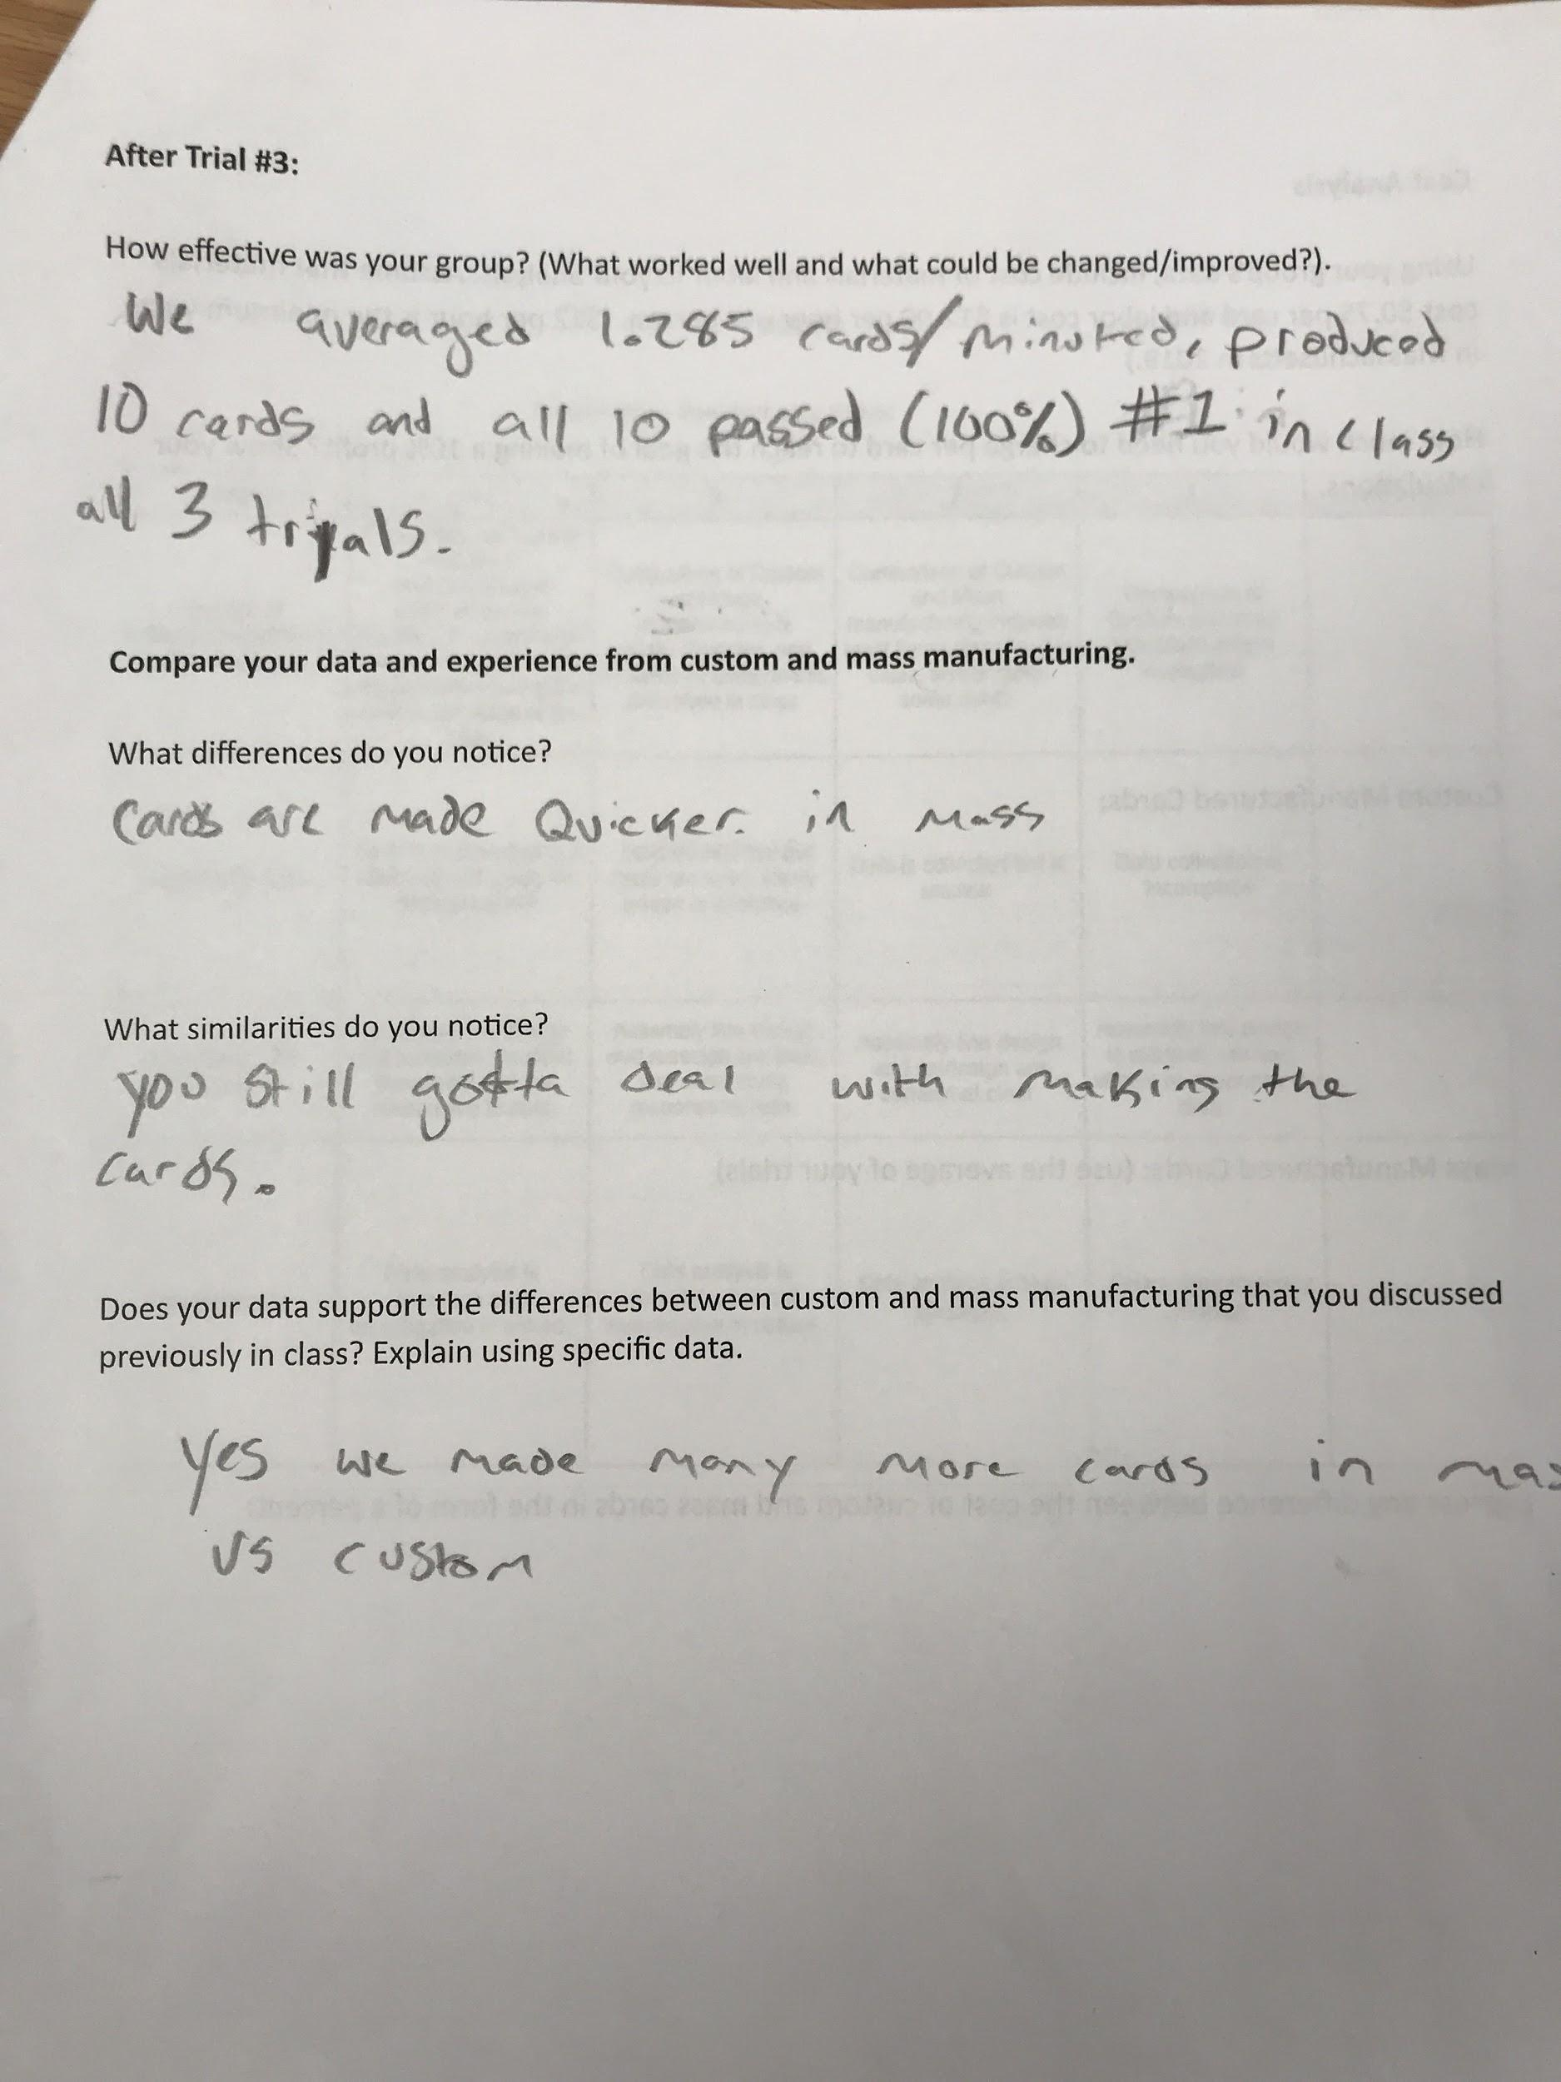

Example #2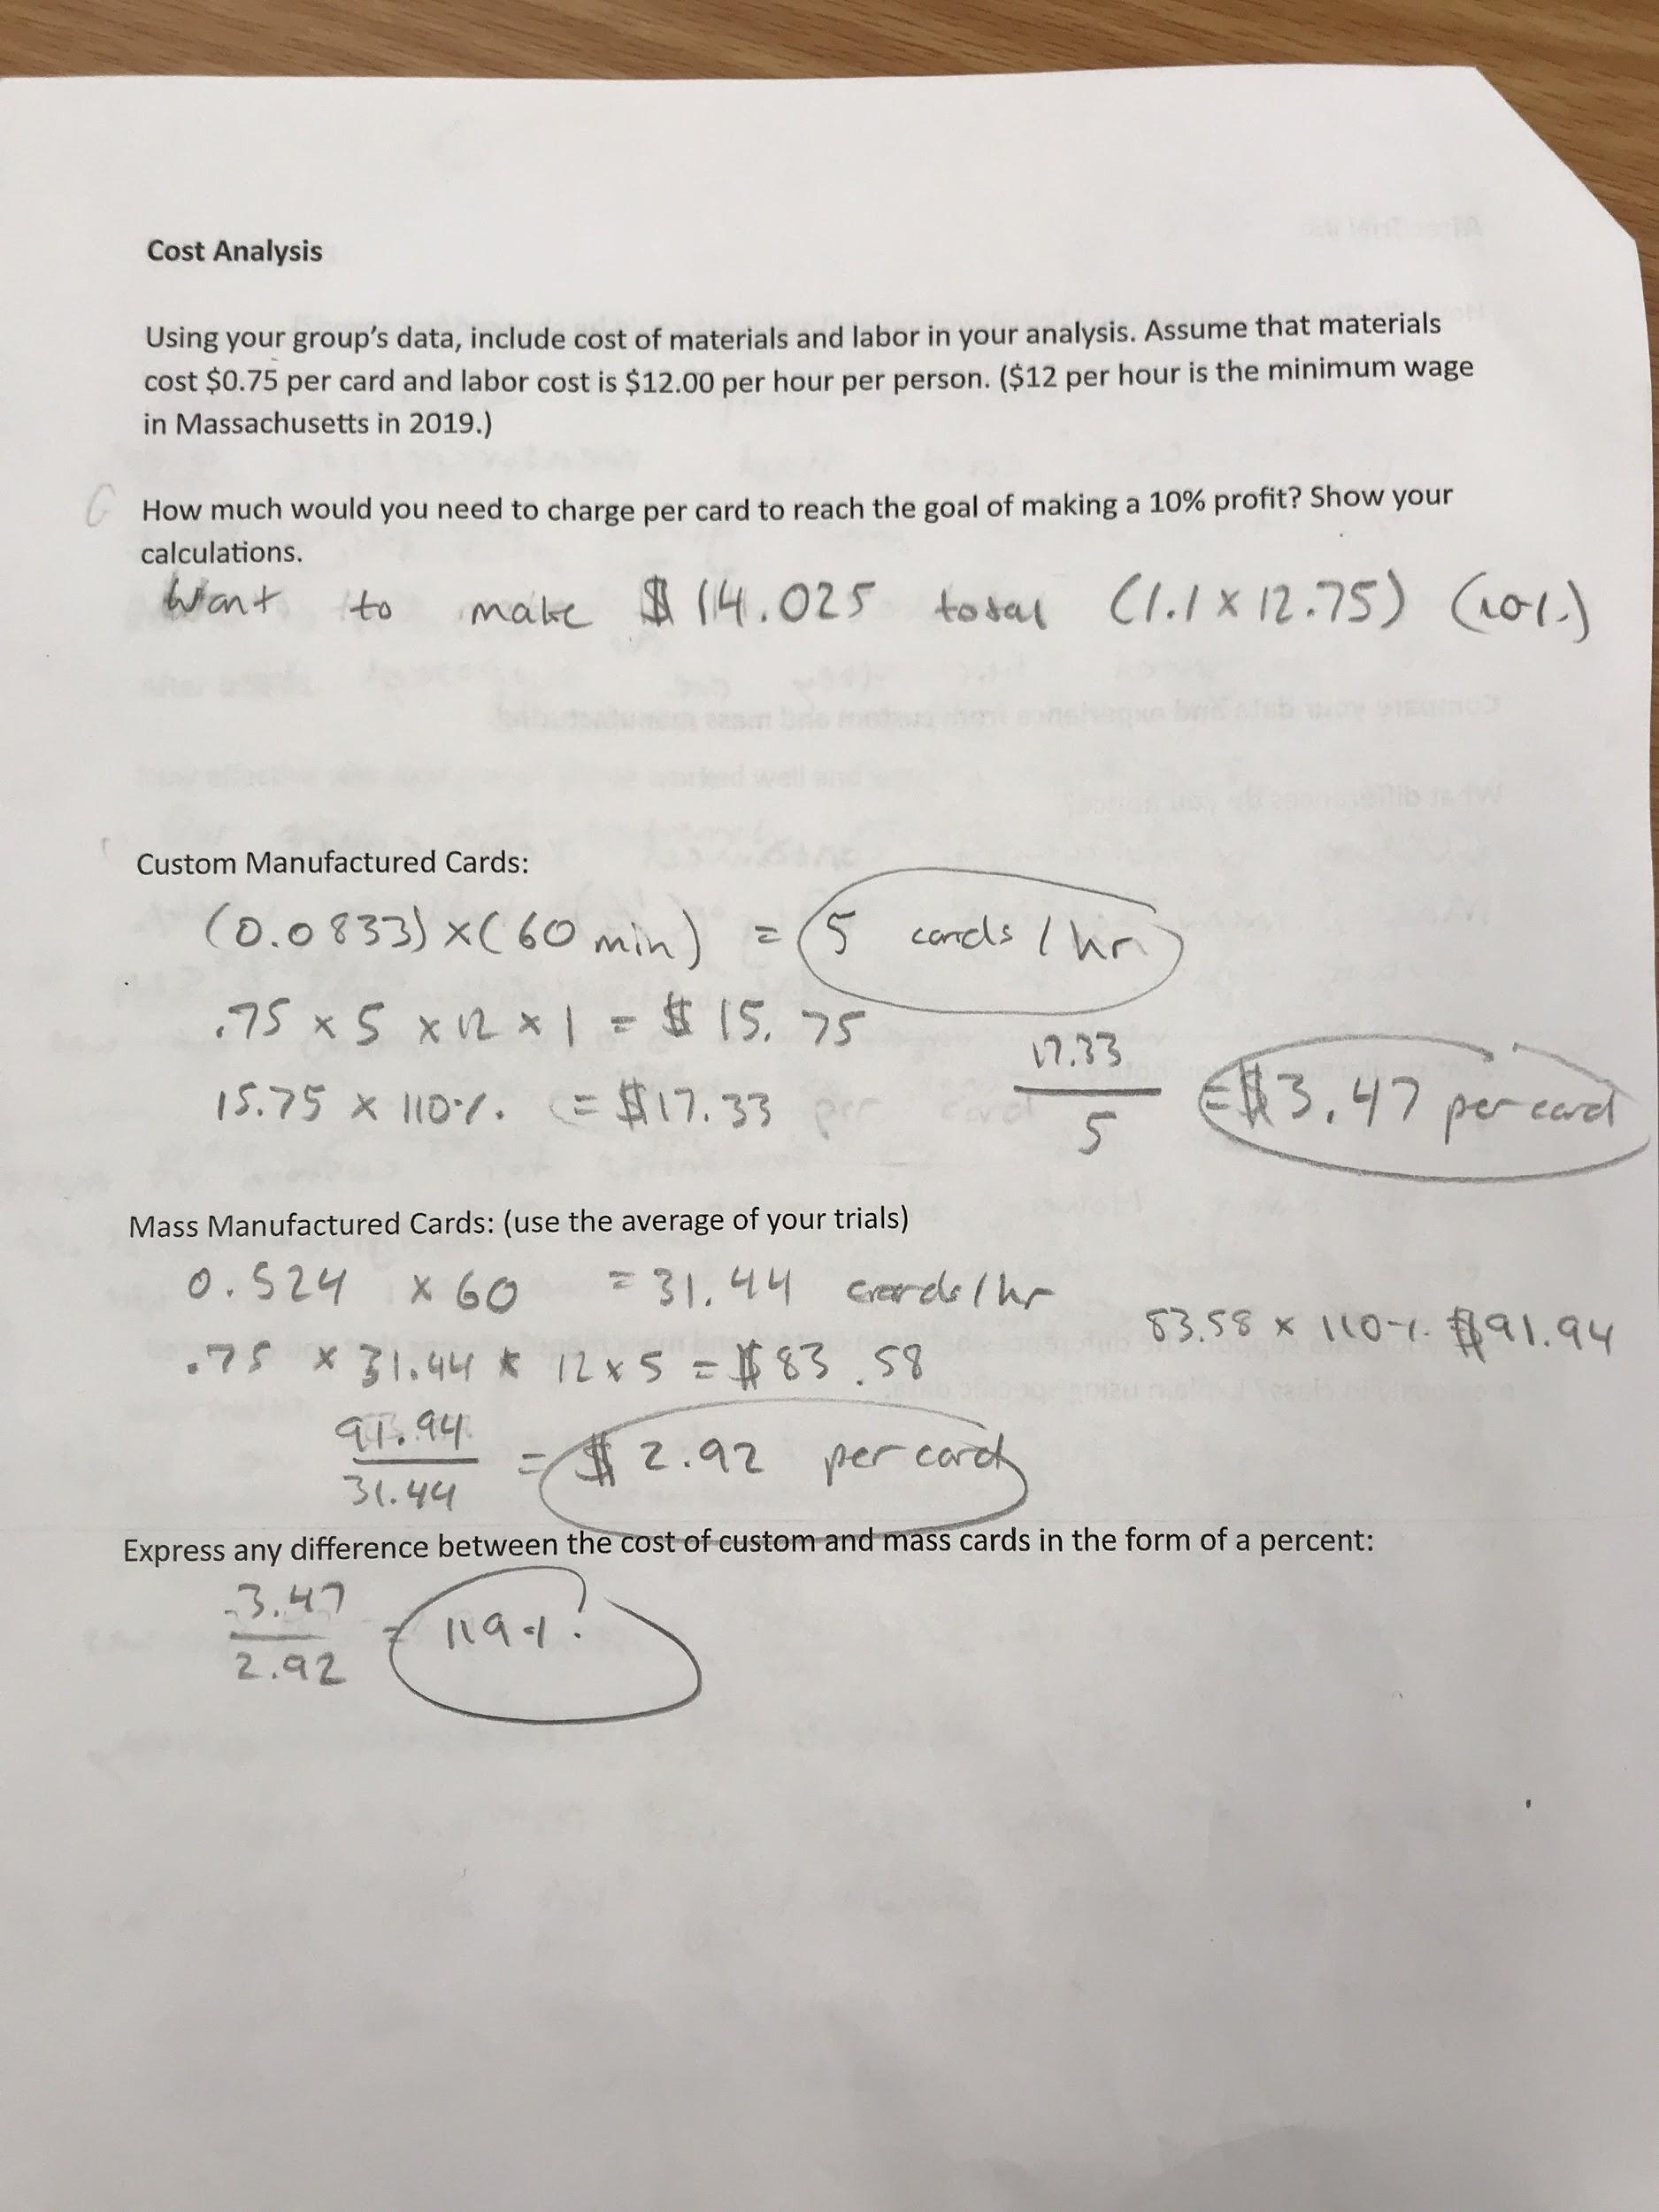

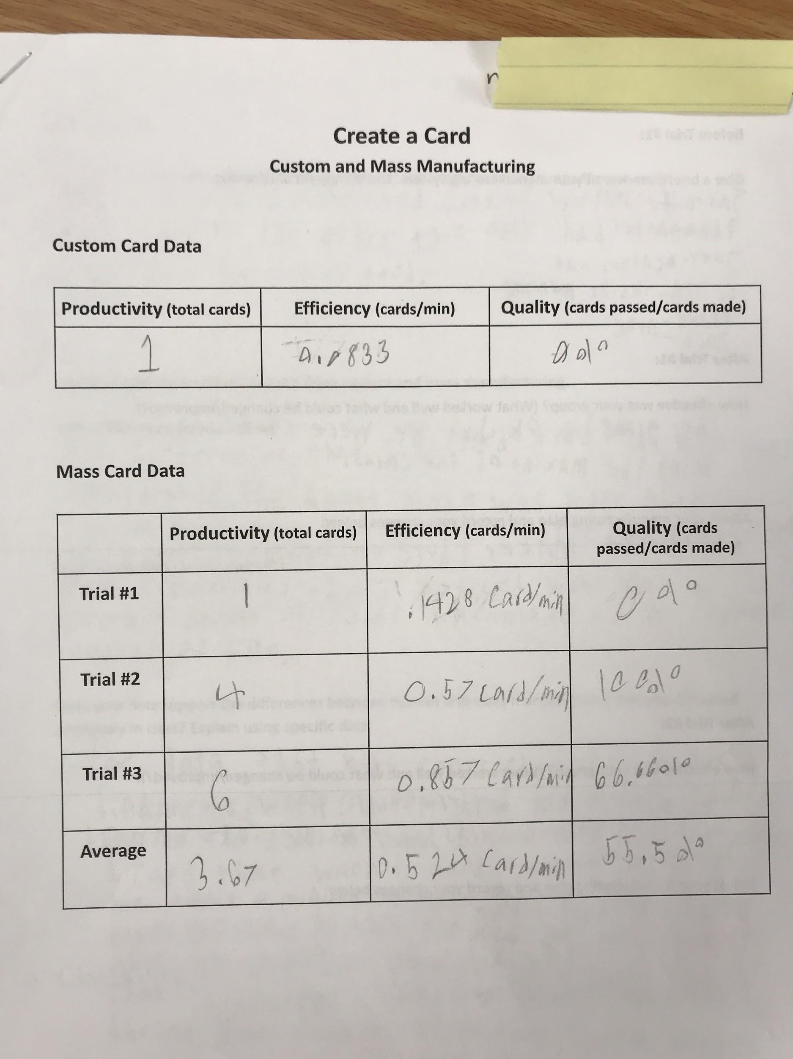

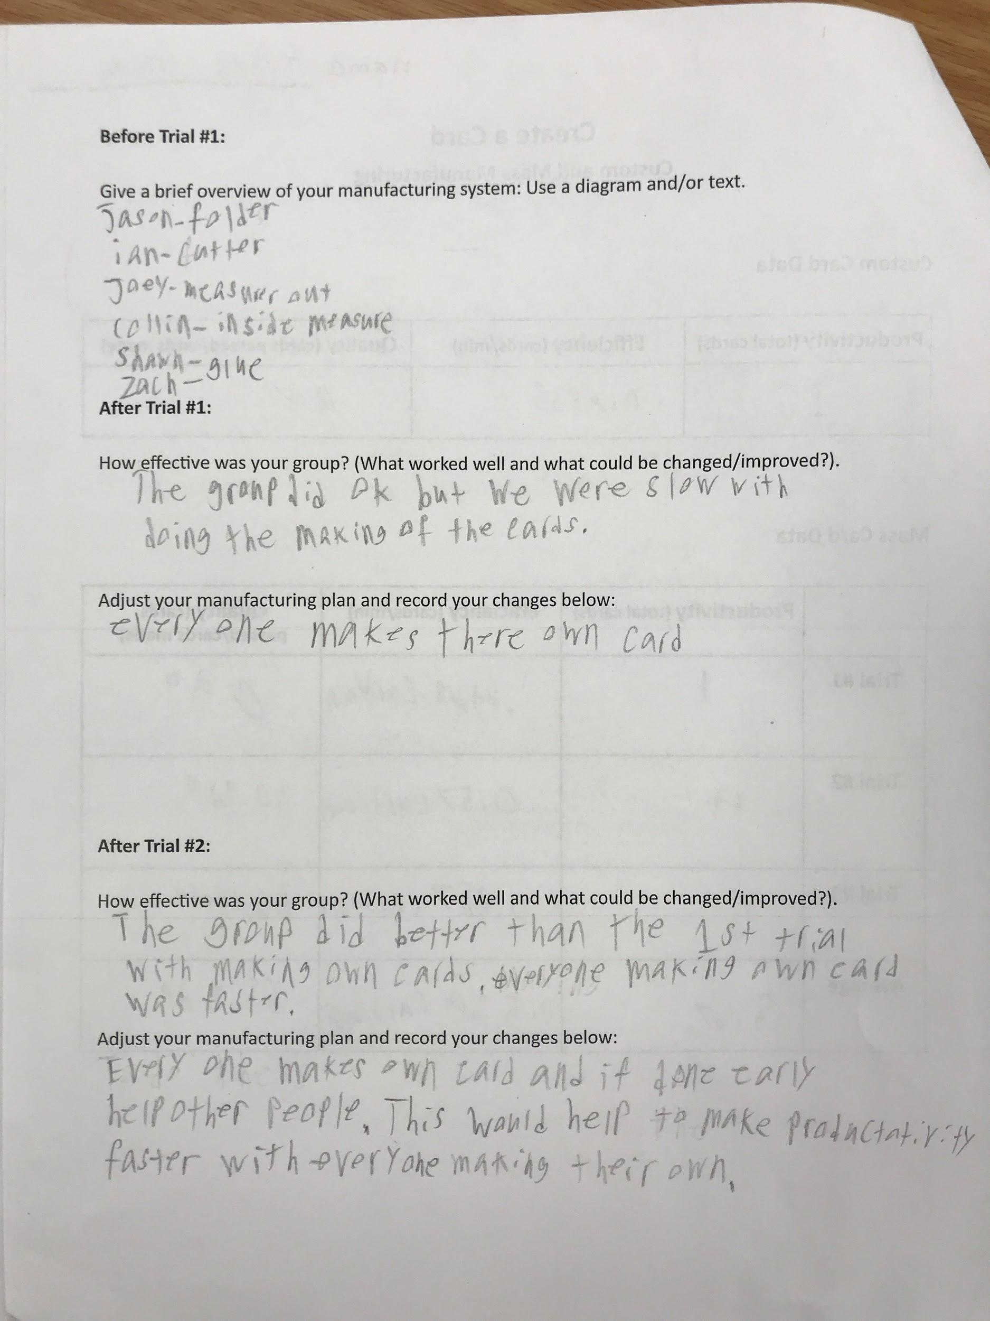
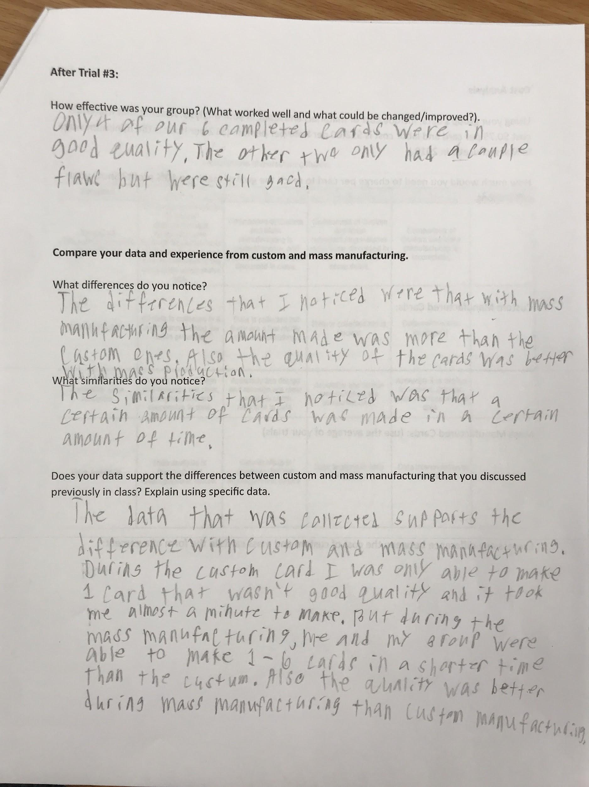

Example #3

