Task-level phenomena:
Students observe two chemical reactions, recording the change in temperature for both reactions. They will observe that the temperature increases in some reactions and decreases in others.

Synopsis of high-quality task:
Students will use data from the lab to model and explain the phenomena using energy level diagrams. For the task that follows, students will be given temperature data from a chemical reaction and, based on these data, students relate the change in temperature to the energy associated with chemical reactions in order to determine whether a reaction is exothermic or endothermic. Students will create energy level diagrams similar to the ones created after performing the lab.

Anticipated student time spent on task: 2 sessions, 75 minutes each
75-minute session to collect lab data, 55 minutes of next session to create the energy level diagrams associated with the lab, 20 minutes was needed to complete the task.

Type of Task (check one):
____ 1. Investigation/experimentation/design challenge
__X_ 2. Data representation, analysis, and interpretation
____ 3. Explanation

Student task structure(s):
Phenomenon Lab: Small groups collect data and create energy level diagrams.
Task: Students work independently
Prior Knowledge:
Previous Standards from Strand Map:
6.MS-PS1-6. Plan and conduct an experiment involving exothermic and endothermic chemical reactions to measure and describe the release or absorption of thermal energy.
Clarification Statements:
- Emphasis is on describing transfer of energy to and from the environment.
- Examples of chemical reactions could include dissolving ammonium chloride or calcium chloride

STE Standards and Science and Engineering Practices:
HS-PS1-4. Develop a model to illustrate the energy transferred during an exothermic or endothermic chemical reaction based on the bond energy difference between bonds broken (absorption of energy) and bonds formed (release of energy).
Clarification Statement:
- Examples of models may include molecular-level drawings and diagrams of reactions or graphs showing the relative energies of reactants and products.
State Assessment Boundary:
- Calculations using Hess’s law are not expected in state assessment.

Science and Engineering Practice(s):
- Analyzing and interpreting data
Connections to the real-world:
- Students experience chemical reactions everyday and have witnessed reactions that give off energy and reactions that take in energy.
- Examples of applications include the burning of fuels during exothermic reactions to generate heat to use as power, and endothermic reactions used in chemical ice packs.
Mastery Goals:
Learning Objective:
- Analyze data from an investigation to create an energy level diagram

Performance Objective:
- Analyze data from a chemical reaction and use models and data as evidence in supporting a claim that a chemical reaction is exothermic or endothermic.

Language Objective:
- Orally discuss temperature data with a small group
- Draw a model and construct a written explanation for how the change in temperature indicates whether a reaction is exothermic or endothermic.
Teacher instructions
Instructional Tips/Strategies/Suggestions:

Lab:
Supply the following materials at each lab station:
- Electronic balance
- Graduated cylinder
- 2 beakers
- Flask containing 100 mL acetic acid (vinegar)
- Beaker containing sodium bicarbonate (baking soda)
- A solution of sodium bicarbonate
- Beaker containing calcium chloride
- Metal spatula
- Weigh boat
- LabQuest2 and temperature probe
- A materials list and/or materials management checklist
- Large white poster paper, markers and rulers to construct the energy level diagrams.
- Safety information if applicable: chemical lab safety rules were followed in the lab

Use the instructional guidance and lab procedure from the American Chemical Society for the phenomenon labs (https://highschoolenergy.acs.org/content/hsef/en/how-can-energy-change/exothermic-endothermic-chemical-change.html)

Task:
Provide to students:
- Student task handout
- Scoring rubric – Focus on including the standards-content and practices for performance criteria. Less focus should be on presentation style, design, etc. unless it is tied directly to an ELA standard
- Allow students at least 20 minutes to complete the task individually

Instructional Materials/Resources/Tools:

- Scoring Rubric: Energy Level Diagram
- Student Handout for Task: Energy Level Diagram Activity

Accessibility and Supports:
Include key academic vocabulary: exothermic, endothermic, enthalpy
Task Source:
The lab was adapted from: ENERGY FOUNDATIONS for High School Chemistry. (2018). Retrieved November 10, 2018, from http://highschoolenergy.acs.org/content/hsef/en/how-can-energy-change/exothermic-endothermic-chemical-change.html
Used with permission from the American Chemical Society.

Student Handout for Task:

Energy Level Diagram Activity
The following data was collected after two substances were combined.
Time (s) | Temperature (℃)
0 | 20.2
30 | 20.0
60 | 19.6
90 | 19.2
120 | 18.0
150 | 17.5
180 | 17.2

Instructions:

- Draw an energy level diagram for this reaction.
- Draw a red arrow representing the energy needed to break the bonds in the reactants. Make sure your arrows point in the proper direction.
- Draw a blue arrow representing the energy released when new products form.
- Draw a thicker arrow using the correct color representing ΔH for this reaction.
- Based on your diagram, determine whether this reaction is endothermic or exothermic.
- Explain how you used the temperature data to determine whether this reaction was exothermic or endothermic.

Scoring Rubric: Energy Level Diagram

Item | Possible Points | Earned Points
Axes properly labeled. | 2
Reactants and products at correct relative energy levels based on temperature data. | 2
Arrow showing the amount of energy needed to break bonds in reactants. | 2
Arrow showing the amount of energy released when new products form. | 2
Arrow showing the overall change in energy. | 2
Diagram properly labeled as exothermic or endothermic. | 2
Total Points | 12

Sample Student Work:

Diagram created after lab:

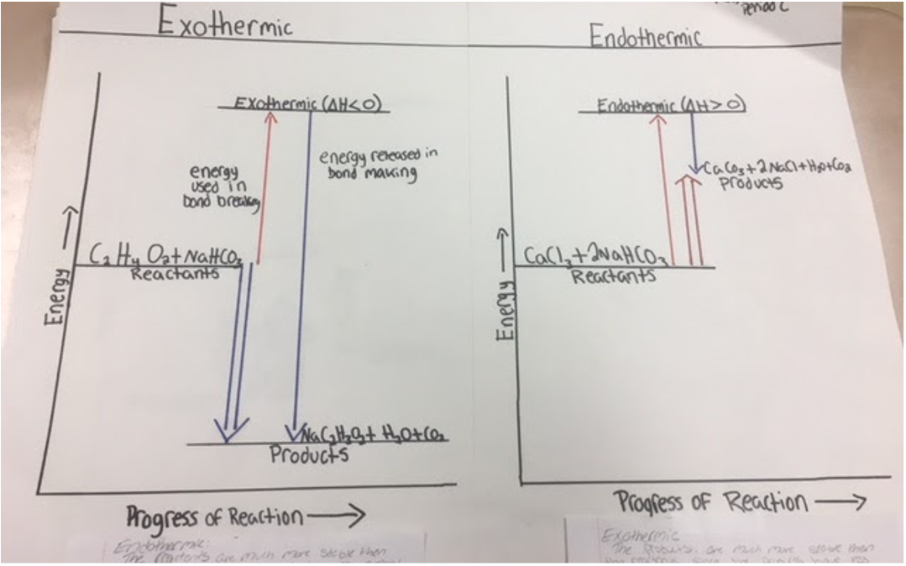

Diagrams from Task:
