Task-level phenomenon: Students will observe excerpts of a drag race, and examples of how some drag race cars have very large engines capable of exerting large forces and how some of the cars are made to be light, using carbon fiber and aluminum for example, to keep car masses as small as possible.

Synopsis of high-quality task:
Using a modified Atwood setup with a cart on a flat, smooth surface connected to a hanging weight, students will gather force, mass and acceleration data using Logger Pro (or a similar data collection system) and use this data to observe the two relationships that make up Newton’s 2nd Law. The two relationships investigated are the direct relationship between force and acceleration and the inverse relationship between mass and acceleration. The student product will be an evidence-based explanation of the trends in data and how they demonstrate the two relationships involved in Newton’s 2nd Law.

Note: This task is part of a larger unit on forces and motion. This task was piloted in 11th and 12th grade physics classes.

Anticipated student time spent on task: 3 sessions, 60 min each

Type of Task (check one):
X 1. Investigation/experimentation/design challenge
____ 2. Data representation, analysis, and interpretation
____ 3. Explanation

Student task structure(s): Partner work

STE Standards and Science and Engineering Practices:

HS-PS2-1. Analyze data to support the claim that Newton’s second law of motion is a mathematical model describing change in motion (the acceleration) of objects when acted on by a net force.
Clarification Statement:
- Examples of data could include tables or graphs of position or velocity as a function of time for objects subject to a net unbalanced force, such as a falling object, an object rolling down a ramp, and a moving object being pulled by a constant force. Forces can include contact forces, including friction, and forces acting at a distance, such as gravity and magnetic forces.

Science and Engineering Practice:
- Analyzing and interpreting data.

Prior Knowledge:
Previous Standard from Strand Map:
7.MS-PS3-1. Construct and interpret data and graphs to describe the relationships among kinetic energy, mass, and speed of an object.
Clarification Statements:
- Examples could include riding a bicycle at different speeds and rolling different sized rocks downhill.
- Consider relationships between kinetic energy vs. mass and kinetic energy vs. speed separate from each other; emphasis is on the difference between the linear and exponential relationships.
8.MS-PS2-2. Provide evidence that the change in an object’s motion depends on the sum of the forces on the object (the net force) and the mass of the object.
Clarification statement:
- Emphasis is on balanced (Newton’s first law) and unbalanced forces in a system, qualitative comparisons of forces, mass, and changes in motion (Newton’s second law) in one dimension.

Previous Topics:
- How to get acceleration from distance and time data.
- How to use video (motion) graphing software.
- What force, acceleration and mass are.
- Higher levels: ability to linearize data and get information from slope.

Connections to the real-world:

Large forces causing large accelerations: drag racers have large horsepower engines to get up to speed very quickly. Small masses enable larger accelerations: drag racers are made as light as possible to have as little resistance to their forces as possible.
Mastery and Language Goals:

Learning Objective:
- Explain the direct relationship between acceleration and force as well as the inverse relationship between mass and acceleration.

Performance Objective:
- Collect and analyze data in order to craft an evidence-based explanation of the relationships between mass, force, and acceleration.

Language Objective:
- Explain, in writing, the relationships between net force, mass and acceleration based on their data analysis.
Teacher Instructions:

Day 1:
Ask students to make a chart in their notebooks with three columns, notice-think-wonder. Show a clip (such as Best of Killer Drag Races in HD 2019: https://www.youtube.com/watch?v=HbtxVcNvHe8) or something similar that has a medley of drag racing videos that shows multiple races from about the same angle (for good comparison). Ask students to write what they notice/observe about the different drag race scenarios, why they think those things happened (for example, who won and why), and what they wonder.
Show students the classroom modified experimental set up, modeled below.

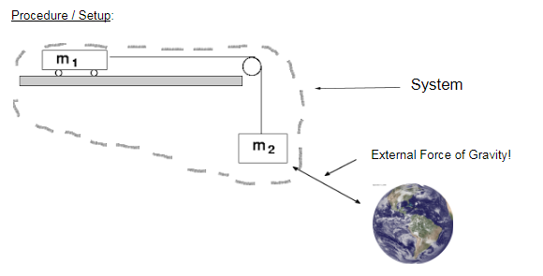
Release mass 2, while students observe and allow them a few minutes to write down what they noticed, what they think caused what they noticed, and what they wonder. Make a class chart on the board, writing all shared answers. Students will likely bring the following ideas up for discussion:
- When one mass moved the other moved.
- The boxes are attached
- The system goes only in one direction naturally
- Gravity causes mass 2 to change its motion (accelerate)

Ask students, “How is this similar to the drag racing videos? Different? “How could we figure out the relationships between force, mass, and acceleration using this set up?”

Show students the materials available for the lab and review what data they can collect. Allow students to revise or build on their investigation ideas. Have students work on their ideas in small groups, and have each small group share out how they think they could collect the data they need.

Day 2:
Review the general lab set up students shared in the previous class. Train all students on how to use the data collection equipment, especially if it is their first experience with Logger Pro. When students have collected some test data successfully, allow them to begin the lab.

There are lab procedures included in the materials for this task. Student ideas for how to isolate mass, acceleration, and force data should be valued; if students are very close to a usable procedure, or are familiar with how to use Logger Pro, allow them to use their own procedure. If students have the general idea of isolating variables, and their major obstacle is their familiarity with the equipment, allow them to use the lab procedure, and emphasize that their ideas for isolating variables (and any other similar factors) are included in the procedure you are providing them.

Day 3:
Students should have about 20 minutes to analyze their data from Day 2. When most students have had a chance to analyze data in small groups, lead a class discussion (~20 minutes) about the trends that groups saw in their data. If you are able, have students submit their data to a class spreadsheet or document and project the class spreadsheet so data can be compared as a class. Track student responses from the discussion on the board. Halfway through the discussion, have students highlight the major ideas that came through by identifying the most important points recorded on the board. Alternate between whole group discussion and small group discussion as students consider new ideas. To go to small group discussion, you can ask, “how does this new observation/idea fit in (or contradict) with what you think is happening?”

For the second half of the discussion, ask students, “how do the results from our lab relate to what we saw in the drag racing videos?” If you have a picture or record of the Day 1 discussion, show the noticings and wonderings from the drag racing videos for students to see. As students progress, an important way to push students is to ask how the lab setup/model is different from the drag racing example and ask how those differences influence their explanations for the trends they saw in the drag racing videos. If necessary, draw a class model comparing the lab set up to the drag racing set up, identifying the force, mass, and acceleration relationships across the two scenarios.

For the last 20 minutes, students should have time to write the conclusions of their lab reports, explaining the relationships between mass, acceleration, and force using evidence from the lab. Students can complete the writing assignment for home learning, or additional time can be granted in the following class period.

Instructional Materials/Resources/Tools:

Included below:
- Student directions for completing the task (as needed)
  - Two versions of the lab handout are included, version 2 includes more rigor
- A materials list and/or materials management
- Safety information about data collection materials
- Any handouts, links, books, videos, materials, etc. that is needed for the student to complete the task
- Scoring rubric – Focus on including the standards-content and practices for performance criteria. Less focus should be on presentation style and design unless it is tied directly to an ELA standard.
Task Source:
The Ambassador would like to recognize the Bourne High School science teachers for their contributions to the development of this task.

Accessibility and Supports:
Key Academic Vocabulary:
Acceleration - the rate of change of velocity with respect to time; a vector; units: meters / second.
Force - a push or a pull; a vector; units: Newtons (kg* m/s²).
Mass - amount of matter that something contains; a scalar; units: kg.

There are two versions of the lab handout – Version 2 has additional rigor.

Student Handout #1: Procedure – Version 1

Proving Newton's 2nd Law Lab Name:_______________________

Purpose: To figure out the two relationships that make up Newton’s 2nd Law of Motion.

Hypotheses:

As force is increased, acceleration will ___________________ (with mass held constant).
As mass is increased, acceleration will ___________________ (with force held constant).

Equipment:

- a motorless vehicle that has a place to hold additional mass(es) that can roll very well (we want to reduce ________________ as much as possible)
- a pulley
- various masses to be used as masses and weights
- Meter stick
- Logger Pro Video Analysis software or other probes or software

Materials:
- string
- duct tape

Setup:
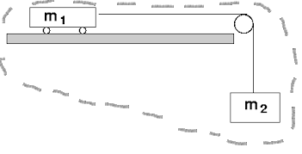

System

External Force of Gravity!

Pre-Lab Questions:

- What is the mass of the “system” (that which is being moved by the external force)? (Hint: m₁ +m₂)

- What is the external force applied to the system? (Hint: Weight of m₂.)

Part 1 - Acceleration vs Force (with mass constant)

Procedure:

Note: It would probably be easiest to increase force applied but keep mass constant by starting out with the maximum mass in the m1 position and after each trial, transfer some mass from the m₁ to the m₂ position.

- Set up the car, pulley and masses as shown above. Again, start out with whatever was going to be your maximum m₁ value in car #1 and your m2 starting at a minimum.
- Make sure there is a meter stick in your video and someone in place to stop the car before it hits the pulley. While filming, release the car.
- Upload your video to Logger Pro or other video analysis program and make sure you have good data by checking how linear the time vs velocity graph is.
- Move some mass from the m₁ location to m2 and repeat steps 1-3 for a total of 5 trials.

Data:

Part 1: Acceleration vs Force Relationship (Mass is held to a constant: ___________)
(Remember: to increase the force but keep the mass the same, move mass from the m₁ location to the m₂ location between trials.)
m₁ (kg) | m₂(kg) | m₁ + m₂ (kg) (This total is held constant) | W₂ (N) | a (m/s/s)*

*Remember: Acceleration will be calculated by taking the force applied (weight of m₂) divided by the sum of the two masses.

Show an example calculation here:

Results: (What trend did you see for the acceleration as the force was increased?)

Part 2: Acceleration vs Mass Relationship (Force is held to a constant:____________)
(Remember: to increase mass and to hold force constant, you can vary m₁, but not m₂.)

Note: It would probably be easiest to increase mass but keep force constant by changing mass m1 only.

- Reuse your car, pulley and masses setup from part 1. Start with either your minimum or maximum m1 value and then go up or down from there respectively.
- Make sure there is a meter stick in your video and someone in place to stop the car before it hits the pulley. While filming, release the car.
- Upload your video to Logger Pro or other video analysis program and make sure you have good data by checking how linear the time vs velocity graph is.
- Increase or decrease the mass of m1 and repeat steps 1-3 for a total of 5 trials.

m₁ (kg) | m₂(kg) | m₁ + m₂ (kg) | W₂ (N) (This is held constant) | a (m/s/s)*

*Remember: Acceleration will be calculated by taking the force applied (weight of m₂) divided by the sum of the two masses.

Show an example calculation here:

Results: (What trend did you see for the acceleration as the total mass of the system was increased?)

Conclusion:
(Remember to include: 1) Purpose fulfilled and how / why? 2) Hypotheses correct? 3) Data analysis? What did you learn from the data trends? 4) Note valid (uncontrollable / unfixable) sources of experimental error.

Modified conclusion questions:

1. Why did we do this lab?

2. Did your data support your hypothesis?

3. What did your data say? Is there a trend? What is the trend?

4. What are some sources of error?

Student Handout #1: Procedure – Version 2

Proving Newton's 2nd Law Lab Name:_______________________

Purpose: To figure out the two relationships that make up Newton’s 2nd Law of Motion.

Hypotheses:

As force is increased, acceleration will ___________________ (with mass held constant).
As mass is increased, acceleration will ___________________ (with force held constant).

Equipment:

- a Lego (or other) motorless vehicle that has a place to hold additional mass(es) that can roll very well (because we want to reduce ________________ as much as possible)
- a pulley
- various masses to be used as masses and weights
- Meter stick
- Logger Pro Video Analysis software

Materials:
- string
- duct tape

Setup:

System

External Force of Gravity!

Pre-Lab Questions:

- What is the mass of the “system” (that which is being moved by the external force)?

- What is the external force applied to the system?

Part 1 - Acceleration vs Force (with mass constant)

Procedure: (Describe your procedure below:)

Data:

Part 1: Acceleration vs Force Relationship (Mass is held to a constant: ___________)

m₁ (kg) | m₂(kg) | m₁ + m₂ (kg) | W₂ (N) | a (m/s/s)*

Show an example calculation here:

Graph: What should you graph on the x:__________ and the y:___________ axes to get a linear graph whose slope represents the mass of the system? Graph those now, include your graph with your report and report that graphed slope (with units) here:_____________.

Results:

Part 2: Acceleration vs Mass Relationship (Force is held to a constant:____________)

Procedure: (Describe your procedure below:)

m₁ (kg) | m₂(kg) | m₁ + m₂ (kg) | W₂ (N) | a (m/s/s)*

Show an example calculation here:

Graph: What should you graph on the x:__________ and the y:___________ axes to get a linear graph whose slope represents the force on the system? Graph those now, include your graph with your report and report that graphed slope (with units) here:_____________.

Results:

Conclusion:

Student Work
Note that the handouts were modified as a result of piloting the task.
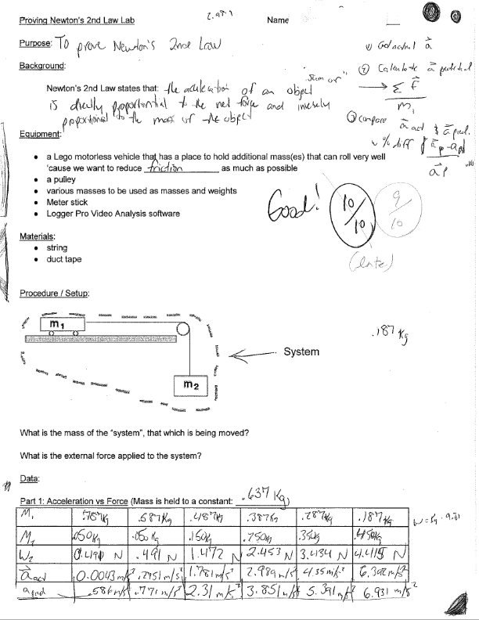

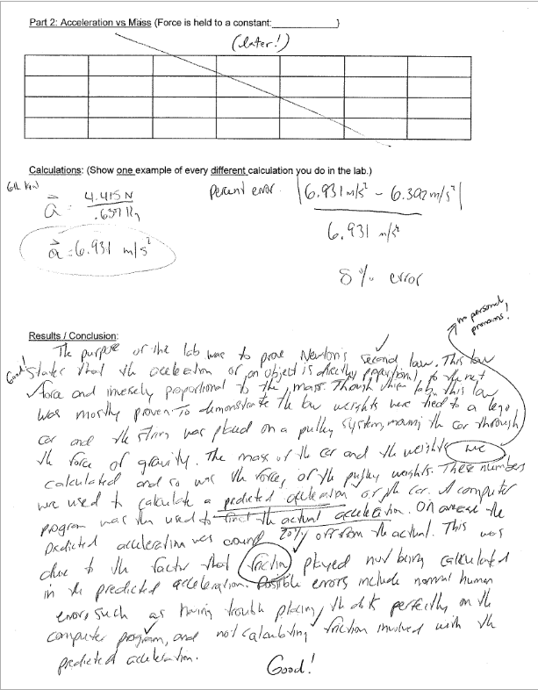

Student Work Example - Honors Level

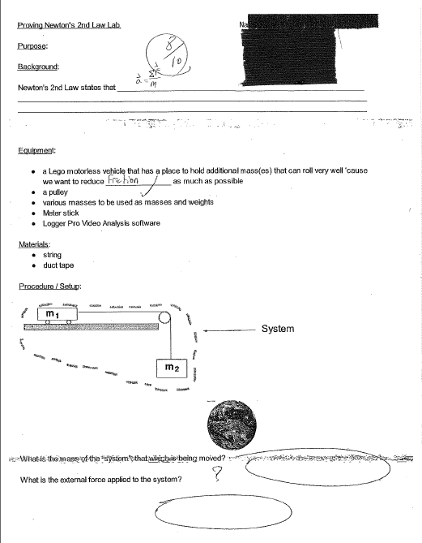
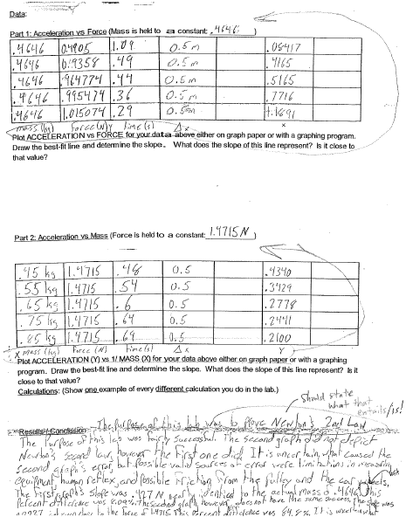

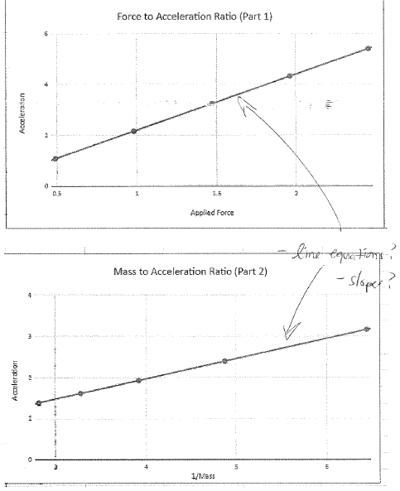

Student Work Example - AP Level

