Task-level phenomenon:
Piping Plover populations along the Maine coastline have become threatened. Piping Plovers in Massachusetts face the same risks.

Synopsis of high-quality task:
Birth and survival of young New England coastal birds is negatively impacted by both biotic and abiotic factors. In this task, students will analyze data in order to determine which factors (biotic or abiotic) had the greater impact on the Piping Plover. The task culminates with students communicating their analysis through a Claims-Evidence-Reasoning prompt.

Anticipated student time spent on task: 2 sessions, 45 minutes each

Type of Task (check one):
____ 1. Investigation/experimentation/design challenge
__X_ 2. Data representation, analysis, and interpretation
____ 3. Explanation

Student task structure: partner work

STE Standards and Science and Engineering Practices:
HS-LS2-2. Use mathematical representations to support explanations that biotic and abiotic factors affect biodiversity, including genetic diversity within a population and species diversity within an ecosystem.
Clarification Statements:
- Examples of biotic factors could include relationships among individuals (feeding relationships, symbiosis, competition) and disease.
- Examples of abiotic factors could include climate and weather conditions, natural disasters, and availability of resources.
- Examples of mathematical representations include finding the average, determining trends, and using graphical comparisons of multiple sets of data.

Science and Engineering Practices
- Analyzing and Interpreting Data
- Constructing explanations

Prior Knowledge:
Previous Standard from Strand Map:
7.MS-LS2-4. Analyze data to provide evidence that disruptions (natural or human-made) to any physical or biological component of an ecosystem can lead to shifts in all its populations.
Clarification Statement:
- Focus should be on ecosystem characteristics varying over time, including disruptions such as hurricanes, floods, wildfires, oil spills, and construction.
7.MS-LS2-6(MA). Explain how changes to the biodiversity of an ecosystem—the variety of species found in the ecosystem—may limit the availability of resources humans use.
Clarification Statement:
- Examples of resources can include food, energy, medicine, and clean water.
Previous Topics:
- Analyze direct and indirect effects of human activities on biodiversity and ecosystem health.
- Use a mathematical model to describe the transfer of energy from one trophic level to another.

Connections to the real-world:
This phenomenon has significant local (Massachusetts, coastal) context:
- According to the U.S. Fish and Wildlife Services the Piping Plover (Charadrius melodus) is listed (12/11/1985) as Endangered in the Great Lakes-Big Rivers Region (Region 3) and Threatened in the Northeast Region (Region 5).
- Annual data about the Piping Plover plight from Massachusetts, New Hampshire, and Maine is available through the U.S. Fish and Wildlife Services; Massachusetts, New Hampshire, and Maine Audubon Society; and the governments of the state of Massachusetts, New Hampshire and Maine. https://www.kennebunkportme.gov/sites/kennebunkportme/files/uploads/2015_piping_plover_and_least_tern_project_report_for_maine_january_2016.pdf

Mastery Goals:

Learning Objective:
- Use data to create a graph of biotic and abiotic factors causing nest loss.
- Analyze and interpret quantitative data to determine which biotic and/or abiotic factors most affect the population of a threatened bird species (Piping Plover) over time within a beach ecosystem.

Performance Objective:
- Analyze and interpret data of nest loss over a period of time.
- Evaluate, graph, and communicate information identifying the independent and dependent variables.
- Make and defend a claim based on evidence from scientific data, and construct an explanation based on the evidence for which factors most affect the Plover population.

Language Objective:
- Research background information through reading and data interpretation and discuss the data orally in small groups.
- Construct a written explanation based on evidence from scientific data using CER (Claim, Evidence, Reasoning).

Teacher instructions/Instructional Tips/Strategies/Suggestions:
Overview:
This task can be used in a unit on Ecosystems: Interactions, Energy, and Dynamics. The goal of this task is to analyze data of Piping Plover bird nest loss due to biotic and abiotic factors on beaches in New England. The Piping Plover is a state and federally threatened shorebird species. The nest loss is due to a number of causes, which includes tides, nest predation, abandonment, and sand burial.

Students will analyze data to determine whether biotic or abiotic factors cause the majority of Piping Plover nest loss. They will also analyze how the population of the Piping Plover has changed over time within the beach ecosystem. Students will use Claim, Evidence and Reasoning (CER) to evaluate and summarize their findings.

The task begins with a student reading to give background information about the Piping Plover and their designation as a Threatened Species. Next, to check student understanding from the reading, students will analyze a data table to confirm their understanding of biotic and abiotic factors as well as the ability to read a chart.

After the formative check on student understanding, they are given a Scientific Question to explore with Scientific Data to analyze. Students will choose independent and dependent variables in order to create a graph from the data. The task of graphing should be differentiated by student ability. The differentiation includes various levels of graph detail. Students analyze both the data and graph in order to answer the scientific question. Students use a CER to connect the data to their understanding of the content. They make a claim by answering the Scientific Question using information from the dependent and independent variables. Next, they use evidence from the data to support their claim. Lastly, they explain how and why the data counts as evidence to support the claim.

Teacher Tips:
- Students should collaborate in partners or small groups during the reading and analyzing the data.
- Students are responsible for doing their individual graphing and written CER analysis
- Teachers should check student understanding during the lesson. This includes the Check Your Understanding formative assessment, dependent and independent variables, and the accuracy of graphs.
- The amount of graph information supplied, such as axis labels and scale, should be differentiated by student ability.

Day 1:
Teacher Facilitation Introduction- In pairs (or small groups) students read the Research Background. (10 minutes)

Part 1- Students complete Check Your Understanding. This includes underlining the hypothesis in the reading and interpreting the data in Table 1 by answering two questions related to the table. Check student understanding in a whole class discussion and/or check individual student written responses. (10 minutes)

Part 2- Watch the video: “Working with partners to conserve piping plovers on the shores of Massachusetts”; U.S. Fish and Wildlife Service (5 minutes)

Part 3- Students complete Biotic and Abiotic Factors Data Analysis worksheet by analyzing data in Table 2: Causes of Nest Losses for Piping Plovers, 2004- 2016 and graphing both the biotic and abiotic factors over time. Teacher should check that students label the graph correctly with Years on the x-axis and Nest Loss on the y-axis. Tell students that the “Hint” for the Independent variable (x-axis) is in the definition above the graph. Differentiation could include inserting the labeling beforehand, so some students could focus only on graphing the data. Clarify Graph 1 is for biotic factor totals and Graph #2 is for the abiotic factor totals. Make sure students label the years starting with 2003 on the first line of the x axis, which will end at 2015 on the last line. Teacher could ask students to count the number of years and then count the number of available lines on the graph. The nest loss on the Y axis works best with using factors of 5 on every other line, which will end at 30 on the last line. However, other numbers could work. (25 minutes)

Day 2:
Part 1- Teacher should check completion and correctness of Graph #1 and #2 of Biotic and Abiotic Factors Data Analysis worksheet. After completion students should begin to write their analysis of the graphs using the CER format (Part 2).

Part 2- Students complete the CER (claim, evidence, reasoning) worksheet.
- Students will make a claim by answering the Scientific Question: Which factor, biotic or abiotic, causes the majority of Piping Plover nest loss? How have the factors and the nest loss changed over time within the beach ecosystem?
- Students will reference parts of the Table 2 and Graph #1 and #2 to notate the evidence used to write the claim.
- Students will use the evidence to explain the reasoning why the evidence supports the claim by connecting the data back to what they learned.

Instructional Materials/Resources/Tools:
Include:
- Student directions for completing the task
- A materials list and materials management
- Safety information as applicable
- Any handouts, links, books, videos, materials, etc., needed for the student to complete the task
- Scoring rubric – Focus on including the standards-content and practices for performance criteria.
- Less focus should be on presentation style, design, etc. unless it is tied directly to an ELA standard.
Materials
- Student handout: Research Background reading
- Student handout: Biotic and Abiotic Factors Data Analysis
- Computer and Internet access to watch video (see below)

Online resources
- Video: “Working with partners to conserve piping plovers on the shores of Massachusetts”; U.S. Fish and Wildlife Service
  - https://www.youtube.com/watch?v=tWxema5pef4&t=155s
- Piping Plover Fact Sheet: Taxonomic name, appearance, nest disturbance and predation.
  - https://www.fws.gov/midwest/endangered/pipingplover/pipingpl.html
- New Hampshire Piping Plover Project-Breeding/productivity monitoring in Seabrook & Hampton, NH.
  - https://wildlife.state.nh.us/nongame/project-plover.html
- Massachusetts Piping Plover Census (2017). Distribution of nesting pairs, causes of nest loss, predation, and productivity.
  - https://www.mass.gov/files/documents/2018/01/25/Plover%20census%20report%20Mass%202017%20FINAL.pdf

Task Sources:
- U.S. Fish & Wildlife Service. Maine Audubon. 2015 Piping Plover and Least Tern Project Report for Maine. (2016, January) Retrieved 2019, May 23 from https://www.kennebunkportme.gov/sites/kennebunkportme/files/uploads/2015_piping_plover_and_least_tern_project_report_for_maine_january_2016.pdf
  - CC BY 2.0
  - Permission granted by the primary author Laura Minich Zitske via email received January 7, 2019 at 10:56:03 AM EST
- Massachusetts Division of Fisheries & Wildlife. Summary of the 2017 Massachusetts Piping Plover Census. Retrieved 2019, May 23 from https://www.mass.gov/files/documents/2018/01/25/Plover%20census%20report%20Mass%202017%20FINAL.pdf
  - CC BY 4.0
- Piping Plover picture. Massachusetts Division of Fisheries & Wildlife. MA Piping Plover Habitat Conservation Plan (HCP) Retrieved 2019, May 23 from https://www.mass.gov/service-details/ma-piping-plover-habitat-conservation-plan-hcp
  - CC BY 4.0
- U.S. Fish & Wildlife Service. Working with partners to conserve piping plovers on the shores of Massachusetts (video). Retrieved 2019, May 23 from https://www.youtube.com/watch?v=tWxema5pef4&t=155s
  - Public Domain video
  - CC BY 4.0
- U.S. Fish & Wildlife Service. Midwest Region Endangered Species: Piping Plover Fact Sheet. Retrieved 2019, May 23 from https://www.fws.gov/midwest/endangered/pipingplover/pipingpl.html
  - Public Domain website
  - CC BY 4.0
- New Hampshire Fish & Game. Piping Plover Project - Nongame and Endangered Wildlife Program. Retrieved 2019, May 23 from https://wildlife.state.nh.us/nongame/project-plover.html
  - Public Domain Website
  - CC BY 4.0

The Ambassador would like to recognize Karen Blaustein of Haverhill High School for her contributions to the development of this task.

Accessibility and Supports:
Two versions of the explanation template are provided below: one open format, and a second that is scaffolded for learners that require more structure:
- The scaffolded version will be helpful for students who are not experienced with the Claim-Evidence-Reasoning writing process, as well as for those who require that tasks be “chunked” into smaller, more manageable steps.

For increased rigor, teachers may consider the following modifications:
- Delete the totaled values for biotic and abiotic factors at the bottom of Table 2 - Causes of Nest Losses for Piping Plovers, 2003- 2015. Students can complete these simple calculations for their analysis.
- For schools sufficiently equipped with technology, students should perform graphing tasks using Excel or Google Sheets.
- Share with students the data table from Appendix A - Number of Piping Plover Nesting Pairs, Totals. Students may be able to make connections between this and data Table 2 for richer data analysis and explanation. NOTE: After piloting, it was determined that students should produce a graph that includes biotic and abiotic loss totals, as well as data from Appendix A in order to best observe trends. This is not reflected in the student work.
Extending student learning:
- As an extension, students can produce an infographic, that incorporates key data points, for the MA Department of Environmental Protection or Mass Audubon to use in order to educate the public via social media/ website posts, emails, and hard copy flyers. NOTE: This component was not able to be completed during pilot testing but was determined afterwards during task evaluation. Its inclusion will increase the cognitive demand of the task and will provide students the opportunity to develop skills with the STE Practice “communicating information.”
Sample Student Work:
Included below.
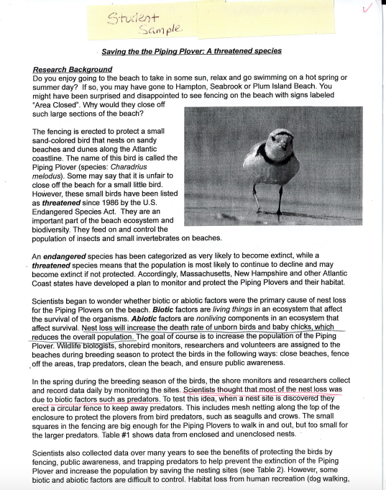
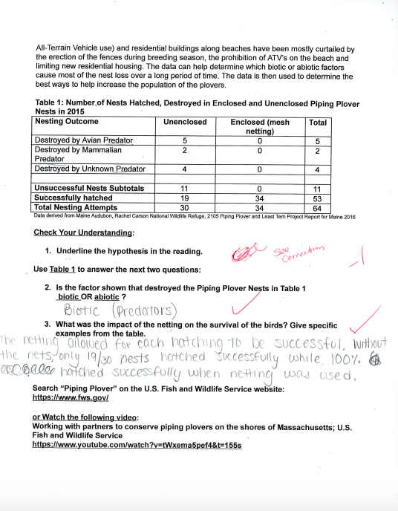
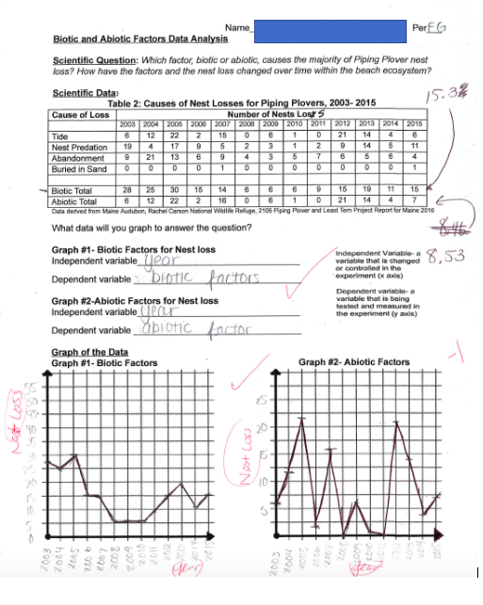
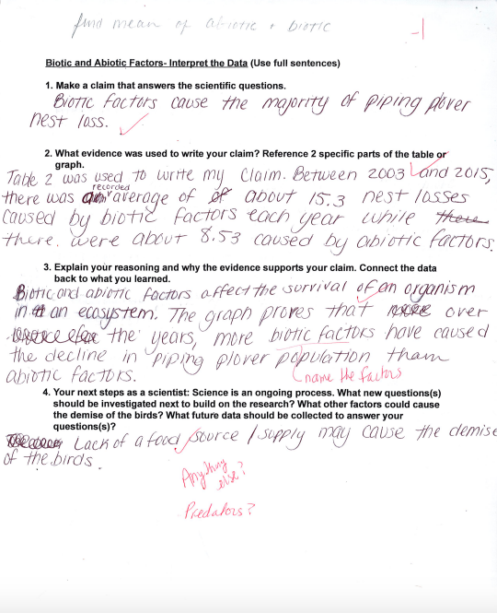

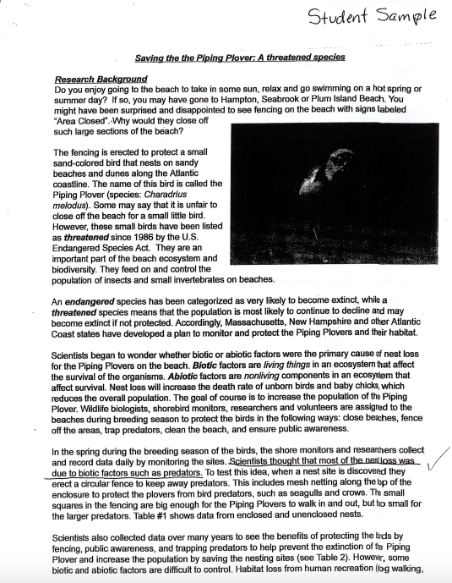

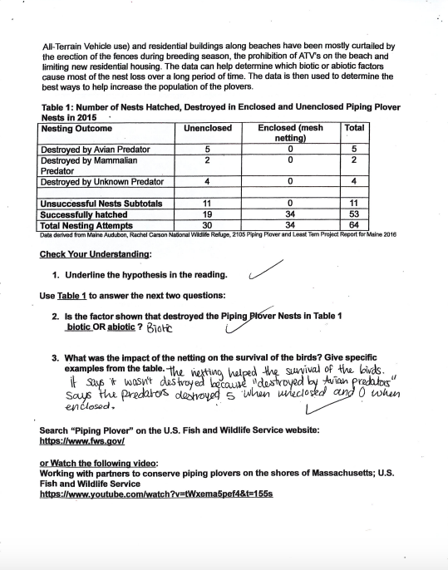
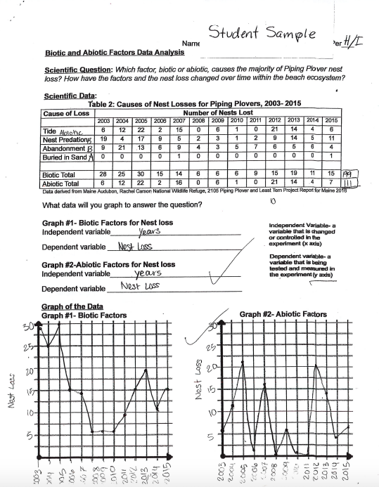

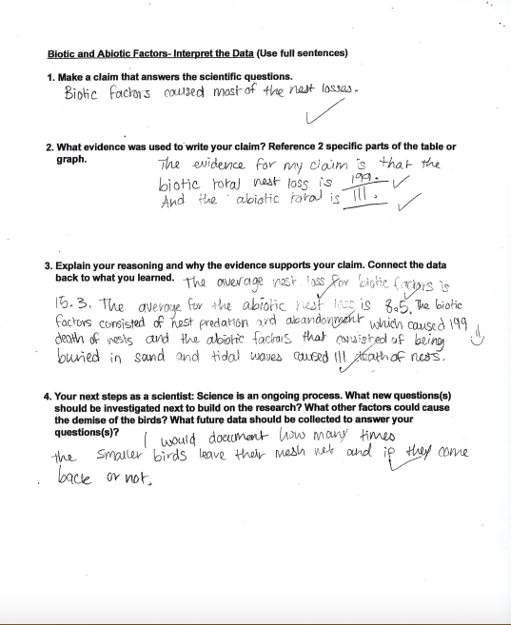

Name___________________________________________________________________________

Saving the Piping Plover: A threatened species

Research Background by Karen Blaustein, Haverhill High School, Haverhill, MA
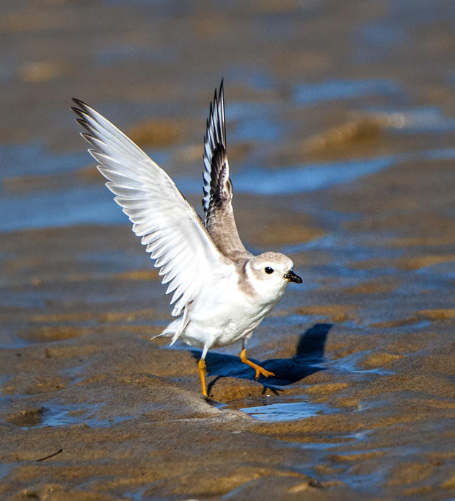
Do you enjoy going to the beach to take in some sun, relax and go swimming on a hot spring or summer day? If so, you may have gone to the beaches of Hampton and Seabrook, NH, or Salisbury and Plum Island, MA. You might have been surprised and disappointed to see fencing on the beach with signs labeled “Area Closed”. Why would they close off such large sections of the beach?

The fencing is erected to protect a small sand-colored bird that nests on sandy beaches and dunes along the Atlantic coastline. The name of this bird is called the Piping Plover (species: Charadrius melodus). Some may say that it is unfair to close off the beach for a small little bird. However, these small birds have been listed as threatened since 1986 by the U.S. Endangered Species Act. They are an important part of the beach ecosystem and biodiversity. They feed on and control the population of insects and small invertebrates on beaches.

An endangered species has been categorized as very likely to become extinct, while a threatened species means that the population is most likely to continue to decline and may become extinct if not protected. Accordingly, Massachusetts, New Hampshire and other Atlantic Coast states have developed a plan to monitor and protect the Piping Plovers and their habitat.

Scientists began to wonder whether biotic or abiotic factors were the primary cause of nest loss for the Piping Plovers on the beach. Biotic factors are living things in an ecosystem that affect the survival of the organisms. Abiotic factors are nonliving components in an ecosystem that affect survival. Nest loss will increase the death rate of unborn birds and baby chicks, which reduces the overall population. The goal of course is to increase the population of the Piping Plover. Wildlife biologists, shorebird monitors, researchers and volunteers are assigned to the beaches during breeding season to protect the birds in the following ways: close beaches, fence off the areas, trap predators, clean the beach, and ensure public awareness.

In the spring during the breeding season of the birds, the shore monitors and researchers collect and record data daily by monitoring the sites. Scientists thought that most of the nest loss was due to biotic factors such as predators. To test this idea, when a nest site is discovered they erect a circular fence to keep away predators. This includes mesh netting along the top of the enclosure to protect the plovers from bird predators, such as seagulls and crows. The small squares in the fencing are big enough for the Piping Plovers to walk in and out, but too small for the larger predators. Table #1 shows data from enclosed and unenclosed nests.

Scientists also collected data over many years to see the benefits of protecting the birds by fencing, public awareness, and trapping predators to help prevent the extinction of the Piping Plover and increase the population by saving the nesting sites (see Table 2). However, some biotic and abiotic factors are difficult to control. Habitat loss from human recreation (dog walking, All-Terrain Vehicle use) and residential buildings along beaches have been mostly curtailed by the erection of the fences during breeding season, the prohibition of ATV’s on the beach and limiting new residential housing. The data can help determine which biotic or abiotic factors cause most of the nest loss over a long period of time. The data is then used to determine the best ways to help increase the population of the plovers.

Table 1: Number of Nests Hatched, Destroyed in Enclosed and Unenclosed Piping Plover Nests in 2015
Nesting Outcome | Unenclosed | Enclosed (mesh netting) | Total
Destroyed by Avian Predator | 5 | 0 | 5
Destroyed by Mammalian Predator | 2 | 0 | 2
Destroyed by Unknown Predator | 4 | 0 | 4
Unsuccessful Nests Subtotals | 11 | 0 | 11
Successfully hatched | 19 | 34 | 53
Total Nesting Attempts | 30 | 34 | 64
Data derived from Maine Audubon, Rachel Carson National Wildlife Refuge, 2015 Piping Plover and Least Tern Project Report for Maine 2016

Check Your Understanding:

- Underline the hypothesis in the reading.

Use Table 1 to answer the next two questions:

- Is the factor shown that destroyed the Piping Plover Nests in Table 1
biotic OR abiotic? Explain your reasoning. Give examples from Table 1.

- What was the impact of the netting on the survival of the birds? Give specific data from the table.

Search “Piping Plover” on the U.S. Fish and Wildlife Service website: https://www.fws.gov/

or Watch the following videos:
https://www.youtube.com/watch?v=XHtTp45giCw

Working with partners to conserve piping plovers on the shores of Massachusetts; U.S. Fish and Wildlife Service
https://www.youtube.com/watch?v=tWxema5pef4&t=155s

Biotic and Abiotic Factors Data Analysis

Scientific Question: Which factor(s) has the greatest impact on Piping Plover nest loss?

Scientific Data:

Table 2: Causes of Nest Losses for Piping Plovers, 2003- 2015
Cause of Loss | Number of Nests Lost
 | 2003 | 2004 | 2005 | 2006 | 2007 | 2008 | 2009 | 2010 | 2011 | 2012 | 2013 | 2014 | 2015 | Total | Mean
Tide | 6 | 12 | 22 | 2 | 15 | 0 | 6 | 1 | 0 | 21 | 14 | 4 | 6
Nest Predation | 19 | 4 | 17 | 9 | 5 | 2 | 3 | 1 | 2 | 9 | 14 | 5 | 11
Abandonment | 9 | 21 | 13 | 6 | 9 | 4 | 3 | 5 | 7 | 6 | 5 | 6 | 4
Buried in Sand | 0 | 0 | 0 | 0 | 1 | 0 | 0 | 0 | 0 | 0 | 0 | 0 | 1
Biotic Total | 28 | 25 | 30 | 15 | 14 | 6 | 6 | 6 | 9 | 15 | 19 | 11 | 15
Abiotic Total | 6 | 12 | 22 | 2 | 16 | 0 | 6 | 1 | 0 | 21 | 14 | 4 | 7
Data derived from Maine Audubon, Rachel Carson National Wildlife Refuge, 2015 Piping Plover and Least Tern Project Report for Maine 2016

Are the factors Biotic or Abiotic? Write A (Abiotic) or B (Biotic) below:

Dependent Variable- the variable being measured in the experiment. Located on the y axis.
Independent variable- the variable controlled in the experiment to get the results. Located on the x axis. Hint: it is usually time or age.

Tide ______ Nest Predation______ Abandonment______ Buried in sand______

What data will you graph to answer the question?
Graph #1- Biotic Factors for Nest loss
Dependent variable________________________________

Independent variable ______________________________

Graph #2-Abiotic Factors for Nest loss
Dependent variable________________________________

Independent variable ______________________________

Graph of the Data- Label the x and y axis

Graph #1- Biotic Factors Graph #2- Abiotic Factors

To help you Interpret the Data. Below, calculate the total nest loss of both the biotic and abiotic factors.

Biotic nest loss (total) = ________________ Abiotic nest loss (total)= _______________

Biotic and Abiotic Factors- Interpret the Data from Table 2 (version 1)

Provide an explanation that answers the scientific question: Which factor(s) has the greatest impact on Piping Plover nest loss?

Ensure that claims are supported by evidence, and that the reasoning between the claim and evidence is strong and clear. Finally, include recommendations for further research and data collection in order to deepen scientific understanding of this topic.

Biotic and Abiotic Factors- Interpret the Data from Table 2 (version 2) (Use full sentences)

- Make a claim that answers the scientific question: Which factor(s) has the greatest impact on Piping Plover nest loss?

- What evidence was used to write your claim? (Reference specific data from the tables above to support your claim.)

- Explain your reasoning and why the evidence supports your claim. Name the biotic and/ or abiotic factors that cause the nest loss.

- Your next steps as a scientist: Science is an ongoing process. What new questions(s) should be investigated next to build on this research? What other factors could cause the decline of this bird population? What future data should be collected to answer your questions(s)?

Appendix A - Additional nesting data.

 | Number of Nesting Piper Plover Pairs, Totals 2003-2015
Year | 2003 | 2004 | 2005 | 2006 | 2007 | 2008 | 2009 | 2010 | 2011 | 2012 | 2013 | 2014 | 2015 | Total | Mean | Median
# of nesting pairs | 61 | 55 | 49 | 41 | 35 | 24 | 27 | 30 | 33 | 42 | 44 | 50 | 62
Data derived from Maine Audubon, Rachel Carson National Wildlife Refuge, 2015 Piping Plover and Least Tern Project Report for Maine 2016

