Task-level phenomenon:
Students see data on the use of seatbelts and watch videos showing a car crash with seat belts vs. no seat belts. Note: Please take precaution, as you may have students in your classroom that have experienced accidents or losses from an accident like these.

Synopsis of high-quality task:
This task is part of a three-lesson sequence. This is the first part in the sequence, followed by Crash Test Investigation, and Seatbelt Prototype Design, which are posted on the STEM Ambassador website. In this task, students analyze real-world seat belt data (reasons why drivers do or do not wear seat belts), and design, and carry out two investigations. For this task, students must propose a solution to why some people refuse to wear seatbelts, give evidence and reasoning from data sets. They then engage in an discussion that provides a formative assessment as to students’ understandings of the data they interpreted and their ability to use evidence-based argumentation to support a claim statement.

Anticipated student time spent on task: 1 session, 55 minutes

Type of Task:
____ 1. Investigation/experimentation/design challenge
__x_ 2. Data representation, analysis, and interpretation
____ 3. Explanation

Student task structure(s): group work
STE Standards and Science and Engineering Practices:

Standards:
HS-PS2-1 Analyze data to support the claim that Newton’s second law of motion is a mathematical model describing change in motion (the acceleration) of objects when acted on by a net force.
Clarification Statements:
- Examples of data could include tables or graphs of position or velocity as a function of time for objects subject to a net unbalanced force, such as a falling object, an object rolling down a ramp, and a moving object being pulled by a constant force.
- Forces can include contact forces, including friction, and forces acting at a distance, such as gravity and magnetic forces.
State Assessment Boundary:
- Variable forces are not expected in state assessment

Science and Engineering Practices:
- Analyzing and Interpreting Data
- Engaging in Arguments from Evidence

Prior Knowledge:
Previous Standard from Strand Map:
8.MS-PS2-2. Provide evidence that the change in an object’s speed depends on the sum of the forces on the object (the net force) and the mass of the object.
Clarification Statement:
- Emphasis is on balanced (Newton’s first law) and unbalanced forces in a system, qualitative comparisons of forces, mass, and changes in speed (Newton’s second law) in one dimension.
State Assessment Boundaries:
- State assessment will be limited to forces and changes in motion in one dimension in an inertial reference frame and to change in one variable at a time.
- The use of trigonometry is not expected in state assessment.

Considerations for the teacher concerning prior knowledge:
- It cannot be assumed that all students have had experience driving in cars or wearing seatbelts. Especially in the urban environment where travel by subway and buses (which don’t use seatbelts) is common, some students may not be as familiar with seat belt use. Some discussion about seat belts and showing of seatbelts in cars (pictures) may be required.
- Groups are encouraged to use the Claim, Evidence, Reasoning format for their interpretations of data and explanation of results. Some students may not be familiar with this format of argumentative reasoning and may need some scaffolding.
- Understanding of qualitative and quantitative data.

Connections to the real-world:
- Driver safety and fatalities from car crashes are a reality.
- Seat belts are a real-world device that save lives, yet many students probably have someone they know that refuses to “buckle-up.”
Mastery Goals:
Learning Objective:
- Analyze data and related phenomena in order to explain how seatbelts improve safety. (Note: This objective is more thoroughly addressed if using this task with the second task in this sequence, Crash Test Investigation)

Performance Objective:
- Engage in evidence-based argumentation, utilizing real-world data from tables and graphs as resources of relevant quantitative to support a claim, and applying Newton’s Laws of Motion as the basis of reasoning for their argument (claim).

Language Objective:
- Read and interpret data sets, pictures, and diagrams, and create meaningful visual representations of experimental data, working collaboratively to orally present relevant findings and conclusions obtained from their investigation.
Teacher instructions - Instructional Tips/Strategies/Suggestions:

Introduction:
Start with a phenomenon-based Do Now that will prime students thinking and interest. Show a video of a car crash with seat belts vs. no seat belts (links included below). Note: Please take precaution, as you may have students in your classroom that have experienced accidents or losses from an accident like these. Students can write questions they have on poster papers or in a notebook. This provides an opportunity to formatively assess students’ prior knowledge and current misconceptions about motion and Newton’s Laws. Refer back to these questions throughout the task.
- Seat belt/no seat belt in the same car - https://www.youtube.com/watch?v=M70yoV2ZizY
- Restrained/unrestrained child in the same car - https://www.youtube.com/watch?v=5RkAIQ6uLxY

Extension (if doing Task 2 - Crash Investigation, omit this extension) – Ask students to describe any similarities they can think of between the seat belt phenomenon and the other phenomena shown. Facilitate a class discussion around the student’s observations and questions. Be careful at this early point in the lesson to not give corrections, answers, or information about Newton’s Laws of Motion or forces at this time. Other phenomena showing Newton’s 1st Law:
- Bike Crash - http://i.imgur.com/3fHBvDd.gif
- Next Level Tablecloth Trick - https://www.youtube.com/watch?v=o94Pm-Cty3M
- Sled Oops - https://static1.squarespace.com/static/56e316c61bbee06d13210ed6/597615d0d482e9419b219cc0/59b546e48fd4d26747fcaa70/1505413031368/sledding+inertia.gif?format=500w

Data Analysis:
Students examine data in groups (no more than 4 students per group). Project the following prompt, “Do seatbelts save lives?”.
- Prompt
- Student Worksheet
Groups should be encouraged to come up with their own interpretation of what the data/graph shows. Emphasis should be placed on coming up with specific evidence from the graph’s data to support the group’s decision, as well as including reasoning to back it up. Each group should briefly present to foster a discussion on data interpretation and using evidence obtained from data sets to prove a claim.
Note: If students have less exposure with data graphs of this type, then you can scaffold this activity by letting students look at the data and come up with questions about it. After collecting question you can then teach how to read this graph using those question.
When groups are given the next set of data (seat belt use and nonuse reasons data tables and graphs). It should be emphasized to groups that the data allows for each group can focus on a different reason (there is no “right answer”), and should be encouraged to do so, as at first many will just pick the one that has the highest percentage on the chart. However, the groups attention should be drawn to the fact that there is a disparity between the reasons for and seat belt use for those that always/never and those that sometimes wear seatbelts. Note: The data table goes beyond the graph in that it breaks the data down into different demographics (such as age and gender), which can also be a way that groups differentiate what they focus their efforts on. If the instructor likes, there are many more data sets that can be investigated at the following link:
- https://one.nhtsa.gov/people/injury/research/safetysurvey/Chapter2.html

Data-based Discussion:
- Explain that students will be discussing the question, “What is the most effective way to get people to use seat belts more?”
- Make sure that each team of 3-4 students pick a different claim on how to get people to use seatbelts. This can be done by having the class brainstorm a list of possible claims on the board and letting each team pick one that they would like to argue.
- Give students a couple minutes with their teams to prepare arguments and prepare questions to ask opposing arguments.
- Optional strategy: Use Comment/Question Cards to support students in preparing for the debate. These cards can be used during the debate to encourage and track participation
  - Count out enough index cards to give at least two out per student (provide students with as many cards as they need)
  - Split the index cards in half and write “Comment” on half and “Question” on the other half of the index cards
Students discuss:
- Students take turns using their prepared arguments and questions to discuss the prompt.
- Have one student track the discussion on the board or on poster paper.
- If using the Comment/Question Cards strategy:
  - Students cash in the appropriate card to make a comment or question and can only speak when they have a card to cash in. Students can discuss with their team and help out their team members but cannot share or trade cards.
  - Students should be encouraged to prioritize using their cards when their card is very closely related to the previous comment or question.
  - You can reward players with extra cards for making excellent points or asking important questions.
Conclude:
- When the discussion reaches an end (or there are at least 10-15 minutes remaining in the session), ask students to review the discussion summary on the board (or in their notes).
- Ask students to write down what they notice and wonder about their discussion, and have students share. These observations and wonderings can be written on the board.
- Ask students to review the class’s observations and wonderings of their discussion and propose what they might need to figure out next about this problem. Record this list. This list can be used by the teacher as a useful navigation tool to the next task in this series, Crash Test Investigation, or the next lesson.
Instructional Materials/Resources/Tools:
Include:
- Student Sheet
- Data Sheet
- Prompt (to display on the board)
- Links for phenomenon videos:
  - https://static1.squarespace.com/static/56e316c61bbee06d13210ed6/597615d0d482e9419b219cc0/59b546e48fd4d26747fcaa70/1505413031368/sledding+inertia.gif?format=500w
  - http://i.imgur.com/3fHBvDd.gif
  - https://www.youtube.com/watch?v=o94Pm-Cty3M
- Materials list (per person): 2 index cards
- Scoring rubric – Focus on including the standards-content and practices for performance criteria. Less focus should be on presentation style, design, etc. unless it is tied directly to an ELA standard.

Task Sources:
Fatalities vs Seat Belt Use graph - https://one.nhtsa.gov/people/injury/research/buckleup/ii__trends.html

The Ambassador would like to recognize Stacy-Michelle Reid and Scott Hubeny for their contributions to the development of this task.
Accessibility and Supports:
Students may require support with using the Claims, Evidence, Reasoning format if they have not had practice with it in the past. Use of an anchor chart can help students by giving them a common reference point. There are also many detailed CER rubrics on the web; one is included below.

Students should be reminded there is no one “right answer” with such a task and encouraged to explore and try various avenues in pursuit of their goal, knowing it may take a few tries to get a desired outcome.

Some students may need support with deciding what is relevant data to measure and collect, as well as the best way to organize this data for analysis and presenting. Examples of data tables and graphs can be provided as inspiration and guidance for students.

Also, students may need help in understanding that the engineering and design process involves several steps and constant evolution along the way. Remind students that the first way to approach an investigation is not always the optimum way, and constant refinement through assessing results from multiple experiments will be in order.

Word walls and/or glossary for reference can be incorporated to help students remember these key terms.

key academic vocabulary
- Inertia
- Acceleration
- Force
- Unbalanced
- Quantitative
- Qualitative
- Newton’s Laws

Sample Student Work:
No student work provided.

Name: _______________________________________________ Date: ________________
EXPLORE - Seat Belts and Safety

The National Association of Motorist Safety (NAMS) strongly believes that seatbelts save lives. They have sent you some data to support this claim. The data is organized in the graph below:

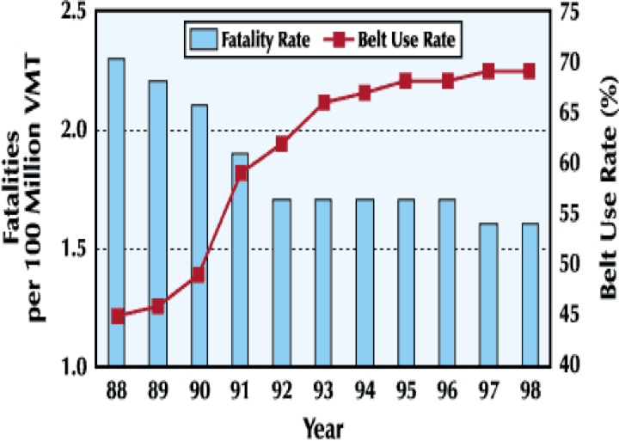

With your group members, examine the graph, and using relevant information obtained from the graph, evaluate the claim by NAMS that seatbelts save lives. Be sure to provide specific evidence to support your evaluation. You should format your response using the CER (Claims, Evidence, Reasoning) framework and write it on the lined piece of paper. Be prepared to briefly share your group’s evaluation with the class.

Name: _______________________________________________ Date: ________________

Claim: (One sentence that answers the question- Do seat belts save lives?)

Evidence: (specific data from the graph that supports your claim)

Reasoning: (Explain how the data you choose supports your claim)

Name: _______________________________________________ Date: ________________

Question: Do seatbelts save lives?

Data:

Use the CER (Claim, Evidence, Reasoning) format to answer the question!
Claim: One complete sentence that answers the question
Evidence: Specific Data that supports your claim
Reasoning: Explain in detail how the data supports your claim

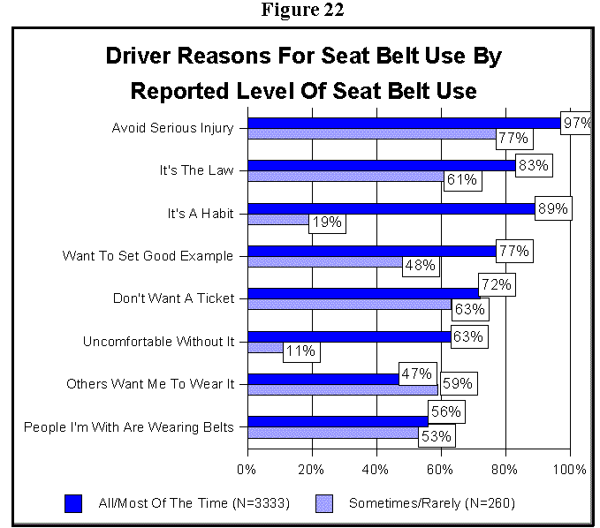

TABLE 17
Driver Reasons For Seat Belt Use By Sex And Age
Qx: When I wear my seat belt, I do so because . . . . .
Base: Drivers whose primary vehicle has seat belts, and who at least on occasion wear their seat belt.
Reason | Sex |  | Age
 | Female | Male | 16-20 | 21-64 | 65+
 | (N=1902) | (N=1692) | (N=314) | (N=2840) | (N=404)
Avoid Serious Injury | 97% | 95% | 97% | 96% | 95%
It's A Habit | 87% | 82% | 83% | 84% | 87%
It's The Law | 87% | 77% | 86% | 80% | 88%
Want To Set Good Example | 80% | 70% | 72% | 76% | 74%
Don't Want Ticket | 73% | 69% | 85% | 70% | 68%
Uncomfortable Without It | 64% | 54% | 57% | 60% | 57%
People I'm With Are Wearing Belts | 57% | 55% | 52% | 55% | 60%
Others Want Me To Wear It | 48% | 48% | 55% | 48% | 46%

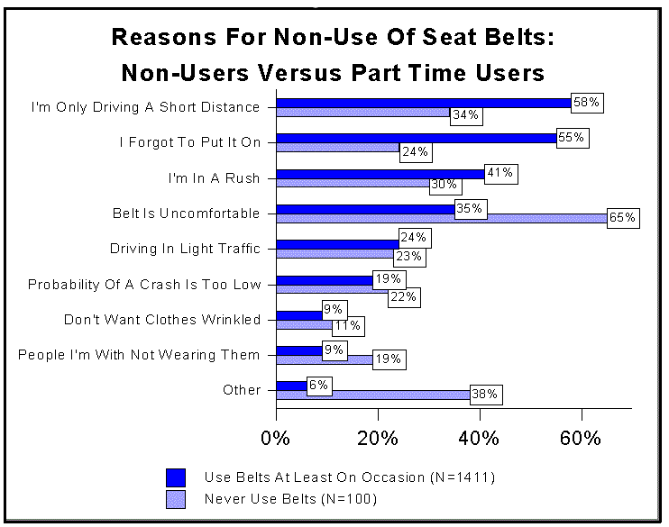

TABLE 23
Driver Reasons For Non-Use Of Seat Belts By Sex And Age
Qx: Sometimes I do not wear my seat belt because . . . . .
Base: Drivers whose primary vehicle has seat belts, and who at least on occasion do not wear their seat belt.
Reason | Sex |  | Age
 | Female | Male | 16-20 | 21-64 | 65+
 | (N=686) | (N=835) | (N=172) | (N=1207) | (N=132)
I'm Only Driving A Short Distance | 56% | 56% | 50% | 56% | 62%
I Forgot To Put It On | 50% | 55% | 60% | 53% | 47%
I'm In A Rush | 38% | 41% | 49% | 40% | 35%
The Seat Belt Is Uncomfortable | 39% | 35% | 37% | 38% | 32%
I'm Driving In Light Traffic | 20% | 27% | 26% | 24% | 22%
The Probability Of Being In A Crash Is Too Low | 13% | 24% | 17% | 20% | 21%
Don't Want My Clothes Wrinkled | 12% | 7% | 8% | 10% | 4%
People I Am With Are Not Wearing Belts | 7% | 11% | 15% | 9% | 5%
Other | 6% | 9% | 4% | 9% | 5%
CER Writing
Rubric
 | 4 Points | 3 Points | 2 Points | 1 Points | 0 Points
CLAIM  I made a statement that answers the original question. | Compelling Claim  Claim is clear and scientifically accurate | Credible Claim  Claim is clear | Partial Claim  Claim is not clearly stated. Claim reveals partial understanding | Weak Claim  An attempt at a claim is made but is minimally accurate | Invalid Claim  No identifiable statement of claim.
EVIDENCE  I supported the claim with relevant evidence using the sources provided. | Ample Evidence  Evidence is ample and incorporates both lab observations and scientific text | Sufficient Evidence  Evidence is sufficient but only comes from 1 source | Partial Evidence  Evidence is basic. Evidence reveals partial understanding | Weak Evidence  Evidence is minimal  (1 piece from 1 source) | Invalid Evidence  Evidence is unclear/not present
REASONING  I explained why the data/evidence supports the answer to the question. | Convincing Reasoning  Explicit reasoning links all evidence to the claim to show support for the answer | Well-developed Reasoning  Reasoning links most evidence to the claim  Reasoning is mostly accurate | Partial Reasoning  Explicit reasoning links some evidence to the claim | Weak Reasoning  Minimal reasoning link evidence to the claim | Invalid Reasoning  Reasoning is inaccurate or incomplete

