COMPREHENSIVE HEALTH AND PHYSICAL EDUCATION DISTRICT IMPLEMENTATION PROCESS
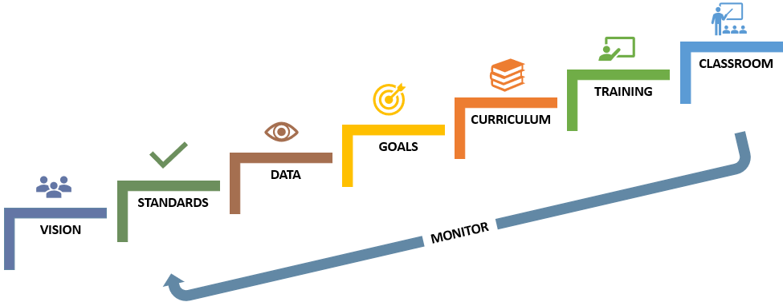
Districts across Massachusetts are in varying states of Comprehensive Health and Physical Education (CHPE) implementation. Many offer a variety of courses at the high or middle school level but few at earlier grades. The purpose of this guidance document is to assist schools and districts in analyzing their current CHPE programming and, from this analysis, design and implement a comprehensive CHPE plan that prepares all students within the district for a lifetime of health and wellness.

SET UP FOR SUCCESS
Before getting started, it is important to put several foundations in place:
- Build a team for this work. To ensure success, this team should include district and school decision makers who can support the implementation and move it forward. CHPE practices and standards are often taught across other MA curriculum frameworks and student learning experiences. Your work will be much more effective with team members who are knowledgeable about current CHPE practices, who may be key in implementing future CHPE curricula, and/or who can support decision making and implementation. It is recommended that your team consists of at least:
  - 1 district administrator
  - 1 building administrator
  - 1 CHPE teacher
  - 1 CHPE curriculum leader, if this role exists in your district
- Know where to get data on CHPE enrollment with demographics on enrollment such as gender, race/ethnicity, students with disabilities (SWD), English learners (ELs), and Economically Disadvantaged. Identify who in the district can provide course and enrollment data or identify the district process to request data. Often a registrar or guidance department can provide this data or you can access the DESE List of District Data Directory Administrators.
- Attend a CHPE training with your team.

OVERVIEW OF THE PROCESS
The CHPE District Implementation Process steps may be used to complete a thoughtful CHPE curriculum and implementation analysis. These steps are intended to be a guideline for your work, but your district context may call for changes to these steps in some way. To further assist you in curriculum selection work, DESE offers an Evaluating & Selecting Network which can guide you through the steps of evaluating and selecting high quality curricula for your implementation. Visit IMplement MA for more information on this network.

DISTRICT and SCHOOL VISION
It is important that your team is clear about the vision and goals of a district and school CHPE program. Throughout this process you will reflect on how your work and choices advance the vision and goals or whether they need to be adjusted as you progress through the process.

MAP STANDARDS
Align your district's current implementation of CHPE curricula and learning opportunities to the CHPE Curriculum Framework (2023). Create spreadsheets to record where CHPE practices and standards are currently being addressed in school curriculum by making copies of the templates below:
PK-2 Standards Alignment Spreadsheet
3-5 Standards Alignment Spreadsheet
6-8 Standards Alignment Spreadsheet
9-12 Standards Alignment Spreadsheet
PK-12 Standards by Sub-Discipline Alignment Spreadsheet
- Identify in which classes or courses CHPE practices and standards are being addressed. Look across the curriculum! For example, CHPE practices and standards may be addressed in subjects such as SEL, Digital Literacy & Computer Science, and Science & Technology/Engineering.
- In your grade span spreadsheets, on the first tab, indicate in relevant cells where a particular standard is taught and leave cells blank if the practice or standard is not addressed. Also, indicate if a practice or standard is taught in depth, only touched upon, or will be taught in the future.
- On the second tab, include basic information for each class or course (such as grade level, whether it is required or elective, and student contact hours).

COLLECT CHPE DATA
Obtain data for each course identified. Data can include:
- Course code #
- Student enrollment; current and over time
- Student demographics; current and over time
- Other data or details as desired, particularly to examine access and performance of different student populations.
- Use the Data Template Spreadsheet with Pivot Tables (this will ask you to make a copy in your Google Drive. Once it opens, you may use File > Move to move it where you want in your Google Drive). This template provides you with sample data to collect and how to analyze it to recognize participation rates of various student populations. Understanding gaps in participation within your district will help you to focus your efforts on equitable access and participation in CHPE.
  - Raw data should be available from your district data office/person. The template spreadsheet provides an example of what can be done with the data. Additional district data may be available that can support even further analysis.

ANALYZE CHPE DATA
Using your STANDARDS MAP Spreadsheet and CHPE DATA, engage your team in an examination of program strengths and needs. The following sample facilitation questions may also be useful:
- Do all students have access to CHPE curricula in all grades? All student populations, including SWD and ELs?
- Do our current offerings provide opportunities to learn all CHPE practices and standards (a comprehensive approach)? What are our strengths? Key needs?
- How can we enhance access, opportunity, and interest to learn CHPE practices and standards for all students, and all student populations?
- What grade levels, CHPE practices, and/or standards need enhancement? Aim to comprehensively address CHPE practices and standards.
- What are the particular curricular design features and instructional strategies that our current CHPE programming emphasizes? How do those relate to other curriculum framework areas?
- What are the particular curricular design features, format, or themes (e.g., integrated; stand-alone; project-based; web-based) that will complement or advance existing programming?
- What is offered to students in the grade(s) above and/or below, and how do those experiences contribute to student needs at the grade(s) being examined?
- Are certain student groups reflected and centered in the curricula while other groups (e.g., BIPOC, LGBTQ+, SWD, EL) are not?
- How are we ensuring that CHPE content is reflecting student voice and interests, including those from underrepresented groups?
- Are there any infrastructure needs (e.g., schedule, time, number of teachers, number of course sections) that are impacting student participation?

SET GOALS FOR THIS YEAR
After planning your current implementation and analyzing your district data, assess where your district is in relation to DESE’s Educational Vision. Use this assessment to determine achievable goals for the year towards this vision and to determine the pathways from one grade to another. Building a strong CHPE implementation plan in a district typically requires a phased approach with an implementation focus on one grade span per year. We recommend beginning with middle school the first year and expanding to high school or elementary (K-2 or 3-5) in subsequent years. Include in your goals how you will select educators, provide training, and support them throughout the school year implementation.
Based on your identified goals, consider the following areas that will help you address priority areas:

SELECT CURRICULUM
Choose core curricula (supplementary in subsequent years) to enhance your CHPE program and student learning opportunities.
- Use the curriculum summaries in the Massachusetts CHPE Curriculum Guide to identify potential core curricula that help meet needs identified in the Data and Goals steps, above. Select a core curriculum for each grade span and, only once that core curriculum has been implemented, supplementary curricula may be added in subsequent years as the CHPE Curriculum Guide is updated.
- Identify necessary teacher professional development and materials needed to pilot a curricular choice.
- Plan a support team or PLC for teacher(s) piloting the course either within your district or with other districts.

ATTEND TRAINING
Successful implementation of any curricular materials is enhanced when participating educators and school leaders are provided professional development on the guiding principles, practices, and standards of the CHPE Framework. Training prior to initial implementation and periodic support for participating educators during implementation helps ensure that students engage with the curriculum as intended, and adjustments made to account for local conditions are consistent with the implementation plan. CHPE Professional Development opportunities can be found on the CHPE Webpage.

IMPLEMENT CURRICULUM and MONITOR
Once a curriculum choice is established, and educators have engaged in relevant training, school and district efforts are on implementation and monitoring. There should be a specific focus on equity with culturally and linguistically sustaining pedagogy to engage all students in CHPE curricula. Support for teachers implementing a new curriculum can include a district or regional professional learning community (PLC).
Districts may reference implementation guidance provided by the IMplement MA Process.
Remember that CHPE Implementation for districts will, most likely, be a phased approach. You may elect to implement new curricula and courses at only one grade, or you may select an entire grade span. Plan for a three or four year implementation plan with time set aside in those years to monitor and review each step of the process before setting goals for the next year. The critical focus each year of implementation will be on providing support for your teachers with initial PD and follow-up meetings, ensuring equity in the curriculum with culturally and linguistically sustaining pedagogy to ensure all students are engaged in CHPE topics, and providing opportunities and encouragement for all students to continue engaging with CHPE practices as they move into high school and beyond.

