Mathematics Learning Community

Number Sense
Session 10

Title: Interpreting Remainders in Division Contexts

Common Core State Standards Addressed in the LASW Problem:
4.OA.3 | Solve multi-step word problems posed with whole numbers and having whole-number answers using the four operations, including problems in which remainders must be interpreted. Represent these problems using equations with a letter standing for the unknown quantity. Assess the reasonableness of answers using mental computation and estimation strategies including rounding.
5.NF.3 | Interpret a fraction as division of the numerator by the denominator (a/b = a ÷ b). Solve word problems involving division of whole numbers leading to answers in the form of fractions or mixed numbers, e.g., by using visual fraction models or equations to represent the problem.

Standards for Mathematical Practice Addressed in the MLC Session:
1: Make sense of problems and persevere in solving them. 3: Construct viable arguments and critique the
4: Model with Mathematics. reasoning of others.

During this session, MLC members work in-depth with division problems leading to quotients that are not whole numbers. Making sense of what to do with a remainder depends upon the context of the problem situation. MLC members, and students alike, write story problems that models a division problem and then argue why their given problem context results in a particular solution. Through this justification is where a deeper understanding of division as an operation develops.

Standards-Based Teaching and Learning Characteristics in Mathematics Addressed in the MLC Session:
- 5.1 Depth of content knowledge is evident throughout the presentation of the lesson.
- 5.2 Through the use of probing questions and student responses, decisions are made about what direction to take, what to emphasize, and what to extend in order to build students’ mathematical understanding.
- 5.3 Students’ prior knowledge is incorporated as new mathematical concepts are introduced.
- 5.4 Student misconceptions are anticipated /identified and addressed.
- 5.5 Classroom strategies incorporate multiple forms of representation.

Session Agenda:
Part I: Mathematical Background

Part II: Math Metacognition

Part III: Looking at Student Work
- Writing Word Problems for 44÷6 (Grade 8)
Part IV: Our Learning

Part V: Feedback and Wrap-up

Materials Needed for this Session:
- Nametags | - Chart paper and markers | - Copies of handouts
- Index cards | - Refreshments | - Highlighters

Possible Ways to Personalize this Session:
- Four student work samples are provided for the LASW problem in this session. However, members of your group may be interested in providing some samples of their own student work. See Page 5 in Part III for more details.
- If your group is interested in extending the content of this session, you can consider the additional problem solving scenarios mentioned on Page 5 in Part III.
- Two Guiding Questions are provided in the Student Work Analysis Grid – the other two can be selected by you or by the group.
Part I: Mathematical Background
Approximate Time: 20 minutes
Grouping: Whole Group

- Welcome members of your group to the Math Learning Community. Remind group of established norms.

- Today’s Content:
  - The mathematics during this session focuses on division and the connections this operation has to fractions.
  - What do we need to know in order to be able to divide fluently? To work fluently with fractions?
  - Chart ideas to refer to during the Protocol for LASW.

- Relating Content to the Three C’s Theme:
  - How does the context of a division situation affect strategy and solution? How does this context relate to what we do when we can no longer fair share?
  - For example, consider the context from the children’s book The Doorbell Rang by Pat Hutchins in which more and more people need to share the same quantity of cookies.
  - Division also represents a ratio, the comparison of two quantities. This ratio can be scaled up or down to create a proportional relationship. For example, a small inn has 4 rooms on each floor. So, 1 floor: 4 rooms, or 2 floors: 8 rooms, or 3 floors: x rooms. When one charts this in fraction notation, it can be thought of as floors per room or as rooms per floor. The same relationship holds constant no matter how many floors you have. If you scale the ratio up or scale it down, one must either multiply or divide.
  - Problem context dictates how the remainder in a division problem is to be interpreted.

Part II: Math Metacognition
Approximate Time: 30 minutes
Grouping: Individual work
Sharing problems: whole group

- Ask group members to complete the following task:

- Write a division problem (two-digit number divided by a one-digit number) where you have a remainder.
- Write a word problem that models this division problem.
- Write a brief explanation interpreting your remainder.

- Solution: Multiple responses to this problem. Some example solutions include:

- 17 4 = ?
- I have 17 toy cars in my toy box. 3 of my friends are coming over to play with me and my cars. If the cars are shared fairly, how many will each person get and will I have any left?
- 1 car remains that no one will be able to use.
- 34 5 = ?
- I am making 5 egg custard pies. I have 34 eggs to use to make the pies. How many eggs will go into each pie and how many will I have left?
- 4 eggs will remain that will not be used in any pie.

- Problem Intent: NOTE: The problem intent for all Math Metacognition problems is the same. See Session 2 for more information.

- Points for Group Discussion:
- With this division task, participants will have to select a context where it is not reasonable to share the remainder. This problem serves as a way to get started on interpreting remainders and quotients within different problem contexts.
- When exploring the operation of division within the classroom, many teachers often teach students the traditional algorithm and then, when expressing a solution to the problem, insist that students use a remainder notation or that they express the remainder as a fraction or a decimal. If we give the problem a context, does this process continue to make sense? Since the context gives meaning to the quantity of the remainder, it is important to interpret the remainder specific to that given context.
- In the real world, we know that we would have one toy car left over, but notice the difference in the correct solutions, based on the way in which the problem is worded:
Word Problem | Word Problem Rewrite
I have 17 toy cars in my toy box. 3 of my friends are coming over to play with me and my cars. If the cars are shared fairly, how many should each person get?  ANSWER: 4 | I have 17 toy cars in my toy box. 3 of my friends are coming over to play with me and my cars. If the cars are shared fairly, how many should each person get and will I have any left?  ANSWER: 4 R 1

- What does the R 1 mean? It is the last part of the question that gets at the remainder. Without it, the true answer to the stated problem is 4.

- If you or your MLC needs further insight with remainders or want additional practice problems, refer to pages 91 – 92 in Math Matters: Understanding the Math You Teach Grades K – 8 by S. Chapin and A. Johnson.

Part III: Looking at Student Work (LASW)
Approximate Time: 50 minutes
Grouping: Refer to protocol

- Complete the MLC protocol with the group.

- Problem: The problem used for this session was given to students in Grade 8 to solve:

1. Write a word problem for 44 ÷ 6 where the answer to the problem is 7.
2. Write a word problem for 44 ÷ 6 where the answer to the problem is 7 or 8.

- Solution: Multiple responses are possible for each problem. Some example solutions include:
1.
- I had 44 pizzas to share fairly with 6 classes. How many pizzas would each class get?
- 44 feet of ribbon was purchased to make some curtains. 6 windows in the room need curtains. How much ribbon can be used for each curtain?

2.
- 44 roses were delivered to go into 6 vases for the banquet. How many roses will go into each vase if we use all of the roses?
- 44 people are coming to a party. There are 6 tables at the party to sit at. How many people will be seated at each table?

- Problem Intent: This problem brings up several interesting questions for the group to ponder:
  - What is the evidence of student understanding of division when interpreting how a division context would dictate that a remainder be expressed as a fraction?
  - What is the evidence of student understanding of division when interpreting how a division context would require rounding up or down to one of two whole numbers?
  - What is the prior knowledge that students use to enter a division problem? How do their strategies relate to our strategies discussed during the Math Metacognition?

- Misconceptions/Questions that May Arise:
  - Students will often select a context for the first problem that would not lead to interpreting the remainder as a fractional part (i.e., gold bars, cans of soda, people).
  - Likewise, they may select a context for the second problem that would not lead to two possible whole number quotients. This is evident by phrases such as: “if the remaining items are to be shared or given away or left over….”
  - When a verbal representation (word problem) does not match the numerical, this is evidence that the students are moving in and out of their understanding of division in context.

Part III: Looking at Student Work (LASW), continued

  - The context of the word problem solidifies the meaning of the mathematics, and thus the remainder. Only with naked numbers does one hear the phrase “remainder 2.” Only in certain contexts do we have a visual image of what is left over. (i.e., shells). If we consider the context 44 shells shared fairly amongst 6 children, the interpretation of the remainder can or cannot be expressed – either answer would be correct in a context with discrete quantities such as shells. The question “How many shells does each child receive?” is still answered.

Options for Customization

- Guiding Questions: Two Guiding Questions have been provided in the Student Work Analysis Grid for this problem. As a way to customize the LASW process, you (or your group) will need to decide on the remaining two questions. You can use the two questions listed below that are specific to this problem or refer to the list of generic questions found on Page 5 in Session 7.
  - Does the word problem actually lead to the answer requested?
  - Does the student’s understanding of division vary in the two different problem scenarios?

- Using A Group Member’s Student Work:
  - Prior to offering this session to your MLC, you would need to collect student work samples for the task: Writing Word Problems for 44÷6
  - See Page 5 in Session 7 for more details on collecting student work samples. For this task, select 4 samples to discuss during the MLC session. Prior to photocopying samples, mark them as A, B, C and D.

- Consider working on the following scenarios to extend your group’s thinking about the ideas presented in the LASW problems:

Ms. Smith’s math class had the following math problem: 44 ÷ 6 = ?

- Max answered 7 R 2. Write a word problem that would represent his thinking.
- Lydia answered 7. Write a word problem that would represent her thinking.
- Mason answered 8. Write a word problem that would represent her thinking.
- Ali answered 7.33…. Write a word problem that would represent her thinking.

Note: Our intent with LASW Problem #2 was that the solution was “7 or 8.” Some of your group members (and some students) will interpret this as “7” or “8.” Regardless of the interpretation, the problem is still worthy of discussion and brings forward interesting mathematics to ponder. See below for examples of how these different interpretations can lead to different word problems:

44 people are coming to a  party. There are 6 tables at the party at which people can sit. How many people will be seated at each table, if seating is divided as evenly as possible?  Answer: 7 or 8  Some tables will have seven people seated at them, and some tables will have eight. | I have 44 toy cars in my toy box. 5 of my friends are coming over to play with me and my cars. If the cars are shared fairly, how many should each person get?  Answer: 7  To share fairly, the quotient needs to be rounded down - each child will have seven cars with which to play. | 44 students are going on a field trip. 6 students can fit in each van. How many vans are needed to go on the trip?  Answer: 8  To accommodate all students, the quotient needs to be rounded up to the nearest whole number.

Part IV: Our Learning
Approximate Time: 20 Minutes
Grouping: Whole Group

- Discussion: After evidence of student understanding has been discussed as a whole group, you want to facilitate discussion around how the LASW process will impact what teachers do within their classrooms. Some questions to help guide discussion include:
- What do we take away after LASW?
- What did we learn? About student thinking? About our own knowledge?
  - Refer back to chart made at the beginning of the session
- How does today’s session relate to important mathematical content and pedagogy?
- How does it impact my practice at my grade level? (Note: In order to help teachers connect this session to the mathematics within their own grade level refer to the information below).

Making Connections Across the Grade Levels

K – 2: Work with division naturally follows from students’ work with counting and with subtraction, along with their real-life experiences in fair sharing. The concept of fractions develops from their early experiences in which fair sharing is impossible (K.CC.4, K.CC.5, 1.OA.1, 1.G.3, 2.OA.1, 2.G.3).

3 – 5: Division as both a concept and a skill are developed during upper elementary school. In addition, fraction understanding begins to truly emerge here, and division as an operation is extended to work with decimals and fractions. The LASW problem is appropriate for this grade band to explore and specifically addresses learning standards 4. OA.3 and 5.NF.3 (3.OA.2, 3.OA.3, 3.OA.4, 3.NF.1, 3.G.2, 4.NBT.6, 4.NF.1, 5.NBT.6, 5.NBT.7, 5.NF.7a-c).

6 – 8: Fluency with the standard division algorithm is expected in this grade band (6.NS.1). Becoming fluent with fractions should be a mathematical goal for all middle school students. The “pinnacle” of fraction understanding often comes with interpreting division of a fraction by a fraction, which is explored here (6.NS.1). In addition, division is extended to include integers and numbers expressed in scientific notation (7.NS.2a-d, 7.NS.3, 7.EE.1, 7.EE.3, 8.EE.3). The LASW problem is appropriate for this grade band to explore.

- Writing a Problem or a Task: As a way to synthesize learning from today’s session, ask MLC members to come up with a math problem or task that would embody the ideas discussed today. The problem should be appropriate to use at their grade level. Writing these problems will help both you as the facilitator and the other group members to develop a stronger sense of how these mathematical ideas show up in classrooms from grades K – 8. (Note: See Part IV in Session 1 for more details).

Part V: Feedback & Wrap-up
Approximate Time: 5 Minutes
Grouping: Individual

- Closing: Close the session with a message such as: “Hope you leave here with more questions – about student thinking, about your teaching, and ways that we as a group can help support one another.” Have group members keep in mind the following: Dialogue, Reflection, and Inquiry are the keys to successful learning.

- Exit Cards: Pass out exit cards for group members and ask them to provide some feedback to you as the facilitator. Select one or two questions from the list below to help them summarize their thinking about the mathematics from today’s session. Collect exit cards so that a summary can be shared during the next session.

Feedback / Exit Card Questions

- How does the mathematics that we explored connect to your own teaching?

- How do I see what we’ve done today relate to key mathematical ideas or pedagogical content knowledge?

- What idea or discussion topic did you find most interesting from today’s session. Why?

- How was this session for you as a learner?

- What ideas were highlighted for you in today’s session that you had not previously considered?

- What are you taking away from today’s session?

Related Student Discourse Video Clips – LASW Problem

Content-Focused Coaching
Disc 3: Grade 4
Problem: Four people share 7 brownies

Lenses on Learning
Video – Course 1
Problem: 6 kids share 14 brownies

Session References

- Content-Focused Coaching: Transforming Mathematics Lessons, by L. West and F. Staub, Heinemann/University of Pittsburgh, 2003.
- The Doorbell Rang by Pat Hutchins, HarperCollins, 1989.
- Lenses on Learning: “Course 1: Instructional Leadership in Mathematics,” by C. Grant, et. al., Dale Seymour Publications, 2003.
- Math Matters: Understanding the Math You Teach Grades K – 8 by S. Chapin and A. Johnson, Math Solutions Publications, 2006.

Math Metacognition

- Write a division problem (two-digit number divided by a one-digit number) where you have a remainder.

- Write a word problem that models this division problem.

- Write a brief explanation interpreting your remainder.
LASW Problem

1. Write a word problem for 44 ÷ 6 where the answer to the problem is 7 .

2. Write a word problem for 44 ÷ 6 where the answer to the problem is 7 or 8.

Student Work Analysis
Problem: Writing Word Problems for 44 ÷ 6 Grade Level: 8

Student A
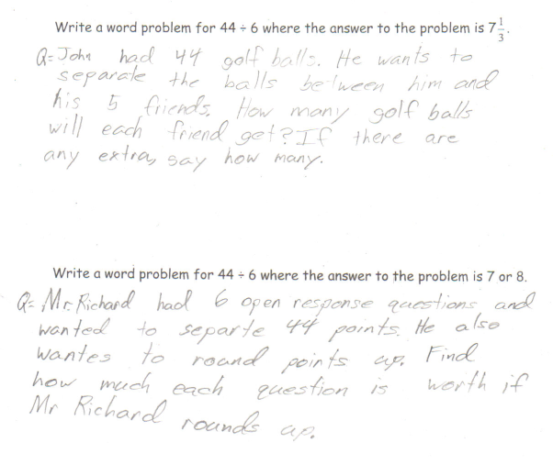

Student Work Analysis
Problem: Writing Word Problems for 44 ÷ 6 Grade Level: 8

Student B
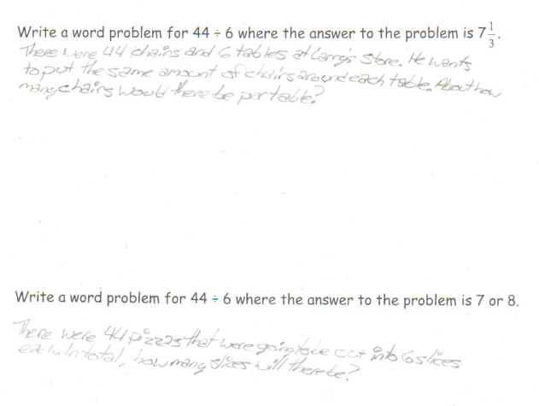

Student Work Analysis
Problem: Writing Word Problems for 44 ÷ 6 Grade Level: 8

Student C
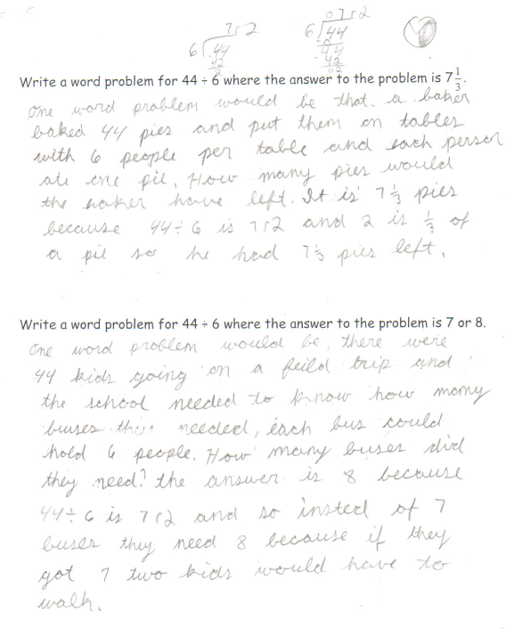

Student Work Analysis
Problem: Writing Word Problems for 44 ÷ 6 Grade Level: 8

Student D
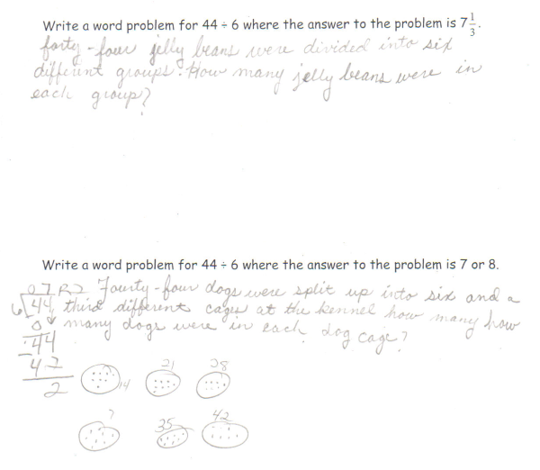
Student Work Analysis for: Writing Word Problems for 44÷6

Student | Is the problem context appropriate and accurate? | What evidence is there of the student’s understanding of division?
A
B

C

D

