Mathematics Learning Community

Number Sense
Session 5

Title: Subtraction Strategies

Common Core State Standards Addressed in the LASW Problem:
7.NS.1c – d | Apply and extend previous understandings of addition and subtraction to add and subtract rational numbers; represent addition and subtraction on a horizontal or vertical number line diagram.  - Understand subtraction of rational numbers as adding the additive inverse, p – q = p + (–q). Show that the distance between two rational numbers on the number line is the absolute value of their difference, and apply this principle in real-world contexts.  - Apply properties of operations as strategies to add and subtract rational numbers.

Standards for Mathematical Practice Addressed in the MLC Session:
2: Reason abstractly and quantitatively. 5: Use appropriate tools strategically.

During this session, subtraction is explored, both with mental computation involving whole numbers and then with translation of written language in order to determine the difference between a negative integer and an unknown value. Teachers are asked to grapple with the disconnect that often exists between mental math strategies for subtraction and the traditional algorithm. Through this process, they reason quantitatively about number situations which then lead the group to discussions on place value and composition. In the LASW problem, students are asked to make use of either a picture or a number line within their solution. All four student samples show a number line, yet the question arises of how, if at all, the students used the number line as a tool in making sense of the problem.

Standards-Based Teaching and Learning Characteristics in Mathematics Addressed in the MLC Session:
- 5.1 Depth of content knowledge is evident throughout the presentation of the lesson.
- 5.2 Through the use of probing questions and student responses, decisions are made about what direction to take, what to emphasize, and what to extend in order to build students’ mathematical understanding.
- 5.3 Students’ prior knowledge is incorporated as new mathematical concepts are introduced.
- 5.4 Student misconceptions are anticipated /identified and addressed.
- 5.5 Classroom strategies incorporate multiple forms of representation.

Session Agenda:
Part I: Mathematical Background

Part II: Math Metacognition

Part III: Looking at Student Work
- -16 is 9 Less Problem (Grade 7)
Part IV: Our Learning

Part V: Feedback and Wrap-up

Materials Needed for this Session:
- Nametags | - Chart paper and markers | - Copies of handouts
- Index cards | - Refreshments | - Highlighters

Possible Ways to Personalize this Session
- Your group may have already discussed many of the key ideas in the Math Metacognition part of today’s session, so this could be a very abbreviated discussion.
- If all group members are not familiar with using the number line as a tool to both represent and solve integer computation problems, spend some time working through a few sample problems.
- If time is short at the end of the session, have group members take their Exit Card “to go” and drop it off later in your mailbox.
Part I: Mathematical Background
Approximate Time: 20 minutes
Grouping: Whole Group

- Welcome members of your group to the Math Learning Community.

- Remind group of established norms.

- Today’s Content:
  - The mathematics during this session focuses on subtraction strategies.
  - What do we need to know in order to be able to subtract fluently?
  - Chart ideas to refer to during the Protocol for LASW.

- Relating Content to the Three C’s Theme:
  - How do the ways in which students learn to subtract relate to the ways in which they count? (Note: This question serves as a good way to summarize both subtraction sessions).
  - In what ways do composition and context play roles in the understanding of subtraction as both a concept and as a skill?

Part II: Math Metacognition
Approximate Time: 25 minutes
Grouping: Whole Group

- Present the group with the following problems, one at a time, on chart paper or on the board. Have them solve the problems MENTALLY – no paper or pencil. After time is given for MLC members to think about each problem individually, elicit strategies from the group and chart them to refer to during future sessions.

52 – 17 = ?

603 – 456 = ?

1001 – 439 = ?

- Solutions: 35, 147, 562

- Problem Intent: (Note: The problem intent for all Math Metacognition problems is the same). See Session 2 for more information.

- Give a name to each strategy used. Refer to the list of subtraction strategies on the next page, along with the addition strategies from previous sessions.

- Discuss strategies that haven’t previously come up before during discussion. Strategies that may be new to the group include the following:
  - Creating an equivalent, easier problem
  - Counting up
  - Subtracting by place
    - This strategy in particular is effective to bring up with the group as it often involves working with negative numbers.

Subtraction Strategies

Subtracting one number in parts from the other

(17 = 10 + 2 + 5)
52 – 10 = 42
42 – 2 = 40
40 – 5 = 35

Subtracting by place and adding differences

2 – 7 = -5
50 – 10 = 40
40 + -5 = 35

Keeping the distance between the two numbers the same (making an equivalent problem)

17 + 3 = 20
52 + 3 = 55
55 – 20 = 35

Changing one number and compensating for the change

17 + 3 = 20
52 – 20 = 32
32 + 3 = 35

52 + 5 = 57
57 – 17 = 40
40 – 5 = 35

Note: Keep an eye out for this particular strategy for problem # 3. If no one does #3 in this way, share this method with the group:

(1001 = 999 + 2)
999 – 439 = 560
560 + 2 = 562

Counting up
17 + 3 = 20
20 + 30 = 50
50 + 2 = 52
3 + 30 + 2 = 35

Removing what’s in common and identifying what’s left over (making an equivalent problem)

52 – 17 = (40 + 10 + 2) – (10 + 2 + 5)
(40 + 10 + 2) – (10 + 2 + 5) = 40 – 5 = 35

Part III: Looking at Student Work (LASW)
Approximate Time: 50 minutes
Grouping: Refer to protocol

- Model a few addition and subtraction problems on a number line. For example, 2 + -3 = ?, -3 – 5 = ?, -11 – -4 = ?

- Complete the MLC Protocol with the group.

- Problem: The problem and student work used for this session are from Grade 7.

-16 is 9 less than a number. Find the number. Show your thinking using a picture or a number line.

- Solution: -7

- Problem Intent:
  - This problem asks for similar thinking as the problem in Session 4 – you may want to refer back to discussions your MLC may have had about the level of understanding at Grade 2 and how students are working to be able to create a visual image/model of the relationship between addition and subtraction.
  - Other points to consider include representation of positive and negative integers, or signed numbers. Do students understand negative quantities? (i.e., that -16 is to the left of – 7 on the number line, meaning that it is a smaller quantity)

- Strategies you might see:
  - See Addition Strategies from Session 3, along with the subtraction strategies on Page 4.
    - What is the same and what is different about whole number computation and integer computation?
  - The problem asks students (and MLC members) to use a picture or a number line to show thinking. Examples of pictures you may see include:
    - Arrows
    - Temperatures on a thermometer
    - Colored chips or tally marks

- Misconceptions/Questions that May Arise:
  - M: Subtracting a negative number is an abstract idea that requires attention. Consider having group members create a story context in which they make sense out of such a subtraction problem.
  - M: Translating a verbal description into a number sentence or algebraic equation can pose a challenge to many students. Students often interpret a verbal description exactly as written, reading the statement from left to right and translating into numbers and symbols without regard to the mathematical operations involved (i.e., subtraction is not commutative).
  - Q: Do students consider the reasonableness of their answer?

Information on the Number Line

The number line is a tool that can be used to both solve problems and to represent problem solutions. It is also an effective way to develop a greater understanding of numbers, and it is a way to notate a problem solving strategy or process (i.e., having a number line in your head).

It can be very helpful in visualizing operations, including subtraction and division (both with whole numbers and integers).

Here are some other key ideas to consider about the number line:

- Use of number line model – it can be used to connect to positive and negative numbers
- Again, go back to counting. Using the number line brings up an interesting question about whether or not to count zero on a number line. Also, are students counting tic marks or space in between them?
- Is the number found on, above, or below the number line? (Is the answer in the number of “jumps” or a point on the number line?)
- Counting backwards brings in a whole other level of complexity. How so?

Part IV: Our Learning
Approximate Time: 20 Minutes
Grouping: Whole Group

- Discussion: After evidence of student understanding has been discussed as a whole group, you want to facilitate discussion around how the LASW process will impact what teachers do within their classrooms. Some questions to help guide discussion include:
  - What do we take away after LASW?
  - What did we learn? About student thinking? About our own knowledge?
    - Refer back to chart made at the beginning of the session
  - How does today’s session relate to important mathematical content and pedagogy?
  - How does it impact my practice at my grade level? (Note: In order to help teachers connect this session to the mathematics within their own grade level refer to the information below).

Making Connections Across the Grade Levels

K – 2: This session highlights how addition and subtraction strategies taught during this grade band are revisited at a higher level in middle school when the computations now involve integers. (K.OA.1, K.OA.2, 1.OA.1, 1.OA. 3, 1.OA.4, MA.1.OA.9, 2.OA.1)

3 – 5: Students in upper elementary school work to find and position positive rational numbers on a number line, which helps to prepare them for thinking about the number line as a tool to represent numbers less than zero. (3.NF.2a–b, MA.5.NS.1). Writing and interpreting numerical expressions and equations is a skill that begins here (5.OA.1)

6 – 8: The LASW problem is appropriate for Grade 7 to explore and specifically addresses learning standards 7.NS.1 c – d. In addition, integer computation is one of the key areas of the Number System domain that is addressed during middle school. Fluency with integers will make symbolic algebraic manipulation, including solving equations, much easier once students enter Algebra I. (6.NS.5, 6.NS.6a – c, 6.NS.7a – d, 6.EE.2a, 7.NS.1a – b, 7.NS.2a – d, 7.NS.3, 7.EE.3).

- Writing a Problem or a Task: As a way to synthesize learning from today’s session, ask MLC members to come up with a math problem or task that would embody the ideas discussed today. The problem should be appropriate to use at their grade level. Writing these problems will help both you as the facilitator and the other group members to develop a stronger sense of how these mathematical ideas show up in classrooms from grades K – 8. (Note: See Part IV in Session 1 for more details).

Part V: Feedback & Wrap-up
Approximate Time: 5 Minutes
Grouping: Individual

- Closing: Close the session with a message such as: “Hope you leave here with more questions – about student thinking, about your teaching, and ways that we as a group can help support one another.” Have MLC members keep in mind the following: Dialogue, Reflection, and Inquiry are the keys to successful learning.

- Exit Cards: Pass out exit cards for group members and ask them to provide some feedback to you as the facilitator. Select one or two questions from the list below to help them summarize their thinking about the mathematics from today’s session. Collect exit cards so that a summary can be shared at the next session.

Feedback / Exit Card Questions

- How does the mathematics that we explored connect to your own teaching?

- How do I see what we’ve done today relate to key mathematical ideas or pedagogical content knowledge?

- What idea or discussion topic did you find most interesting from today’s session. Why?

- How was this session for you as a learner?

- What ideas were highlighted for you in today’s session that you had not previously considered?

- What are you taking away from today’s session?

Related Student Discourse Video Clips – Math Metacognition Problem
Bridges to Classroom Mathematics, Segment #1: Grade 4 Subtraction
Problem: 9003 – 410 = ?

Developing Mathematical Ideas: BST, Session 2 Video: Subtraction
Students: Naillil / Becky

Lenses on Learning, Video – Course 1
Problem: 2003 – 359

Relearning to Teach Arithmetic, Session 3, Tape 1
Student: Naillil

Session References
- Bridges to Classroom Mathematics, TERC/COMAP, 1998

- Developing Mathematical Ideas: “Number and Operations, Part 1: Building a System of Tens,” by D. Schifter, V. Bastable, and S. Russell, Dale Seymour Publications, 1999.

- Lenses on Learning: “Course 1: Instructional Leadership in Mathematics,” by C. Grant, et. al., Dale Seymour Publications, 2003

- Relearning to Teach Arithmetic: Addition and Subtraction Guide, Dale Seymour Publications, 1999.

Math Metacognition

52 – 17 = ?

603 – 456 = ?

1001 – 439 = ?

LASW Problem

-16 is 9 less than a number. Find the number.
Show your thinking using a picture or a number line.

Student Work Analysis
Problem: -16 is 9 Less Grade Level: 7

Student A
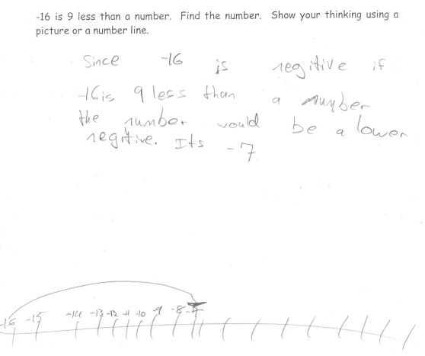

Student Work Analysis
Problem: -16 is 9 Less Grade Level: 7

Student B
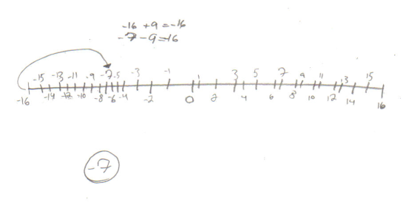
Student Work Analysis
Problem: -16 is 9 Less Grade Level: 7

Student C
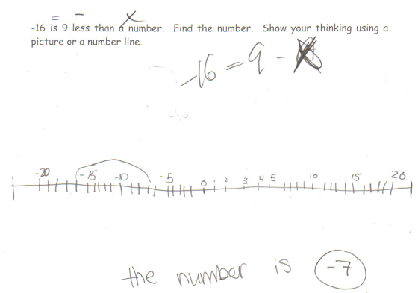

Student Work Analysis
Problem: -16 is 9 Less Grade Level: 7

Student D
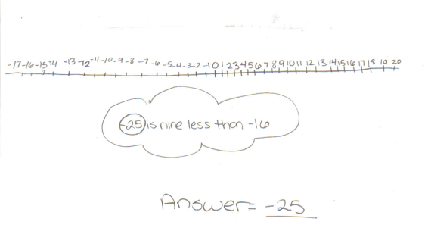

Student Work Analysis for: -16 is 9 Less

Student | What role does the number line play in the student’s solution? | What evidence is there that the number line helped or hindered the student’s understanding? | How do number sentences and verbal descriptions correspond with the number lines? | What does the student understand about subtracting negative numbers based on the evidence?
A
B

C

D

