Science and technology/engineering (STE) are key components of an elementary education and a natural focus for young children who are beginning to develop their own understandings of the world and how it works. By introducing children to science and engineering at a young age, we support their curiosity, promote their understanding, and give them the tools they need to investigate, design, observe, and draw evidence-based conclusions about the world. Children who are able to think critically, solve problems, and base their ideas on evidence at an early age will have a strong foundation as they engage with a world that is increasingly rooted in science, technology, and engineering.
“Children who engage in scientific activities from an early age develop positive attitudes toward science, which also correlate with later science achievement, and they are more likely to pursue STEM expertise and careers later on.”
(McClure, E. R., Guernsey, L., Clements, D. H., Bales, S. N., Nichols, J., Kendall-Taylor, N., & Levine, M. H., 2017)

The Massachusetts Science and Technology/Engineering Curriculum Framework emphasizes the need for students to have regular opportunities to experience STE in the classroom including purposeful hands-on and minds-on activities, investigations and design challenges. Curriculum and instruction should be rigorous, designed to support a progression of learning over time, and instill wonder and excitement in students. This guide provides recommendations for increasing high quality science in the elementary classroom.
What is new about the elementary science standards?
The 2016 STE standards are intended to drive coherent, rigorous instruction that emphasizes student mastery of both disciplinary core ideas (content) and application of science and engineering practices (skills). In particular, the 2016 STE standards include:
- Grade-level standards Pre-K to grade 8;
- Integration of disciplinary core ideas (content) and practices (skills) to reflect the discipline of science and technology/engineering. The science and engineering practices are embedded into the standards and usually are the first part of the standard, for example in grade 2: Develop and use models to compare how plants and animals depend on their surroundings;
- A focus on conceptual understanding and application of concepts;
- Coherent progressions of STE core ideas and practices from Pre-K to High School.
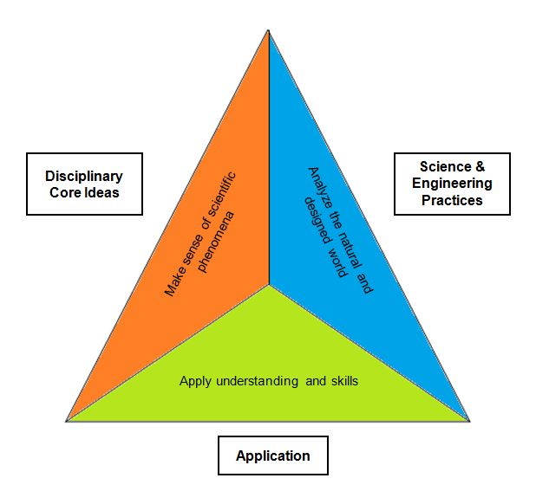
STE Rigor Triangle
The STE standards are designed to include the three interrelated components (core ideas, practices, and application) shown here. A rigorous STE lesson, unit, or curriculum must include all three parts. In an elementary classroom students should be asking scientific questions about the natural and designed world, learning through various experiences, like observations and experiments, collecting and analyzing data to solve problems, and constructing explanations to communicate how the world works. These components create the foundational knowledge and skills necessary for a STE education.
Elements to consider during implementation
Administrators and leaders have a critical role to play in the implementation process:
- Understand the standards as a leader. The STE standards represent a fundamental shift in science education and require a different approach to teaching science than has been done in the past. Know the standards enough to identify and provide feedback on student mastery of both disciplinary core ideas (content) and application of science and engineering practices (skills). Resource: STE standards Vision and Guiding Principles, Standards Navigator

- Develop a STE Message for your school/district. By creating a specific science message, goal, or vision STE becomes one of the core components of the school/districts values while providing direction and the means of accomplishing it. Understanding the components of an effective STE program and how best to communicate and disseminate that message and plan to all stakeholders is vital for success. Resources: Parent Guides, National Science Teachers Association (NSTA) Position Statement on Elementary Science and STEM Teaching Tools Practice Briefs are very short pieces that highlight ways of working on specific science issues.
Grade Span | Assumed Minutes per Day  (Hours per week)
K–2 | 25 minutes/day (~2 hours/week)
3–5 | 35 minutes/day (~3 hours/week)
6–8 | 55 minutes/day (~4.5 hours/week)
9–12 | 65 minutes/day (~5.5 hours/week)
- Dedicate adequate time on science. Instructional leaders ensure time for science instruction in every grade, as well as time for teacher learning and collaboration. Students need regular and ongoing dedicated time to science to achieve success. The chart provides the time assumed to be provided for STE instruction by grade span that informed the standards development. Resources: Science teachers learning: enhancing opportunities, creating supportive contexts report (2015) and National survey of science and mathematics education: Highlights Report (2013) provide national time on science data.
- Choose a model for elementary science instruction. Examples of popular models include classroom generalist, classroom specialists, support teams, departmentalization and science specialists. Each model has advantages and disadvantages and need to be evaluated by the school/district for their particular situation. Resource: Delivery Models for Elementary Science Instruction: A Call for Research is a paper that suggests different structures for teaching elementary science and provides advantages and disadvantages.

- Select high quality curriculum, materials and assessments. Select aligned and researched curriculum that emphasizes student mastery of both disciplinary core ideas (content) and application of science and engineering practices (skills); is relevant and engaging; and includes formative and summative classroom assessments. STE also requires physical space that can accommodate a variety of set-ups, materials, and equipment.
Curriculum Selection Resources: DESE Curriculum heat map, CURATE Science Rubric, Next Gen TIME toolkit
Classroom resources: Next Generation Science Storylines, National Science Teachers Association (NSTA) Classroom Resources
Assessment Resources: DESE Instructional Guidelines, Science Assessment Task Screening Tools

- Attend to STE progression of learning. The standards set a coherent progression of learning of STE concepts from PreK-12. These core ideas begin in PreK and become foundational knowledge learned in elementary. If students do not have the access and opportunity to learn in the elementary years, they are at a disadvantage going into middle school. Resource: Strand Maps.

- Understand how to observe shifts in instructional practices. The STE standards are outcomes that identify and reflect what students should know and be able to do. They emphasize a student-centered instructional focus therefore instruction in the classroom should look different. Elements of good practice “to look for” includes: students conducting investigations, solving problems, and engaging in discussions with teacher guidance; and students discussing open-ended questions that focus on the strength of the evidence used to generate claims. There should be less focus on the teacher leading the investigation as a “demo”, lessons diconnected from the real world, students copying notes, following step by step instructions to investigations, and student discourse limited to only one exact outcome. Resource: Instructional Leadership for Science Practices has developed tools to support instructional leaders in the science practices including case studies and observing the science classroom resources.
- Provide professional learning opportunities. Seek out or develop learning experiences that support the development of STE content and pedagogical skills for teachers. Relate these learning experiences back to your science message and the STE Curriculum Framework. Resources: STEM Teaching Tools Practice Briefs offer ideas on topics to include in professional development, National Science Teachers Association (NSTA), Massachusetts Science Education Leadership Association, Massachusetts Association for Science Teachers. These organizations all have annual conferences that teachers and administrators are encouraged to attend.

