The goal of STE education is to develop scientifically and technologically literate citizens who can solve complex, multidisciplinary problems and apply analytical reasoning and innovative thinking to real world applications needed for civic participation, college preparation and career readiness.
“High school students are expected to engage with major global issues at the interface of science, technology, society and the environment and to bring to bear the kinds of analytical and strategic thinking that prior training and increased maturity make possible.“
-NGSS: For States, By States V1

This guide provides recommendations for the integration of the Technology/Engineering Standards into High School STE Courses as outlined in the Massachusetts Science and Technology/Engineering Curriculum Framework. Massachusetts specifically includes Technology/Engineering as a high school discipline equivalent to traditional sciences in the 2016 STE Curriculum Frameworks. Districts choose whether to teach students the Technology/Engineering standards within a unique course or through integration with other science courses. This flexibility reflects the nature of STE as complex and interdisciplinary. Scientists and engineers typically do not work in isolation; rather they create networks of professionals within and across disciplines. Students’ understanding of science, technology, and engineering as interdisciplinary and interconnected is enhanced in the 2016 STE Framework by the integration of these standards from Pre-K to grade 8. STE Integration at the high school level presents specific challenges, such as; building schedules, staffing, and course alignment. However, with these challenges come meaningful opportunities to focus on real world contexts and problems within Biology, Chemistry and/or Physics. Integration can make a curriculum relevant and engaging to students, motivate deeper understanding, and build student identity as civic participants.
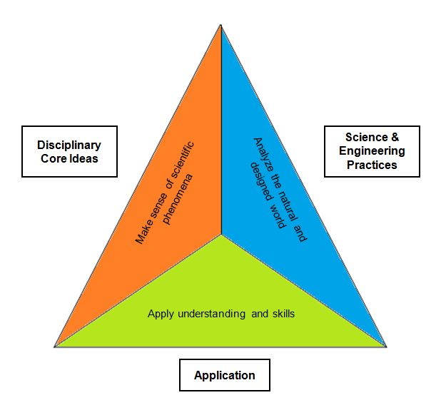
High School Connections to Engineering, Technology and Applications of Science
The STE standards are designed to include the three interrelated components shown here. At the high school level, integration of Science and Engineering practices could be a project that involves teams of students investigating a phenomena or a problem that is connected to a core idea in chemistry, physical, life or earth science. In this example, students would then apply their understanding by communicating an explanation or possible solution to an authentic audience.

The three diagrams on the reverse side are included to demonstrate how districts may authentically integrate Technology/Engineering standards into traditional high school science courses. Districts across the Commonwealth organize their science courses in different sequence, however the three sequences presented are typical. Each diagram shows what Technology/Engineering Disciplinary Core Ideas could naturally integrate with the content of the traditional science course. For more information about the Integration of Technology/Engineering standards please see the resources list at the end of this document.

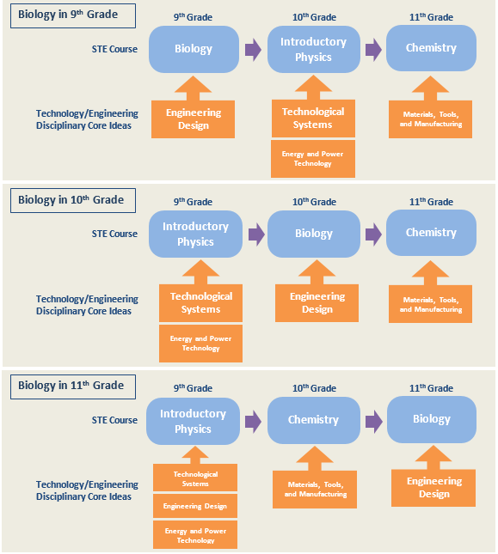
Resources
Bundling the Next Generation Science Standards
STEM Teaching Tools

