OpenSciEd in Massachusetts
Middle School Field Test
Focus Group and Survey Summary Report

March 2, 2021

OpenSciEd in Massachusetts Middle School Field Test Focus Group and Survey Summary
Prepared by the UMass Donahue Institute’s
Applied Research & Program Evaluation Group
Project Leader
Jeremiah Johnson, Ph.D.
Senior Research Manager

Project Staff
Donna Spraggon, M.Sc.
Senior Research Analyst

The University of Massachusetts Donahue Institute is an outreach and economic development arm of the University of Massachusetts. Established in 1971, the Institute strives to connect its clients with the resources of the University, bridging theory and innovation with real world public and private sector applications. For more information: www.donahue.umassp.edu.
The Institute’s Applied Research & Program Evaluation (ARPE) group enables education, public health, and human service organizations to make data-driven decisions to enhance program quality and capacity.
Specializing in rigorous and innovative social science research methods, ARPE works closely with federal, state, and local agencies, quasi-public agencies, and both non-profit and for-profit organizations to support programmatic and system-wide decision making.

Contents
Overview 2
Summary of Key Findings 3
Notable Quotes 11
Appendix A: Focus Group Instrument 12
Appendix B: Focus Group Findings 15
Appendix C: Survey Instrument 22
Appendix D: Survey Findings 27

Overview
This document summarizes feedback on the OpenSciEd instructional materials field test 2018- 2021 provided by middle school teacher participants through two focus groups and one survey.
The Department of Elementary and Secondary Education (DESE) drafted the focus group protocol and the survey instrument. The University of Massachusetts Donahue Institute (UMDI) moderated the focus groups. A DESE staff member was present for each focus group. DESE distributed the survey electronically and provided UMDI with a data summary. A total of eight teachers participated in the focus groups. A total of 43 survey responses were received, 38 respondents completed the survey and five respondents partially completed the survey.
In addition to a summary of key findings from the focus groups and survey, this document includes a list of notable quotes from the focus groups. Appendices include a copy of the focus group protocol, focus group key findings by question, the survey instrument, and the survey findings.

Summary of Key Findings
Teachers reported:
- The OpenSciEd curriculum is effective and engaging.
Most teacher participants reported that OpenSciEd instructional materials helped teachers create a science class that was effective and engaging for students. Teachers reported that the OpenSciEd curriculum increased their repertoire of strategies for making science learning more accessible to historically underserved populations, including students of color, ELL students and students with IEPs.
From Focus Group:
  - Increased levels of engagement allowed students to achieve learning objectives with a higher degree of fluency.
  - OpenSciEd empowers students by giving them more agency over their own learning, as well as supporting them to “think like a scientist.”
  - OpenSciEd unit content was engaging and the connections between units reinforced previously learned material.
  - OpenSciEd was readily adaptable in classroom with ELL and students with IEPs.
From Survey:
Please indicate how effective you believe the OpenSciEd Instructional Materials (i.e., Teacher Handbook/Unit Teacher Guide, Materials Kit) are for each of the following:

 | Extremely Ineffective | Somewhat Ineffective | Somewhat Effective | Extremely Effective | NA  Did not use for this purpose | Responses
Improving my background knowledge | 0  0.0% | 0  0.0% | 20  50.0% | 13  32.5% | 7  17.5% | 40
Increasing my understanding of phenomena-based science instruction | 0  0.0% | 0  0.0% | 12  30.0% | 27  67.5% | 1  2.5% | 40
Moving from teaching about science “facts” to helping students figure things out through phenomena-driven instruction | 0  0.0% | 0  0.0% | 9  22.5% | 31  77.5% | 0  0.0% | 40
Increasing the time we spend collaboratively as a whole class “figuring out” science ideas | 0  0.0% | 1  2.5% | 15  37.5% | 24  60% | 0  0.0% | 40
Fostering a classroom community that supports students from historically underserved communities to share their ideas | 0  0.0% | 2  5.0% | 21  52.5% | 16  40% | 1  2.5% | 40
Increasing my understanding of how to make student thinking visible/public | 0  0.0% | 1  2.5% | 12  30.0% | 27  67.5% | 0  0.0% | 40
Assessing student learning | 0  0.0% | 10  25.0% | 21  52.5% | 9  22.5% | 0  0.0% | 40

Considering all of the OpenSciEd units you taught as a whole, please indicate how effectively you believe the student materials (i.e., student education book, student notebook, and student classroom artifacts) are in supporting the development of each of the following student science skills/abilities:

 | Extremely Ineffective | Somewhat Ineffective | Somewhat Effective | Extremely Effective | Responses
Coherently organize science evidence and/or science ideas | 0  0.0% | 1  2.6% | 20  51.3% | 18  46.2% | 39
Understand science ideas build on one another | 0  0.0% | 0  0.0% | 18  46.2% | 21  53.8% | 39
Independently develop science models | 0  0.0% | 1  2.6% | 18  46.2% | 20  51.3% | 39
Support final scientific claims with evidence | 0  0.0% | 0  0.0% | 15  38.5% | 24  61.5% | 39
Use science and engineering practices to engage with science ideas | 0  0.0% | 0  0.0% | 7  17.9% | 32  82.1% | 39
Demonstrate self-motivation to learn independently | 0  0.0% | 6  15.4% | 25  64.1% | 8  20.5% | 39
Ask science questions that direct class discussions | 0  0.0% | 1  2.6% | 14  35.9% | 24  61.5% | 39
Explain science ideas in their own words | 0  0.0% | 2  5.1% | 9  23.1% | 28  71.8% | 39
Monitor their own learning progress | 0  0.0% | 2  5.1% | 26  66.7% | 11  28.2% | 39

How has your participation in the OpenSciEd pilot influenced your repertoire of strategies to teach science to students from historically underserved communities?

 | Responses
No change | 7  17.5%
Increased the number of specific strategies | 33  82.5%
Total | 40

- Professional development activities are well structured, relevant, and necessary for teachers to implement the OpenSciEd curriculum successfully.
A majority of teacher pilot participants reported that they received professional development from the OpenSciEd Instructors for the units they later taught in their classrooms. The majority of teacher participants reported that professional development was effective, and necessary, in preparing them to implement the OpenSciEd curriculum successfully—in a way that enabled students to engage meaningfully with the learning process.

From Focus Group:
  - Professional development activities helped teachers feel confident about implementing the curriculum as designed—in a way that enabled students to engage with the learning process as designed and expected by OpenSciEd.
  - The teachers did not believe that they would have been able to successfully implement the curriculum without having participated in the professional development activities. Most said that at least 2 series of trainings were necessary, and all were helpful.

From Survey:

Did you participate in the PD for the units you taught? Selected from: Which of the following OpenSciEd units have you taught?
 | Received PD from OpenSciEd Facilitators | Received training from a fellow teacher/district leader | Received no PD | Responses
Sound (grade 6) | 10  6.25% | 2  12.5% | 4  25.0% | 16
Light (grade 6) | 9  75.0% | 2  16.7% | 1  8.3% | 12
Forces at a Distance (grade 6) | 4  100.0% | 0  0.0% | 0  0.0% | 4
Plate Tectonics & Rock Cycling (grade 6) | 6  60.0% | 1  10.0% | 3  30.0% | 10
Earth and Space (grade 6) | 1  50.0% | 0  0.0% | 1  50.0% | 2
Thermal Energy (grade 6) | 15  83.3% | 0  0.0% | 3  16.7% | 18
Matter Cycling & Photosynthesis (grade 7) | 3  60.0% | 0  0.0% | 2  40.0% | 5
Contact Forces (grade 7) | 14  87.5% | 0  0.0% | 2  12.5% | 16
Ecosystem Dynamics (grade 7) | 7  77.8% | 2  22.2% | 0  0.0% | 9
Natural Hazards (grade 7) | 10  76.9% | 2  15.4% | 1  7.7% | 13
Metabolic Reactions (grade 8) | 13  100.0% | 0  0.0% | 0  0.0% | 13
Weather (grade 8) | 5  50.0% | 1  10.0% | 4  40.0% | 10
Genetics (grade 8) | 7  100.0% | 0  0.0% | 0  0.0% | 7
Chemical Reactions Part 1 (grade 8) | 13  100.0% | 0  0.0% | 0  0.0% | 13
Chemical Reactions (grade 8) | 5  100.0% | 0  0.0% | 0  0.0% | 5

Please indicate how effective you believe the OpenSciEd Professional Development (recognizing PD content varied but used highly consistent models and facilitators) is for each of the following:
 | Extremely Ineffective | Somewhat Ineffective | Somewhat Effective | Extremely Effective | Responses
Improving my background knowledge | 0  0.0% | 2  12.5% | 22  55.0% | 16  40.0% | 40
Increasing my understanding of phenomena-based science instruction | 0  0.0% | 0  0.0% | 5  12.5% | 35  87.5% | 40
Moving from teaching about science “facts” to helping students figure things out through phenomena-driven instruction | 0  0.0% | 0  0.0% | 10  25.0% | 30  75.0% | 40
Increasing the time we spend collaboratively as a whole class “figuring out” science ideas | 0  0.0% | 1  2.5% | 9  22.5% | 30  75.0% | 40
Fostering a classroom community that supports students from historically underserved communities to share their ideas | 0  0.0% | 3  7.5% | 11  27.5% | 26  65.0% | 40
Increasing my understanding of how to make student thinking visible/public | 0  0.0% | 1  2.5% | 9  22.5% | 30  75.0% | 40
Assessing student learning | 0  0.0% | 7  17.5% | 19  47.5% | 14  35.0% | 40

- Teachers appreciate the sense of community established through the professional development activities.
From Focus Group:
  - Access to a community of teachers implementing OpenSciEd was particularly beneficial to those without other OpenSciEd teachers in their schools.
  - Teachers expressed a strong preference for co-planning and reflecting on lessons with other teachers using OpenSciEd.

From Survey:
N/A

- Most focus group participants reflected that before the training they were skeptical about implementing a curriculum that was so pedagogically different from other—more traditional—science curricula. The training eased their concerns.
While most teachers rated each of the instructional routines as somewhat effective or extremely effective, teachers did not use each of the instructional routines with the same frequency. More specifically, teachers reported adapting the OpenSciEd curriculum for particular instructional environments, as necessary.
From Focus Group:
  - Traditional science curriculum emphasizes science vocabulary as a first step in learning science. Alternatively, OpenSciEd begins the learning process with discovery and, through modelling, leads students to science vocabulary. This reduces language as a barrier to learning science.
  - Adapting the content and pacing of OpenSciEd lessons for particular instructional environments (i.e., online learning) was not overly burdensome, although teachers felt some guidance on where curriculum customization for online learning and for groups of students (e.g., ELL students and students with IEPs) was possible, if needed, would be helpful.
From Survey:
In your opinion, how effective are each of the following OpenSciEd instructional routines in supporting positive development in your instructional practice?

 | Extremely Ineffective | Somewhat Ineffective | Somewhat Effective | Extremely Effective | NA did not use | Responses
Initial models | 0  0.0% | 0  0.0% | 11  28.9% | 27  71.1% | 0  0.0% | 38
Generating Driving Question Board | 0  0.0% | 0  0.0% | 13  34.2% | 24  63.2% | 1  2.6% | 38
Revisiting/Adding New Questions to Driving Question Board | 0  0.0% | 0  0.0% | 20  52.6% | 15  39.5% | 3  7.9% | 38
Related Phenomena | 0  0.0% | 2  5.3% | 9  23.7% | 26  68.4% | 1  2.6% | 38
Notice and Wonder | 0  0.0% | 0  0.0% | 7  18.4% | 30  78.9% | 1  2.6% | 38
Collect and Analyze Data | 0  0.0% | 1  2.6% | 6  15.8% | 31  81.6% | 0  0.0% | 38
Navigation | 0  0.0% | 1  2.6% | 20  52.6% | 16  42.1% | 1  2.6% | 38
Consensus Models | 0  0.0% | 3  7.9% | 14  36.8% | 21  55.3% | 0  0.0% | 38
Critiquing Consensus Models | 0  0.0% | 4  10.5% | 21  55.3% | 11  28.9% | 2  5.3% | 38
Progress Tracker (“What did we figure?”) | 0  0.0% | 1  2.6% | 15  39.5% | 22  57.9% | 0  0.0% | 38
Scientist Circles | 0  0.0% | 3  7.9% | 17  44.7% | 16  42.1% | 2  5.3% | 38
Attending to Equity | 0  0.0% | 1  2.6% | 19  50.0% | 17  44.7% | 1  2.6% | 38

Considering all of the OpenSciEd units you taught as a whole, how often did you use each of the following OpenSciEd instructional routines?
 | Never | Somewhat Frequently | Very Frequently | Extremely Frequently | Responses
Initial models | 0  0.0% | 4  10.5% | 13  34.2% | 21  55.3% | 38
Generating Driving Question Board | 0  0.0% | 6  15.8% | 10  26.3% | 22  57.9% | 38
Revisiting/Adding New Questions to Driving Question Board | 1  2.6% | 23  60.5% | 9  23.7% | 5  13.2% | 38
Related Phenomena | 1  2.6% | 4  10.5% | 17  44.7% | 16  42.1% | 38
Notice and Wonder | 0  0.0% | 0  0.0% | 12  31.6% | 26  68.4% | 38
Collect and Analyze Data | 0  0.0% | 4  10.5% | 11  28.9% | 23  60.5% | 38
Navigation | 0  0.0% | 6  15.8% | 21  55.3% | 11  28.9% | 38
Consensus Models | 0  0.0% | 9  23.7% | 17  44.7% | 12  31.6% | 38
Critiquing Consensus Models | 3  7.9% | 17  44.7% | 16  42.1% | 2  5.3% | 38
Progress Tracker (“What did we figure?”) | 0  0.0% | 7  18.4% | 17  44.7% | 14  36.8% | 38
Scientist Circles | 1  2.6% | 18  47.4% | 9  23.7% | 10  26.3% | 38
Attending to Equity | 0  0.0% | 8  21.1% | 20  52.6% | 10  26.3% | 38

How has your participation in the OpenSciEd pilot influenced your enthusiasm for teaching science?

 | Responses
Enthusiasm unchanged | 14  35.0%
Increased my enthusiasm for teaching science | 26  65.0%
Total | 40

Notable Quotes
- “OpenSciEd is the way I’ve always wanted to teach science but never really knew how.”
- “The learning was deep. The learning was real. It was not memorization.”
- “OpenSciEd allows teachers to be more thoughtful about their approach to teaching and what they want students to get out of the experience.”
- “Take your most challenging class and imagine it being your best class, your most favorite class, the class that you look forward to every part of every day.”
- “It’s mind-blowing to sort of really be organic about things rather than algorithmic. I think that will stick with students for longer.”
- “I also saw a significant increase in engagement from students who tended to struggle to access science previously.” (referring to students on IEPs becoming excited to share and engage during Heat Transfer unit)
- “OpenSciEd leads them down the path of ‘I really like science. I like the way they validate my thinking and they don’t make me memorize this vocabulary word first. They validate what I thought all along or they didn’t validate it and I discovered something else and it was exciting for them.’”
- “I really believe that my students understand what they are talking about.”
- “I’ve loved the use of models and the students being able to record their increasing understanding and even having them go back and look at a previous model and have sticky notes a right and where they change their ideas so being able to analyze what they had previously.”
- “Trusting the process piece was a big part of that experience.”
- “OpenSciEd has helped me paint that big brush in a deep way.”
- “Professional development was key, especially that first time we did it, was key to understanding … phenomenon based [instruction] and to [learn how to get students to] be able to make the driving questions and to ask the questions up front.”
- “How engaging it is for students and making science fun, they can feel successful as scientists and students, it's a very personal experience that also builds their self-confidence, and they're working through so many science process skills without realizing that how much they are improving as they go through it.”

Appendix A: Focus Group Instrument

Focus Group Protocol

Introduction
My name is (Jeremiah Johnson / Donna Spraggon), and this is my colleague (Jeremiah Johnson/Donna Spraggon). We work with UMass Donahue Institute, an independent research organization that is collaborating with the Department of Elementary and Secondary Education to gather feedback about the OpenSciEd program/curriculum. Thank you for taking this time to speak with us.
Purpose
DESE would like to gather feedback from you about your experience with OpenSciEd so that they have a better understanding of your experiences with it. The input you provide during this focus group will help DESE better understand the strengths, challenges, and opportunities for improving the Institute in the future.
Confidentiality

We want to assure you that all information obtained today will be kept confidential and will only be used for the purposes of improving the OpenSciEd implementation and to inform other teachers about the experiences of those of you who participated in the pilot. We will be producing a short two to five page summary of these focus groups. In this report, we will de-identify all information meaning that no names will be used (and if necessary, pseudonyms will be assigned), no quotes will be attributed to individuals, and your schools, grades you teach, or positions will not be revealed. We also ask that you each maintain the confidence of the other participants in this room.

Permission to Record
The focus group will take about 55 minutes. If you have additional comments you would like to share, then we would be happy to hear those comments after the focus group is complete. I will be available by Zoom for 15 minutes after the focus group is complete. If you don’t mind, we would like to record our conversation simply for note-taking purposes. We will be the only people to have access to the recording, and the recoding will be destroyed after our notes are complete. If you want me to turn off the recorder at any point, please just let me know. May I have your permission to record this conversation? Before we get started, do you have any questions for me? Ok, I am turning on the recorder, and we will begin the focus group.

Focus Group Questions

First, it would be great to hear a little about your backgrounds. Would each of you please share with me how long have you been teaching science, what grades you teach, and how many years have you participated in the pilot?

- Did OpenSciEd have a positive influence on your science instruction? If so, in what ways (did OpenSciEd positively influence your science instruction) and, specifically, what about OpenSciEd supported these improvements?

Only if necessary use these prompts:
  - Influenced how you plan?
  - Deliver instruction?
  - What about the storyline approach?
  - How you think about student science learning?
  - Challenge your beliefs about science instruction? Content knowledge?]

- Learning and implementing a new curriculum presents challenges including developing(?) new pedagogy, new content, and different ways to engage with students. What challenges did you experience when transitioning to using OpenSciEd?

Only if necessary use these prompts:
- What has been the hardest thing about implementing OpenSciEd?
- What if anything would have made learning how to use OpenSciEd easier?
- What most excited you about the OpenSciEd Curriculum?

- In your experience, do you think student learning was different using OpenSciEd compared to student learning using other science curricula? In what ways was it different?

Only if necessary use these prompts:
- Was there a difference in student ownership of learning?
- Quality of student scientific reasoning/sensemaking?
- Student use of the science and engineering practices?
- What is it about the OpenSciEd curriculum that you think has influence student engagement?

- How did the Professional Development impact and support your implementation of the curriculum?

***Necessary Follow up if not addressed:

How many unit specific Professional Development trainings did you need to participate in before you felt comfortable teaching using the structure and approach of OpenSciEd?

Optional Follow ups if not addressed:
  - What portions of the OpenSciEd PD are absolutely necessary to implement well?
  - What if any part of the PD would you eliminate?
  - What were your experiences in your school beyond the unit PD?
  - Did you co-plan with teachers, etc.?

- Would you recommend the OpenSciEd curriculum to colleagues, and why?

- [Probe if necessary for specific aspects. Did anyone have a different experience? How so?]

- Are there aspects of the OpenSciEd curriculum you thought were not helpful or necessary and if so why?

  - [If necessary probe for: Did anyone have a different experience? How so?]

If there is time, please ask the following:

- To what extent did you follow the OpenSciEd lessons and to what extent did you diverge? In the areas did you diverge, why? [We may have asked this question in the survey – if time]

Appendix B: Focus Group Findings
Introductory Question: Demographics
First, it would be great to hear a little about your backgrounds. Would each of you please share with me how long have you been teaching science, what grades you teach, and how many years have you participated in the pilot?

- Participants are experienced teachers 9 – 30 years of teaching experience. They have all been teaching science for at least six years, most have been teaching 10 or more. All teach middle school grades 6 through 9 with most teaching grades 7 and/or 8. Participants were evenly distributed between having participated in the pilot for two or three years.

Session 1
Participant | Years Teaching | Years Teaching Science | Grades  Teaching | Years in Pilot
P1 | 20 | >10 |  | 3
P2 | 9 | 9 | 6 | 3
P3 | 10 | 10 | Middle | 2
P4 | 30 | 29 | 7/8/9 | 2
P5 | 11 | 11 | 7 | 3

Session 2
Participant | Years Teaching | Years Teaching Science | Grades Teaching | Years in Pilot
P6 | 15 | 6 | 8 | 2
P7 | 15 | 15 | 7/8 | 2
P8 | 20 | 20 | 7 | 3

Question 1
Did OpenSciEd have a positive influence on your science instruction? If so, in what ways and, specifically, what about OpenSciEd supported these improvements?

- Participants in agreement that OpenSciEd had a positive impact on their science instruction.
  - “OpenSciEd is the way I’ve always wanted to teach science but never really knew how.”
  - “OpenSciEd allows teachers to be more thoughtful about their approach to teaching and what they want students to get out of the experience.”
  - OpenSciEd assists teachers to reconcile previously held beliefs that science teaching should be phenomenon based but also needing to adhere to the regular curriculum of memorization and learning vocabulary.
- Teachers felt empowered by the design of OpenSciEd with the ability to effectively facilitate students’ science learning. Here are some specific features mentioned by

Question 2
Learning and implementing a new curriculum presents challenges including developing new pedagogy, new content, and different ways to engage with students. What challenges did you experience when transitioning to using OpenSciEd?

- Switching from teaching directly to being a facilitator of learning was identified as a challenge when first starting.
  - This role switch becomes more natural as students get involved in the process and more experience in class and as teachers engage in PD over time.
- Modelling—being deliberate about establishing norms for how, starting with beginning model, adding to that model as students go
  - New process to teachers and more deliberate than drawing diagrams
  - “Diagrams are different than models, and I am building models with students now rather than just drawing diagrams.”
- Not giving away the answer—would get through curriculum quicker
  - COVID Remote: more likely to give away answer due to the slowness of learning process within the remote setting
- Unease when starting a unit that had not worked through on their own
  - “I felt caught in the headlights. I actually don’t know where this is going to go.”
- Using OpenSciEd in classroom with ELL students
  - Worried students would not be able to access discussion based units
  - Two ways to assist
    - Grouped ELL students together at tables resulted in increased comprehension levels and output
    - Using Google translator on phone to translate class instructions and then sharing phone with tables (note: ELL students spoke same language in this case)
- Suggestions identified by teachers as being potentially helpful when learning how to use OpenSciEd.
  - Having teachers within school or district with experience in OpenSciEd to act as a resource for those just starting out.
  - Having a colleague in same grade using OpenSciEd to bounce ideas off and with whom to share class preparation tasks.
  - Guidance as to what, if pressed for time, could be cut or skipped in a unit would be helpful, particularly in times of instructional disruption such as what is being experienced with COVID-19.

Question 3
In your experience, do you think student learning was different using OpenSciEd compared to student learning using other science curricula? In what ways was it different?

- Teachers are no longer teaching content, and students are no longer expected to learn by memorizing. Instead, students are learning science skills and practices through modelling.
  - “Learning now just comes naturally as we start to develop and really hone our skills.”
  - OpenSciEd goes beyond the traditional “hands-on” classroom in that teachers no longer step in to demonstrate the way it should work if the students do not achieve the expected results. The students now have the ability to do the next iteration of attempts.
- Students’ depth of understanding of science topics is significantly greater than with other science curricula.
  - “OpenSciEd has helped me paint that big brush in a deep way.”
  - “I really believe that my students understand what they are talking about.”
  - “Mind-blowing to sort of really be organic about things rather than algorithmic. I think that will stick with students for longer.”
- Teachers noted key ways in which the OpenSciEd not only differed from other science curricula, but also enhanced student learning.
  - The use of anchoring phenomenon allows the science to become personal for the students in a way that does not happen in other science curricula.
  - Science practices are incorporated into the objectives for each lesson in OpenSciEd in such a way that is easy to have students use. Other science curricula did not incorporate these science practices and, as a result, may not have been addressed in the classroom if it was not one of the teacher’s strengths.
  - “I’ve loved the use of models and the students being able to record their increasing understanding and even having them go back and look at a previous model and have sticky notes a right and where they change their ideas so being able to analyze what they had previously.”
  - “The learning was deep, the learning was real, it was not memorization.”

Question 4
How did the Professional Development impact and support your implementation of the curriculum?
***Necessary Follow up if not addressed:
How many unit specific Professional Development trainings did you need to participate in before you felt comfortable teaching using the structure and approach of OpenSciEd?

- Teachers ability to understand and implement the OpenSciEd curriculum was greatly impacted by the PD trainings.
  - Smaller group sessions of the PD were absolutely necessary to actually experience the unit itself.
    - “Professional development was key, especially that first time we did it, was key to understanding that phenomenon based and to be able to make the driving questions and to ask the questions up front.”
  - The preview of the unit gives the teachers the language necessary to be able to communicate effectively with principals, STEM directors, superintendents about the OpenSciEd units and program.
  - Returning as a group to review videos of peer OpenSciEd classrooms was found to be very helpful.
  - “Trusting the process piece was a big part of that experience.”
- The community developed through PD supported teacher implementation both while at PD and throughout year. This was particularly important for those teachers who were the only OpenSciEd teachers within their school.
  - “going to the PD’s gave me a community of other science teachers to connect with.”
  - Teachers that had the opportunity to co-plan with other teachers within their school expressed a positive experience and preference over doing it alone.
- Teachers felt respected and that their time was valued when attending PD. Time was used effectively and teachers were continually engaged in the units (or sharing with their peers during break time).
- Teachers noted that OpenSciEd had been responsive to the feedback from the teachers during the Professional Development sessions during the pilot.
  - The addition of the Storylines was pointed to as an example of OpenSciEd response to teacher feedback and discussion during PD.
    - “I find the Storylines invaluable.”
- Over half of teachers said that they felt comfortable teaching using the structure and approach of OpenSciEd after attending two unit specific Professional Development trainings. A few teachers felt three were necessary.
  - Teachers recognized the difference between comfort and perfection.
    - “Comfortable is not the same as perfected.”
  - Teachers recommend OpenSciEd teachers take all of the available PD trainings.
Question 5
Would you recommend the OpenSciEd curriculum to colleagues, and why?

- All focus group participants highly recommend the OpenSciEd curriculum to colleagues, and have.
- Reasons given for recommending the OpenSciEd curriculum:
  - Engages students more than regular science curriculum.
    - “how engaging it is for students and making science fun, they can feel successful as scientists and students, it's a very personal experience that also builds their self-confidence, and they're working through so many science process skills without realizing that how much they are improving as they go through it.”
  - Engages students with language barriers and learning disabilities.
    - “Take your most challenging class and imagine it being your best class, your most favorite class, the class that you look forward to every part of every day.”
  - OpenSciEd curriculum thoughtful about diversity.
    - Example: Typically, genetics is taught using characteristics that are personal to the students such as eye or hair color. This fails to consider classrooms with high proportions of some race/ethnic populations where those characteristics do not vary by individual. In OpenSciEd, the genetics unit centers on cow muscles, which can be made common to all students.

Question 6
Are there aspects of the OpenSciEd curriculum you thought were not helpful or necessary and if so why?

- Teachers expressed that no aspects of the OpenSciEd curriculum were not helpful/necessary.
  - In some instances, further reflection and/or attending more PD resolved initial doubts of the helpfulness of the approach to delivery of the PD.
- Teachers’ feedback on the teacher’s manual/guide varied. While one teacher found it very useful, another found it to be too prescriptive and overwhelming.

Question 7
To what extent did you follow the OpenSciEd lessons and to what extent did you diverge? In the areas did you diverge, why?

- Teachers of OpenSciEd have modified assessments or skipped something due to time constraints. This is similar to the teachers approach to other science curricula. In particular, teachers modified their approach for the following:
  - ELL and students with IEPs
  - In response to shortened instruction time during COVID/Remote learning—activities have been cut to compensate for lost time (e.g., Turn and Talks)
- Teachers diverge to line up with Massachusetts standards and review for MCAS.

Appendix C: Survey Instrument
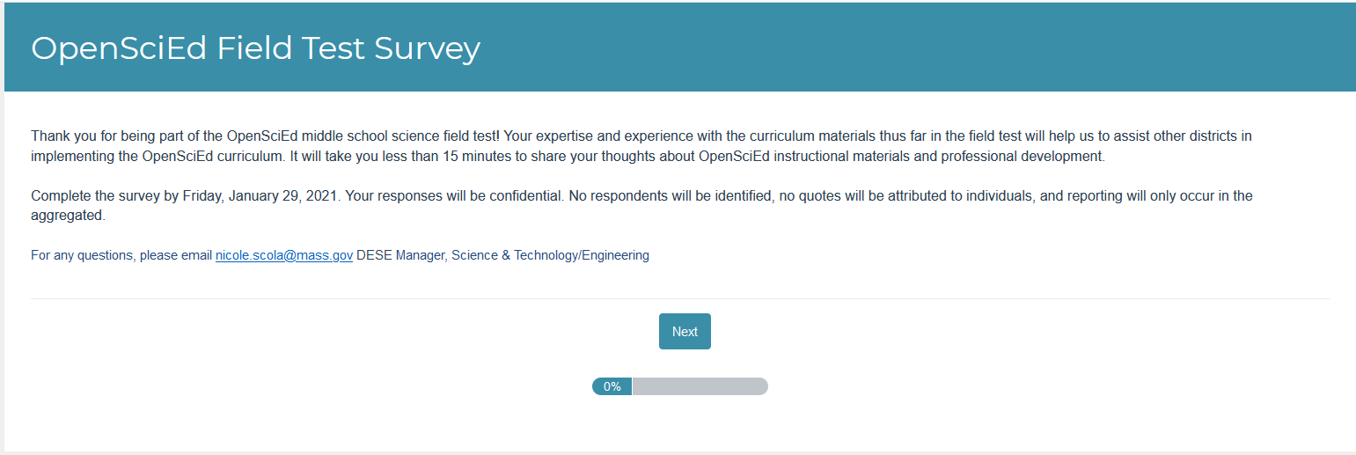

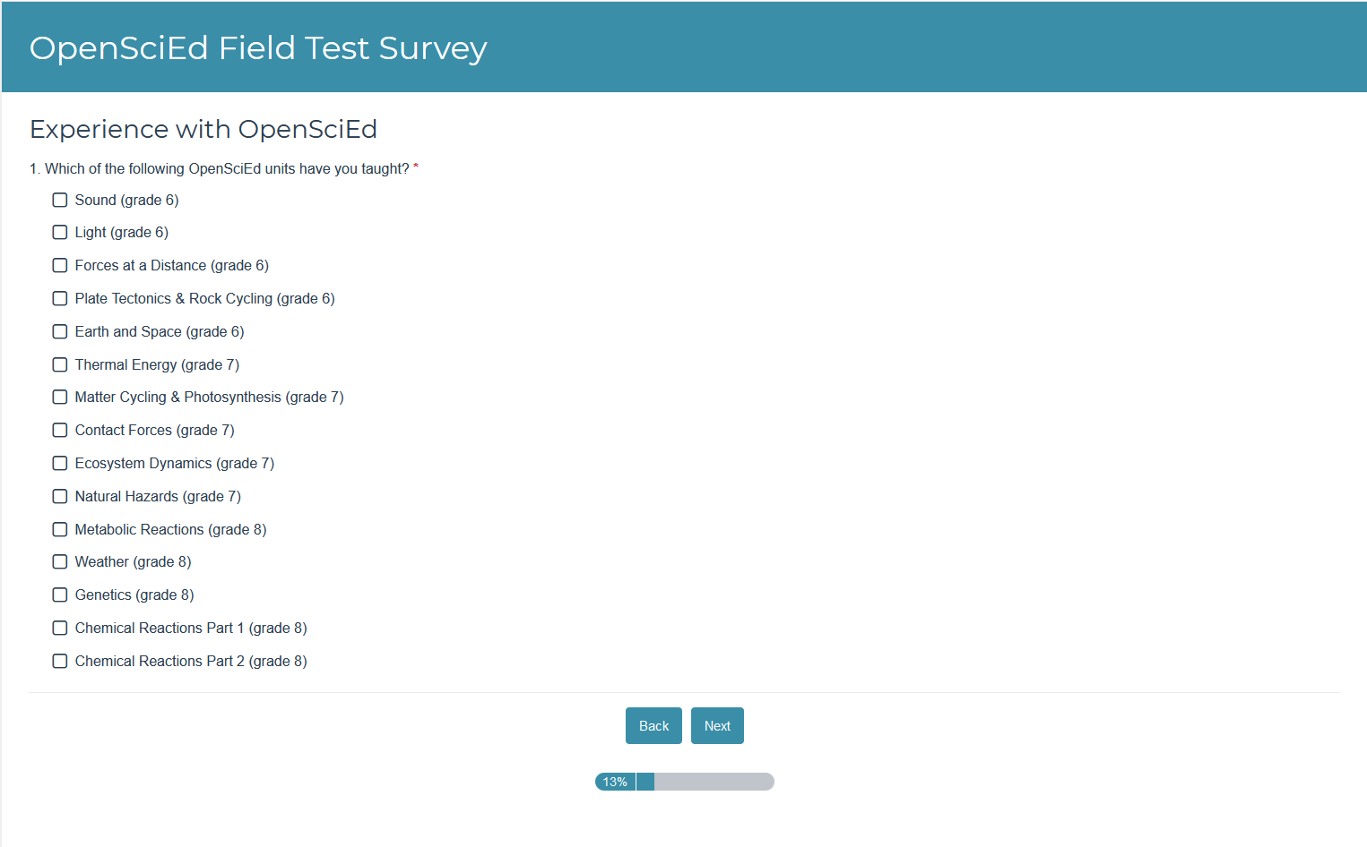

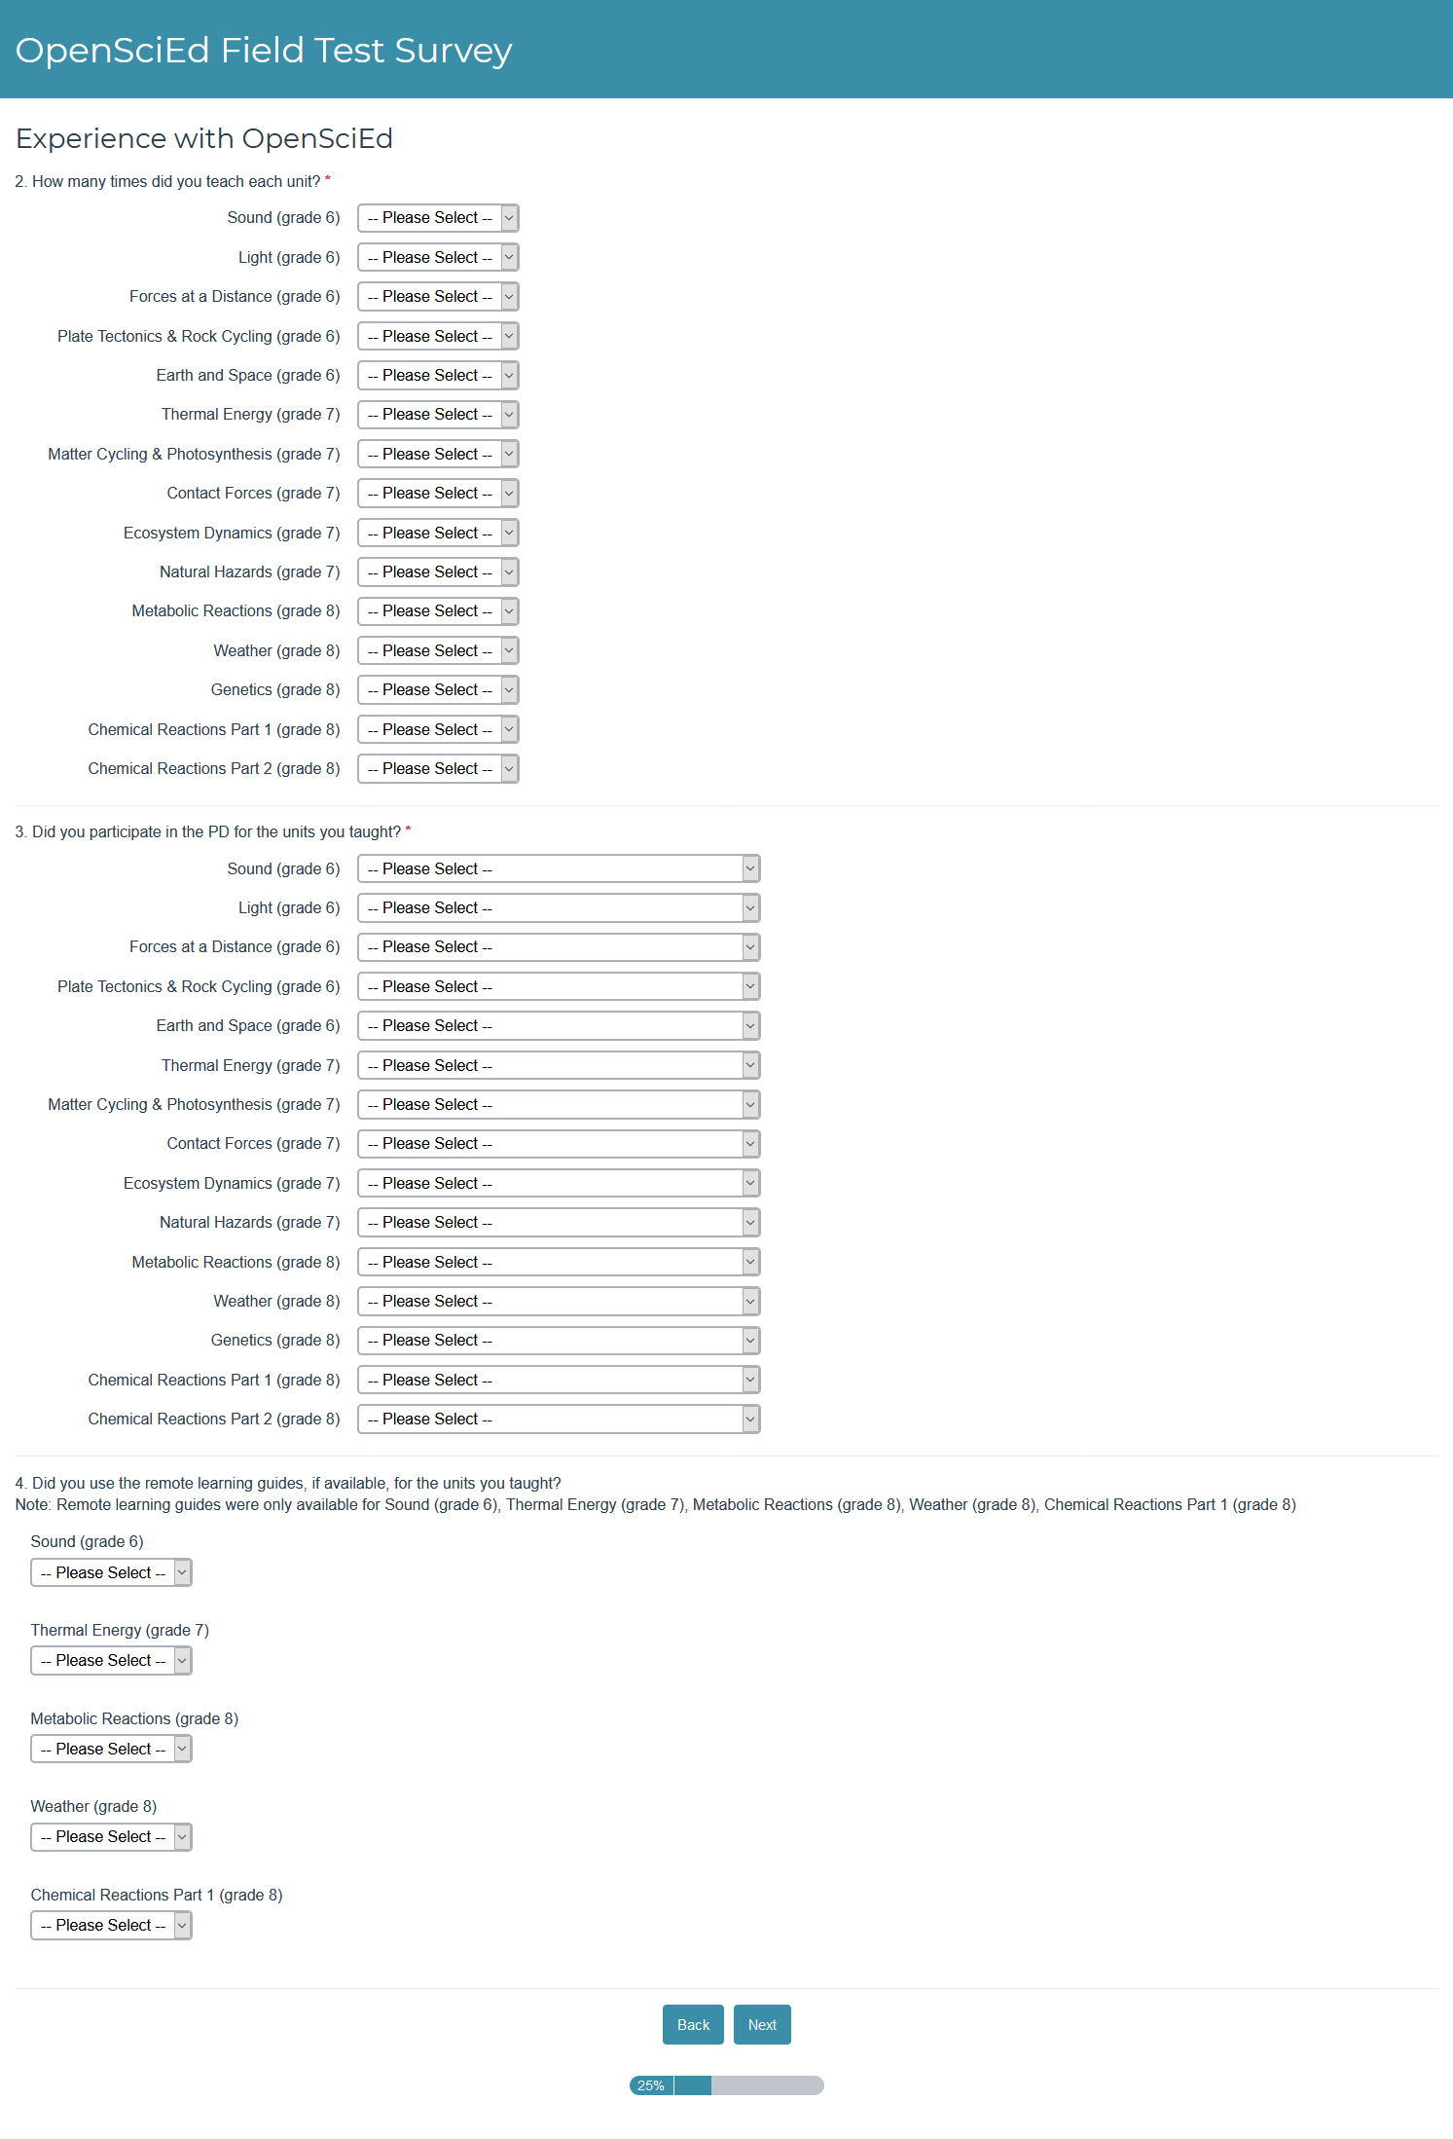
Please Select
- Received PD from OpenSciEd Facilitators
- Received training from a fellow teacher/district leader
- Received no PD

Please Select
- Yes
- No
Please Select
- 1
- 2
- 3
- 4+
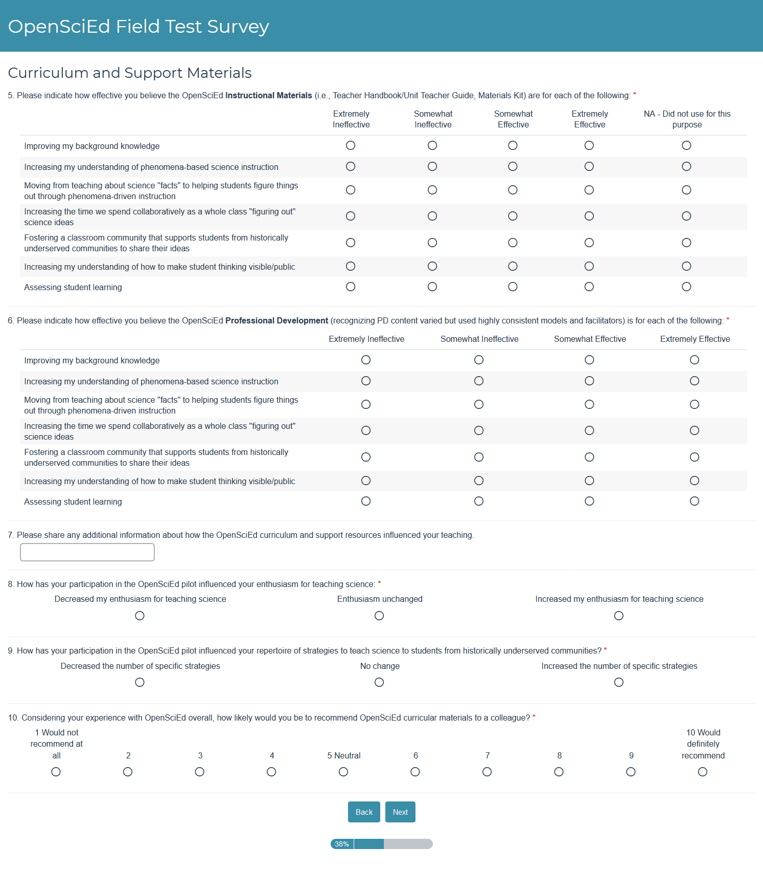
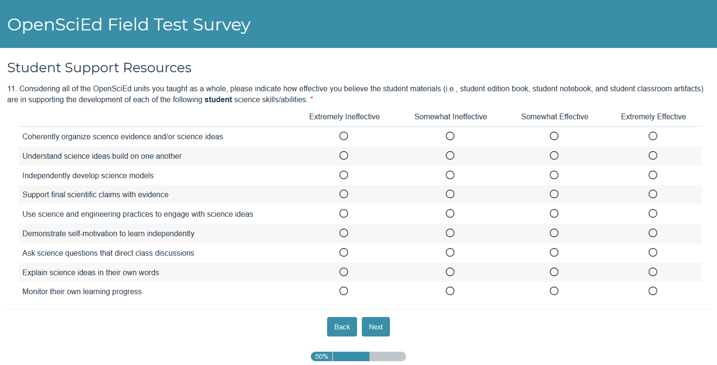
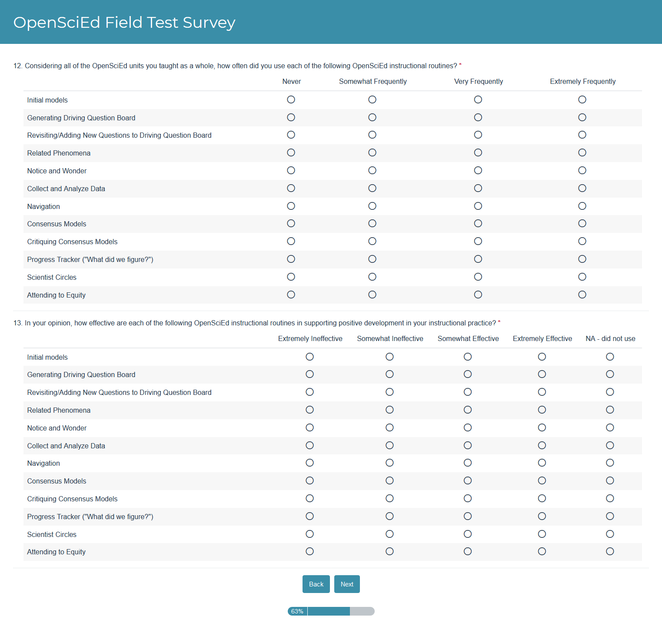
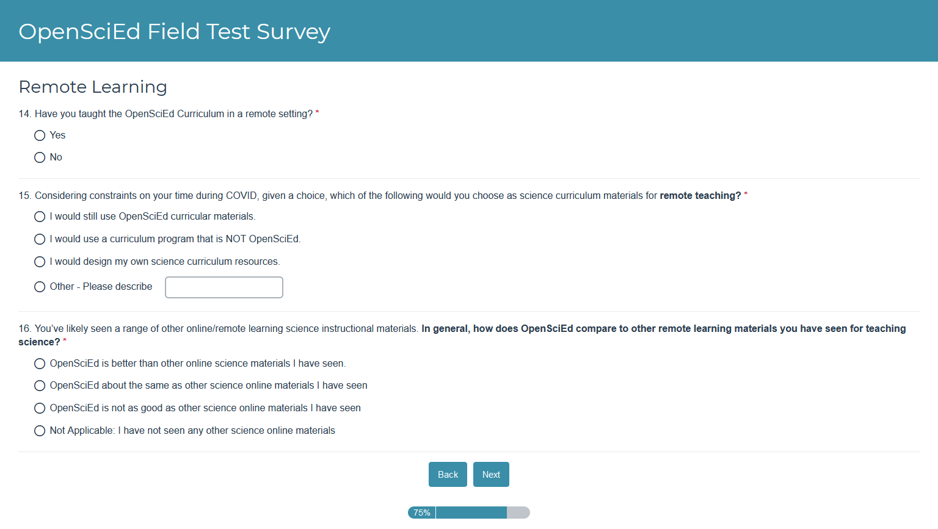

Appendix D: Survey Findings
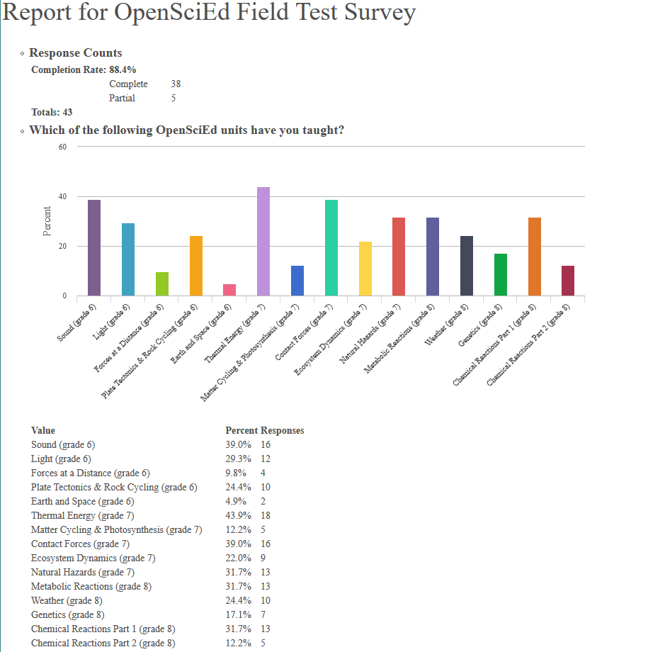
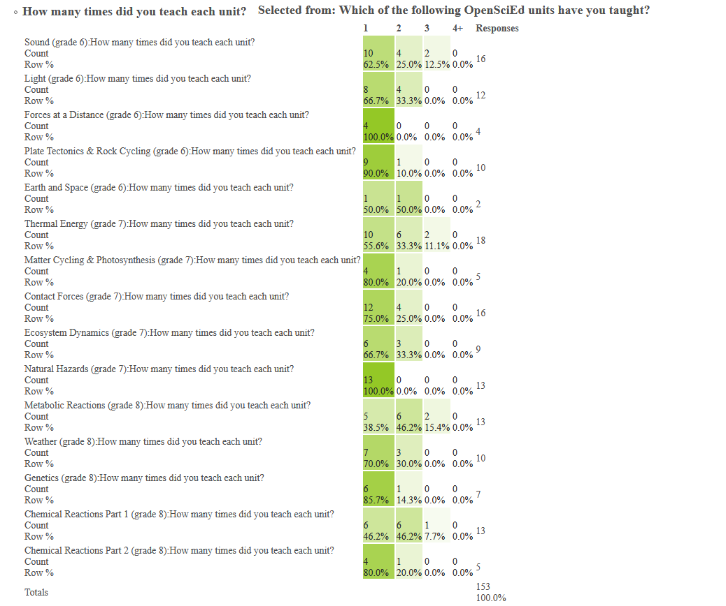
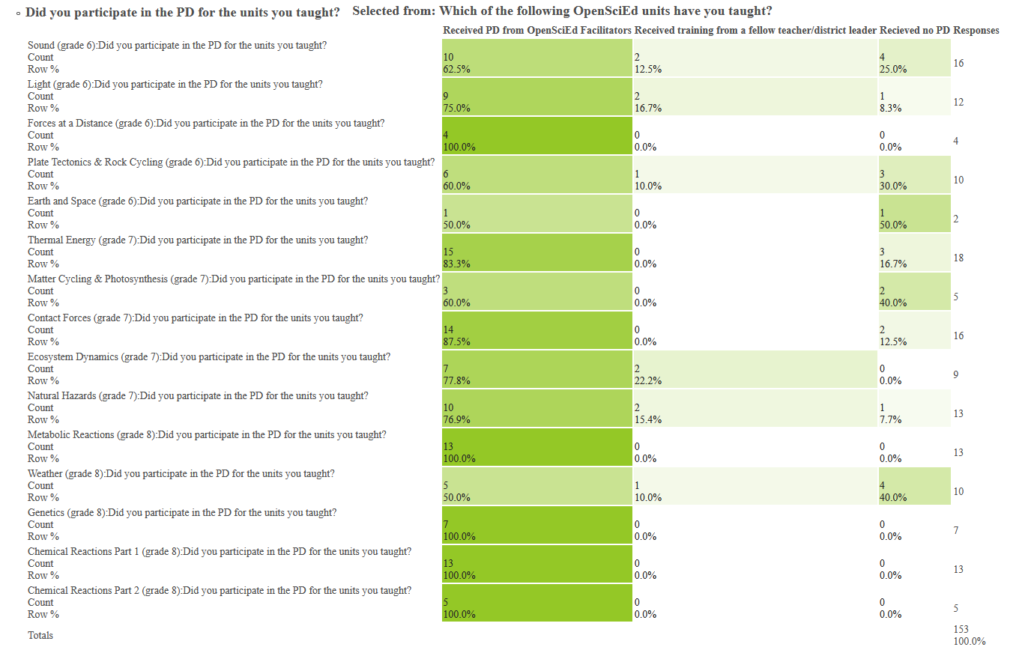
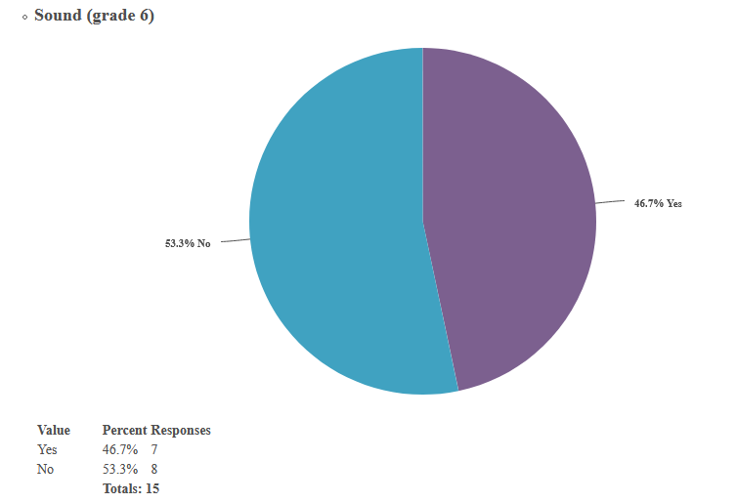
Did you use remote learning guides, if available, for the units you taught?
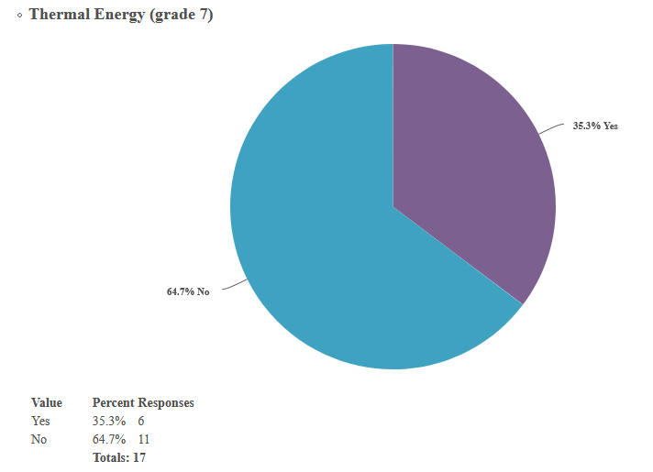
Did you use remote learning guides, if available, for the units you taught?
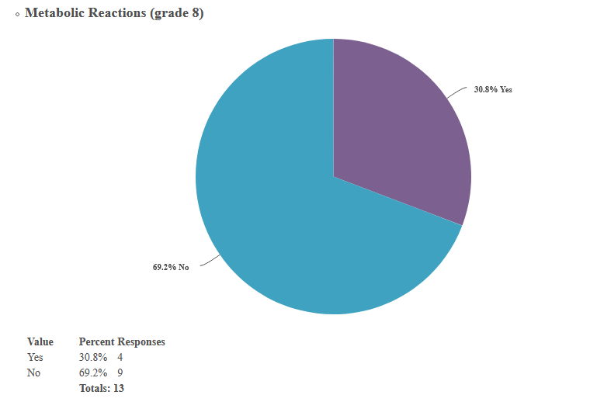
Did you use remote learning guides, if available, for the units you taught?
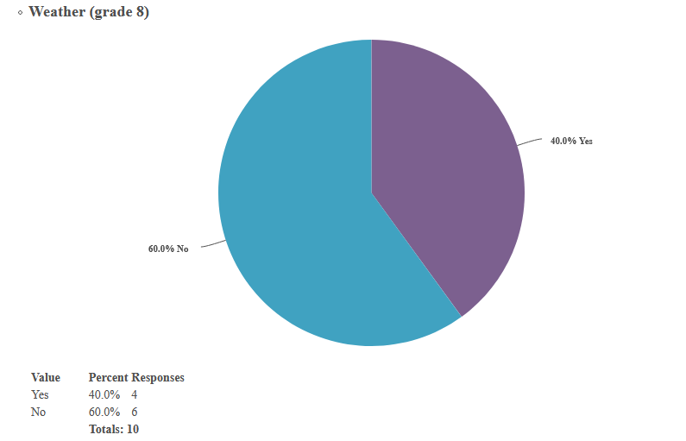
Did you use remote learning guides, if available, for the units you taught?
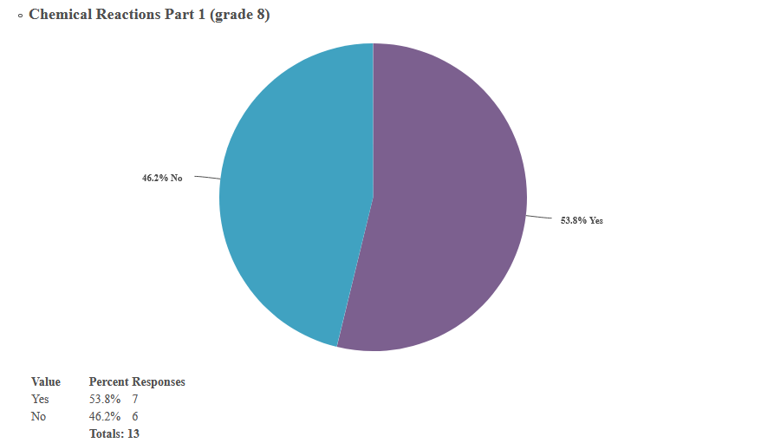
Did you use remote learning guides, if available, for the units you taught?
