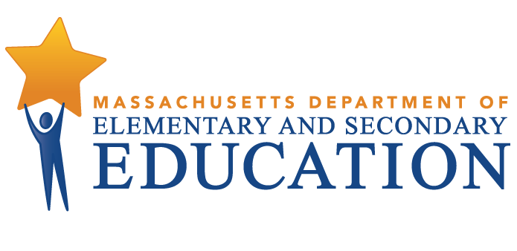
DeBerry Elementary School
Video Facilitation Guide

Guiding Question: What can be learned from DeBerry School story in terms of identifying and prioritizing practices in the sustainable improvement process as well as the importance of whole-school effort in the process?
_____________________________________________________________________________________
The educators at the William N. DeBerry School utilized elements of Massachusetts’ four Turnaround Practices. As you watch the video, identify how educators changed their practices and the resulting effects for student opportunities and learning that developed through their sustainable improvement process.
Leadership, Shared Responsibility, and Professional Collaboration (Turnaround Practice 1)
Leaders and teachers are jointly committed and have assumed shared ownership and collective responsibility for improving student achievement: “Year one we really did a lot of conversations between ourselves and where did we want to go and where did they think they wanted to go? What did they need to make them better teachers and to improve the skills of the students?” (Roseanna, 3:49)
Intentional Practices for Improving Instruction (Turnaround Practice 2)
Instruction-specific conversations are taking place throughout the school with the intent of improving instruction of each and every teacher: “During our PLCs, we participated in book studies that focused on intentional practices to use in our classroom. So, some of those intentional practices include creating essential questions, creating rigorous questions, various ways to check for understanding and different ways we can give quality, specific feedback.” Sarah, 5:03
Student-Specific Supports and Instruction to All Students (Turnaround Practice 3)
Establishing a structure to deliver social-emotional supports as important to school success: “The first year of PBIS it was a little bit of a struggle to get all of the students following the expectations and it just got better every year after that with more practice and more consistency. From kindergarten to first grade they’ve already learned the expectations. Now they can build on it and you know master their classroom routines and then they can really focus on their academics.” Lisa, 2:36
School Climate and Culture (Turnaround Practice 4)
The school has established a communitywide set of student behavioral expectations and teacher responses: “Once we had begun, I realized you know that we really needed to take on the environment and management and student behavior . . .we also came up with a list of what needed to be in the classroom. So, all classrooms would have data walls, all classrooms would have student work with feedback and rubrics and standards posted. As well as with expectations for behavior.” Stephania, 1:37

Detailed Reflection Questions. The following sections of the video illustrate key points where the staff at William N. DeBerry focused on important efforts in their sustainable improvement work. As you watch the video, consider pausing after viewing the indicated times, and reflecting on the following questions.

- Looking at data. (3:02-3:29) How does the examination of student data help a school focus its’ sustainable improvement efforts? What does incomparable data – such as the difference between what students were receiving for report card grades and what their standardized scores were--indicate about teacher expectations?
- Professional development/support. (3:35-3:50) Why is strong professional development and support critical to the sustainable improvement process in schools? What does effective professional development look like at DeBerry? What should be the result of strong professional development and how would you know it is having the desired effect?
- Decisions driven by teachers/shared leadership (6:14-6:30, 6:31-6:56) Why is it important for a school to create a culture of shared ownership for improvement efforts? What are some of the different ways that teachers can serve as leaders in a school? What is the potential impact for the teacher individually and for the school as a whole?

Additional Reflections for Your Context
- What strategies, insights, or specific actions from the video most resonate with you?
- What questions do you have about the video?
- What strategies or actions did you see in the video that you are already doing in your classroom, school, or district?
- What strategies or actions did you see that you could consider implementing in your classroom, school, or district?
- What are the next steps for your classroom, school or district planning?

Related Resources
Research on Effective Practices in School Turnaround - Learn more about the four key practices that characterize effective sustainable improvement efforts in Massachusetts schools

Sustainable Improvement Plan Guidance - Resources for districts and schools on developing an effective sustainable improvement plan, including how to use data to identify school assets, challenges, and opportunities

