# Massachusetts State Heritage Language Programs Guidance

June 30, 2025

## Table of Contents

Framing Heritage Language Programs 3

Participation in Heritage Language Programs 5

Course Placement and Credit Considerations for Heritage Language Programs 6

Compliance and Non-Discrimination in Heritage Language Programs 7

Licensure and Instructional Expectations for Heritage Language Programs 8

Sustainability and Reporting in Heritage Language Programs 8

## Framing Heritage Language Programs

In the context of Massachusetts public schools, heritage languages (HLs) are languages other than English used in homes, communities, and families. Heritage language (HL) programs are a vital component of comprehensive world languages (WL) education, which along with English Learner Education (ELE) programs is an essential part of the robust multilingual programming offered in Massachusetts schools/districts. The following diagram shows where HL programs are situated in the broader ecosystem of multilingual programming:

**Multilingual Programs in Massachusetts Schools and Districts[1]**

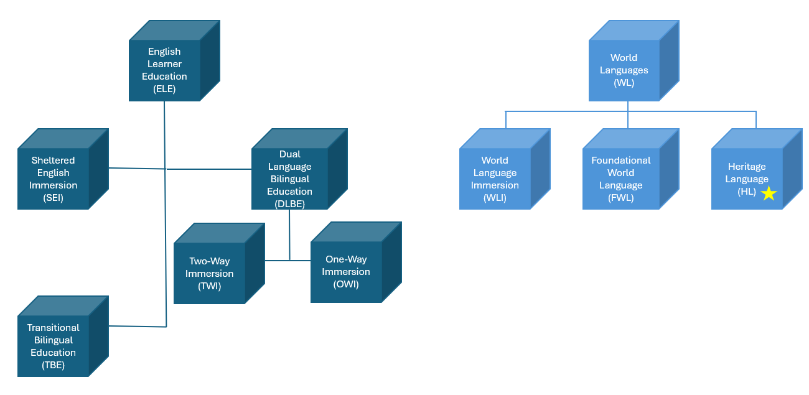

In Massachusetts, HL programs:

* can be offered at any grade level
* can be offered in any HL, including HLs not taught in the school/district’s Foundational World Language (FWL) programs
* may consist of a single HL course (at a minimum) or multiple HL courses at varied levels

Although each HL program will be unique and should be tailored to local needs, they differ from other types of language education programs in that they (1) are designed specifically for students with HLs; (2) include students with HLs as the primary participants; and (3) focus more exclusively on developing, maintaining, and/or strengthening students’ skills and abilities in the HL, as well as connections to and relationships with HL cultures and communities.

As described in DESE’s Educational Vision:

* all students in Massachusetts, particularly students from historically underserved groups and communities, will have equitable opportunities to excel in all content areas across all grades;
* culturally and linguistically sustaining classroom and school practices will support students to thrive by creating affirming environments where students have a sense of belonging, engage in deeper learning, and are held to high expectations with targeted support; and
* all students are known and valued; learning experiences are relevant, real-world, and interactive; and individualized supports enable students to excel at grade level (or beyond).[2]

The vision emphasizes that, as a result of the education received in Massachusetts schools and districts, students will understand and value themselves and others, and also see themselves as valuable and involved members of their communities. They will also understand differences and perspectives, think critically about the world around them, and feel empowered to play a role in their communities. Students and their families will have a sense of belonging in the school/district community and will be valued for what they bring to that community, including their languages.

* HL programs are helpful for ensuring that all students can engage in the inclusive, supportive, and culturally and linguistically sustaining learning experiences described in DESE’s Educational Vision.
* HL programs provide a rich opportunity for students with HLs, their families, and their communities to feel represented in the school/district, and they provide students with individualized and equitable learning opportunities that center their unique backgrounds, skills, and abilities.
* HL programs can support students in building proficiency in their HL; strengthen students’ relationships with the HL and HL cultures; connect students with HL communities; support students’ identity development as it relates to their HL; and guide students to achieving the Seal of Biliteracy.

It is strongly recommended that schools and districts actively inform students and families about HL programs, including what they are, who they serve, and why they are important. Students, families, and communities should be centered in the design and delivery of HL programs, and they should be seen as equal partners in the program’s success. Their input is critical for ensuring access and equity and that programs reflect student, family, and community interests and needs.

## Participation in Heritage Language Programs

HL programs provide key opportunities to create affirming environments that sustain and value students’ home cultures and languages while giving them opportunities to excel in content areas and connect with their communities. It is therefore critical to ensure that all students who would benefit from HL programs are given opportunities to participate in these programs when they are offered. All students should be considered for participation in HL programs without regard to race, ethnicity, socioeconomic status, English Learner (EL) status, disability status, immigrant status, or country of origin.

* While HL programs are designed for students with HLs, schools and districts should provide equitable access to HL programs for all students who would benefit from participation in these programs and meet the criteria for participation.
* This may include students who have completed Dual Language Bilingual Education (DLBE) programs; students who previously lived in another country where the HL is spoken, such as children of military servicemembers or children whose parents held jobs in other countries; and students who completed well-articulated K-8 FWL programs.
* It is important to remember that HL programs are **not** substitutes for ELE program services (including ESL services), though students who are being served in ELE programs, including English Learners (ELs), English Learner students with disabilities (ELSWD), students with limited or interrupted formal education (SLIFE), and Newcomers should have access to HL programs in addition to ELE programs.

Schools and districts are encouraged to have well-defined, comprehensive, and inclusive systems for determining which students would benefit from participation HL programs. When deciding how to determine which students would benefit from participation, schools and districts should:

* understand the students who potentially would be served by the program;
* define distinguishing characteristics between students with HLs and other learners; and
* consider if there should be any additional criteria for participation in the program.

Any additional criteria for participation in HL programs should not discriminate against or disproportionately exclude diverse learners, such as ELs, students with disabilities (SWD), ELSWD, SLIFE, Newcomers, and students from additional marginalized or minoritized communities, such as Asian/AAPI students, Black/African American students, Latino/a/x students, Indigenous students, immigrant students, multiracial students, etc.

Based on the type and/or number of courses that can be offered in the HL program, schools and districts may decide that students who can be best supported by the program should have certain proficiency levels in certain skills or domains of the HL. This is a local decision, and it should be made in collaboration with varied stakeholders, including families.

* The decision to have additional criteria for participation, especially based on proficiency, should be approached with caution due to the potential for exclusion of students who would benefit from and otherwise qualify for the program if not for such criteria.
* This may include diverse learners, such as SWD and students who speak minoritized dialects/varieties of the HL, who many need additional supports to demonstrate what they know and can do and their proficiency in the HL.
* Opportunities to enter the program through introductory or preparatory courses should be provided to students who are below desired proficiency levels to help them access the broader sequence of HL courses in the program.

After establishing criteria for participation, schools and districts need to decide what tools and methods they will use to determine which students would benefit from the HL program. This is also a local decision, and should be made in collaboration with varied stakeholders, including families.

* It is strongly recommended that schools and districts use multiple tools/methods for determining which students would benefit from HL programs, as using a combination of approaches provides robust information that is more likely to be accurate.
* Schools and districts should consider leveraging existing practices for gathering student information, such as the Language Survey and DESE-approved, standardized language proficiency assessments administered for the purpose of awarding the Seal of Biliteracy.
* To supplement these tools/methods, schools and districts may considering asking students to self-select into HL programs; administering student questionnaires about HL use and/or exposure; conducting student interviews about HL use and/or their motivations for learning; gathering information from teacher interviews and observations of students’ HL use; and/or reviewing records of family requests for communications in languages other than English.

## Course Placement and Credit Considerations for Heritage Language Programs

In many cases, decisions about placement of students into appropriate HL courses will be made based on information gathered from the process of determining which students would benefit from participating in the program, or at the very least, supplemented and supported by this information.

* As a reminder, the placement process is not the same as the process of determining which students would benefit from the program, though the decisions made within each process may involve use of the same data about students’ backgrounds skills, and abilities.

Decisions about placement should prioritize students’ strengths over areas of struggle; be based on information gathered from a variety of sources and stakeholders, including students and their families; and made fairly and systematically. As with determining which students would benefit from participation, schools and districts should not use race, ethnicity, socioeconomic status, EL status, disability status, immigrant status, or country of origin when making placement decisions.

It is strongly recommended that HL programs include courses for students with HLs who may not have high levels of proficiency in all skills/areas, and these students should be considered early in the process of developing the program. If such courses are not offered, HL programs should work collaboratively with teachers within and beyond the program to ensure students have opportunities to prepare to later enter the HL program; this may involve placement into a lower-level FWL course in the interim and providing appropriate supports and scaffolding as needed. Schools and districts may also consider providing students in HL programs with opportunities to earn Honors, Advanced Placement (AP), and/or dual enrollment credits within their HL courses in an equitable manner to those students enrolled in FWL courses.

After decisions have been made about what courses will be offered in a HL program, schools and districts should consider what type of credit students can earn by completing the courses. Districts which opt into MassCore can count HL courses toward WL requirements for MassCore, though any and all decisions about graduation requirements are locally made at the district level.

Schools and districts should also think about how they will code HL courses in the Massachusetts Education Personnel Information Management System (EPIMS). Although not required, an EPIMS code is available for HL courses; it is labeled as “Spanish for Spanish Speakers,” “Portuguese for Portuguese Speakers,” etc. Using this code will support DESE in collecting data that can more appropriately serve students and programs.

## Compliance and Non-Discrimination in Heritage Language Programs

Schools and districts must ensure HL program compliance with Title VI of the Civil Rights Act; the Individuals with Disabilities Education Act (IDEA), and the Equal Educational Opportunities Act (EEOA). As such, HL programs must not discriminate based on race, ethnicity, socioeconomic status, EL status, disability status, immigrant status, or country of origin when determining which students would benefit from HL programs; placing students into appropriate courses in HL programs; and designing and delivering HL programs.

* All eligible students must be provided with equal access to HL programs, regardless of race, ethnicity, socioeconomic status, EL status, disability status, immigrant status, or country of origin. This includes (but is not limited to) ELs, SWD, ELSWD, SLIFE, Newcomers, and students from additional marginalized or minoritized communities, such as Asian/AAPI students, Black/African American students, Latino/a/x students, Indigenous students, immigrant students, multiracial students, etc.
* Students in HL programs must not be penalized, discriminated against, or segregated based on their participation, and they must be provided with opportunities for participation in the wider school and/or district community in an equitable manner to those not enrolled in HL programs.
* Schools and districts must allow students the option to enroll or unenroll in HL programs in accordance with their skills and interests in order to avoid tracking of students in ways that could be interpreted as discriminatory.

## Licensure and Instructional Expectations for Heritage Language Programs

Teachers working in HL programs are only required to have a WL teaching license, though schools and districts are strongly encouraged to provide training opportunities for HL teachers and targeted professional development (PD) for all school/district personnel working with students with HLs.

* By providing targeted, sustained HL training and PD opportunities, schools and districts are making a valuable investment that will have immediate and long-lasting impacts on all stakeholders in HL programs, including students, families, and communities.

As HL programs are a type of WL program, the 2021 Massachusetts World Languages Curriculum Framework is the guiding document for curricular considerations and content standards in HL programs. Additional supports and recommendations for using the Framework in HL programs can be found in the Massachusetts Best Practices Manual for Heritage Language Programs.

When selecting instructional materials, schools and districts should ensure content is standards-aligned, proficiency-based, and linguistically and culturally sustaining for the students being served in the program. Materials should be accessible for diverse learners, including ELs, SWD, ELSWD, SLIFE, and Newcomers.

## Sustainability and Reporting in Heritage Language Programs

To support HL program sustainability, schools and districts are encouraged to track implementation over time and conduct HL program evaluations on a regular basis from year to year.

* Schools and districts may consider integrating HL program evaluations into required ELE program reviews (which occur at least once every two years) for a more comprehensive evaluation of ML programming as a whole.
* Students, families, and members of HL communities should be at the center of HL program evaluations and seen as equal partners in the evaluation’s success.[3] Schools and districts are encouraged to capture student, family, and community voices at key points throughout the evaluation to ensure that it is carried out in an equitable way and is representative of the varied perspectives of those being served by the program.
* When designing and conducting HL program evaluations and reporting evaluation results, it is important to remember that if the evaluation does not account for all students (including ELs, SWD, ELSWD, SLIFE, Newcomers, and students from additional marginalized or minoritized communities, such as Asian/AAPI students, Black/African American students, Latino/a/x students, Indigenous students, immigrant students, multiracial students, etc.), it may give false impressions of program effectiveness and success. It is therefore important to consider these groups of students during all stages of the evaluation.

1. Note: The diagram of multilingual (ML) programs in Massachusetts schools and districts includes many of the ML programs offered, but does not necessarily include a comprehensive list of ML programs.
2. Massachusetts Department of Elementary and Secondary Education. (2023). *Educational vision*. <https://www.doe.mass.edu/bese/docs/fy2023/2023-05/item7.1-educational-vision.pdf>
3. Lynch, B. K. (2008). Locating and utilizing heritage language resources in the community: An asset-based approach to program design and evaluation. In D.M. Brinton, O. Kagan, & S. Bauckus (Eds.), *Heritage language education: A new field emerging* (pp. 321-334). Routledge.