Module 2: The Framework Through the Lens of Proficiency
This module provides an overview of the Framework through the lens of proficiency, discussing proficiency-based approaches to language teaching and highlighting ways in which proficiency is addressed through the Framework.

Proficiency
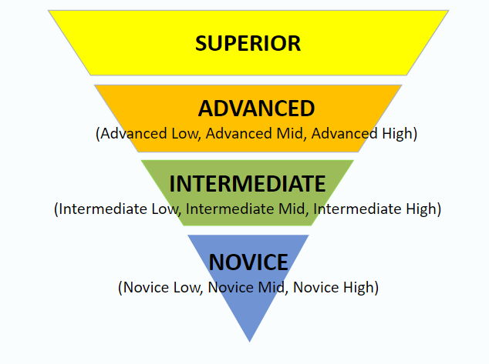
This part of the module defines proficiency and explains why it is important for world language education. World language proficiency is defined as the ability to use a language in real-world situations in spontaneous, non-rehearsed contexts, and learners are also expected to acquire cultural proficiency to effectively communicate in the language and interact with target-language cultures in an increasingly interconnected world. Proficiency in more than one language has multiple cognitive benefits and it helps students gain important insights into peoples, cultures, and communities that allow them to critically and empathetically view and respond to the world around them. Students acquire proficiency primarily by engaging with comprehensible input. Learners acquire proficiency in different ways and at different rates depending on a variety of factors, including (but not limited to) students’ age and grade levels, the type of language program offered, the nearness and familiarity of the language, and the amount of time students have been interacting with the language.

Proficiency-Based Language Teaching
This part of the module provides information about how you can use proficiency to guide instruction. Proficiency-based language teaching is a framework for language teaching. It is not a methodology, as you can and should use various instructional methods and activities that are best suited to your teaching style, your students, and your classroom. This adaptive, student-centered approach to language teaching is a way of framing language learning with the overall goal of our students being able to communicate meaningfully and appropriately for real-life purposes. To use this approach, it is important to get to know your students, create appropriate goals, and assess your students over time. High-leverage teaching practices, commonly referred to as the ACTFL Core Practices, are recommended.

Proficiency and the Framework
This part of the module explains how the Framework supports proficiency-based language teaching by providing standards aligned to the national ACTFL standards and proficiency levels and supporting districts to design programs in which students meet or exceed the high levels of proficiency to obtain the Massachusetts Seal of Biliteracy. Specific supports include recommended topics for different proficiency levels, a list of high-leverage teaching practices, and guidance on determining proficiency outcomes for different types of courses.

Additional Resources
ACTFL Core Practices • ACTFL Performance Descriptors • ACTFL Proficiency Guidelines • NCSSFL-ACTFL Can-Do Statements • CARLA Proficiency-Oriented Language Instruction and Assessment Handbook • MaFLA Programming • Massachusetts World Languages Curriculum Framework • Massachusetts World Languages Leadership Network

