Tips for Printing School and District Report Cards
Every year, the Massachusetts Department of Elementary and Secondary Education releases a report card for each school and district in the state. Massachusetts sees families and the community as important partners in a school’s success and spent time listening to parents to make sure the report cards were designed as easy-to-use tools that provide meaningful information. The report cards are designed to be viewed online but can be printed by following the instructions below.
Helpful Hints:
- Use a recommended web browser. The most recent versions of Google Chrome, Internet Explorer, Safari, and Microsoft Edge work best. We do not recommend using Firefox.
- Use direct links when sharing electronically. When sending report cards by email or other digital means and when posting to school and district websites, do not send a PDF. Instead, send a direct link to the report card (e.g., https://reportcards.doe.mass.edu/2023/Your-8-Digit-Org-Code). Having access to the direct link allows users to translate, interact with, and search for reports.
- Report cards print data for “All Students” only. Student group-level report cards cannot be printed at this time.
To Print a Report Card in English:
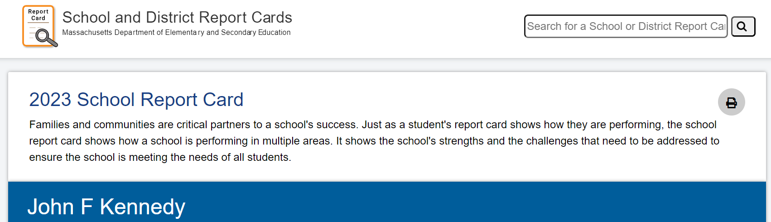
- Search for a report card at reportcards.doe.mass.edu.
- Click the Quick Print button at the top of the report card.
- Adjust your print settings (optional). Through your computer’s print driver, you can change the orientation (portrait or landscape) and add or remove headers and footers.
- Select your print destination. Send the report to a printer or print to PDF.
- Print.
To Print a Translated Report Card:
Note: Translations are made available by the third-party Google Translate application. The availability of languages and the accuracy of translations are not determined by DESE.
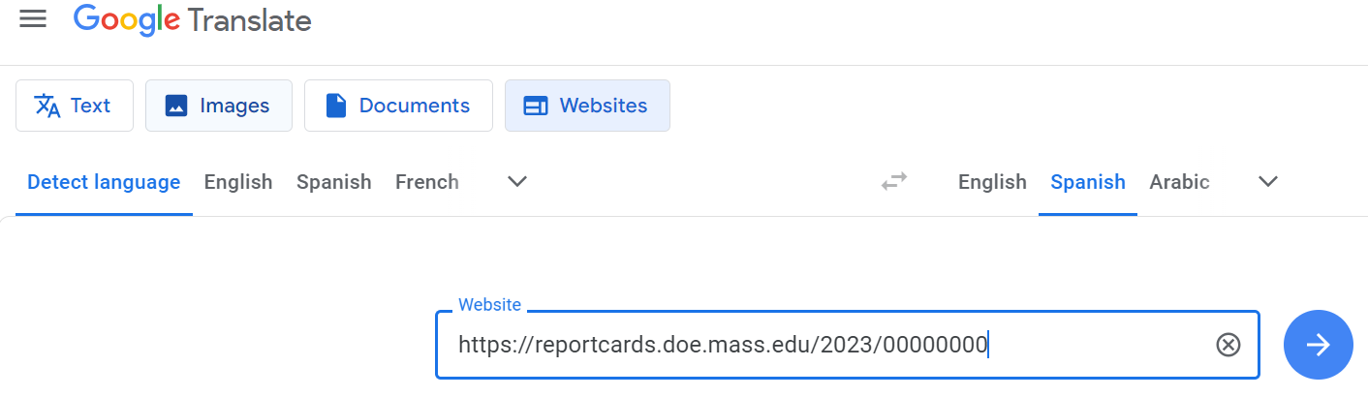
- Search for the report card you wish to translate. Copy the URL.
- Go to https://translate.google.com, then click on Websites.
- Paste the URL for the report into the box shown, and select the desired language at the top. Click enter.
- Click the Quick Print button at the top of the report card.
- Adjust your print settings (optional). Through your computer’s print driver, you can change the orientation (portrait or landscape) and add or remove headers and footers.
- Select your print destination. Send the report to a printer or print to PDF.
- Print.

